Application Package
ENGL 301
Lesson 4:1

By: Jenny Zhu, ENGL 301 student

December 9, 2019

JOB DESCRIPTION
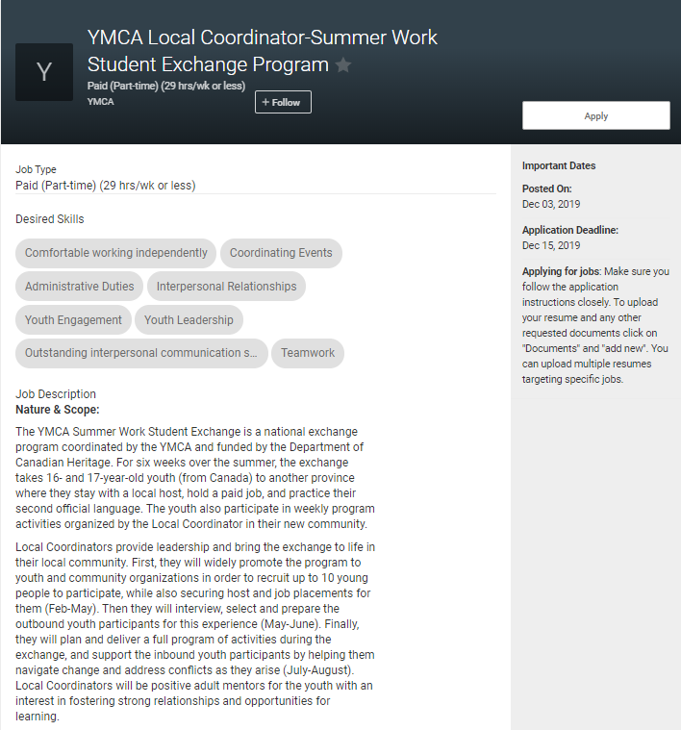
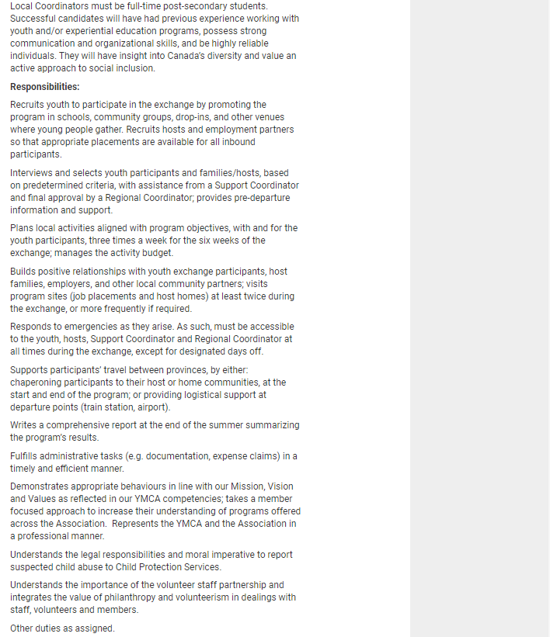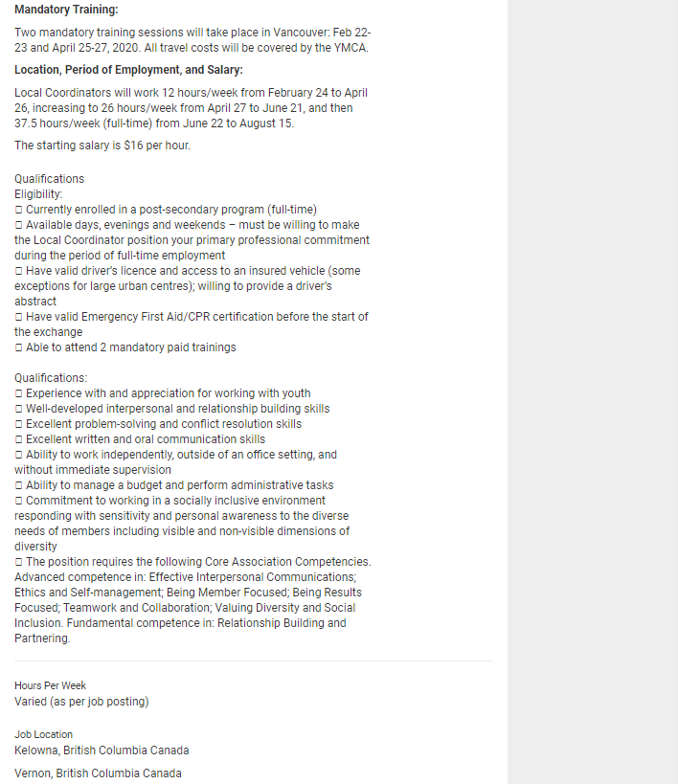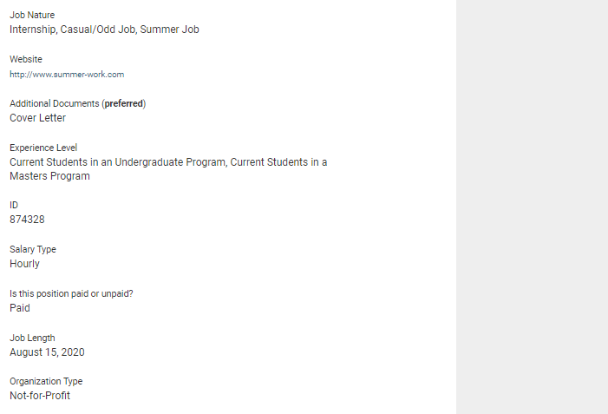
MLA Citation:
“YMCA Local Coordinator-Summer Work Student Exchange Program”. YMCA. 2019, https://ubc-csm.symplicity.com/students/index.php/pid776259?s=jobs&ss=jobs&mode=form&id=1fb3538168f18450386f72aa2dcdad30. Accessed December 9, 2019.

December 9, 2019

6016 Larch Street
Vancouver, V6M 4E4

Kelowna Downtown YMCA
1011-505 Doyle Ave
Kelowna, BC V1Y 6V8

To Whom It May Concern:

I am writing to you to express my sincere interest for the position of Local Coordinator at the YMCA Summer Work Student Exchange Program. I have always had a passion for education and interacting with youth. I find the focus and motivation behind this program not only crucial to the rich experience of learning second languages and culture, but also in alignment with my own personal interests.

Experience in the field of education has given me exceptional interpersonal skills as well as the ability to work in dynamic environments through interacting with a wide range of people. For example, as a Science Facilitator at Science World, I was constantly immersed in a teaching environment where customer service and problem-solving were at the forefront of my job. Not only had I developed exceptional communication skills orally, and in writing, I have become very flexible in problem solving under time constraints and well.

This past summer in my role as a high school camp instructor, I planned curriculum and led 8 weeks of camps, including an overnight camp where students from all over Canada explored attractions in Vancouver. As a student at UBC, I am very familiar with the city of Vancouver, having gained knowledge of its culture through activities and programs, making me a suitable candidate to navigate through the city to different employer workplaces and homes. Being a past participant in the SWSE, I am very familiar with the expectations and learning goals of the program. This experience also heightens my ability to understand and help youth participating in the upcoming session.

Currently, in my role as the Teacher Pro-D Instructor I execute and plan Professional Development events for teachers. This position has allowed me to be more adept at meeting tight deadlines, be more productive, and manage time more effectively. The initiative I take allows me to work collaboratively and creatively with the members of my team and serve as a liaise between Geering Up and educators across the lower mainland.

I would appreciate a role in contributing to the development and innovation the YMCA is making for youth. Thank you for your consideration, I look forward to speaking with you further.

Sincerely,
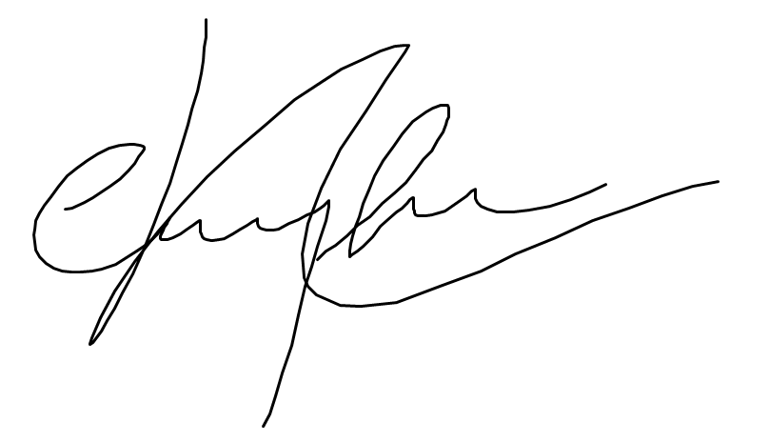

Jenny Zhu

JENNY ZHU
6016 Larch Street | Vancouver, BC V6M 4E4
604.717.0407 | jennyszhu@gmail.com

EDUCATION

University of British Columbia — BSc. Biology, Science Co-op
September 2015 - May 2020

WORK EXPERIENCE

Geering Up, Vancouver, BC— General Instructor, Curriculum Instructor (Co-op), Teacher Pro-D Instructor
September 2019 - Present (General Instructor, Curriculum Instructor)
- Planning and leading full-day professional development teacher and teacher candidate workshops with up to 120 participants, that incorporate hands-on STEM design challenges and activities
- Designing and revising curriculum for high school workshops for Geering Up instructors centered around Biology and Chemistry
April 2019 - August 2019 (General Instructor, Curriculum Instructor)
- Taught workshops for elementary students (grades K - 7) on STEM topics closely tied to the BC Curriculum, such as electricity, circuits, simple coding, human biology, Computer Aided Design and 3-D printing
- Led and planned high school, camps including Sustainability in Engineering, Biomedical, and Overnight camps
- Ordered materials for 120 campers

Center for Teaching, Learning and Technology, Vancouver BC — Canvas Technology Rover (Co-op)
May 2018 - December 2019
- Worked under the Faculty of Education at Education Technology Support as appointed by CTLT to help with the migration from the Connect learning platform to Canvas
- Assisted with reviewing and redesigning courses migrated to Canvas, ensuring content was migrated over successfully, appropriate layout and content, and resolving issues that arise
- Provided Tier 1 support to faculty members in their departments by gathering information, analyzing systems, and providing resolutions

Science World at TELUS World of Science, Vancouver, BC — Science Facilitator (Co-op)
January 2018- May 2018
- Positively influenced visitor’s attitudes towards science, technology, and creative thinking by explaining exhibits and instructing curriculum-based workshops
- Provided customers with friendly, responsive service, including hosting OMNIMAX Theatre presentations
- Created workshop curricula in English and in French and writing detailed instructions for workshop presenters

Starbucks, Vancouver, BC — Barista
July 2016 - December 2017
- Provided exceptional customer service by ensuring satisfaction and resolving any problems with patience and care
- Adapted to high pressure by keeping the store organized and adjusting to any needs that arose in a timely manner
- Closely followed instructions and successfully completed new tasks, and trained other baristas periodically

CBC/Radio Canada, Vancouver, BC— Co-Host
January - March 2015
- Conducted, compiled, and edited interviews for a show segment
- Co-hosted a 1-hour live show that involved 5 high school students

VOLUNTEER EXPERIENCE

UBC Faculty of Science, Vancouver, BC — Orientation Leader
March 2016 - December 2016
- Welcomed a group of 6 students entering university by guiding a campus tour and answering questions about university
- Supported these students through their first day of classes, midterm exams, and final exams by providing advice, encouragement, and academic aid

Let’s Talk Science, Vancouver, BC — Workshop presenter
December 2015 - December 2017
- Communicated and presented biology, chemistry, and physics concepts to high school students by engaging them through hands-on activities
- Planned educational activities for students about Biology, Physics, and Chemistry
- As part of the Teacher Partnership program, collaborated with a grade 8 class at King David School to teach hands-on activities that align to the BC Curriculum

EXTRA-CURRICULAR ACTIVITIES

UBC Red Cross Co-President

UBC Red Cross Community Outreach Co-director
Simard Lab for Ecological Research Volunteer
UBC Right to Play First Year Outreach Coordinator

April 2018 - April 2019

September 2017 - April 2018

March - August 2017

September 2015 - April 2016

To: Katarina Smith
From: Jenny Zhu
Date: December 9, 2019
Subject: Request for Reference

Dear Katarina Smith,

I hope this letter finds you well. First of all, you were a pleasure to work with this semester and I look forward to expanding our program in the upcoming months. As mentioned in person, I am applying for a position with the YMCA of Kelowna as a Local Coordinator for their Summer Work Student Exchange program. Since you have seen me work in teaching environments I would like for you to be one of my references.

The Local Coordinator position is very similar to the High School Overnight Camps Instructor position at Geering Up. I will be working with high school students from Quebec, helping them find a full-time summer job, and tour the lower mainland with them. This opportunity is only open to current Undergraduate or Master’s students, and I would like to take advantage of being in the last year of my degree. This job will be a great experience for becoming a French Immersion teacher later on.

Having you vouch for me as a reference means a lot, as you have observed me in environments working with high school students and understand my career goals. Please let me know if you are willing to take on this role or would like to have a discussion in person. The best way to reach me is by email at jennyszhu@gmail.com, or at 604-717-0407 for a faster reply. Here is a link to the job posting and attached is my resume.

Thank you for your time and consideration. I look forward to speaking with you soon.

Yours Truly,

Jenny Zhu

Encl. Resume

To: Trevor Wou
From: Jenny Zhu
Date: December 9, 2019
Subject: Request for Reference

Dear Trevor Wou,

I hope you are doing well and enjoying your new position. I enjoyed working closely with you this Summer and maybe you can come back next Summer to direct camps again. Currently I am applying for a position with the YMCA of Kelowna as a Local Coordinator for their Summer Work Student Exchange program. This role is closely related to my position last summer and you would be the ideal reference for me.

Similar to the High School Overnight Camps Instructor position at Geering Up, this role entails spending six weeks with high school students from Quebec and exploring the lower mainland with them. Being in my last year of my degree, this would be the last chance to experience this opportunity. This job is a perfect stepping stone for becoming a French Immersion teacher later on.

Having you as a positive reference would mean a lot, as you have worked with me closely and have given me constructive feedback before. Please let me know if you are available to be my reference or would like to have a discussion in person. The best way to reach me is by email at jennyszhu@gmail.com, or at 604-717-0407 for a faster reply. For your curiosity, here is a link to the job posting and attached is my resume..

Thank you for your time and consideration. I look forward to hearing from you soon.

Yours Truly,

Jenny Zhu

Encl. Resume

To: Dr. Marina Milner-Bolotin
From: Jenny Zhu
Date: December 9, 2019
Subject: Request for Reference

Dear Dr. Marina Milner-Bolotin,

I hope you are doing very well and that your course was a success this year. Thank you for giving me the opportunity to work with you on the Geology project. I am applying for a summer Local Coordinator position with the YMCA and would like to ask you to be one of my references.

This position is part of the Summer Work Student Exchange program at the YMCA, a program I participated in in high school and I hope to be a part of it again. This opportunity is only open to current Undergraduate or Master’s students, making this summer the first and the last chance for me to apply. This job will allow me to work with french-speaking high school students, and be a great experience for becoming a French Immersion teacher later on.

Having you vouch for me as a reference means a lot. You have always encouraged me to pursue my passion for working with young people and you have also observed me in such environments. Please let me know if you are willing to take on this role or would like to have a discussion in person. The best way to reach me is by email at jennyszhu@gmail.com, or at 604-717-0407 for a faster reply. Here is a link to the job posting and attached is my resume.

Thank you for your time and consideration. I look forward to speaking with you soon.

Sincerely,

Jenny Zhu

Encl. Resume

