Application Package Draft

By

Ranjit Dhaliwal

ENGL 301 Student

December 12, 2019

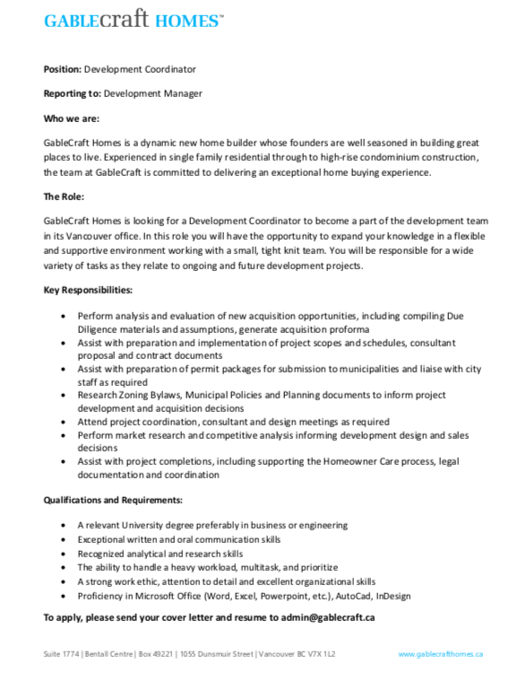
Citation:

“Careers.” Urban Development Institute, https://udi.bc.ca/careers-list/page/2/.

Ranjit Dhaliwal
1885 E 43rd Avenue
Vancouver, BC V5P 1XT

December 12, 2019
Gable Craft Homes Inc
#1774 – 1055 Dunsmir St
Vancouver, B.C
V7X 1L2

To: Human Resources Department

As a graduate with a Diploma in Urban Land Economics with a specialization in Real Estate Development, I am pleased to submit my resume for the position of Development Coordinator with Gable Craft Homes Inc as advertised on the Urban Development Institute website. Along with my current educational background, 7 years of construction and project management experience working on single family homes in the Lower Mainland and the knowledge I have acquired as a Real Estate Trading Services Representative, I am certain in my ability in becoming a Development Coordinator.
During my education and practical experience in the real estate industry, I have gained strong skills and knowledge in the various aspects that apply to real estate development and the industry in general. I have a solid understanding of the real estate development process, economic & appraisal theory, real estate finance and investment analysis including various measures of pro formas & DCF analysis. I’m also proficient in various computer software programs like Microsoft Office. I’m currently in the process of obtaining my Bachelor’s Degree in Business & Real Estate from the Sauder School of Business and my current educational background along with my work experience also makes me eligible for my RI designation from REIBC. My enclosed resume gives details about my qualifications and experience.
As an enthusiastic and passionate individual in regards to real estate development along with my continuing pursuit of real estate & business education, I welcome the chance to meet with you to discuss how my education, experience and skills would be beneficial for Gable Craft Homes Inc. If you have any questions or would like to get into contact with me, I can be reached at 778-995-4085 or ranjdhaliwal@live.com. Thank you for your time and consideration.

Sincerely,
Ranjit Dhaliwal

Enclosed: Resume
Ranjit Dhaliwal
1885 East 43rd Avenue, Vancouver B.C. V5P 1XT
ranjdhaliwal@live.com 778-995-4085

Objective

To obtain a challenging position within the real estate industry with a reputable organization that allows me to utilize my current skills and education in implementing the real estate development process & investment analysis.

Profile

- Energetic self-starter with excellent communication skills
- Ability to work independently and as a team player
- Solid understanding in programs of Microsoft Office
- Excellent leadership skills, with the ability to take necessary actions in tasks when required
- Highly skilled in all aspects of real estate including finance, development, management, appraisal and investment analysis

Education/Certificates

- UBC Sauder School of Business
- Bachelor of Business in Real Estate Degree / May 2015 - Present
Real Estate Management Specialization – December 2017
Real Estate Brokerage Specialization – June 2017
Real Estate Appraisal Specialization – February 2017
- Diploma in Urban Land Economics - April 2015
Real Estate Development Specialization – December 2014
Real Estate Trading Services License – September 2014

- REFM Certification in Excel for Real Estate - Levels 1, 2 & 3 With Distinction / February 2018
- ULI Certificate in Commercial Real Estate Pro Forma Fundamentals / In Progress

Experience

Axium Development Ltd.
July 2012 – Present
Vancouver, BC
Site Supervisor/Project Coordinator
- Oversaw and managed the construction & development of single & multi-family homes from initial design to final occupancy.
- Responsibilities included: communicating with clients, architects, structural engineers, city officials and other professionals during the entire project life cycle, obtaining bids, negotiating contracts and selecting sub trades for each aspect of the building process, providing quality control and effective resolutions for job site issues, liaising with building inspectors and warranty providers during inspections to ensure a high standard of compliance, completing projects both on time and within budget with a high standard of quality.

Amex-Fraseridge Realty
November 2014 – Present
Vancouver, BC
Real Estate Trading Services Representative:
- Providing professional services for the acquisition & disposition of Real Estate Assets while exhibiting exemplary ethics and care.
- Responsibilities Included: Maintaining current & extensive knowledge of prevailing trends in the local real estate market, providing accurate appraisal theory and comparative market analysis for clients when making real estate value determinations, providing clients with strategic and professional advice in making investment decisions, conducting effective negotiations to meet and exceed client expectations, liaising with brokers and real estate professionals throughout the sales process.

Ellen McIntosh, LLB, LLM
Professor
Sauder School of Business
University of British Columbia
Office LAM 411
2033 Main Mall
Vancouver, B.C V6T 1Z2

Subject: Request for reference

Dear Mrs. McIntosh,

I hope you doing well and are continuing to make business law as interesting as it was for me. Hopefully you also got around to teaching that MBA/JD curriculum that you are so passionate about. I am reaching out to you in hopes of using you as a reference for a job application I am applying too.

I am applying to a company called GableCraft Homes Inc for a position they posted for a development coordinator. This position is directly related to the development side of real estate and entails extensive exposure to the development of multi-family projects throughout B.C. As you know, I am very passionate about real estate development and the creation of built environments, therefore this potential job is a great step in the progression of my career.

Having you as a reference would be beneficial for me, as you can attest to my work ethic, collabortaion and focus that I brought to your classes. Please let me know if you’re willing and comfortable with providing a reference for me. If you would like to discuss this matter further, feel free to send me an email at ranjit.dhaliwal@alumni.ubc.ca. I have also attached to this email a copy of my resume for your convenience.

Thank you for your time and consideration.

Sincerely,

Ranjit Dhaliwal

Enclosed: Resume

Brigid Greenville
Inhaus Consulting Corp.
5011 Smith Ave
Burnaby, B.C V3W 2T6

Subject: Request for reference

Dear Mrs. Greenville,

I hope you doing well and are getting ready to enjoy the upcoming holiday break. Hopefully there isn’t too much snowfall and you get a chance to drive up north and enjoy your family cabin. I am reaching out to you in hopes of using you as a reference for a job application I am applying too.

I am applying to a company called GableCraft Homes Inc for a position they posted for a development coordinator. This position is directly related to the development side of real estate and entails extensive exposure to the development of multi-family projects throughout B.C. As you know, I am very passionate about real estate development and the creation of built environments, therefore this potential job is a great step in the progression of my career.

Having you as a reference would be beneficial for me, as you can attest to my analytical skills and willingness to learn which I exhibited during my time as an intern analyst with your organization. Please let me know if you’re willing and comfortable with providing a reference for me. If you would like to discuss this matter further, feel free to send me an email at ranjit.dhaliwal@alumni.ubc.ca. I have also attached to this email a copy of my resume for your convenience.

Thank you for your time and consideration.

Sincerely,

Ranjit Dhaliwal

Enclosed: Resume

Bel Dhillon
Manager
Fortress Homes Inc
Richmond, B.C V6Y 3C9

Subject: Request for reference

Dear Mr. Dhillon,

I hope you doing well and are staying busy during this current slowdown in real estate construction. Hopefully you also got a chance to get your pilots license and if you did, I might have to take you up on that offer for flying lessons. I am reaching out to you in hopes of using you as a reference for a job application I am applying too.

I am applying to a company called GableCraft Homes Inc for a position they posted for a development coordinator. This position is directly related to the development side of real estate and entails extensive exposure to the development of multi-family projects throughout B.C. As you know, I am very passionate about real estate development and the creation of built environments, therefore this potential job is a great step in the progression of my career.

Having you as a reference would be beneficial for me, as you can attest to my project management skills and ability to manage and deliver projects on time and within budget which I exhibited while we worked together. Please let me know if you’re willing and comfortable with providing a reference for me. If you would like to discuss this matter further, feel free to send me an email at ranjit.dhaliwal@alumni.ubc.ca. I have also attached to this email a copy of my resume for your convenience.

Thank you for your time and consideration.

Sincerely,

Ranjit Dhaliwal

Enclosed: Resume

