Application Package Draft

By:
Connor Runnalls
UBC Student

December 12th, 2019

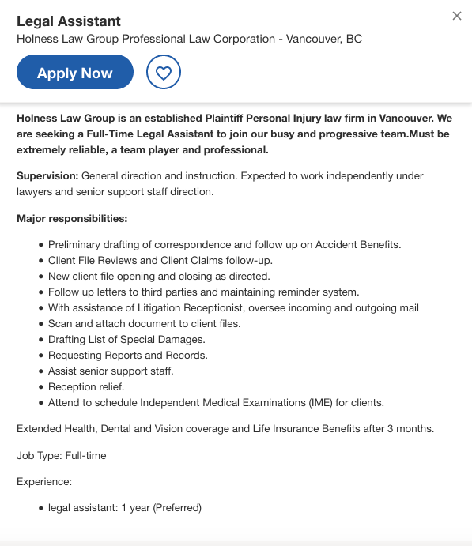

Connor Runnalls
3952 W22nd Ave.
Vancouver, B.C., V6S1K1

December 12, 2019

Holness Law Group
507-808 Nelson St.
Vancouver, B.C., V6Z2H2

Dear Holness Law Group,

I am writing the firm to express my interest in the position of legal assistant at your firm, as listed on ca.indeed.com. I am currently a 5th year UBC psychology undergraduate student graduating in April 2020, and planning to attend law school in September 2021. In the time leading up to my admission to Law School, I am looking to gain a year of full-time work experience in a legal setting to begin learning the business.

It should be noted that based on the experience section in my Résumé attached below, I have little to no experience in a law setting. With that said, what I lack in experience I make up for in my ability to learn quickly and attention to detail. Over the three years spent with Lululemon, I have developed a strong ability to multitask in high-pressure situations and learn on the fly. Furthermore, during my time in a storefront setting, I was tasked with resolving guest issues ranging from product issues to interpersonal conflict.

Lululemon also stressed the importance of “being your own entrepreneur” which to the company meant being able to take basic instruction from leads or managers and being able to expand on this instruction independently, or working independently as necessary without instruction. This allowed for my development of identifying what needs to be done and accomplishing it without any form of reminder or direction from management.

My strengths in an office setting revolving around my attention to detail and strong writing abilities. My provincial exams in high school reflect an overall score in the ’90s, while classes focused on writing in university have been my strongest courses reflecting similar scores in the 80’s and 90’s. This ability should fit well with the responsibility of drafting correspondence, and the follow-up letters as outlined by the job posting.

As a future lawyer, I am eager to begin learning and developing the basic skills required in a legal setting, though, I understand that for this position there may be a slight learning curve to overcome through training. With that said, I am certain my ability to work hard, pay attention to fine detail, and desire to learn will not only mitigate those learning curves but allow me to excel in the position as I cultivate my path towards a legal career.

If this skill set, in addition to a positive team player, is of interest for addition to the Holness Law Group, please call at 250-863-1794 during standard business hours, or email at connor.runnalls@gmail.com

I look forward to further correspondence with your firm.

Sincerely,

Connor Runnalls

Connor Runnalls
3952 W 22nd Ave
Vancouver B.C., V6S1K1
2508631694
Objective
First experience working for a law firm during a year of full time work experience, before entering law school.
EXPERIENCE
Educator, Lululemon — 2017-2019
From 2017-2019 I have worked at three locations of Lululemon including their Kelowna location, the original store on W 4th Avenue, Vancouver, and their Flagship store on Robson St. in Vancouver. As an Educator, I was relied upon to first and foremost create meaningful connections with all guests, while educating on product details and ensuring a quality guest experience. Skills developed throughout my time with Lululemon include guest/customer service, meticulous attention to detail, leadership, training on product knowledge, teamwork/communication with a large staff, and working in a high volume, high pressure store.

Camp Leader, UBC baseball — 2019
In the summer of 2019, I worked as a kids camp leader/trainer in which I led drills and games for kids aged 7-13 for the purpose of skill development. Throughout the camp, I was tasked with managing and organizing kids and their games, ensuring player safety, and developing their skills. Furthermore, as a requirement for the job, I renewed my CPR certification.

EDUCATION
Edmonds College, Edmonds Wa. — Associate of Arts 2015-2017
University of British Columbia, Vancouver B.C. - Arts Psychology, 2017-2020

Volunteer Work
Special Assistant to the president Okanagan Humane Society
2018 - present
Over the course of the previous three years, I have served as an assistant to the president of the Okanagan Humane Society, fulfilling tasks such as transportation of animals and set up of events. Recently, I have been granted access to a supplemental role of aiding in the management of the OHS instagram page.
Personal
Awards
Captain of the Junior Varsity UBC baseball team 2019-2020, Grade 6 Royal Conservatory
Skills
Bilingual English-French, Strong interpersonal abilities, Leadership, Loyal, Dedicated

REFERENCES
References available upon request

To: Dewi Peters
From: Connor Runnalls
Date: December 9th, 2019
Subject: Request for reference

Dear Dewi Peters,

I hope all is well with you, Dr. Lars, and all of the adventures you two are experiencing in this new chapter of your life. Currently, I am in the beginning stages of applying for position openings as a legal receptionist or assistant. As you and I have discussed extensively, the legal world is without question my desired outcome in life, and I am excited to be able to take this first step in my transition from student to the legal workforce.

Legal receptionists, secretaries, and assistants provide introductions to the drafting and previewing of legal documents, the scheduling and organization required from a lawyer, and a preview of the fast pace setting that lawyers immerse themselves in. I intend to carry out this job for a year as I study for my LSAT’s and gain full-time work experience before entering law school. This job ultimately serves as an excellent introduction of sorts for what to expect for a career in law.

Given my experience of working for you and the role you had in my development as an educator and contributing member of the Kelowna Community, it would be greatly appreciated if you would be willing to provide a positive reference. Please let me know if you would be willing to provide a reference, and if you have any further questions on the matter. As always, I can be reached either through my email connor.runnalls@gmail.com or my phone number 250-863-1794. For further reference with information pertaining to the positions I will be applying for, attached is a link to a prospective opportunity, as well as an updated resume.

Thank you so much for all of your time and consideration. My best wishes to you and Lars, and I look forward to hearing from you soon.
Sincerely,

Connor Runnalls

To: John Embry
From: Connor Runnalls
Date: December 9th, 2019
Subject: Request for Reference

Dear Mr. Embry,

I hope that all is well with you and your family. I certainly missed seeing you this summer, but I am already looking forward to making it back out to see you this upcoming year.

The reason I am writing to you today is with the request for an updated letter of reference. I am currently applying for positions as a legal assistant or legal receptionist to get my foot in the door of the legal world. As a legal assistant, I will be drafting correspondence letters, reviewing client files, as well as other administrative tasks. This job will require close attention to detail and strong interpersonal skills while exposing me to the basics of law.

I am very excited about this position as it will be the first step in my law career. I intend to maintain a position as a legal assistant full time for the next year to gain full-time work experience going into law school. Beyond this year, I expect that I will be carrying out similar jobs/internships throughout summers of work while in school until finally passing the bar.

I would be extremely grateful if you would be willing and able to write a letter of recommendation to help get my career started as we have spoken so often about during our visits. If you have any further questions or comments regarding the letter of reference, please don’t hesitate to ask.

Thank you so much for all your time and consideration, Mr. Embry. I look forward to hearing from you soon and seeing you again in the summer.

Sincerely,

Connor Runnalls

To: Carleana Lesyk
From: Connor Runnalls
Date: December 9th, 2019
Subject: Request for Reference

Dear Carleana Lesyk,

I hope all is well for you and the staff at the Robson store. I have certainly been missing being around the store and can’t begin to describe how grateful I am for the opportunity you gave me by bringing me to your store. I am writing this letter for the purpose of requesting a letter of reference from you personally. Currently, I am in the process of beginning the application process for a variety of job openings as a legal receptionist or a legal assistant.

I am reaching an exciting point in my life in which I am graduating from my undergraduate degree and can commence my transition to more career-focused jobs to supplement my path through Law school. In this upcoming year, I will be taking a work year between my undergraduate program and Law school with the purpose of gaining full-time work experience, and studying for the LSATs. The opportunity presented by working as a legal receptionist or assistant is first and foremost, getting my foot in the door of the law world. Furthermore, I will be exposed to drafting and previewing legal documents, coordinating meetings, and court dates for lawyers and their clients, all while being exposed to the daily life of a lawyer.

It would be greatly appreciated if you would be willing to provide a letter of reference for my application process. You and the Robson team were crucial to my development in working in a high paced environment while being able to multi-task and not becoming overwhelmed by guest or job demands. Please let me know if you are able and willing to provide a letter of reference that I may include in my application process. If you have any further questions, please don’t hesitate to email me at connor.runnalls@gmail.com or contact me by phone at 250-863-1794. Furthermore, if you have any further questions regarding the types of positions I would be applying for, I have attached a link with a prospective opportunity, as well as my updated resume.

Thank you so much for your time and consideration. I look forward to hearing from you soon and I hope to see you around the Robson store soon.

Sincerely,

Connor Runnalls

