Application Package
Assignment 4.1

By: Amy Vergouwen, ENGL 301 Student

December 4, 2019
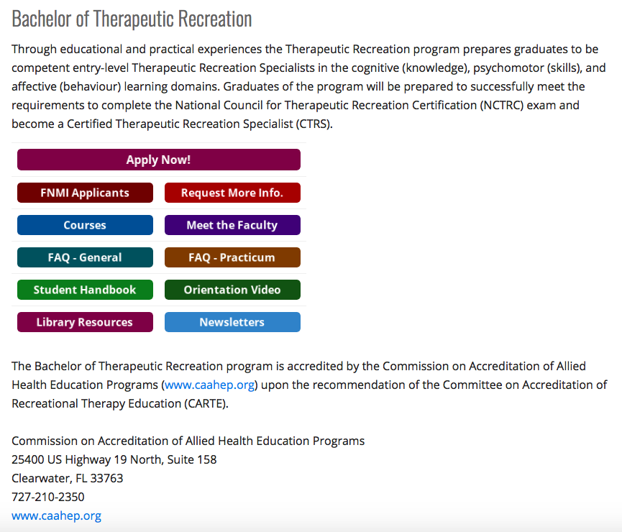
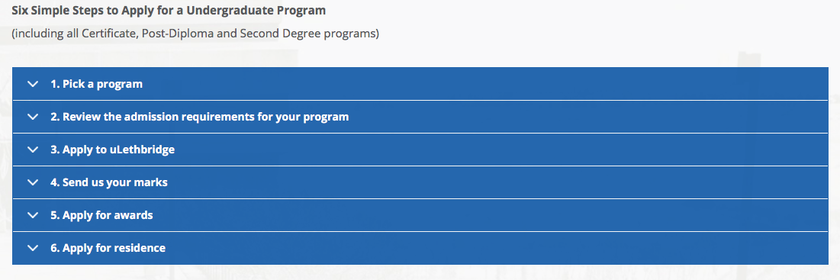

MLA Citation:

“Bachelor of Therapeutic Recreation.” University of Lethbridge. 2019, https://www.uleth.ca/healthsciences/tr. Accessed December 4, 2019.
Amy Vergouwen
1873 Country Club Drive
Kelowna, BC, V1v 2r6

December 4, 2019

Devan McNeill
Therapeutic Recreation Coordinator
University of Lethbridge Faculty of Health Sciences Admissions
4401 University Drive
Lethbridge, AB, T1k 3m4

Subject: Application for Bachelor of Therapeutic Recreation Program

Dear Mr. McNeill,

It is with pleasure that I submit my application to the University of Lethbridge Bachelor of Therapeutic Recreation Program. I am very interested in the therapeutic recreation program due to its accreditation by the Commission on Accreditation of Allied Health Education Programs, and the ability to become a Certified Therapeutic Recreation Specialist after completion of the program. The chance to complete a practicum alongside a Certified Therapeutic Recreation Specialist is an incredible opportunity.

I am currently completing the final year of my undergraduate degree at The University of British Columbia Okanagan. I am majoring in psychology, and have taken a variety of classes that have provided me with a strong background in health psychology, such as psychopharmacology, healthy aging, and lifespan development. In addition to my educational background in health psychology, I have spent a year volunteering at the Glenmore Lodge long-term care facility as a therapeutic recreation assistant. I have assisted in muscle strengthening therapy, brain exercises, mathematical exercises, target practice workouts, and activities like arts, crafts, and games. My time spent at Glenmore Lodge is what inspired me to apply to the Bachelor of Therapeutic Recreation Program, as I realized I could see myself working at a long-term care facility for my career.

With my education paired with my experience, I believe I possess the necessary skills to enter the therapeutic recreation program. I have developed patience, reliability, and communication skills, all while maintaining a compassionate and respectful nature working with the older population. One of the hardest skills I have had to learn is coping with the decline in residents’ health and death within the facility, but I believe it is an important skill to possess. I have worked very hard to develop the necessary strengths and abilities to make myself a great candidate for the Bachelor of Therapeutic Recreation Program at The University of Lethbridge.

Along with my application package, I have included my resume, proof of enrolment at UBC, and three letters of recommendation from my current boss at Glenmore Lodge. If you require any other information, please do not hesitate to send me an email at amy.vergouwen@alumni.ubc.ca. Thank you for your time and your consideration, and I look forward to speaking with you in the near future.

Sincerely,

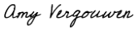

Amy Vergouwen

Amy T. Vergouwen
1873 Country Club Drive
Kelowna, BC, v1v 2r6
Phone: (403) 463-2535
Email: amy.vergouwen@alumni.ubc.ca
Objective

Admission into the University of Lethbridge Bachelor of Therapeutic Recreation Program.
Education

University of British Columbia Okanagan (UBCO): B.A. expected August 2020. Psychology major. Maintaining GPA 3.75.
2016-2020
2012-2016
Cochrane High School: French Immersion high school diploma.
Employment

Carbon Solutions Group Canada, Airdrie, AB
April 2019-August 2019
Marketing Summer Student. Performing marketing and sales of combined heat and power units to colonies and agricultural corporations. Specific daily tasks include working closely with a visually impaired individual in the company, providing help and support to his sales work, working gas and electricity data into ROI analysis sheets, and research on potential new clients.
April 2013-August 2018
Play Golf Calgary, Cochrane, AB
Proshop, Sales and Guest Services. Performing various administrative duties, customer service, inventory, marketing/sales and special event support.
January 2018-April 2018
UBC Okanagan Disability Resource Centre, Kelowna, BC
Peer Notetaker. Providing class notes and documents from university classes for students with disabilities.
Volunteer Experience
Glenmore Lodge Care Community, Kelowna, BC
Therapeutic Recreation Assistant. Volunteer therapeutic recreation assistant, ensuring the wellbeing of seniors with dementia by helping with care and recreation therapy twice a week. Assisting with muscle strengthening therapy, brain exercises, mathematical exercises, target practice workouts, and fun activities like arts, crafts, and games. January 2019-present.
January 2019-present
September 2017-April 2018
The Phoenix News, Kelowna, BC
Junior Copy Editor. Volunteer junior copy editor at UBC Okanagan’s student-run newspaper The Phoenix News. Proofread, edited and fact-checked 6-10 newspaper articles bi-weekly.
September 2014-May 2016
École Elizabeth Barrett Elementary School, Cochrane, AB
Literacy Tutor. Volunteer literacy tutor at Elizabeth Barrett Elementary School. Helped 7-10-year-old French immersion students learn how to read and write three times a week.
Personal
Awards
Honour roll all 4 years of high school. Alexander Rutherford scholarship in first year university.
Special skills
Fluent in French. Extensive experience working in geriatrics. Tri-Council Policy Statement: Ethical Conduct for Research Involving Humans Certification.
Activities
Symphonic, Jazz & Pit Bands, Leadership, Senate, The Voice Newspaper.
Interests
Horseback riding, reading, golfing, hiking.
References

Available on request.
Michael Woodworth, PhD
Professor
Department of Psychology
The University of British Columbia Okanagan
Office ASC 205
3333 University Way
Kelowna, BC V1V 1V7

Subject: Request for reference

Dear Dr. Woodworth,

I hope you are doing very well, and I hope your classes have been a success this year. Hopefully you were able to get the RCMP in this year to present in your forensics class! I am reaching out to you in hopes of using you as a reference for an academic program I am applying to.

I am applying to the Bachelor of Therapeutic Recreation Program at The University of Lethbridge. This is an after degree program only available to those who have already completed an undergraduate degree. As you know, I volunteer at a long-term care facility with the therapeutic recreation team, so this academic program is a natural step for me to progress my career.

Having you as a reference would be very beneficial to me, as you can vouch for my work ethic and academic performance from the classes I have taken with you. Please let me know if you are comfortable providing a reference for me. If you would like to talk more about this in person, please don’t hesitate to send me an email at amy.vergouwen@alumni.ubc.ca, and I can come by your office any time. I have attached my resume for your convenience, as well.

Thank you for your consideration and I look forward to speaking with you very soon.

Best,

Amy Vergouwen

Encl: Resume

Heather Owens
Director of Resident Programs
Glenmore Lodge Care Community
325 Drysdale Blvd
Kelowna, BC V1V 1P5

Subject: Request for reference

Dear Heather,

I hope you are doing very well and I hope that you are having a relaxing few weeks leading up to the holiday season. I am reaching out to you in hopes of using you as a reference for an academic program I am applying to.

I am applying to the Bachelor of Therapeutic Recreation Program at The University of Lethbridge. This is an after degree program only available to those who have already completed an undergraduate degree. I have had such a wonderful year working at the care facility on your therapeutic recreation team, so this academic program is a natural step for me to progress my career.

Having you as a reference would be very beneficial to me, as you can vouch for my passion in recreation therapy and the skills I’ve developed while on your team. Please let me know if you are comfortable providing a reference for me. If you would like to talk more about this in person, I will be returning to the care facility on January 8, or feel free to send me an email at amy.vergouwen@alumni.ubc.ca. I have attached my resume for your convenience, as well.

Thank you for your consideration and I look forward to seeing you in the New Year.

Best,

Amy Vergouwen

Encl: Resume

Matt Alfke
Sales Manager
Carbon Solutions Group Canada
724 East Lake Road NE
Airdrie, AB T4A 2J5

Subject: Request for reference

Dear Matt,

I hope you are doing great, and that sales are going very well for you and the CSG team. I am reaching out to you in hopes of using you as a reference for an academic program I am applying to.

I am applying to the Bachelor of Therapeutic Recreation Program at The University of Lethbridge. This is an after degree program only available to those who have already completed an undergraduate degree. As you know, I volunteer at a long-term care facility with the therapeutic recreation team while I am attending university, so this academic program is a natural step for me to progress my career.

Having you as a reference would be very beneficial to me, as you can vouch for my work ethic and the skills I developed while working for you. Please let me know if you are comfortable providing a reference for me. If you would like to talk more about this over the phone, please don’t hesitate to give me a call at 403-463-2535, or send me an email at amy.vergouwen@alumni.ubc.ca. I have attached my resume for your convenience, as well.

Best,

Amy Vergouwen

Encl: Resume

