Jonathan Ho
ENGL301 99A
Assignment 1.3 – Three Definitions

Introduction:
Explaining technical terms to a non-technical audience is a common occurrence, often requiring definitions. This assignment aims to highlight the importance and role of definitions in technical writing. The following term will be defined at three levels of detail to accommodate for different situations.

Technical Term:
PCR

Scenario:
A biologist explaining PCR to a person with little to no knowledge of science and biology. Assumes the person has heard of DNA but does not know what it is in detail.

Parenthetical Definition:
PCR (technique for copying DNA) is the foundation for many other complex biological techniques and applications.

Sentence Definition:
PCR is a biological technique that is used to make many copies of a small section of DNA.

Expanded Definition:
The term PCR is an acronym for Polymerase Chain Reaction. Like its name suggests, PCR describes a continuous cycle of reactions involving a special molecule called polymerase.

PCR is a reaction, meaning there are inputs and outputs. The output is known to be many copies of DNA; the inputs are described as follows.
- DNA template – the sample which contains the section of DNA to be copied
- Polymerase – a special molecule that can build DNA.
- Nucleotides – can be thought of as “building blocks” that polymerase puts together to build the DNA.
- Primers – attach to the DNA template and show where the polymerase should start the copying process.
Once all the inputs have been mixed, there are three steps that occur (see figure 1 below).
- Denaturation – under high temperature the DNA sample splits into two separate strands.
- Annealing – primers attach to the single stranded DNA at a slightly cooler 50-60 degrees Celsius.
- Extension – polymerase attaches to the primers and uses the nucleotides (building blocks) to make a copy of the DNA.
These three steps produce two identical copies of the original DNA sample. The reaction can then be repeated or chained together many times to make millions of copies.

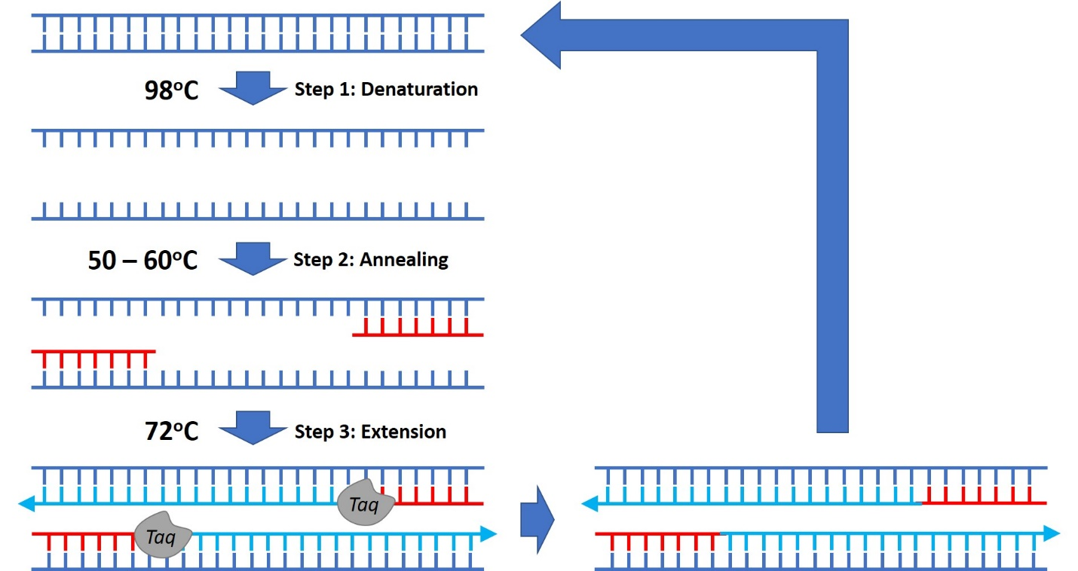

Figure 1. Simplified overview of PCR. Taq is a type of polymerase.

As previously mentioned, PCR is the foundation for many other biological techniques and applications. One such application is forensic analysis. There are certain sections of DNA that are unique to each person, so even if only trace amounts of DNA are found, they can be copied many times allowing scientists to investigate and determine the person of interest. Another use of PCR is infectious disease detection. Because bacteria and viruses have unique genetic material as well, PCR can detect bacterial and viral infections even if the traces are incredibly small.
Works Cited
Bradburn, S., & PhD. (2017, November 22). What Is The Polymerase Chain Reaction (PCR)? Top Tip Bio. https://toptipbio.com/polymerase-chain-reaction-pcr/
Polymerase Chain Reaction (PCR). (n.d.). Retrieved September 28, 2020, from https://www.ncbi.nlm.nih.gov/probe/docs/techpcr/
Polymerase Chain Reaction (PCR) Fact Sheet. (n.d.). Genome.Gov. Retrieved September 28, 2020, from https://www.genome.gov/about-genomics/fact-sheets/Polymerase-Chain-Reaction-Fact-Sheet
Ruano, G., Pagliaro, E. M., Schwartz, T. R., Lamy, K., Messina, D., Gaensslen, R. E., & Lee, H. C. (1992). Heat-soaked PCR: An efficient method for DNA amplification with applications to forensic analysis. BioTechniques, 13(2), 266–274.
Tiner, S. (n.d.). The Science Behind the Test for the COVID-19 VirusDiscovery’s Edge. Https://Discoverysedge.Mayo.Edu/. Retrieved September 28, 2020, from https://discoverysedge.mayo.edu/2020/03/27/the-science-behind-the-test-for-the-covid-19-virus/

