English Assignment 1-3
Criteria: Assignment 1-3 is an exercise that focuses upon the ability to translate professional jargon and terms into a simpler format. This exercise is useful as professionals of all industries will interact with consumers or individuals from other industries. The objective of this assignment is to practice strategies that we could employ in different professional situations. I chose a term that is from my major and is also commonly explained to consumers.
Term: Bridge Financing
Situation: Developer explaining to a consumer at a development open house
Parenetical definition: Bridge financing (short-term loans) can be required before obtaining traditional financing for real estate developments.
Sentence Definition: Bridge financing is a loan type used commonly in real estate development. These loans are characterized by their short-term length, above-market interest rates, and are issued by non-traditional lenders.
Expanded Definition: Bridge financing first emerged as a non-traditional lending form in the 1960s (Hersch). Due to lending restrictions imposed on traditional financial institutions, a secondary lending market was creating. This new lending market was primarily funded by private investors, as banks and other traditional institutions were barred from issuing these loans (Hersch).
Bridge financing is an essential part of the real estate development financing process. The three defining characteristics that separate bridge financing from other types of financing in the process is the loan timing, interest rate, and lending source (Kagan). All three elements work cohesively and can be used to explain bridge loans. Bridge loans tend to have interest rates above the prevailing market rates, this is because the source of the loans is from private investors. The lending source is limited to private investors as the development fails to meet the risk threshold from banks. Bridge financing is used in the initial stage of the development process as traditional loans with lower interest rates can be obtained once the development is well underway. The development process and matching financing arrangements are illustrated in Figure 1.
=
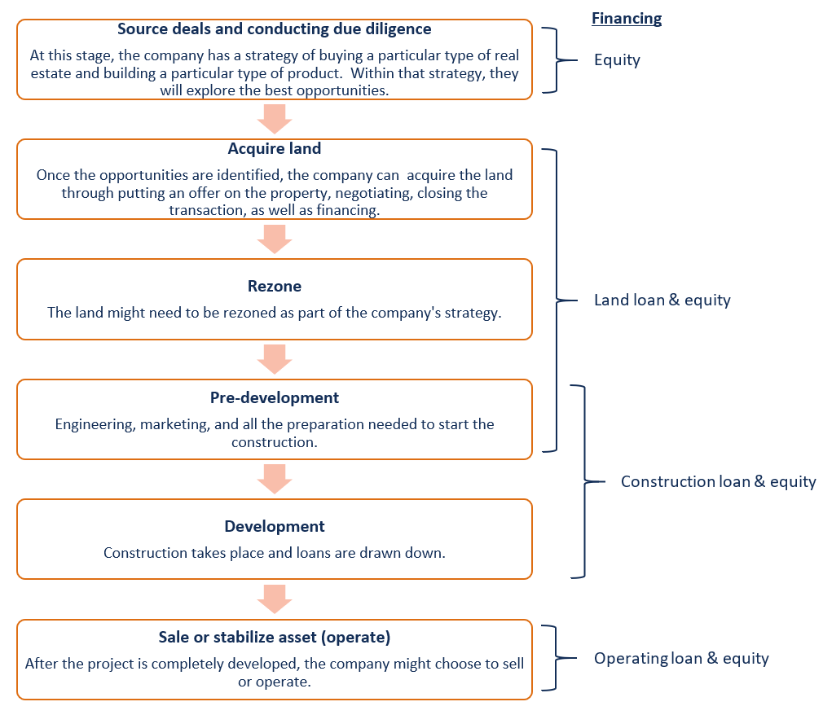
Figure 1: Land Development Process (Corporate Financial Institute)

In the figure above bridge financing, would take place during the acquire land and rezoning stages. While the figure specifies two types of financing during these two stages bridge financing only represents the land loan portion. In contrast, the equity portion of financing represents the cash investment made by the developer of the project. The financing during this stage is often represented as a ratio that compares the percentages of the two financing sources.

Bibliography
Corporate Financial Institute. Real Estate Project Financing. 2020. September 24, 2020. <https://corporatefinanceinstitute.com/resources/knowledge/finance/real-estate-project-finance/>.
Hersch, Benson. Brief history of the bridging finance sector. 4 August 2016. September 24 2020. <https://www.mortgagefinancegazette.com/features/brief-history-of-the-bridging-finance-sector-04-08-2016/>.
Kagan, Julia. Bridge Loan. 29 May 2020. September 24, 2020. <https://www.investopedia.com/terms/b/bridgeloan.asp>.

