Soft Costs
Audience and Use Profile: The indented readers are contractors who are planning to build a project. Learning soft costs is very important because these costs are not as clear as hard costs. One needs to figure out the soft costs in the preparation stage, otherwise, there will be unexpected hard costs in the future.
What is Soft Costs?
Consider the situation where the land agent needs to build a building. The budget is divided into two categories: soft costs and hard costs. Soft costs (indirect costs) refer to the costs that related to pre-construction preparation.
What is the difference between soft costs and hard costs?
People might assume that soft costs are less expensive than hard cost, but sometimes that is not always true. According to Feldman, hard costs include : “material costs, labor costs, contingency, land acquisition, and environmental remediation” (Feldman, 1). Unlike hard costs, soft cost depends on things that go into the creation of the building, and how architecture like this building going to be. Sometimes, people would like to count the time spent in preparation as soft costs, because when we view time as an opportunity costs, time is a resource that people own.

Figure 1. Hard Costs vs. Soft Costs (retrieved from https://www.arifleet.com/wp-content/uploads/2018/01/Infographic_Costs_of_Downtime.png)
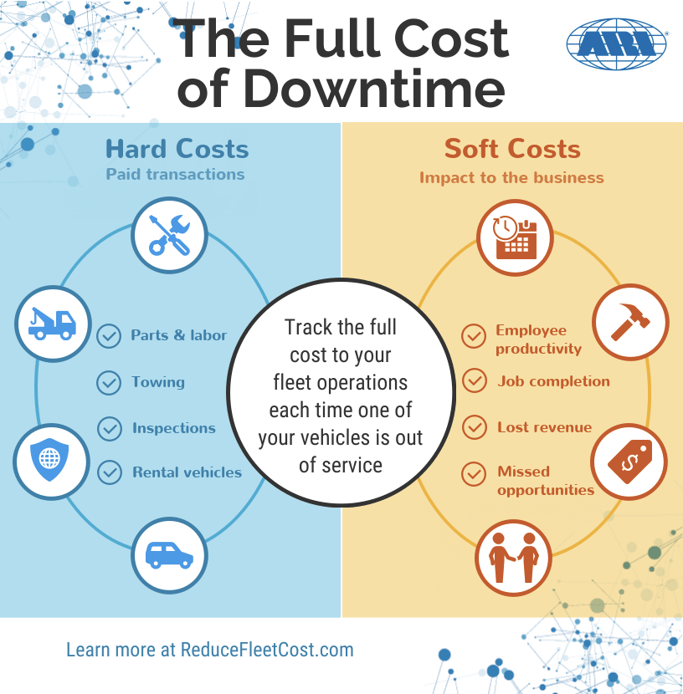
What are the major parts of soft costs? According to Jeremy Lowe, soft costs include “ Architecture, engineering, project management, accounting legal fees, inspection fees, utility and road extensions” (1). A more easier way to understand soft costs, is to calculate costs that are not fixed costs and variable costs; fixed costs is a easy concept, when think of fixed costs we usually think of rent. Anything that goes into the construction is your fixed costs (Zahirah &Zahirah, 3601). Variable costs are labour fees. Hence, soft costs cannot be categorized into either fixed costs or variable costs, because these costs are used in construction period instead of the preparation period.
Why is it important?
Find out soft costs is also a process of finding out the goal and the risks of projects. For example, market risk, construction risk, entitlement risk are things that people need to consider before delve into a project development (Mykhayliv et al., 265). Including soft costs also helps people to evaluate risk & return on investment (Mykhayliv et al., 265). In Economics, a reasonable person would think about risk and return when he or she is investing in a project.Reasonable people will ask themselves what do they expect back from this project, is it worth to invest time and money in such project. Finding out soft costs, therefore, helps make a wise investment decision (Mykhayliv et al., 266).

Works Cited:
Feldman, Equities. “Hard Costs vs. Soft Costs in Real Estate Development”. https://www.feldmanequities.com/education/hard-costs-vs-soft-costs-in-real-estate-development/. Accessed on Sept30, 2020.
Mykhayliv, Dariya, and Klaus G. Zauner. "Investment behavior and ownership structures in Ukraine: Soft budget constraints, government ownership and private benefits of control." Journal of Comparative Economics 41.1 (2013): 265-278.
Zahirah, Nurul, and N. Zainul Abidin. "Main elements of soft cost in green buildings." International Journal of Economics and Management Engineering 6.12 (2012): 3601-3606.

