Aleem Tariq 10417153
ENGL 301 October 7, 2020

Introduction:
The goal of this week’s assignment is to write a parenthetical, sentence, and expanded definition of a complex term that is specific to our respective fields. The purpose of this is for us to appreciate how the complexity of a definition is dependent on the audience we are communicating with. My previous degree was in Biology, so I chose a term from this field, as I am most comfortable with it. The term I will be delving into is Clustered regularly interspaced short palindromic repeats cas9 system (shortened as CRISPR-Cas9), which is a technique that can be used in gene editing.
Term:
Clustered regularly interspaced short palindromic repeats cas9 system (CRISPR-Cas9)
Situation:
A marketing director wants to convince a board of investors to invest into a new gene-editing technology. This person will now have to learn more about CRISPR-Cas9, in order to make the case to the board.
Parenthetical Definition:
CRISPR-Cas9 is a novel gene-editing technology.
Sentence Definition:
CRISPR-Cas9 is a genetic engineering technique, adopted from bacterial cells, that is now being used to modify the genes of plants, animals, and even humans.
Expanded Definition:
Genome editing, also known as gene editing, consists of several technologies that grant scientists the ability to alter an organism’s DNA. CRISPR-Cas9 is a revolutionary example of such a technology and has made significant strides in the realm of gene-editing, offering the means for a simple, affordable, and highly accurate way to manipulate and edit DNA.
CRISPR-Cas9 has already been used in the health-related field numerous times, and to great effect. Researchers are currently treating cancer in patients using this technology, as part of ongoing clinical trials. CRISPR-Cas9 is in fact, being used to precisely modify human immune cells so that they become cancer killers, which have proven to be safe to non-cancerous cells. In addition, CRISPR-Cas9 has also been used to slow the growth of cancers, to moderate effect.
DNA will first need to be described in order to properly explain CRISPR-Cas9. DNA is simply a set of hereditary instructions that determine almost all the characteristics of a living thing. These instructions come in the form of a sequence of letters: A, G, T, and C. We can think of genes as functional units of DNA, that when ‘read’, eventually go on to produce proteins; a fundamental building block of all life.
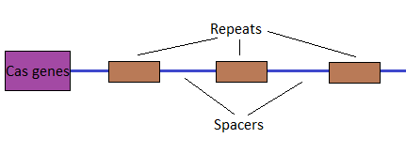
Fig 1. CRISPR array and Cas

CRISPR-Cas9 was first identified by Francis Mojica as a naturally occurring system in bacteria. It’s composed of two parts; a CRISPR array, and a Cas9 system. The array consists of palindromic repeats of the letters of DNA, and unique spacers in between these repeats. The palindromic repeats are sequences of letters that read the same backward as forward, while the spacers are sequences which form gaps between repeats. The Cas genes identified in the figure above will make Cas proteins that cut DNA.
Interestingly the spacers match up exactly to viral DNA. This is because in a bacterium, snippets of DNA from invading viruses are captured, and using Cas proteins, ‘cut and pasted’ into the CRISPR array as a spacer between repeats.
This allows the bacteria to “remember” the viruses. If a future viral attack occurs, information from these spacers will help “guide” the Cas9 to the viral DNA, which will then be cut and disabled by Cas9.

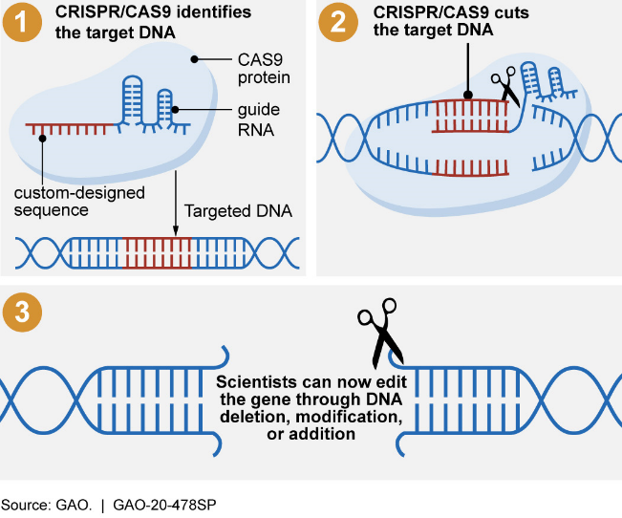
This naturally occurring system was modified so that we could use it to target DNA of our choice, rather than viral DNA.
In the lab, researches will add our desired sequence and a short “guide” that attaches to our target sequence in DNA. Our desired sequence and guide will then attach to the Cas9 protein (1).
Like the mechanism in bacteria, the guide will attach to the DNA target, allowing the Cas9 protein to cut the site (2). Following the cut, our desired sequence is inserted (3).

Fig 2. CRISPR-Cas9 System being used

Works Cited

Andersen, P. (Director). (2016, February 18). What is CRISPR? [Video file]. Retrieved September 30, 2020, from https://www.youtube.com/watch?v=MnYppmstxIs
Office, U. (2020, April 07). Science & Tech Spotlight: CRISPR Gene Editing. Retrieved September 30, 2020, from https://www.gao.gov/products/GAO-20-478SP
Scarpelli, D., & Burrows, W. (2020, April 01). Diseases of genetic origin. Retrieved September 30, 2020, from https://www.britannica.com/science/human-disease/Diseases-of-genetic-origin
Stadtmauer, E., Fraietta, J., Davis, M., Cohen, A., Weber, K., Lancaster, E., . . . June, C. (2020, February 28). CRISPR-engineered T cells in patients with refractory cancer. Retrieved October 08, 2020, from https://science.sciencemag.org/content/367/6481/eaba7365
Stapleton, A. (n.d.). Scientists Have Used CRISPR to Slow The Spread of Cancer Cells. Retrieved October 08, 2020, from https://www.sciencealert.com/scientists-use-crispr-to-slow-the-cancer-cells-from-spreading
What are genome editing and CRISPR-Cas9? - Genetics Home Reference - NIH. (n.d.). Retrieved September 30, 2020, from https://ghr.nlm.nih.gov/primer/genomicresearch/genomeediting
What is DNA? -. (2016, April 21). Retrieved September 30, 2020, from http://www.sciencemadesimple.co.uk/curriculum-blogs/biology-blogs/what-is-dna

