Hello Mitchell,

Thank you for your helpful review of my definitions. I was glad to hear that you have already been trained in using naloxone! See below for my revised definition of ‘naloxone’.

ENGL 301 Assignment 1.3 – Definitions

Introduction: Hello team! As you know, the objective for assignment 1:3 is to understand the importance of definitions in technical writing, to properly consider the audience and purpose of the document, and to know how to cater your writing and definitions to the appropriate audience and context. The criteria for this assignment are to choose an intended audience and situation, and then draft three definitions – a parenthetical, sentence, and expanded definition – to suit the chosen context.

Below you will find definitions for the term ‘naloxone’, the name for a drug often invoked by public health professionals in the context of the current opioid overdose crisis in British Columbia. Naloxone is used to reverse the effects of opioid overdoses, and in this assignment, I have chosen to address community members being trained to use naloxone to respond to overdoses in their communities.

Term: Naloxone

Situation and audience:
Public health professional who is training community members in overdose recognition and response, including on how to administer naloxone in situations of suspected opioid overdose.

Parenthetical Definition:
John administered two doses of naloxone (an antidote to opioid overdose) and called the paramedics.

Sentence Definition:
Naloxone is a drug used to temporarily reverse the life-threatening effects of opioid overdose, including overdose caused by heroin and fentanyl.

Expanded Definition:

History
Canada is currently experiencing a public health crisis related to alarming levels of illicit and prescription opioid overdoses – colloquially referred to as the ‘opioid crisis’ (Health Canada, 2018). In response, distribution of the drug naloxone, an opioid antagonist that counteracts the life-threatening effects of an opioid overdose, has been identified as a key emergency measure to effectively prevent rising deaths (McDonald R. & Strang J., 2017).

When an individual uses opioid drugs (including morphine, heroin, and fentanyl), their body’s central nervous system is affected and their breathing, heart rate, and blood pressure slows. An individual is said to have overdosed when these effects become more severe, sometimes to the point where their breathing or heartrate stops completely and the individual dies (Boyer, 2012).
Operating principle and negation
Naloxone works to reverse opioid overdoses by replacing opioids in the brain’s opioid receptors, allowing central nervous system functions to resume. Naloxone is not a drug that can be used on any drug overdose; it will only work for individuals who have opioids in their system, and it has no effect on other drugs or in otherwise healthy individuals.

Analysis of parts
While naloxone has been used by clinicians and paramedics for over 50 years, it can also safely be administered by laypeople. To administer naloxone, an individual should first confirm the signs and symptoms of opioid overdose – presented in the visual below. Overdose response and naloxone administration involves the following SAVE ME steps:

- Stimulate. Shake and call the individual’s name to confirm that they are not moving and cannot be woken. If you cannot wake them, call 911.
- Airway. Check and open their airway by lifting up their chin and moving their head, checking for signs of breathing.
- Ventilate. Give the individual breaths using mouth-to-mouth or a rescue breathing mask; brain damage can occur within minutes without oxygen.
- Evaluate. See if they are any better, and if the individual’s breathing has improved. If not, prepare the naloxone
- Medication. Swirl the vial of naloxone. Snap open the vial, uncap the syringe, and draw up all the liquid. Inject the naloxone into the meaty part of the arm, thigh, or butt. Go through clothing if you need to and inject the syringe until you hear a clicking sound.
- Evaluate and support. Naloxone usually takes effect in 3 – 5 minutes. If the individual does not respond, give them another dose of naloxone. Repeat until the individual wakes up.

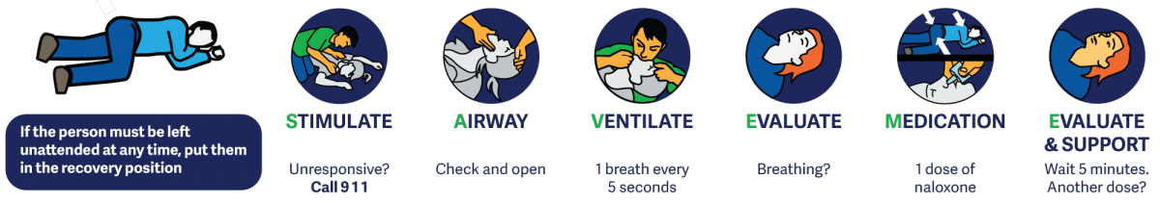

Require Conditions
In British Columbia (BC), naloxone kits are available for free to anyone at risk of witnessing or experiencing an opioid overdose, including family and friends of people who use drugs. Naloxone kits include everything you need to respond to an overdose, including a carrying case, non-latex gloves, alcohol swabs, a one-way rescue breathing mask, three safety syringes, three 0.4 mg/mL naloxone vials (each with a vial (or ampoule) breaker). There are over 1600 participating naloxone distribution sites in BC, including most community pharmacies. If you or someone you know uses drugs, pick up your free naloxone kit today – it may help save someone’s life.

References

Boyer, E. W. (2012). Management of Opioid Analgesic Overdose. The New England Journal of Medicine, 367(2), 146–155. https://doi.org/10.1056/NEJMra1202561
Health Canada. (2018, December 18). Overview of national data on opioid-related harms and deaths [Datasets]. Government of Canada. https://www.canada.ca/en/health-canada/services/substance-use/problematic-prescription-drug-use/opioids/data-surveillance-research/harms-deaths.html
McDonald R., & Strang J. (2017). Systematic review: Do take-home naloxone programs effectively reduce opioid overdose deaths? A Bradford Hill analysis. Drug and Alcohol Dependence, 171((McDonald, Strang) Addictions Department, King’s College London, London, United Kingdom), e137. https://doi.org/10.1016/j.drugalcdep.2016.08.380

