Improving the Recruitment and Hiring Process
for Female Developers and Managers
at SAP Vancouver

for
SAP Vancouver D&I (Diversity and Inclusion) Initiative,
SAP Vancouver HR and Hiring Managers,
and
SAP Intern Experience Program (iXp) Canada

By
Roxanne Joie Robles
ENGL 301 Student
University of British Columbia

December 1, 2020

SAP Canada Inc.
910 Mainland St.
Vancouver, BC V6B 1A9
December 1, 2020
SAP Vancouver D&I Initiative Team
Vancouver, BC V6B 1A9

Dear members of D&I Team,

Here is my report, Casual Analysis of Improving the recruitment and hiring process for female developers and managers at SAP Vancouver. With this study, I have gained a deeper understanding about the reasons to why there are less women available in the talent pool for technical and leadership roles. Using this knowledge, I hope that it can help you and fellow hiring managers to further attract talented individuals to your organization. Thank you for your support during my research.

I am aware of the challenges to obtain full gender diversity, and the need to for women in tech. Hopefully, by eliminating these problems, SAP can further diversify its workplace for the benefits of its employees and of the company.

I am grateful for this experience this project has brought and I would be available to answer any questions you may have. Please contact me via email at rroxanne@student.ubc.ca.

Sincerely,
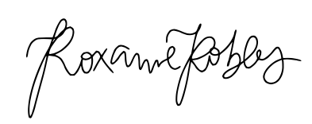
Roxanne Robles
Table of Contents
Table of Figures 3
Abstract 4
I. Introduction 5
A. Background on Current State of Women in Tech at SAP 5
B. Overview of Problem and Purpose of Report 6
C. Methods and Scope 7
II. Collected Data 8
A. Women in Tech at SAP 8
Current Demographic of Women at SAP 8
Perspectives of SAP Vancouver Employees 8
Need for Women in Tech 9
B. Current Recruitment and Hiring Process at SAP Vancouver 10
D&I Initiative Team and HR 10
Existing Process and Strategies Implemented 10
Effectiveness of Current Process 11
Key Challenges 12
III. Conclusion 13
A. Summary of Findings 13
B. Recommendations 13
IV. References 15
V. Appendices 16
A. Appendix A: Interview Questions 16
B. Appendix B: Survey Questions 16

Table of Figures
Figure 1: Ratio of Women at SAP 4
Figure 2: Ratio of Women in Management Positions 5
Figure 3: Need for Women at SAP 7
Figure 4: Survey on women in technical and managerial roles at SAP 8
Figure 5: Importance of company reputation to SAP Vancouver employees 10
Figure 6: Effectiveness of Early Talent & Recruitment Programs 11

Abstract

The improvement of the recruitment and hiring process at SAP is needed in order to help increase the female representation at SAP, more specifically those in technical and leadership roles, and hopefully help achieve further gender diversity. In 2019, SAP reported that their workplace consisted of 34% women with 27% women in management roles. With 12,833 employees newly hired in 2019, only 37.5% of them were women. Women in tech, in particular, face many challenges when applying to jobs. Therefore, interviews with those behind the hiring process and a survey with SAP Vancouver employees were conducted to understand these difficulties and find possible improvements.

This study established four common challenges that women in tech face when applying. These difficulties are attributed to female representation, self-confidence, and hesitation.

Anyone with the means to help improve of the hiring and recruitment processes to help women in tech, can following these recommendations:
- Including female interviewers especially for candidates who are women.
- Encouraging prospective females in high school and university programs who are interested in STEM.
- Work on SAP’s current demographics, encouraging those at SAP and promoting
- Analyzing promotion and demographics of women in senior roles. Encouraging current demographic to apply for leadership roles, and utilize this for recruitment.
- Further promote SAP’s female representation through recruitment, and network, career development events.

Introduction

Background on Current State of Women in Tech at SAP
Gender diversity is an undeniable problem that many tech companies aim to solve by building diverse and inclusive environments. In order to achieve better representation for women, companies are making efforts towards the recruitment and hiring to increase the demographic of women in the candidate pools (Hill, 2019). SAP, a market leader for enterprise application software, is no different (Huhman, 2017); they are attributed for its growing diverse and inclusive culture, but has also recognized their need for better gender representation. As of 2019, the following is the total yearly ratio of women in the SAP workforce. It is evident, they are on an upward trend every year (SAP, 2020).

Figure 1: Ratio of Women at SAP

SAP sees the need for change especially in technical and leadership roles. So in 2011, they set goals to increase the percentage of women in managerial positions to 25% by 2017, and 30% by 2022 (SAP News, 2020). As pictured below, there is an upwards trajectory in the head count of women in leadership positions (SAP, 2020).

Figure 2: Ratio of Women in Management Positions

In addition, 12,833 employees were externally hired with 37.5% of them were women (SAP, 2020). By working through its “blind spots” in the entire HR lifecycle of women, SAP hopes to further increase their talent pool, and subsequently, increasing the women in their workplace (Huhman, 2017).

Overview of Problem and Purpose of Report
Research conducted by multiple sources found that the lack of women in the workplace and the difference between how male and women applicants apply, are what lead to a male dominated hiring pool (Ignatova, 2019; see also Mohr, 2018). Common challenges found were the lack of female representation (Kurter, 2019), the feeling that they are not 100% qualified for the position regardless of the fact (Mohr, 2018), the hesitancy that companies want to hire them and gender bias (SAP News, 2019). This study aims to recognize the current challenges that the women have face when hiring, and recommend ways for SAP Vancouver’s hiring managers and the SAP Vancouver’s D&I (Diversity and Inclusion) Initiative team to optimize the existing recruitment and hiring process. Hopefully resulting in an increase of female candidates in the talent pool and therefore, better representation for women.

Methods and Scope
To access the feasibility of improving the recruitment and hiring process for females, the following areas of inquiry was investigated:
- How does the difference in head counts between men and women in developer and managerial roles impact employees and hiring? What benefits are there to more females?
- What are the yearly average hires for men and women?
- To what extent do female specific recruitment events positively impact the candidate pool?
- What areas of the hiring/recruitment process can be improved upon based on female experiences?
- What obstacles do women face when applying to these types of positions? How to diminish these obstacles?
The main sources for this inquiry was from various members of the SAP Vancouver community. For information regarding the existing hiring process, and the perspectives on the current gender demographics, interviews (see Appendix A) were held were made with members of the D&I Initiative team, many of which are also hiring managers. A survey (see Appendix B) with SAP employees was conducted to gain knowledge on hiring experiences, on their perspective of gender diversity at the office and any suggestions for improvement. Additional research was done concerning the struggles that female applicants face within the tech industry and the current public knowledge of the female population at SAP. By analyzing the collected data, this reports hopes to provide recommendations to improve the overall hiring and recruitment experience, especially for women, so that the representation at SAP can be improved.

Collected Data

Women in Tech at SAP

Current Demographic of Women at SAP
From the perspective of many individuals of the SAP Vancouver community, many believe that like most companies, SAP still has a long way to go. As reported in 2019, SAP has 34% women in the workplace and 27% women in management roles (SAP, 2020). With early talent and entry-level hiring, SAP has recognized the need for improvement and have implemented strategies that so far, has provided promising results. However, SAP is aware that there is a lack of women especially in managerial positions and mid to high-level technical roles, which they are continually working on. It is suspected that the main area of concern is attracting and getting candidates in the hiring pool, as well as retaining employees for senior positions. (Interview, Nov 23 2020; see also Interview, Nov 26 2020)

Perspectives of SAP Vancouver Employees
A survey with SAP Vancouver’s employees was conducted to get an understanding of how they feel about SAP’s demographic of women. It found the majority, 63.9% of respondents, felt that more women are needed at SAP.
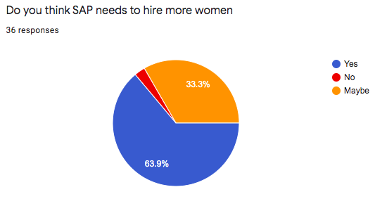
Figure 3: Need for Women at SAP
In particular, when asked about employee’s feelings toward the amount of females in technical and managerial roles, 38.9% felt good about the demographic. However not many (5.6%) were satisfied enough. About 25% of employees did not feel good about the current demographic and 30.6% felt neutral about the topic (see fig. 4).
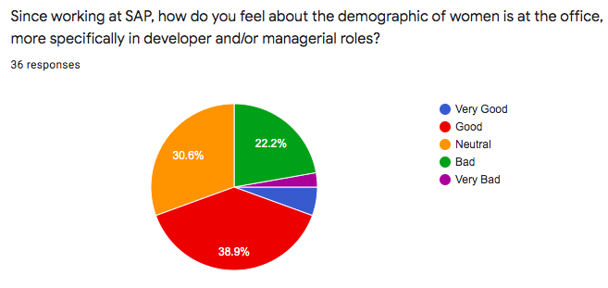
Figure 4: Survey on women in technical and managerial roles at SAP

Need for Women in Tech
Interviews with SAP Vancouver’s employees and managers brought out two main reasons for the need for more women. First, is the want for products, services and a work culture that is reflective of the world we live in. By diversifying their teams, they aim to have diverse thinking that is applicable to their consumers. (Interview, Nov 26 2020; see also Interview, Nov 25 2020) SAP has actually researched that studies have shown companies with higher gender diversity outperform companies in terms of equity, operating results and stock prices. Thus, a higher profit will result from a higher amount of women in leadership positions since they are capable to serving a diverse customer base (SAP, 2020). Secondly, they believe in helping those of the minority, especially women, to be given equal opportunities for success (Interview, Nov 23 2020). The need for women in tech is not just for a better team or organization, but rather the belief in fairness and success for all. SAP has recognized as a member of the tech community; it is their responsibility to do better in regards to a diverse culture.

Current Recruitment and Hiring Process at SAP Vancouver

D&I Initiative Team and HR
The Global and Regional D&I teams, i.e. the Vancouver team, are one of many that are focused on female talent recruitment (Interview, Nov 26 2020). In addition to their daily roles at SAP, members of are actively working towards further diversifying the workplace. These members are active in the hiring process, most of which are hiring managers themselves, who are looking for ways to improve these processes. They also provide support and training to managers when hiring. i.e. training managers how to remove gender bias from job postings. (Interview, Nov 23 2020; see also Interview, Nov 26 2020) They first noticed the lack of female and diverse candidates in the iXp intern program and working to fix the issue there first. By focusing on this issue firsthand, they hope it would recruit more females for full-time positions and also pave the way for how they hire for full-time roles as well (Interview, Nov 23 2020).

Existing Process and Strategies Implemented
Global and local HR have a strategy pillar, for both hiring and promoting, to increase the number of women especially in technical and leadership roles. Many strategies are set into place to further their inclusivity. For example, SAP is very active in Early Talent programs. SAP’s internship program is a way to attract potential full time hires through training and experience. They also work to attract future talent by working with universities and participating in competitions/hackathons, groups, student club sponsorships and webinars (Interview, Nov 26 2020).
Additionally, to promote SAP and their female representation, the following initiatives have been implemented: Women’s Personal Growth Webinar series, the Business Women’s Network (BWN) and the Women@SAP online community. SAP has also participated in job fairs to spread the word about their company (SAP News, 2020).
To minimize gender bias, SAP has implemented methods to address this and some challenges women face when applying, i.e. hiring managers hide applicant names to eliminate bias. Managers are also trained to ensure that job postings are carefully written to not overbear candidates so they do not feel alienated or hesitant even though they are well qualified (Interview, Nov 23 2020; see also Interview, Nov 26 2020).

Effectiveness of Current Process
To test the effectiveness of SAP’s hiring, feedback was received from SAP employees on their experiences. With SAP job postings, 51.4% were confident about their applications relative to their job postings, while 28.6% felt neutrally and 20% felt unconfident. (Survey, Nov 2020). The reasons that were included for those who felt unconfident are not unfamiliar to what we already know, i.e. hesitancy about their qualifications, unsure about their fit, etc. Many of these, SAP has already addressed in their existing methods (Interview, Nov 23 2020).
When asked about what factors contribute to whether someone applies to a company or not, the survey found that work life balance, career advancement, a company’s reputation and a company’s work culture were the main areas people look at. Pictured below is the percentage those who believe in a company’s reputation and work culture are impactful for prospective jobs. 83.3% of respondents agreed inclusivity and diversity are important values to have as a company, while 91.7% believe that the kind of culture a company is influential to the job application process (see fig.5 & fig.6).
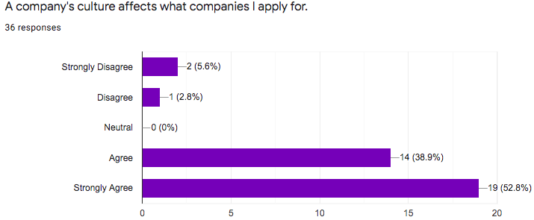 | 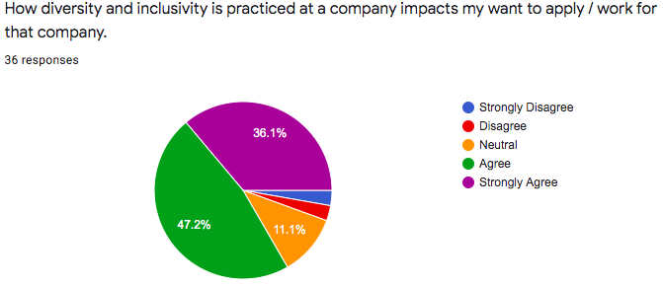

Figure 5: Importance of company reputation to SAP Vancouver employees

Additionally, many participants discussed how effective internships and recruitment events were on their decision to work at SAP since they provided positive experiences of a good work environment and an understanding of what SAP values. However, more than half of the respondents did not participate in these recruitment initiatives, and could not contribute to their effectiveness, as shown below.
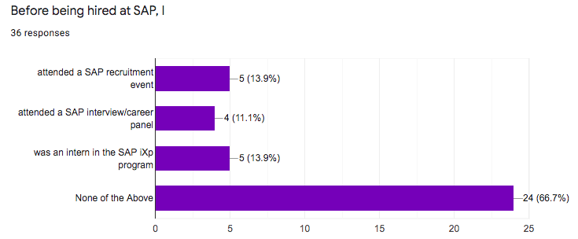
Figure 6: Effectiveness of Early Talent & Recruitment Programs

Key Challenges
From the feedback (Survey, Nov 2020) and consolations (Interview, Nov 2020) received, the most mentioned and common challenges that contribute to the lack of women applying are
- The overall lack of women in STEM programs. From the current data that HR and the D&I team have, there is underrepresentation from the start, therefore resulting in the lack of qualified individuals.
- Imposter syndrome is very common for most candidates have when applying. People who are perfectly qualified, do not believe they fit the requirements entirely or do have enough experience. Many do not believe they have a chance in the first place, so they do not apply at all. The effects of this hesitancy also delays when the application is sent. However, the position can be filled before they can get an interview.
- Intimidation from what is expected from them during the hiring process, whether it be from the job posting or from the interview. Many are unsure about how better to prepare and how to feel confident when they come in for an interview, which may affect their performance.
- Lack of role models and better representation of women in these technical roles. Not seeing successful people who they can relate to or see themselves in, does not motivate them to want to work at a company. The lack of women in senior roles is contributed to not being able to retain those already in the company due to various reasons such as pay, work life balance, etc.

Conclusion

Summary of Findings
Majority of SAP Vancouver employees believe that they have made great progress towards better female representation, but agree there is still progress to be made. One of the most significant contributors to this is the lack of females as candidates. The challenges that attribute to this type of talent pool, includes and is not limited to the hesitancy about qualifications and experience, intimidation about position, lack of female role models and being a minority in STEM. In order to achieve gender diversity, most believe women through better support and encouragement.

Recommendations

If possible, consider these suggestions to help improve the hiring and recruitment process for women:
- Hosting and promoting more women focused recruitment events, networking events, workshops and career development sessions.
- Supporting high school and university programs to motivate females to go into STEM. Seeking engagement and encouraging them that it is possible in the fields they are passionate about.
- Utilizing employee networks to recruit by encouraging references. People are most likely to trust someone’s opinion that matters to them.
- Gender quota for interviews. If there are enough candidates, for every male moving onto the interview stage, 1 female moves forward. Therefore, there is an equal opportunity of getting the position.
- Diversifying interviewers, especially for candidates who are women, so that they do not feel there is a high men ratio and feel more be comfortable, less scrutinized.
- Further educating managers on implicit gender bias and the value of diversity.
- Analyzing promotion and demographics of women in senior roles. Need more women in leadership roles, and utilize this for recruitment.
- Better advertisement of SAP’s work and inclusivity with competitive salaries.

References
Budhai, Roy. Interview. 23 November 2020.

Kurter, Heidie Lynne. “4 Reasons Why You Might be Failing to Attract More Women In Tech”. Forbes,
27 Jan. 2019, forbes.com/sites/heidilynnekurter/2019/01/27/4-reasons-why-you-might-be-failing-to-attract-more-women-in-tech/#4ed859d72da3.

Hill, Lizzy. “This is why women don’t want to work at your tech company”. Fast Company, 26 Nov.
2019, https://www.fastcompany.com/90435093/this-is-why-women-dont-want-to-work-at-your-tech-company.

Huhman, Heather R. “Simply Hiring More Women Isn’t Enough to Fix Tech’s Gender Issue”.
Entrepreneur, 19 Oct. 2017, https://www.entrepreneur.com/article/302178.

Ignatova, Mana. “New Report: Women Apply to Fewer Jobs Than Men, But Are More Likely to Get
Hired”. LinkedIn Talent Blog, 5 Mar. 2019, business.linkedin.com/talent-solutions/blog/diversity/2019/how-women-find-jobs-gender-report.

McMillan, Jayne. Interview. 26 November 2020.

Mohr, Tara Sophia. “Why Women Don’t Apply for Jobs Unless They’re 100% Qualified”. Harvard
Business Review, 2 Mar. 2018, https://hbr.org/2014/08/why-women-dont-apply-for-jobs-unless-theyre-100-qualified.

Robles, Roxanne. Employee Survey. Questionnaire. November 2020.
SAP, 2020. 2019 Integrated Report, www.sap.com/docs/download/investors/2019/sap-2019-integrated-report.pdf.
SAP News. “SAP Recognized by Bloomberg Gender-Equality Index for Second Consecutive Year”. SAP
News Center, 21 Jan. 2020, https://news.sap.com/2020/01/sap-bloomberg-gender-equality-index/.

Smythe, Michelyn. Interview 26 November 2020.

Spratley, Sarah. Interview. 25 November 2020.

Appendices

Appendix A: Interview Questions

  - What is your job title and how long have you been working at SAP?
  - How is your role related to hiring and/or implementing a diverse and inclusive work culture?
  - Do you feel that there should be more women in tech and if so, why?
  - How do you feel about the women and men demographic in developer and managerial positions at SAP? What do you think attributes to this difference?
  - Do you think SAP’s current recruitment events are effective? Do they positively impact the candidate pool with more diverse people?
  - From your experience, do you find that there are less women in candidate pools? If so, why do you think so?
  - What are common challenges that find that women face during job searches and hiring? I.e. their hesitations about themselves and/or skills, etc.
  - In your opinion, what are the most effective practices SAP is doing to allow for more inclusive hiring? What can be done better?
  - What are other additional practices that can be done to attract more women to tech? Are there any methods that other companies use that SAP can do as well?

Appendix B: Survey Questions

Introduction:
I am Roxanne. I am an agile developer intern here at SAP, working on the HANA & Analytics Cross-Engineering team. I am also a science undergraduate student at UBC working on a research study for my technical writing course. My topic is focused on women in tech, more specifically how to improve the demographic numbers through the hiring and recruitment process.

The aim of this survey is to collect data for research and analysis purposes. All are welcome to answer. I hope to analyze this data in order to provide recommendations on how to further improve SAP’s recruitment and hiring process for a more diverse workplace. So that SAP can have even more talented women in the hiring pools, and subsequently in the workplace. All genders are welcome to participate. The following is an anonymous and voluntary survey that should only take about 5-8 minutes of your time. I truly appreciate and am grateful for your participation. Thank you.

Survey questions:
- What is your job title?
- How long have you been working at SAP?
- Before being hired at SAP, I
___ attended a SAP recruitment event
___ attended a SAP interview/career panel
___ was an intern in the SAP iXp program
___ none of the above
  - In the previous question, if you were an intern or attended one of the mentioned events, did this impact your want to work at SAP? If so, how and why? ___________
- A company's culture affects what companies I apply for.
___ Strongly Disagree ___ Neutral ___ Strongly Agree
___ Disagree ___ Agree
- How diversity and inclusivity is practiced at a company impacts my want to apply / work for that company.
___ Strongly Disagree ___ Neutral ___ Strongly Agree
___ Disagree ___ Agree
- At the time you applied, do you agree that SAP is an inclusive and diverse culture with a large population of women in your desired field?
___ Strongly Disagree ___ Neutral ___ Strongly Agree
___ Disagree ___ Agree
- What are some factors that impact your decision to apply for a job? __________________
- Finding jobs to apply for at SAP or other tech companies is
___ Pleasant and comfortable ____ Sometimes pleasant and/or uncomfortable
___ Neutral ____ Always unpleasant and/or uncomfortable
- When you applied and was looking at SAP job postings, you were
___ confident about your fit in the job requirements and description
___ unconfident about your fit in the job requirements and description
___ neutral about your fit in the job requirements and description
  - If you find the job application process uncomfortable or unconfident about your fit based on the job posting, please briefly elaborate as to why. _____________
- What other challenges do you face during the job application, recruitment and/or hiring process? What challenges do you believe that other people face during this process? _________
- From your experience and/or in your opinion, is there anything that you wished were different with the SAP job application/hiring process? Are there any changes that you would make to the process? __________________
- Since working at SAP, how do you feel about the demographic of women is at the office, more specifically in developer and/or managerial roles?
____ Very Good ____ Neutral ____ Very Bad
____ Good ____ Bad
- Do you think SAP needs to hire more women? ____ Yes ____ No ___ Maybe
- Briefly describe any recommendations on how SAP can attract and find more talented individuals. Any recommendations for how to increase the demographic of women at SAP?

Data was published to SAP website. Unable to obtain confidential data of SAP Vancouver’s Office Demographics.

