Formal Report:
Formal Report Regarding Alternate Work-From-Home Policy

Prepared for:
Noorjean Hassam
Chief Operating Officer
BC Centre for Disease Control (BCCCD)
Vancouver, British Columbia

Prepared by:
Amina Moustaqim-Barrette
Research Epidemiologist
BC Centre for Disease Control (BCCDC)
Vancouver, British Columbia

December 1, 2020

Table of Contents
Abstract 3
Letter of Transmission 4
I. Introduction 5
A. Background 5
B. Problem statement 5
C. Purpose of the report 6
D. Research plan and data sources 6
E. Scope and limitations of the report 6
II. Results 7
A. Current workplace context 7
B. Impacts of COVID-19 and current policies 8
8
C. Alternatives to current policies 9
II. CONCLUSION 10
A. Summary of findings and overall interpretations 10
B. Recommendations 10
III. WORKS CITED 11
IV. APPENDICES 12
Appendix A: Survey Questions 12

Abstract

Letter of Transmission

Noorjean Hassam
Chief Operating Officer
BC Centre for Disease Control, 655 W 12th Ave, Vancouver, BC

December 1st 2020
Dear Ms Hassam,
I am writing to submit my formal report pertaining to alternate work-from-home policies at the BC Centre for Disease Control (BCCDC).
As you know, the COVID-19 pandemic has presented significant challenges in all domains of life, and affected work in healthcare and beyond. As first line respondents in the fight against COVID-19 in British Columbia, it is vital that employees at the BC Centre for Disease Control have optimal and sustainable work conditions, which balances the need for physical distancing as well as the need to respond quickly and effectively to issues of public health.
As a fairly new intervention, and one whose duration was not known at the time of conception, current work-from-home policies could be optimised to balance employer and employee needs, as well as health and safety requirements in the time of COVID-19. The current report uses literature search and participant interviews conducted in November 2020 to understand the effect of work-from-home policies on employee work and home life and make recommendations to improve productivity and work-life balance.
I have saved this report and survey results in the BCCDC secure drive. As always, no identifiable information from survey participants was collected, and required ethics approval was obtained. I am available to address any questions or clarifications you may have at the phone number and email provided below, and look forward to hearing your feedback.
Sincerely,
Amina Moustaqim-Barrette
Epidemiologist
BC Centre for Disease Control, 655 W 12th Ave, Vancouver, BC
(514) 229-5843
aminamoustaqim377@gmail.com

I. Introduction

A. Background
On March 17, 2020, a public health emergency related to the ongoing pandemic of coronavirus disease 2019 (COVID-19) (World Health Organisation) was declared. Due to the pandemic, strict physical distancing measures have impacted work, movement, social interactions, and access to essential goods and services (Andrea Woo). Preliminary evidence from Statistics Canada suggests that almost five million people are currently working from home due to COVID-19 (Statistics Canada).
The sudden shift to work-from-home means that workers could prepare for, or assess, their home working environment to ensure that these were optimal or conducive to their work duties (Bouziri et al.). On top of that, closures across society have meant that many parents are forced to work their full-time paid jobs, while also taking care of children at home (Bouziri et al.). Indeed, about 4 in 10 (39.6%) surveyed Canadian workers reported living with a child under the age of 18, and therefore likely experience challenges in balancing work and family life (Statistics Canada). Nevertheless, working from home may have benefits over strict work-in-office options, allowing for more flexibility in individuals’ days, as well as eliminating commuting times (Wessels et al.).
At the BC Centre for Disease Control (BCCDC), like in many workplaces, individuals who do not provide direct patient or clinical services were asked to work from home in early March 2020. As the public health arm of the British Columbia’s Provincial Health Services Authority, the BCCDC is uniquely placed given that it must both lead by example in having its employees work from home, while also continuing to do its work effectively in order to coordinate the response to the COVID-19 pandemic and ensure the population is able to continue working and living safely.

B. Problem statement
Work-from-home presents a number of potential barriers and advantages. During COVID-19, work-from-home policies have also been some of the most effective interventions to stop the spread of COVID-19 disease, as fewer people must take public transit and be in close contact with individuals outside of those they live with. Nevertheless, as employees working to track and stop the spread of COVID-19 disease, strict work-from-home policies may also impact individuals’ abilities to do their work in a timely and efficient way. Current work-from-home policy at the BCCDC requires employees to request office time two weeks in advance of when they plan to come into their office space. Given that many of these employees are reacting to situations that require them to work on new and emerging issues in a timely manner, the current work-from-home policy may be hampering their ability to do their work.

C. Purpose of the report

The purpose of the current report is to evaluate the impact of the BCCDC’s current work-from-home policy and summarise employees’ experience with working from home over the last several months. The report also seeks to offer alternatives or adjustments to current policies, in order to increase worker health and safety, as well as the sustainability of such arrangements.

D. Research plan and data sources

Survey questions for this report were designed and implemented between October and November 2020. A convenience sampling method (Elfil and Negida) was used and 15 employees were contacted by email and given one week to complete a five-minute survey (Appendix A). Of employees contacted, 12 of 15 (80%) filled and returned the survey in the time allotted. Descriptive statistics and thematic analysis were used to analyse survey responses in an Excel workbook. No identifiable information was collected or reported.

E. Scope and limitations of the report

Research for this report was conducted in November 2020 and represents the first formal report conducted at the BCCDC in regard to work-from-home policies implemented after the emergence of the COVID-19 policies. As such, data and analyses are preliminary, and as the context around COVID-19 changes, so too will the need to be flexible with workplace and work-from-home considerations and needs.

II. Results

A. Current workplace context
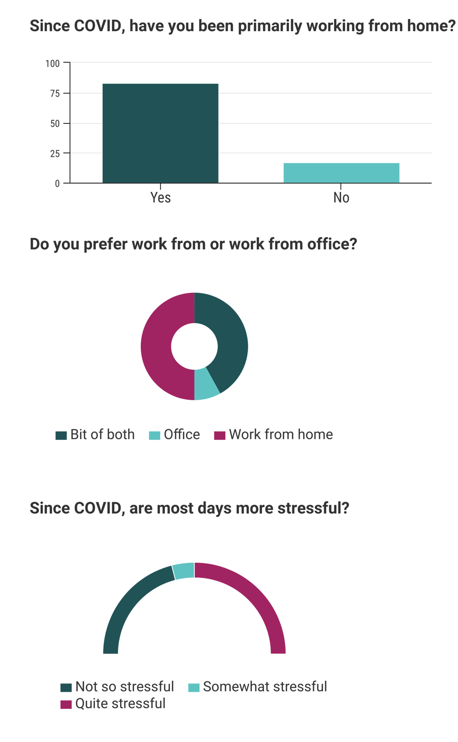
Of all survey respondents, 83.3% reported currently working from home (Figure 1). Most respondents worked in policy, knowledge translation, administration, or epidemiology work, which are heavily reliant on technology and do not require for employees to have face-to-face interactions amongst one another or with patients or customers. Two respondents continued to work on site during the pandemic due to meetings or privacy requirements that could not be accommodated through work-from-home.
When asked whether the time since the emergence of COVID-19 had been more or less stressful than prior, more than 50% of respondents reported their days to be ‘somewhat stressful’ or ‘quite stressful’. When asked whether the employees preferred work-from-home to work-in-office, 50.0% (n = 6) responded that they preferred working from home, only 1 respondent (8.0%) reported preferring work from the office, while 5 respondents (41.7%) reported that they would prefer having a mixed work-from-home and work-from-office schedule.
Figure 1-Current work context

B. Impacts of COVID-19 and current policies

Respondents were subsequently asked whether work-from-home policies had impacted their work, and whether these policies had made their work or home life more stressful (Figure 2). 67% of respondents reported that their work had been ‘somewhat’, ‘quite’ or ‘heavily’ impacted, while 33% said that their work had been ‘not so impacted’ or ‘not at all impacted’. When asked whether work-from-home policies had made work or home life more stressful, 83.0% respondents said that their lives were either somewhat, quite, or much more stressful due to these policies.
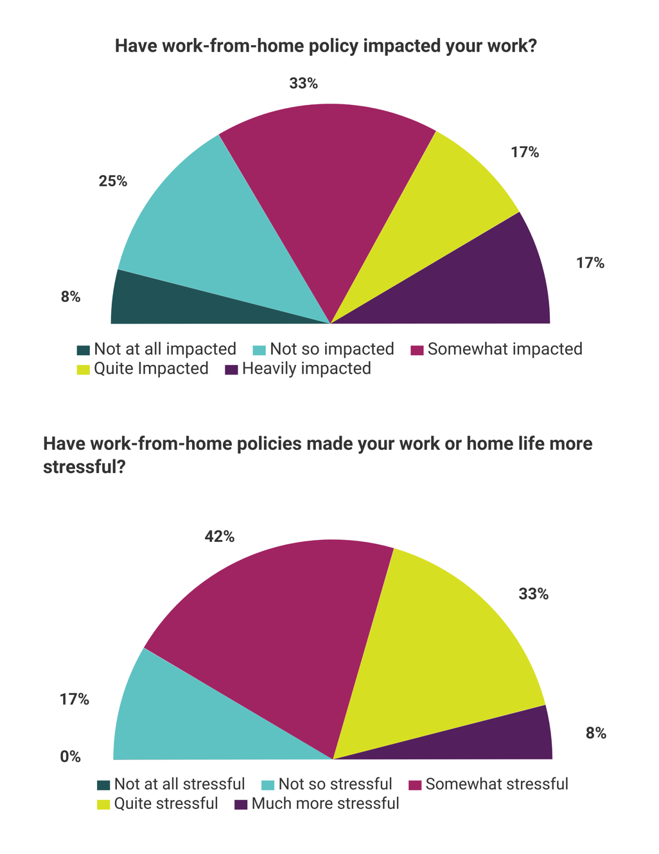

Figure 2- Impact of work-from-home policies

C. Alternatives to current policies

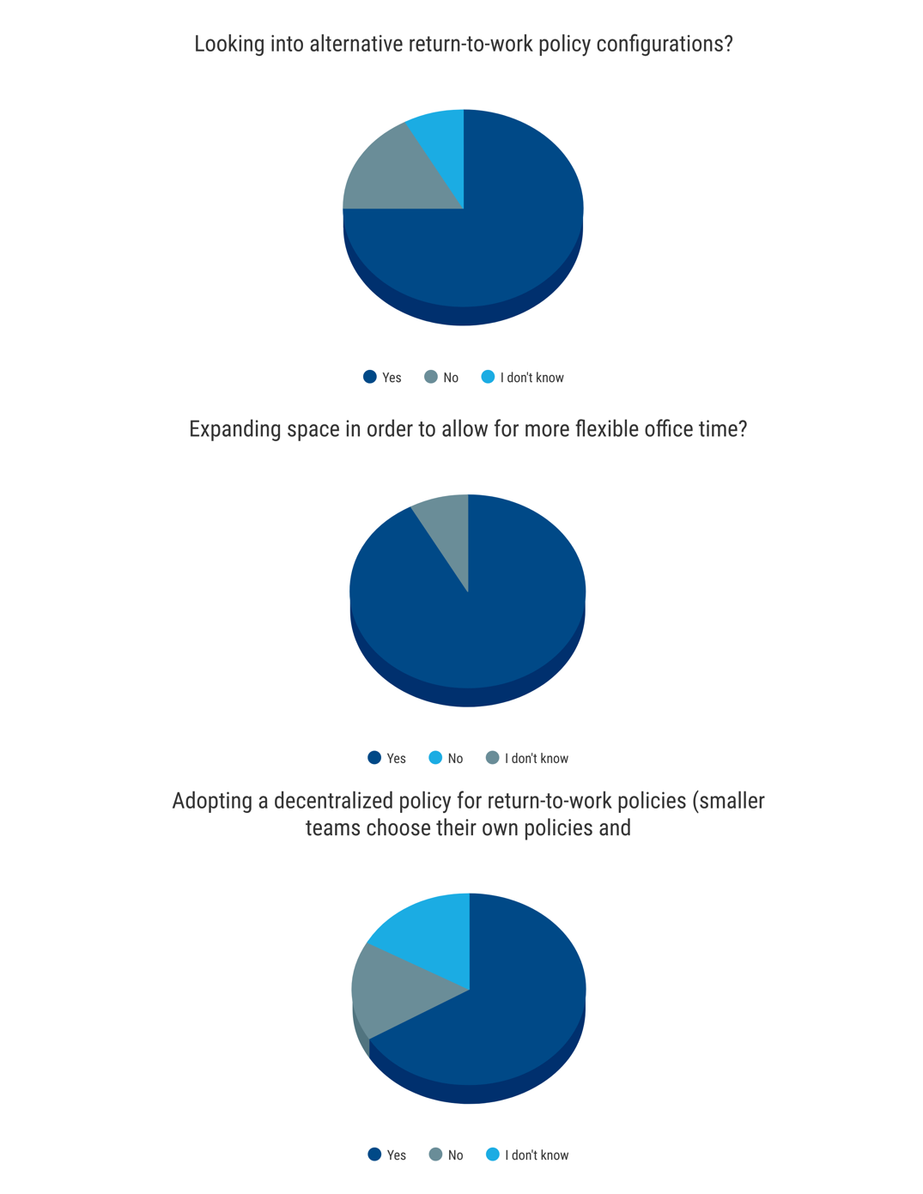
When asked about potential alternatives to current work-from-home policies, 75% of respondents said that they would support the BCCDC looking into alternative return-to-work policy configurations (Figure 3). 66.7% of respondents supported the option of the BCCDC allowing a de-centralized work-from-home policy, wherein teams organize their own space to abide by physical distancing measures, while 91.7% supported the option of expanding space in order to allow for more flexible office time.
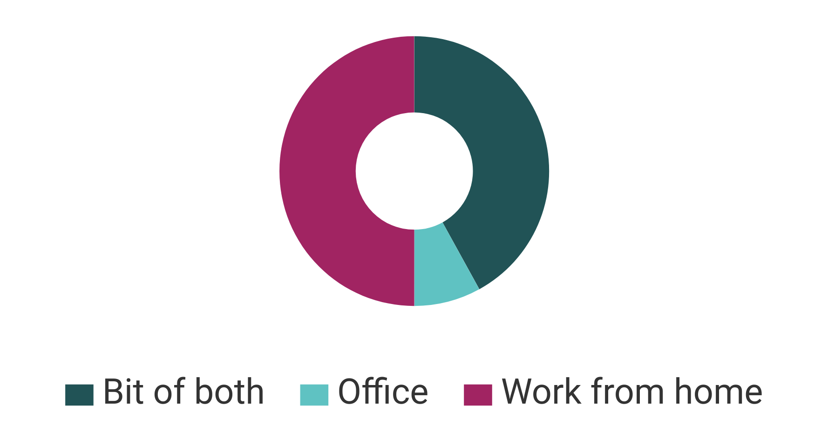
Since COVID, are most days more stressful?

Figure 3-Alternatives to work-from-home policies

II. CONCLUSION

A. Summary of findings and overall interpretations
A work environment which facilitates essential tasks is necessary; not only for the employees of the BCCDC, but for the employers and employees across the province that depend on the BCCDC’s work in order to maintain a sense of normalcy and productivity in their own lives. Current BCCDC work-from-home policies may not be best suited to offer the flexibility needed to work in the highly stressful context of COVID-19, but feasible options exist that are acceptable and indeed, preferable, to current employees.

B. Recommendations

- Create a BCCDC-wide policy which allows increased flexibility for employees across all teams. Where employees are not part of frontline services (non-clinical and non-direct patient services), allow for individual work teams to organise their space and schedules in regard to time spent in office.
- As a long-term solution, space limitations at the BC Centre for Disease Control should be addressed. Renting additional space would allow for labs, pharmacy, and clinical services, which require special security systems, to continue to operate in the main building, while other public health teams primarily reliant on technology can be moved into offices next door.

III. WORKS CITED

Andrea Woo. Virus Measures May Be Hurting Overdose Prevention in Vancouver, Official Says. Apr. 2020, https://www.theglobeandmail.com/canada/british-columbia/article-virus-measures-may-be-hurting-overdose-prevention-in-vancouver/.
Bouziri, Hanifa, et al. “Letter: Working from Home in the Time of Covid-19: How to Best Preserve Occupational Health?” Occupational and Environmental Medicine, BMJ Publishing Group, Apr. 2020. www.ncbi.nlm.nih.gov, doi:10.1136/oemed-2020-106599.
Elfil, Mohamed, and Ahmed Negida. “Sampling Methods in Clinical Research; an Educational Review.” Emergency, vol. 5, no. 1, Shahid Beheshti University of Medical Sciences, 2017. www.ncbi.nlm.nih.gov, https://www.ncbi.nlm.nih.gov/pmc/articles/PMC5325924/.
Statistics Canada. The Daily — Canadian Perspectives Survey Series 1: COVID-19 and Working from Home, 2020. Government of Canada, 17 Apr. 2020, p. 4, https://www150.statcan.gc.ca/n1/daily-quotidien/200417/dq200417a-eng.htm.
Wessels, Christina, et al. “Fostering Flexibility in the New World of Work: A Model of Time-Spatial Job Crafting.” Frontiers in Psychology, vol. 10, Frontiers Media SA, 2019. www.ncbi.nlm.nih.gov, doi:10.3389/fpsyg.2019.00505.
World Health Organisation. WHO Announces COVID-19 Outbreak a Pandemic. World Health Organization, 12 Mar. 2020. www.euro.who.int, http://www.euro.who.int/en/health-topics/health-emergencies/coronavirus-covid-19/news/news/2020/3/who-announces-covid-19-outbreak-a-pandemic.

IV. APPENDICES

Appendix A: Survey Questions
Survey related to BCCDC work-from-home policy
I am currently engaged in an undergraduate UBC course involving a technical writing project. This survey is being conducted to collect primary data to analyse and understand the impact of current work-from-home policies and explore alternative work configurations. The final formal report will be addressed to Noorjean Hassam, Chief Operating Officer and Chief Professional Practice Officer at the BCCDC. The survey contains 11 questions, and it should not take more than 5 minutes of your time. Your responses are voluntary and no identifiable information will be collected or shared. Feel free to contact aminamoustaqim377@gmail.com with any questions. Thank you in advance for your participation!

1. Since March 2020 when the COVID-19 pandemic hit, have you been primarily working from home?
Yes
No
I don’t know
Prefer not to answer

2. Thinking about the amount of stress in your life, would you say that most days since the coronavirus pandemic are:
1 2 3 4 5
Not at all stressful | Very stressful

3. Do you prefer work-from-home or work in the office?
Work-from-home
Work-in-office
A bit of both
I don’t know
Prefer not to answer
Additional comments?

4. Current work-from-home policy currently requires that you give 2-week advance notice before coming into the office. Has this impacted your work?
1 2 3 4 5
Not at all impacted work | Heavily impacted work

5. Work-from-home policy currently requires that you give 2-week advance notice before coming into the office. Has this made your work or home life more stressful?
1 2 3 4 5
Not at all stressful | Much more stressful

6. Would you support the BCCDC looking into alternative work-from-home policy configurations?
Yes
No
I don’t know
Prefer not to answer

7. What needs do you have in order to work efficiently from home? From the office?
_________________________________________________________________________________________________

8. Would you support the BCCDC adopting a decentralized policy for work-from-home policies (smaller teams choose their own policies and organize their own space to abide by physical distancing measures?)
Yes
No
I don’t know
Prefer not to answer

9. Would you support the BCCDC expanding space in order to allow for more flexible office time?
Yes
No
I don’t know
Prefer not to answer

10. Are there technical solutions that could be implemented to facilitate work-from-home and current work-from-home policies?
_________________________________________________________________________________________________

11. Do you have any other comments about preferences related to work-from-home and your current work environment?
_________________________________________________________________________________________________
_________________________________________________________________________________________________
_________________________________________________________________________________________________
_________________________________________________________________________________________________
_________________________________________________________________________________________________

