INCREASING STUDENT REGISTRATIONS AT POTT’S EDUCATION STUDIO THROUGH SOCIAL MEDIA

Prepared for:
Mr. Phillip Potts
Owner of Pott’s Education Studio
Richmond, BC

Prepared by:
Phoebe Wu
Pott’s Education Studio Instructor
University of British Columbia

December 16, 2020

TABLE OF CONTENTS – PG #s to be updated
LETTER OF TRANSMISSION 1

ABSTRACT 4

INTRODUCTION 4

METHODS 4
CONSUMER ANALYSIS 5
SOCIAL MEDIA BUSINESS RESEARCH 5

RESULTS 4
CONSUMER PREFERENCES ON SOCIAL MEDIA BUSINESSES 5
TECHNIQUES UTILIZED BY SUCCESSFUL SOCIAL MEDIA BUSINESSES 5
Crash Course 6
Khan Academy 6

CONCLUSION AND RECOMMENDATIONS 4
SOCIAL MEDIA ACTION PLAN 5
MAINTAINING SOCIAL MEDIA PRESENCE LONG TERM 5

WORKS CITED 4

APPENDIX 4
APPENDIX A: SURVEY QUESTIONS 5

LETTER OF TRANSMISSION
ABSTRACT

INTRODUCTION
Tutoring services have been a prominent business in the Lower Mainland for many decades. Parents needed experts to teach and help their children with school subjects they were struggling with. Particularly, extracurricular tutoring is a critical part of growing up in an immigrant family, as parents, whose native tongue was not English, needed a way to help their children succeed in their classes.

The majority of clientele at Pott’s Education Studio has been the children of immigrant families since opening in 2009. However, within the last few years, there has been a shift in the makeup of the study body. While the majority of the students at Pott’s Education Studio are from immigrant families, an increasing portion of students are coming from home stay children or children whose parents in other countries, like China, for most of the year.

This shift in demographic has lowered student registrations as Pott’s relies purely on word of mouth as advertisement. As word of mouth is typically passed through the parents of students, potential students whose parents are not in the country often are not reached. As a way to increase student registrations at Pott’s Education Studio, this report proposes that increasing Pott’s Education Studio’s presence on social media will not only be an effective way to reach potential new students, but also a way to reinforce and strengthen bonds with our current students.

Previous research done on the effectiveness of social media marketing indicate that having a prominent social media presence can increase sales in many service industries. For example, businesses such as travel agencies have increased sales by promoting brand awareness through Instagram (Novita and Nilowardono 218). What social media marketing offers is a chance for businesses to consistently interact with their clientele in an intimate way, providing their followers with new content that is tailored to a particular niche, something traditional advertising cannot provide. Therefore, social media has helped many businesses grow exponentially by showcasing their expertise and converting interested people into customers.

Currently, the Pott’s Education Studio Instagram has fifty followers and has been inactive since August 2019. In this report, we will investigate the techniques used by prominent social media businesses like Crash Course and Khan Academy as well as survey consumers on what attracts them to businesses on social media to construct a viable and feasible long term social media action plan.

The results of this report suggest that Pott’s Education Studio focus primarily on Instagram as its main social media account, as recommended by a consumer analysis done by this report. Moreover, content should be posted on this Instagram account at least 2-3 times a week with content like seasonal promotions, media appearances, student reminders and updates, educational memes, and student giveaways. Content posted on Pott’s Education Studio’s main Instagram can be then translated into Chinese and posted onto Weibo to reach a wider audience. Long-term social media presence can be attained by using apps to schedule posts and monitor audience impressions. Showcasing Pott’s Education Studio’s merits and proficiency in tutoring on Instagram will drive interested students to the studio, thereby increasing student registrations.

METHODS
Consumer Analysis

Consumers were given a survey with questions asking their opinions on their preferences on how businesses on social media behave (Appendix A). Survey was distributed through Google Forms. Surveyed consumers were all frequent users of social media and have everyday experience with advertising on social media.

Social Media Businesses Research

Crash Course and Khan Academy were used as instances of businesses who have a prominent and successful social media presence. These companies were chosen as they all use social media as an avenue to primarily build customer relations and sell or promote a service, not a physical product. Additionally, Crash Course and Khan Academy were selected because they have the same educational focus behind its content as Pott’s Education Studio. Marketing journals and reputable marketing websites will also be consulted to figure out what steps need to be taken to build a social media action plan that is sustainable long term.

RESULTS
Consumer Preferences on Social Media Businesses
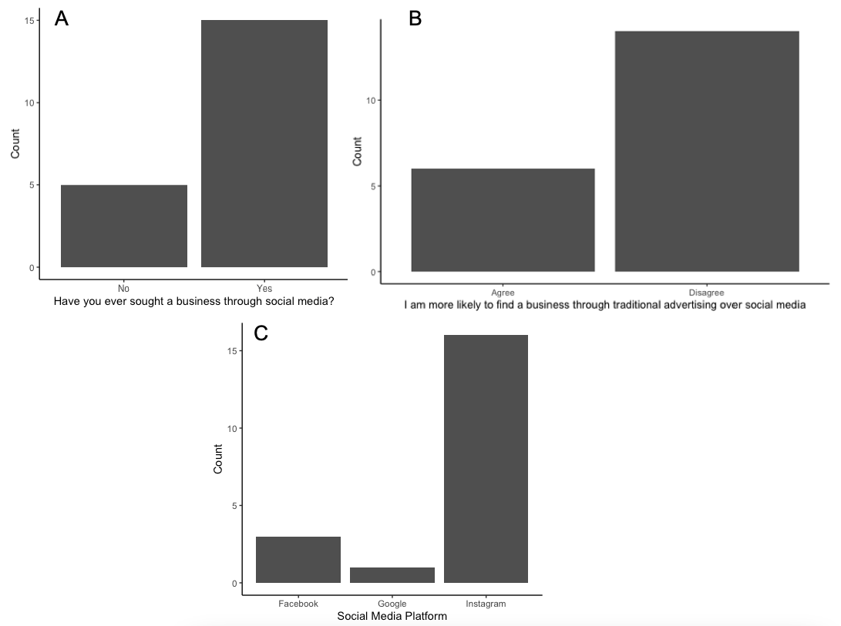
In total, twenty consumers were surveyed on their impressions on businesses on social media. Seventy-five percent of consumers said that they had sought a service through social media (Figure 1a) and seventy percent disagreed with the statement “I am more likely to seek businesses through traditional advertising” (Figure 1b). Eighty percent of consumers stated that Instagram is the social media platform they are most likely to seek out a business on (Figure 1c).
Figure 1. Consumer response when asked their opinions on businesses promoting on social media. 15 consumers reported that they had never sought a business through social media and 5 had not (A). 14 consumers disagree with the statement “I am more likely to seek a business through traditional advertising than social media (B). 16 consumers reported that they were most likely to seek out a business on Instagram, while only 3 people voted for Facebook, and 1 for Google (C). A total of 20 people were surveyed.

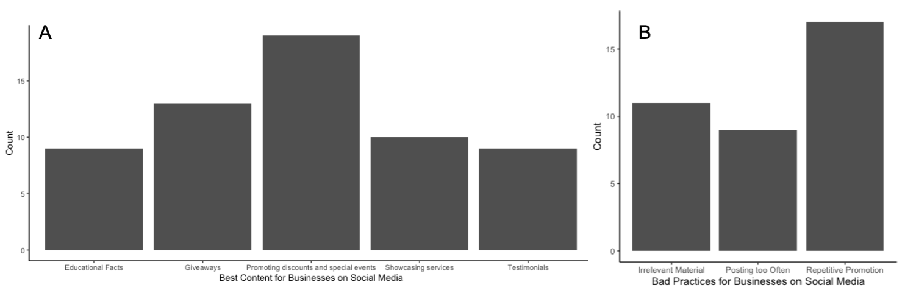
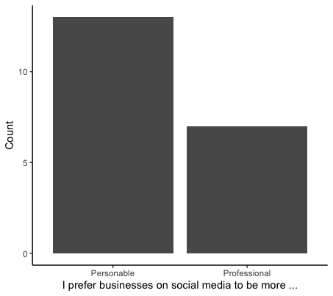
Regarding the content posted by businesses on social media, sixty-five percent of consumers surveyed said they prefer businesses to have a more personable presence on social media (Figure 2). Consumers reported that the thing they like most that businesses do on social media is promoting discounts, promotions, or special events and giveaways, with testimonials and fun facts being a less popular option (Figure 3a). Pushing the same service or product repeatedly was voted as the most disliked behaviour done by businesses on social media (Figure 3b). Consumers suggested that the optimal frequency to post is between two to three times a week (Figure 4).
Figure 3. Consumer response when asked what they liked (A) and disliked (B) the most about what businesses on social media do. The most liked thing that businesses do are promoting discounts, followed by giveaways, showcasing services, testimonials, and educational facts. The most disliked behaviour was repetitive promoting of the same service/product, followed by posting irrelevant material and posting too often.

Figure 2. Consumer response when asked if they prefer businesses on social media to be more personable or professional. 13 consumers preferred a personable approach, while 7 consumers prefer a professional approach. A total of 20 people were surveyed.

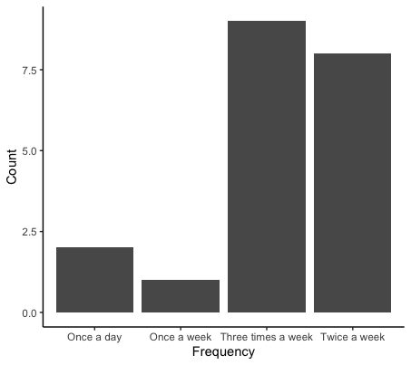
Figure 4. Consumer response when asked the optimal frequency to post as a consumer. The majority of consumers voted between two and three times a week, with 8 and 9 votes respectively. Two people voted for once a day and one voted for once a week. 20 people were surveyed

Techniques Utilized by Successful Social Media Businesses
Crash Course
Crash Course is a YouTube channel that posts educational videos on topics in science, English, history, and math. Their Instagram currently has over 24 thousand followers and they post 2-3 times a week. Their content on Instagram consists primarily of clips from their YouTube videos which shows that their main goal for their Instagram is to drive viewers to their YouTube channel. Additionally, they also post fun educational facts relating to the topics they teach as well as behind the scene photos from shooting their videos.
Figure 5. Typical posts made by the Crash Course Instagram features clips of their YouTube videos, education facts, and behind the scenes of their videos.

Khan Academy
Khan Academy is a large non-profit educational organization that teaches students around the world through thousands of YouTube tutorials and its own set of online tools on its own website. The Khan Academy Instagram currently has over 250 thousand followers and their Facebook page has over 27,000 likes. Posting around two to three time a week, their content on Instagram is centered around communicating with their clients and building a strong client relationship. They post mostly educational memes, relevant facts on the world, and often post questions that prompt their audience for answers (Figure 6).
Figure 6. Typical posts made by the Khan Academy Instagram features educational memes, facts, and questions that interact with their audience

Techniques to Maintain a Successful Businesses on Social Media
Businesses need to constantly update and interact with their audience in order to not lose relevancy as determined by Instagram and Facebook’s algorithms. Posting on weekday mornings is highly recommended as this is often regarded as the time when most people are on social media (Powers, Wahid and Wahdud 312), thereby maximizing the amount of people your post is exposed to.

CONCLUSION AND RECOMMENDATIONS
Based on the data collected from the consumer survey and the research on currently successful social media businesses, the recommendation is for Pott’s Education Studio to increase student registrations by revitalising and rebranding their social media accounts, primarily focusing on Instagram. With 80% of the consumer vote, Instagram was determined to be the social media platform consumers are most likely to seek out a service business. While other sectors of Pott’s clientele in China may be more inclined to use Weibo, the content posted on Instagram can be easily translated to be posted on other social media platforms. Furthermore, focusing on Instagram fosters a stronger connection with current local students which piques interest at the student level rather than at the parent level to encourage self-motivated study habits. Influencers and ads on Instagram are undoubtedly a critical part of social media marketing due to their global platform; however, without mentioning the large fees of influencers and ads, the target audience of Pott’s Education Studio is mostly students from Canada and China. Consequently, this report suggests that Pott’s Education Studio grow their social media following by providing their target audience with strong content that showcases the studio.

Action Plan
The research and consumer reports suggest that the optimal frequency for a business to post on social media is between two to three times a week (Figure 4). Content posted on the Pott’s Education Studio Instagram should closely align with other educational services as well as incorporating some personable elements to which the students can relate and respond to. Repetitive promotion of the same service was voted as the least liked behaviour of businesses on social media, therefore, this report suggests the Pott’s Education Studio Instagram to cycle through various types of content and to wait at least two weeks until posting about the same promotion again, unless the promotion is for a limited time only. Suggested content includes educational facts and memes, seasonal promotions and reminders, testimonials, introducing new services, promoting YouTube appearances and special events hosted by the studio, and homework card* giveaways for students (Figure 7). This report suggests a dedicated team at Pott’s Education Studio to get together during the second last week of the month to plan out the social media posts for the following month (Figure 8).
Figure 7: Sample posts – to be added!

Figure 8. Sample Content Plan for January 2021. Plan cycles through suggested content, focuses on customer interaction, and limits repeating promotions too often.

Homework Card: A card signed by the student’s instructor that gives the student an exemption from any assignment or quiz of their choosing.

Maintaining Social Media Presence
- Use apps like ________ to schedule all posts at the beginning of the month
- Use _______ to easily create unique branded text posts
- Reply to comments on posts

WORKS CITED – To be Updated
Wahid, Risqo M., and Muhammad Wadud. "Social Media Marketing on Instagram: When is the most Effective Posting Timing?" EPRA International Journal of Multidisciplinary Research (IJMR), 2020, pp. 312-321.
Powers, Katie. “The Best Times to Post on Social Media.” American Marketing Association, 28 June 2019, www.ama.org/marketing-news/the-best-times-to-post-on-social-media/.
Alfian, Novita, and Sengguruh Nilowardono. "The Influence of Social Media Marketing Instagram, Word of Mouth and Brand Awareness of Purchase Decisions on Arthenis Tour and Travel." IJEBD (International Journal of Entrepreneurship and Business Development), vol. 2, no. 2, 2019, pp. 218-226.

APPENDIX
Appendix A: Consumer Survey Questions
Businesses on Social Media Research
I am an undergraduate student at UBC engaged in a technical writing project. The purpose of this survey is to obtain primary data for an investigation that aims to provide recommendations for growing and improving a small local tutoring business. The final report will be addressed to the owner of the business. The data I gather from this survey along will provide recommendations on how this small business can grow its clientele and serve its community better through social media. The survey contains 9 questions, and it should take less than 5 minutes of your time. Your responses are voluntary and will remain anonymous. I appreciate your participation in my survey. Thank you.
- Have you ever sought a service through social media?
  - Yes
  - No
- The social media platform I am most likely to find a business is:
  - Instagram
  - Weibo
  - Facebook
  - Other: _____________
- I am more likely to seek out businesses through traditional advertising than social media
  - Agree
  - Disagree
- I prefer businesses on social media to be more
  - Personable
  - Professional
- I follow businesses on social media because (Circle all that apply):
  - To keep up with their latest offerings/promotions
  - To show friends
  - I am their customer
  - To support their business
- Something I like that businesses do on social media are
  - Promoting discounts, promotions, or events
  - Providing positive testimonials from past clients
  - Showing what the service has to offer
  - Giving fun facts or educational pieces of information
  - Giveaways
  - Other: ____________________
- Something I dislike that businesses do on social media are
  - Posting too often
  - Posting irrelevant material
  - Pushing the same service/product too much
  - Other: ___________________
- A good frequency to post is
  - Once a week
  - Twice a week
  - Once a day
  - Three times a week

