Wheelchair Attachable Shoping Carts

Date : December 1st, 2020

To : DaRun Fa Managing team (Mr. Huang, Mr. Bao, and Ms. Wu)

From : Shujun Peng, ENGL 301 Student

Subject: Proposal for providing wheelchair attachable shopping carts to handicapped shoppers

Dear Managing team,

The wellness of the customers is always the DaRunFa’s top priority. As a former employee of DaRunFa company, I observed that there’s a continuous customers complains about grocery stores not making accommodations to customers with disabilities city wide. As Shanghai’s biggest grocery store, it is recommended that we listen to customer’s diverse demands, and making adjustments in our service in order to serve them better.

Here is my report on proposing DaRunFa to purchase wheelchair attachable shopping carts.My report will include the following information :
- This report will contain reasons of why this is necessary
- The results from my online customer survey.
- Cost Analysis

Thank you in advance for your time, once you have review the project, please contact me by e-mail or phone.

Sincerely,

Shujun Peng
shujunpengschool@gmail.com

778-345-678

Introduction

As International Day of Persons with Disabilities approaches (December 3rd), we need to again raise awareness to improve handicapped people’s living experience, starting with the very essential things, such as purchasing daily necessities at the grocery store. Although most grocery stores in Shanghai provided wheelchair access and the staff were trained to help the handicapped people when shopping, not enough space and privacy were given to handicapped customers while they are shopping for goods. There’s an enormous pressure of going inside a store, and knowing that people are waiting to assist and helping to find the goods on the list. As customers, we sometimes need assistance, but other times we just want to shop without interference because we don’t know exactly what we want to buy. This is a feeling we all share, and handicapped people might not get such freedom due to one reason: not enough wheelchair attachable shopping carts, so that they need other people’s assistance.
Handicapped customers in grocery stores are always deemed as a group of customers that need special assistance. This perception takes away their privacy and freedom to shop mindlessly, and pressuring them to have a list of daily necessities they want to purchase. This is a very different shopping experience compared to non-handicapped customers, and it is also an issue that grocery stores tend to overlook. The amount of shopping carts and the amount of wheelchair shopping carts in the store were not evenly distributed, which almost pressured handicapped customers to seek special help when there’s an absence of shopping carts that can fit their needs. In order to protect the handicapped customers’ personal space and their privacy, the grocery store should accommodate them using all resources they could, which includes increasing the use of wheelchair attachable shopping carts is one way to solve the issue.
Improving handicapped customers’ shopping experience is not equivalent to giving them assistance every step of the way but also means to give them the experience that every customer wants to have. To increase the wheelchair attachable shopping carts, this project plans to pursue five areas of inquiry: 1) What kind of assistance do handicapped customers need? 2) What kind of shopping carts do they prefer? 3) Do staff’s assistance give handicapped customers pressure? 4) What do they think when they are entering the grocery store? 5) How do they perceive privacy and personal space in grocery stores? 6) My intended audience is the managers of DaRunFa grocery stores, because they can act on my recommendations if they agree with my proposed solution.
Procedure :
The study will be based on customer surveys aimed at the handicapped customers. In order to protect their privacy, this survey will be conducted online. Another reason to conduct the survey online is to decrease person-to-person contact, due to the ongoing COVID-19 situation. My secondary data will be gathered during the interviews with the manager of DaRunFa grocery stores.
Body
Literature Review :
While the grocery stores’ paid attention to provide easy access for people in wheelchairs, not enough attention was paid to customer’s shopping experience. Thanks to Carol Felker Kaufman’s article “ Shop’til you drop : Tales from a physically challenged shopper”, it revealed many personal experience of handicapped customer, and allowed us to see the areas of improvement.
The author states that shopping has become a depressing experience for most challenged shoppers. Why is that? Challenged shoppers often have to making a clear list of what they are going to buy, they tried to reduce their shopping trips as much as possible, because they know that “shopping often has to depend on the time of others” and they don’t feel at ease when they don’t have a detailed shopping list. (Kaufman, 1995, p. 45). While most of us do not share that experience, we might go to the grocery store without having a clear idea of what we will be having for dinner, and just buy whatever comes it our mind during shopping.
Furthermore, different challenged shoppers have different needs. “ For instance, people with emphysema are found to change their living patterns, in terms of doing errands like banking and shopping, in order to conserve their energy. Tactics like planning their shopping, and saving breath by stopping to rest every block or so, are conscious efforts of such shoppers to maintain their independence, yet prevent health difficulties. Thus a goal is to promote conservation of the patient’s energy, as well as their structural, personal and social integrity” (Kaufman, 1995, p. 42). Kaufman (1995) pointed out several unreasonable designs in grocery stores, such as “shopping carts were an awkward height for use with wheelchairs” (Kaufman, 1995,p. 46), which will be the focus of this project. Other unreasonable designs such as high shelves, which is unfriendly to challenged shoppers, it means that challenged shoppers will always need assistance when they want something high up on the shelf. One other thing that Kaufman (1995) didn’t point out, but I think is important— freezing zone. A lot of the doors of these huge refrigerators require shoppers to pull the handle, which could be a very big challenge for handicapped customer, it should be replaced by sliding doors.
Survey Data (Survey see Appendix)
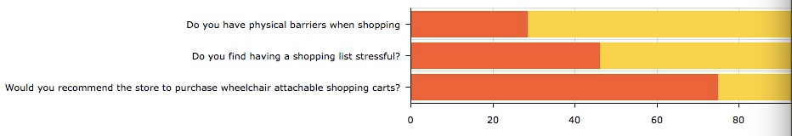
Type 1 : Yes& No questions (Yes-red; No-yellow)
Fig 1. Yes& No Questions survey data
According to the survey result, we can see that challenged shoppers are not minority groups. And most of both challenged shoppers as well as others find having a shopping list stressful. Furthermore, over 67% of respondents recommend that DaRunFa purchase wheelchair attachable shopping carts.
Type 2. Opinion questions.
Most respondent had reported that shopping is a private experience for them. They would like less involvement unless it’s necessary. Same thing goes for challenged shoppers, showing shopping list to grocery’s staffs sometimes make them feel like they were deprived of privacy. They turned to online shopping when it comes to private goods. When the rest of the shoppers are able to enjoy that kind of privacy, challenged shoppers cannot, my observation is, they needed help from the staffs because there’s no tool for them to use. As Kaufman (1995) suggested, the most important thing for them is to “ promote conservation of the patient’s energy, as well as their structural, personal and social integrity” (Kaufman, 1995,p. 42).

Cost Analysis
Product Description
Type #1 Baskets attached to wheelchair

Fig. 2 Shopping carts for use with wheelchairs (All rights go to : Terry Gipson. retrieved fromhttps://patents.google.com/patent/US8794655B1/en)
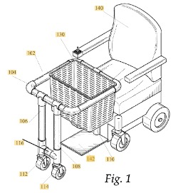
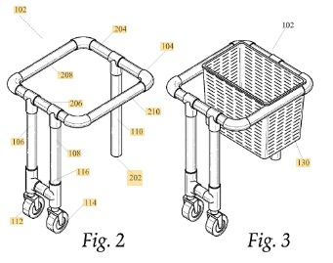
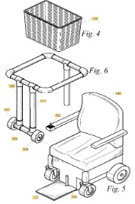

Fig. 3. Real example of Terry Gipson design.
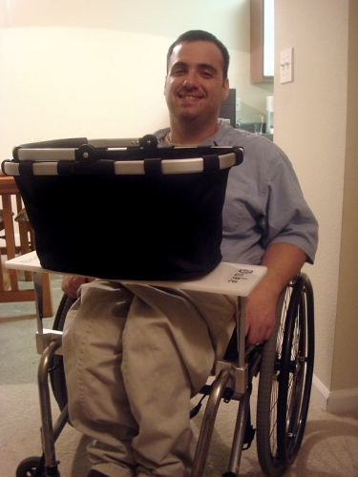

Type #2

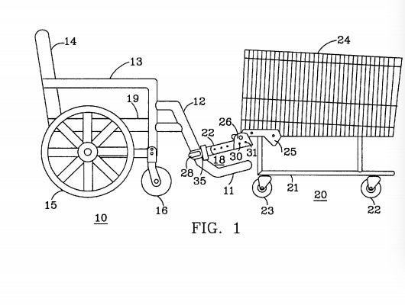
Fig.4 wheelchair attachable shopping cart (All rights go to: Forshee/ patent number US 6,702,313）
Fig5. Real example of Forshee’s design ( retrieved from https://www.resna.org/sites/default/files/legacy/conference/proceedings/2007/Practice/Mobility/Forney/Photo1.jpg)
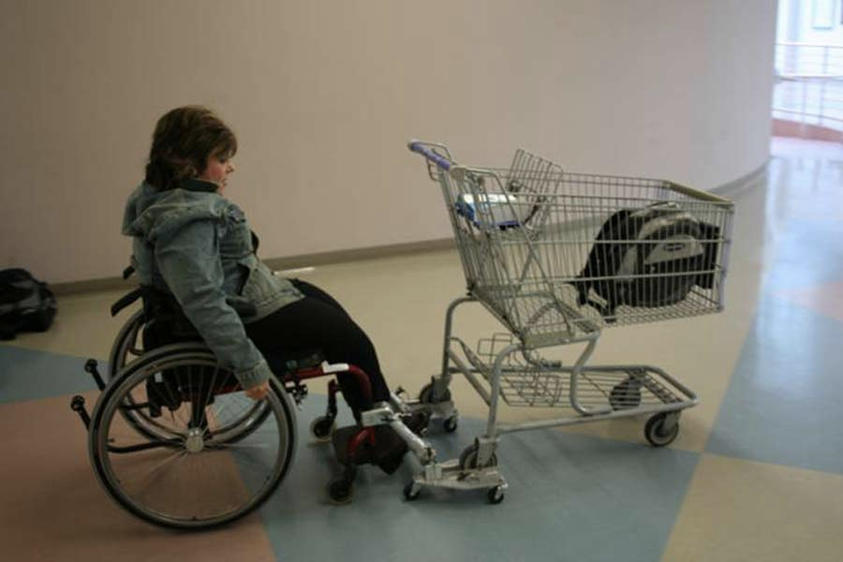

The reason to show both types of shopping carts is because store should have purchase these two kinds. Unchallenged shoppers have two types of shopping carts, one with the basket, one with the pulley. Therefor, the challenged shoppers should have access to these kinds as well.

Cost Analysis:

Appendix

Purchasing Wheelchair Attachable Shopping Carts in at DaRunFa Grocery store in Shanghai Survey

I am an undergraduate student at UBC engaged in a technical writing project. The purpose of this survey is to obtain primary data for analysis and investigation that aims to provide recommendations for improving your experience with shopping at DaRunFa Grocery store. The final formal report will be addressed to DaRunFa Grocery store manager. The data I gather from this survey will serve the ultimate purpose of providing recommendations for increasing shopping satisfaction of handicapped people. The survey contains 10 multiple choice questions, and it should take you less than 5 minutes of your time. Your response are voluntary and anonymous.Thank you, I appreciate your generous participation in my survey.

- Do you have physical barriers when shopping?

  - Yes
  - No

- While shopping groceries, what kind of shopping experience are you looking for

  - Uninterrupted shopping environment
  - Staffs are enthusiastic in helping you
  - Help are available and easily accessible when you need it

- Do you have a shopping list when you go to the supermarket
  - I usually do
  - I know what I want to buy, but I enjoy the experience of going around the store and see what else I might need.
  - I do not have the habit to create a shopping list

- Do you find having a shopping list stressful?
  - Yes, sometimes
  - Yes, most of the times
  - No, not at all.

- Are you comfortable with providing your shopping list (if you do have one) to our staff ?

  - Yes, if showing my list will not invade my privacy
  - Yes, I think that is more efficient and less time-consuming
  - No, because of privacy issue

- If you have physical struggles when shopping, would you prepare a shopping list?
  - Yes, because I need the staff to help me
  - No, I enjoy the shopping alone
  - It depends, if I am in a rush, I will need to have a shopping list
- Do you think the store is accommodating handicapped customers sufficiently?

  - Yes, I do find the staffs are supporting
  - No, there’s more improvements could be done.
c) If you checked b option, please provide your reason here

___________________________________________________________

- If you have physical struggles when shopping, what kind of things that bugs you the most ?
  - Too much attention on me when shopping
  - I always need someone else to accompany me
  - It’s hard to buy things on my own with my wheelchair
- Would you recommend the store to purchase wheelchair attachable shopping carts?
  - Yes
  - No
- How many handicapped customers do you normally see in store.
  - I rarely see them
  - I see them occasionally
  - I am a handicapped customer myself, and I think it’s rare to see another handicapped customer when I am shopping
  - I am a handicapped customer myself, and I often see handicapped customers.

References:
Forshee, D. C., & Reed, B. B. (2004). U.S. Patent No. 6,702,313. Washington, DC: U.S. Patent and Trademark Office.

Gipson, T. (2014). U.S. Patent No. 8,794,655. Washington, DC: U.S. Patent and Trademark Office.

Kaufman, C. F. (1995). Shop′ til you drop: tales from a physically challenged shopper. Journal of Consumer Marketing.

