SPORTS DEVELOPMENT VOLUNTEER PROJECT IN TABLE VIEW - SOUTH AFRICA
After-school sport is hugely popular with children from low-income communities in South Africa, as a way to play their favorite games and spend time with their friends. Not only that, but it helps with their development and exposes them to better role models. As a volunteer, you’ll help to provide these programs to keep children busy after school and less likely to engage in negative behaviors, playing a key role in lowering some of the socio-economic problems often found in South Africa.

You’ll act as a volunteer sports coach, and have three options to choose from for your project:
- You can help to run the existing sports being offered, including skateboarding, netball, soccer, boxing or swimming. This involves practicing and playing these sports and running the program that is already in place.
- You can be in more of a leadership role, working with the local team, analyzing the way sport is offered and finding ways to improve it.
- You can run a sports clinic, teaching a sport that’s not currently being offered. This is likely to involve more planning and you may need to bring your own equipment.
The project runs in the afternoons from Tuesday through Thursday. In the mornings, you’ll spend time in pre-schools on the Kindergarten project, helping with games, activities and general duties. This is another active volunteer experience, working with younger children and helping their development.
The Sport Development project is closed for the school holidays in January, April, July, October and December. Volunteers during these months will be switched to the Holiday Club project. The project also doesn’t run on Mondays, but you can help to plan the week’s activities.
School Holidays 2020:
- February 17th - February 21st
- April 11th - May 3rd
- June 15th - June 19th
- August 8th - August 30th
- October 31st - January 4th, 2021
Source:

“Sports Development Volunteer Project in Table View - South Africa.” International Volunteer HQ. https://www.volunteerhq.org/ca/destinations/south-africa/sports-development-in-table-view/.
Accessed December 8, 2020.

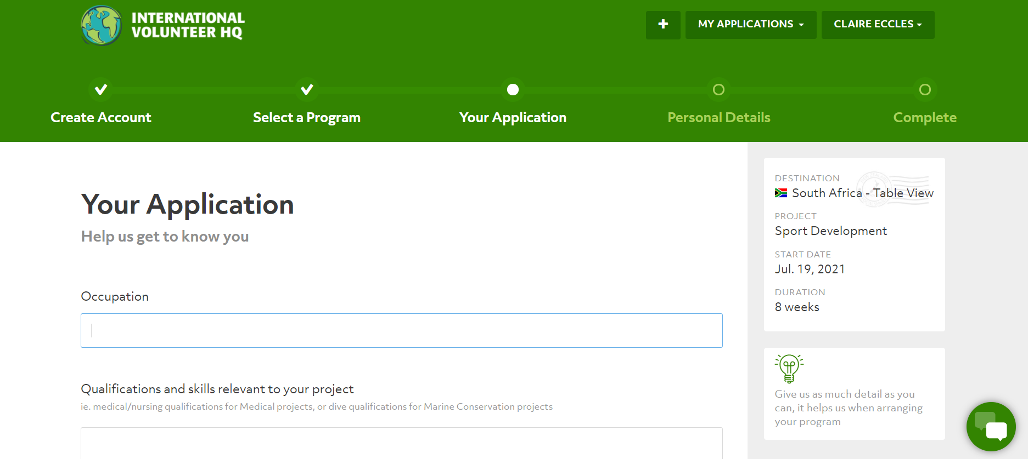
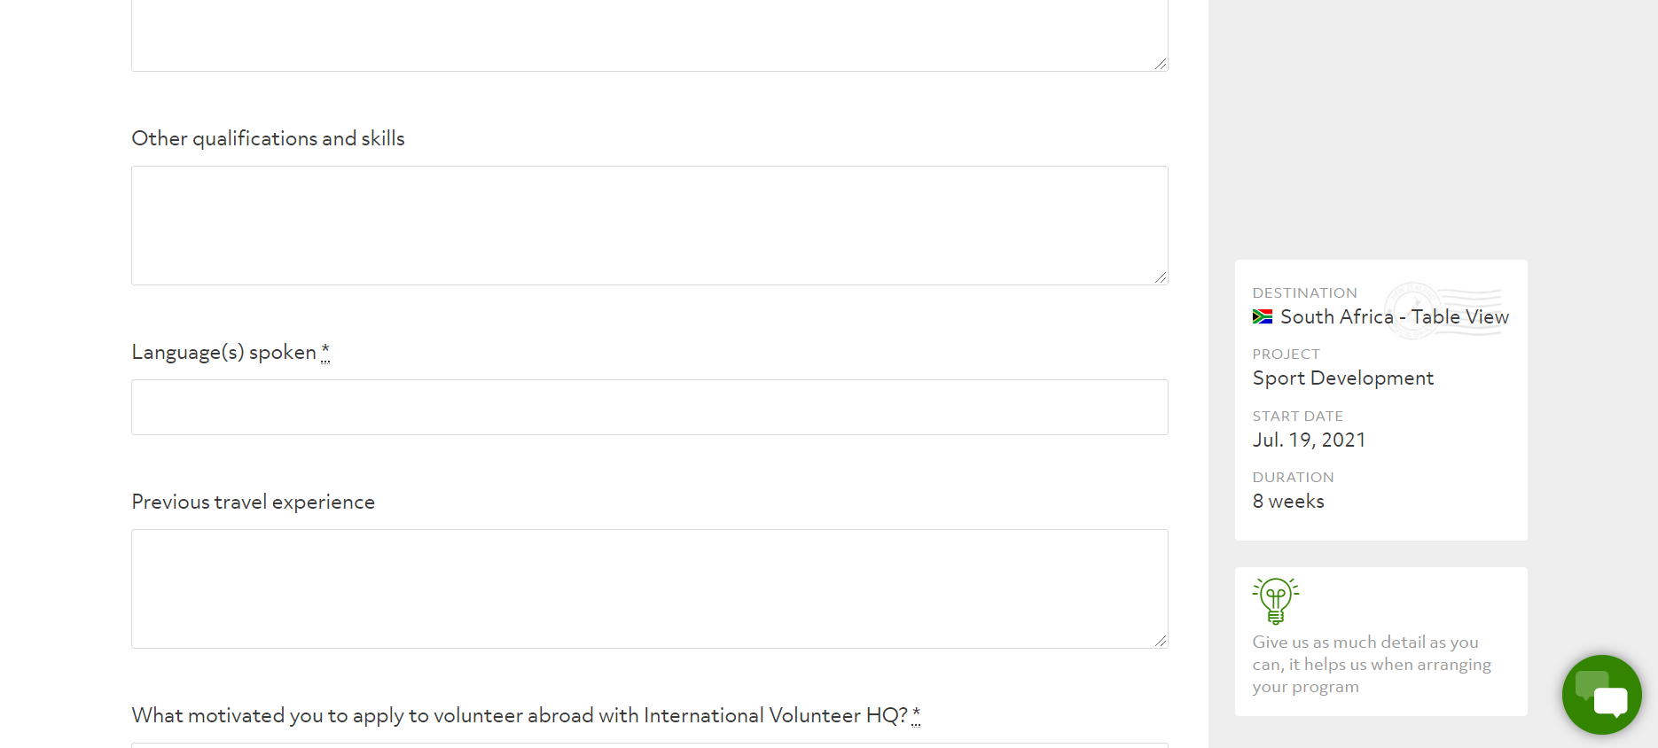
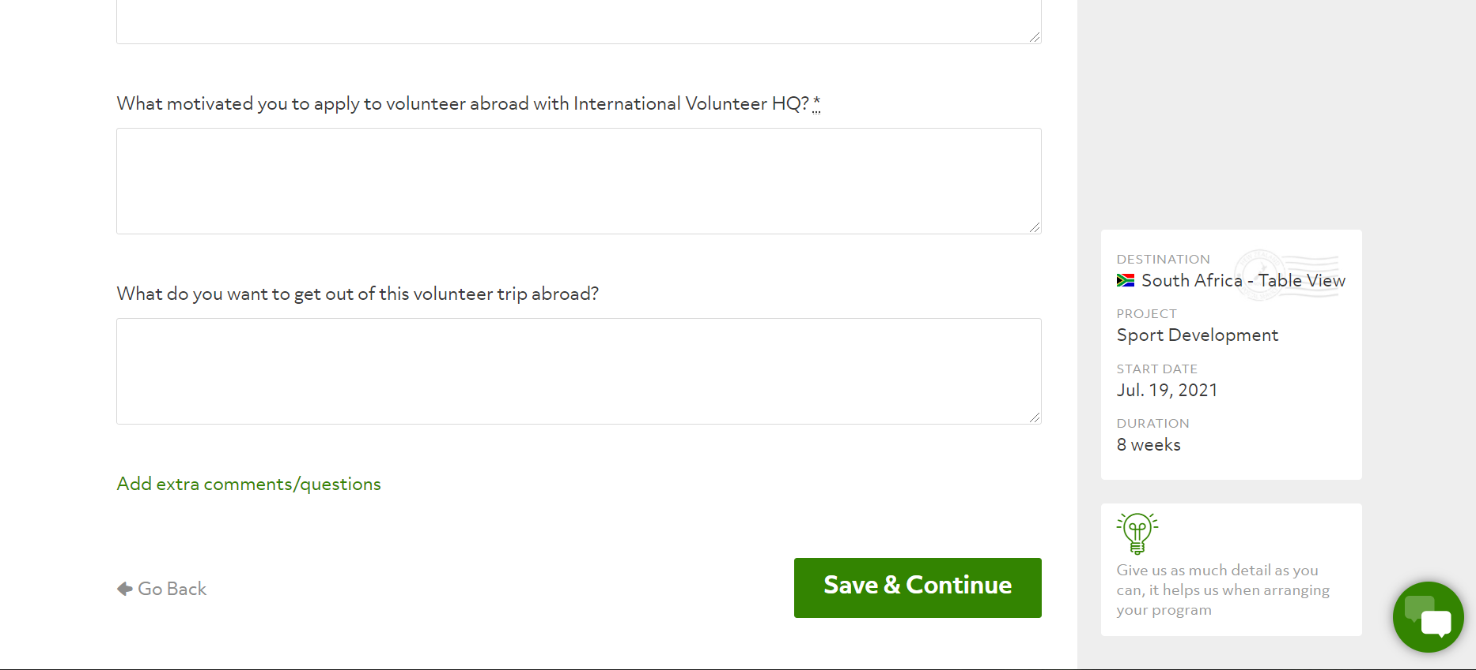
13868 19A Avenue
Surrey, BC V4A 9M2

December 12, 2020

International Volunteer HQ
99 Devon Street W
New Plymouth, New Zealand 4310

Attention: International Volunteer HQ Office

Please consider my application for a youth sports development volunteer position in Table View, South Africa. I will be taking a break from school to focus on the next steps I want to make in my life that will provide more fulfillment and enjoyment. Having a deep connection to sport and its ability to bring people together and create joy pushes me to pick this opportunity as my first step to finding that sense of value.

As you will read in my enclosed resume, I have spent a lot of time involved in sport over the years. Being a member of Canada’s women's baseball team and the University of British Columbia’s softball team has rewarded me with opportunities to coach and volunteer with young and upcoming athletes. I have participated in running hitting clinics out of the university, coaching the girl’s provincial baseball team, and facilitating summer camps for young baseball girls.

In addition, I played multiple sports in high school to the extent of being offered to play soccer or basketball in post secondary. Therefore, I am well rounded in my knowledge and ability to partake in different athletic activities.

I would be thrilled to bring the sport of baseball into the lives of Table View kids by running a baseball sports clinic, or to help the continuation of popular sports in South Africa play an important role in youth development. I believe staying healthy and active while having fun with peers leads to positive growth, and I would love to be a part of the process.

If you feel I would be a good fit for this volunteer position, please give me a call anytime at (XXX) XXX-XXXX or email me at claire.eccles4@gmail.com.

Sincerely,

Claire Eccles

Claire Eccles

Claire Kirino Eccles
13868 19A Avenue
Surrey, BC V4A 9M2
Phone: (XXX) XXX-XXXX
Email: claire.eccles4@gmail.com

Objective Sports Development Volunteer position in Table View, South Africa

Education University of British Columbia, Vancouver, BC
2015-present Bachelor of Arts with a Major in Psychology, graduated April 2020. Currently studying Bachelor of Science with a Major in Computer Science, Integrated Computer Science (ICS) Program. Scholarship 2015-2019 for varsity softball team.

Employment Baseball BC Girls Coach/High Performance Instructor, Vancouver, BC
2016-present Assistant/Pitching coach to U14 Provincial Girls baseball team. Ran practices, coached pitchers in game, provided guidance and advice on play (2016-2018). Representing Senior Provincial Team/National Team in high performance camps, running drills and providing experience and mentorship.

2019-2020 UBC Athletics, Vancouver, BC
Department of Athletics, Alumni Manager’s Assistant. Assisted in organization of Alumni gathering at sporting events. Connecting alumni to current and prospective athletes.

2019 Pacific Football Club, Victoria, BC
Fan Store Manager, ran game day and in store sales and merchandise for Canadian Premier League (CPL) team. Coordinated and scheduled with other departments for operating youth tournaments and camps.

2016-2017 UBC Baseball Facility, Vancouver, BC
Front Desk Staff, scheduled camps and lessons for the UBC baseball instructors. Involved in maintenance of the facility, aided in assisting baseball instructors with youth clinics and drop-ins.

Leadership Awards
Captain of UBC Softball team, 2017-2019; Twenty-8 group Blue and Gold Women’s Varsity Endowment Fund Recipient, 2019; Women’s Baseball World Cup Medalist, 2016 (Silver) & 2018 (Bronze); Captain of Women’s U20 National Baseball Team, 2016; Toronto Pan Am Games Silver Medalist, 2015; Surrey Basketball All-Star Team & Top Shooter, 2015.

Languages
Fluent in English

Activities
Women’s National and Provincial Baseball teams (7 years, 11 years, respectively); Victoria Harbourcats Collegiate Baseball team- first female to play in men’s collegiate summer league (2 years); I’m Going to UBC (IGUBC)- ran sport day camps for primary school kids (2 years); CiTR Radio 101.9 Sportscaster- reported UBC sports highlights weekly (6 months), High School Basketball, Soccer, Volleyball and Ultimate teams (5 years, 5 years, 2 years, 2 years, respectively); Babysitter (9 years).

References Available upon request.
13868 19A Avenue
Surrey, BC V4A 9M2

December 12, 2020

Gord Collings
UBC Softball Head Coach
2329 West Mall
Vancouver, BC V6T 1Z4

Dear Gord,

I hope this letter finds you well, and I am thrilled to hear that the new softball field will be named in your honour for all the dedication and hard work you have put into the program.

As you know, I am currently looking to make a shift out of my schooling at UBC and onto a different path for my future. Fittingly, I came across an opportunity to be a youth sports development volunteer in South Africa. This would be a great leaping off point for me, gaining a rewarding experience to teach sport to youth and taking on a new challenge.

The many years you guided the softball team with your knowledge and philosophies has made you an influential figure in my life. Not only have you made an impact on me with your on-field coaching, but your values and leadership off the field will stay with me throughout my life. With this opportunity, I hope to make a fraction of an impact on these kids as you have with me.

If you are willing and able, I hope you will consider writing a reference letter for my application for this position. I will attach my resume and the volunteer posting at the end of this letter. You can email me at claire.eccles4@gmail.com if you wish to accept my offer. If you have any further questions you may also address them to my email.

Thank you for taking the time to read this, I look forward to hearing from you and catching up as well.

Sincerely,

Claire Eccles

Claire Eccles

Enclosed. Resume and Volunteer Application Posting
13868 19A Avenue
Surrey, BC V4A 9M2

December 12, 2020

Brad Norris-Jones
Pacific Football Club, Vice President of Operations
665 Fort Street
Victoria, BC V8W 1G6

Dear Brad,

I hope this letter finds you well, and I hope the football team is doing okay despite the impact of COVID-19 on the season.

As you know, I am currently looking to make a shift out of my schooling at UBC and onto a different path for my future. Fittingly, I came across an opportunity to be a youth sports development volunteer in South Africa. This would be a great leaping off point for me, gaining a rewarding experience to teach sport to youth and taking on a new challenge.

When you first approached me about playing for the Victoria Harbourcats, we both underestimated how much of an impact that idea would make on young girls who hope to play baseball. Your role as General Manager of the team led to a trailblazing decision and I am honoured you asked me to be a part of it. As you transitioned from the role of GM of a baseball team to Vice President of the Pacific Football Club, you awarded me with the opportunity of becoming the team’s fan store manager. Without your mentorship and belief in me throughout those years, I would not be where I am today. With this chance to mentor and coach youth in sport, I hope to make a fraction of an impact on these kids as you have with me.

If you are willing and able, I hope you will consider writing a reference letter for my application for this position. I will attach my resume and the volunteer posting at the end of this letter. You can email me at claire.eccles4@gmail.com if you wish to accept my offer. If you have any further questions you may also address them to my email.

Thank you for taking the time to read this, I look forward to hearing from you and catching up as well.

Sincerely,

Claire Eccles

Claire Eccles

Enclosed. Resume and Volunteer Application Posting
13868 19A Avenue
Surrey, BC V4A 9M2

December 12, 2020

Scott Mackenzie
Baseball BC, Director of Programming and Female Development
#310 - 15225 104th Ave
Surrey, BC V3R 6Y8

Dear Scott,

I hope this letter finds you well, and I am looking forward to the next camp we will be able to run for the girls.

As you know, I am currently looking to make a shift out of my schooling at UBC and onto a different path for my future. Fittingly, I came across an opportunity to be a youth sports development volunteer in South Africa. This would be a great leaping off point for me, gaining a rewarding experience to teach sport to youth and taking on a new challenge.

The many years you have put into growing baseball for girls and providing them with more opportunities has meant a lot to the women’s BC baseball community. Your help with the national team has been important for girls across Canada. Not only have you made an impact on me with your ability to coach and lead a team, but you are helping to break barriers and increase baseball development for both sexes. With this opportunity, I hope to make a fraction of an impact on these kids as you have with me.

If you are willing and able, I hope you will consider writing a reference letter for my application for this position. I will attach my resume and the volunteer posting at the end of this letter. You can email me at claire.eccles4@gmail.com if you wish to accept my offer. If you have any further questions you may also address them to my email.

Thank you for taking the time to read this, I look forward to hearing from you and catching up as well.

Sincerely,

Claire Eccles

Claire Eccles

Enclosed. Resume and Volunteer Application Posting

