Formal Proposal for Licensing a 3D Human Anatomy Software

For
Dr. Tanya Forneris
Associate Director of Health Sciences
University of British Columbia Okanagan Campus
Kelowna, British Columbia

By
Hilton Ma
Student Number - 85756393
University of British Columbia

December 1, 2020

Table of Contents
Abstract 5
Introduction 6
Background 6
Statement of Problem 6
Data Section 7
Impact of Remote Learning Anatomy 7
Survey Data 7
Interview Data 8
Available Applications 8
Applications 8
Cost 8
Features 8
Interoperability 8
Conclusion 8
Recommendations 8
Works Cited 10
Appendix A: Survey 11
Survey Introduction 11
Survey Questions 11
Appendix B: Interview 12
Interview Questions 12

Abstract
…

Introduction

Background
Since mid-March of 2020, the COVID-19 virus has caused schools to close and switch to online and virtual solutions. As a result, students at the University of British Columbia Okanagan (UBCO) campus, enrolled in hands-on lab-based classes, are deprived of learning resources that would normally be available. Anatomy courses are among the courses most severely affected. These courses would typically include a lecture component, as well as an in-person component. The in-person lab component would facilitate learning through student interaction of three-dimensional (3D) anatomical models. Through COVID restrictions, this lack of in-person learning resources causes greater reliance on learning (and teaching) from online and textbook human anatomy images – drastically undercutting student comprehension of the course material. The purpose of this investigation was to determine whether a 3D anatomy software is necessary for remote learning of anatomy courses, which applications are available, and which applications are appropriate.

Statement of Problem
The lack of hands-on learning resources available to students enrolled in anatomy courses leads to a more superficial understanding of the subject. These are some of the implications as a result:
- Lack of learning resources will lower student satisfaction of the course, ultimately lowering teaching evaluation scores.
- Students become more stressed from the lack of perceived knowledge, which can negatively impact self-efficacy and GPA
- Superficial understanding from students reduces competency, and will result in a negative reflection on UBCO

Data Section

Impact of Remote Learning Anatomy
Remote learning of anatomy courses provides unique challenges to student such as overwhelmed by the content, the teaching quality, and perceptions of teaching support – all of which subsequently affect how well a student performs (Barbagallo, Porter, & Lamunu, 2020). Remote learning of anatomy loses the hands-on practical experience, which is of particular relevance in studies of anatomy. Hands-on experience is considered the gold standard, and early anecdotal studies suggest that the remote learning format is not capable of replacing the face-to-face aspect and hands-on experience, ultimately causing a decrease in student enrollment of such courses (Brassett, et al., 2020).

Survey Data
The purpose of the survey was to obtain primary data regarding the usage of education resources and resources available in an anatomy class in a COVID pandemic. The survey was available to both the student and teachers of an Advanced Functional Anatomy class.
Questions 1 and 2 of the survey ensured that the participants of the sample were apart of the anatomy class and indicated their roll in the class. Of the 129 people in the class, 22 student and no teachers have responded to the survey.
The next survey question, as represented in Figure 1 below, was conducted on the learning resources that were available to individuals in the class. Apart from text, images, and videos which were provided in online video lectures and notes, all other resources were sourced individually. This question provides valuable insight into which resources the individuals found important.
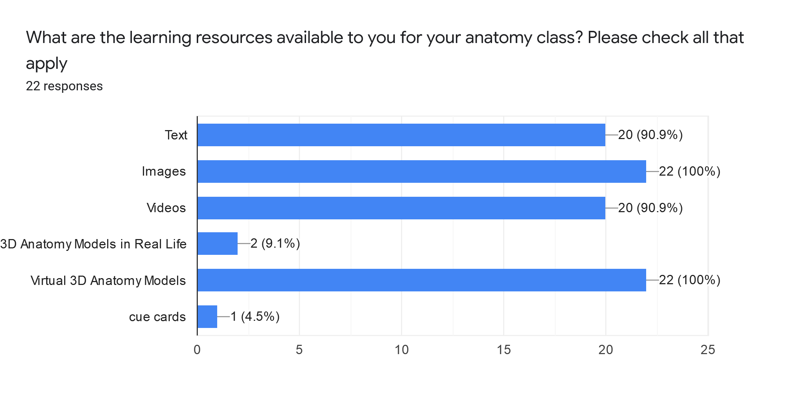
Figure 1. Available Learning Resources from Survey Question 3
Figure 2 correlates with questions 4 of the survey and shows the satisfaction with the available learning resources. Overall, the majority (72.7%) felt that learning resources available were adequate, while 22.7% felt it neutral, and 4.5% felt it was inadequate. This provides valuable insight on whether additional resources were required on top of available resources. 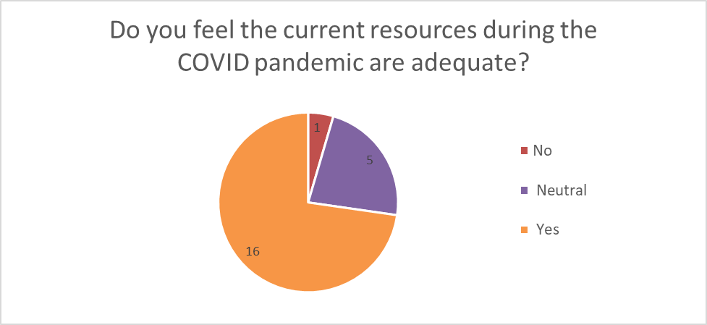
Figure 2. Satisfaction with Learning Resources from Survey Question 4
The 5th and 6th questions of the survey indicate the perceptions of missing learning resources. Of all polled individuals, all 22 indicated that in-person lab components were missing, leading to inability to view in-person models and palpate muscles.

Interview Data

Applications
The popular 3D anatomy applications are Complete Anatomy, Muscle Premium, and Human Anatomy Atlas. Complete anatomy was published by 3D4Medical from Elsevier, while Muscle Premium and Humana Anatomy Atlas were both published by Visible Body.

Features
In terms of features, both Human Anatomy Atlas by Visible Body and Complete Anatomy by 3D4Medical were similar. They both provided 3D anatomical models of the nervous, muscular, skeletal, and circulatory systems as well as others. Muscle Premium was less feature rich but focused on the skeletal, muscular, nervous, and blood supply.

Interoperability
Interoperability is a crucial component in deciding which application is appropriate as it may limit availability to some individuals. While all applications are available on the Windows, Mac, Android, and iPhone/iPad operating systems, there some difference in hardware requirements. Complete Anatomy is the most hardware heavy with the minimum requirement of Windows 10 and 3GB of memory for PC, iOS 11 for iPad, macOS10.13 for Macs, and Android 7.0 with 2GB memory for android and Chromebook products (3D4Medical, n.d.). In comparison, Muscle Premium is less hardware intensive and has minimum requirements of iOS Windows 7 with 2GB of memory, OS X 10.10.0 on Macs, iOS 13.0 on iPhones/iPads, and Android 4.4 (Visible Body, n.d.). Human Anatomy Atlas is the least hardware demanding. Its minimum requirements are Windows 7 or newer with 2 GB of memory, OS X 10.9.0 for Mac, iOS 8.0 for iPad and iPhones, and Android 2.3 or newer for Android and Chromebook. (Visible Body, n.d.)

Cost
Costs for licensing these applications are currently unknown. 3D4Medical has declined to comment regarding the costs for licensing Complete Anatomy for the UBC Faculty of Health Science, while email discussions with Visible Body are still in progress.

Conclusion

Recommendations
To determine whether 3D anatomy software was appropriate for remote learning anatomy courses, this report explored the necessity of 3D anatomy applications and which software would be appropriate. Early anecdotal studies on remote learning anatomy courses indicated 3D anatomy software were a required alterative, yet not as effective as in-person resources. These studies were further supported by the primary survey and interview data. Survey results indicate that students considered 3D anatomy applications necessary, and with it, the majority found the available learning materials to be adequate. However, students interviewed stated that due to remote learning the course was lacking hands-on learning and affected their ability to learn from palpating on other people. This is consistent with findings that show that in-person models are the gold standard in anatomy courses (Brassett, et al., 2020).
An examination in the available anatomy software found Human Anatomy Atlas as the most recommended due to interoperability. While all applications examined provided features required for the Advanced Functional Anatomy course, Human Anatomy Atlas was recommended due to requiring the least demanding computer hardware and was also available on all operating systems but had the highest minimum hardware requirements. This however does not take into account for licensing costs.

Works Cited
3D4Medical. (n.d.). System requirements for Complete Anatomy. Retrieved from 3D4Medical: https://3d4medical.zendesk.com/hc/en-us/articles/360039363451
Barbagallo, M. S., Porter, J. E., & Lamunu, M. (2020). Evaluation of a Blended Online and Digital Learning Mode of Anatomy and Physiology for Undergraduate Nursing Students. CIN: Computers, Informatics, Nursing, 38(12), 633 - 637. doi:10.1097/CIN.0000000000000639
Brassett, C., Cosker, T., Davies, D. C., Dockery, P., Gillingwater, T. H., Lee, T. C., . . . Wilkinson, T. (2020). COVID-19 and Anatomy: Stimulus and Initial Reponse. Journal of Anatomy, 237(3), 393 - 403. doi:10.1111/joa.13274
Visible Body. (n.d.). Human Anatomy Atlas System Requirements. Retrieved from Visible Body: https://support.visiblebody.com/hc/en-us/articles/115002834114-System-Requirements
Visible Body. (n.d.). Muscle Premium System Requirements. Retrieved from Visible Body: https://support.visiblebody.com/hc/en-us/articles/115002838053-System-Requirements

Appendix A: Survey

Survey Introduction
I am an undergraduate student engaged in a technical writing class. The purpose of this survey is to obtain primary data for an investigation into the sentiment on currently available learning resources in anatomy courses at UBC Okanagan during the COVID-19 pandemic. The collected data will be used to write a formal report that will be addressed to the administrative body of the Health Science faculty. This survey contains 6 questions and should require no more than 5 minutes. Your responses will remain anonymous. I appreciate your participation.

Survey Questions
- Are you a currently apart of an anatomy class?
  - Yes
  - No
- In what capacity are you currently engaged in the anatomy class?
  - Student
  - Professor / Teaching Assistant
  - Other: _____________
- What current resources are available to your class? Please check all that apply.
  - Text
  - Images
  - Videos
  - Real life 3D anatomy models
  - Virtual 3D anatomy models
  - Other: ___________________
- How do you feel about the current resources during the COVID pandemic are adequate?
  - Yes
  - No
- Are there any potential resources (that you know of) that are missing during the pandemic compared to non-pandemic standards?
  - Yes
  - No
  - Unsure
- If you answered yes to question 5, what resources currently are unavailable?
________________________________________________________________________________________________________________________________________________________________________________________________________________________

Appendix B: Interview

Interview Questions
- In what capacity are you engaged in an anatomy course?
- Is your anatomy class lacking in any learning resources? If yes, what are they and how do you feel this is affecting your learning/teaching ability?
- How do you feel about the current resources your anatomy class has access to?
- In your opinion, what are some potential solutions if your class is lacking resources?
- Would your anatomy class benefit from the licensing of a virtual 3D anatomy application?
- How would the 3D anatomy software potentially benefit your class?

