|  |  |  |
| --- | --- | --- |
|  | |  |
| Optimizing a Hand Hygiene Program at the BC Children’s and Women’s Hospital | |  |
|  |  | |
|  | ForIPAC and QPS TeamsBC Children’s and Women’s HospitalVancouver, British ColumbiaByQuentin MichalchukTechnical Writing StudentUniversity of British ColumbiaDecember 1, 2020 | |

TABLE OF CONTENTS

Introduction #

Background #

Proper Performance of Hand Hygiene #

Associations/Teams Tasked with Hand Hygiene Standardization #

Past Initiatives #

Problem Statement #

Methods #

Intended Audience #

Scope of the Inquiry #

Recommendations #

Body (Data section) #

Demographics #

HH Importance According to HCWs #

HH Compliance and Understanding in HCWs and Students #

Student Compliance #

HCW Compliance #

Demographics #

Student Compliance #

HCW Compliance #

Most Effective HH Improvement Methodologies #

HCW Opinion #

Student Opinion #

The Best Methods #

Possible Solutions #

Benefits #

Challenges #

Solutions #

Interesting Ideas #

Conclusion #

Summary of Findings #

Limitations #

Recommendations #

**Introduction**

**Background.** Hand hygiene (HH) in a hospital setting such as the BC Children’s and Women’s Hospital (BCCH) has the potential to reduce antibiotic-resistant organisms, leading to reduced nosocomial pathogenesis (Mathur, 1). Following school closures due to COVID-19 emergence, HH performance improved at acute care hospitals by 16% (Moore et al., 1). More recent data in August suggested this number has dropped 6% (Moore et al., 1). Despite this increase in HH performance, visitor, patient, and healthcare worker (HCW) hand hygiene must be maintained or even increased for optimal compliance rates.

**Proper Performance of Hand Hygiene.** HH must be performed at 4 key “moments” in hospital settings: before an aseptic procedure, after contact with bodily fluids, and before and after entering the patient’s room (Mathur, 1). Patient and visitor HH is similar in nature, yet it is important to differentiate the two. In the midst of the COVID-19 pandemic, HH with alcohol-based hand rub (ABHR, ~70% alcohol) has been proven to be the most effective, low-cost procedure in transmission prevention via virucide (Lotfinejad et al., 1). HCW adherence to the 4 moments, as well as those required of patients and visitors ensures reduces the transmission, infection, saving lives (Lotfinejad et al., 1).

**Associations/Teams Tasked with Hand Hygiene Standardization.** A part of the provincial health services authority (PHSA), the infection prevention and control (IPAC) team are tasked with ensuring the protection of patients, staff and visitors from preventable infections. As the PHSA begins the recovery phase from COVID-19, HH has been identified as a key preventative measure for COVID-19, as well as other healthcare-associated infections. IPAC’s responsibility in this regard is to ensure an evidence-based HH program is in place during the pandemic. In addition, the quality and patient safety (QPS) team are intimately involved, as the hygiene program in question both involves patient safety and must be monitored for quality improvement.

**Past Initiatives.** In the BCCH, a number of initiatives have been trialled to improve HH rates: Examples include a pilot intervention in 2016-17, a survey for patients, families and visitors in 2018 as well as a gap analysis and multimodal HH pilot (Srigley, 11). In 2018-2019, multi-media work on HH was facilitated, and in 2019 a patient HH education pilot in the antepartum ward, as well as a quality improvement (QI) project were performed (Srigley, 11).

**Problem Statement.** Recent auditing results from the BCCH in 2019-2020 on patients and visitors in the inpatient surgical unit surveyed the 4 moments of HH. Compliance was determined to be 4.7%, although implementation of an improvement strategy had to be arrested due to the onset of COVID-19. In addition, it has been found that HCW compliance rates are not as high as reported (Erasmus et al., 1). Changing HH behavior was found to be challenging, with current efforts proving to be insufficient (Srigley et al., 1). The primary purpose of this report is to provide new perspectives and recommendations for optimization of the HH program present at the BCCH.

**Methods.** Primary data sources include two interviews consisting of 15 questions conducted with Dr. Jocelyn Srigley (via Skype for business), a medical microbiologist at the BCCH and IPAC physician as well as the PHSA QI initiative lead, Joanne Fernando (via Zoom). The interviews (performed using Qualtrics) allowed for elucidation of the current BCCH HH program proposal and expert ideas for improvement. Online surveying was performed on HCWs (28 multiple-choice, 6 short answer) and students (23 multiple-choice, 2 short answer, primarily attendees of the University of British Columbia), who were used to elucidate the HCW, patient, and visitor perspectives on the project.

Secondary sources were used to help understanding and history, with review studies, progress reports, and recommended readings written and suggested by Dr. Srigley on the subject.

**Intended Audience.** The target audience of this Formal Report is the IPAC and QPS teams, who are tasked with development and implementation of the HH project in question.  Specifically, Dr. Jocelyn Srigley and Joanne Fernando will be sent the final report, for further distribution if necessary. These two healthcare workers are spearheading the implementation and optimization of HH at the BCCH and thus have the capacity to turn the suggestions of the Formal Report into reality.

**Scope of the Inquiry.** In order to determine the details and efficacy of implementing such a program in the BCCH, the five lines of inquiry will be pursued:Reasons for inadequate HH compliance, the impact of COVID-19, the most important elements of the proposed campaign, how HCW accountability can be improved, and how HH improvement can be maintained in the future.

**Recommendations.** This report concludes by acknowledging its potential limitations in extrapolation as well as recommending additional measures in ensuring successful HH program implementation.

**Body (Data Section)**

**Demographics.** The interviews with Dr. Srigley and Fernando were 30 and 15 minutes long, respectively. The HCW survey had 9 respondents, mostly physicians, with one nurse. The student survey had 33 responses diverse in study area.

**HH Importance According to HCWs.** The HCW survey shows HH importance according to population in a healthcare setting. (**Figure 1**).

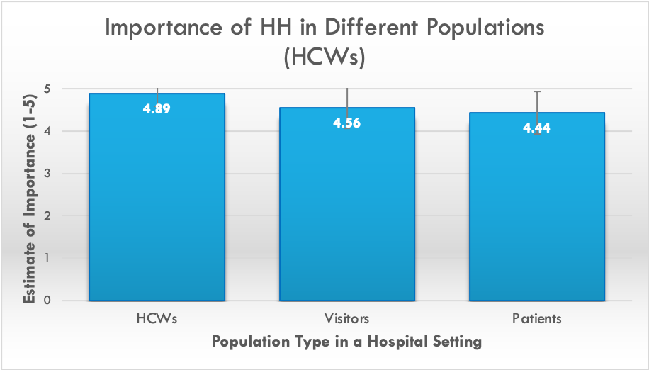

**Figure 1.** HH Importance among HCWs, visitors and patients according to 9 HCWs. On a scale of 1-5 where 5 is most important and 1 is least important. Data is represented as a mean +/- standard deviation (error bars, cut off above 5). HH = hand hygiene, HCW = healthcare worker

HCWs deem their HH most important in relation to other clinical concerns, followed by visitors, and finally patients. This is further emphasized in the interview with Dr. Srigley, who describes the focus of HH being on HCWs, however “patients and visitors can pick things up on their own hands just as easily as they can from HCWs” (Michalchuk). Although the proposed HH program is primarily targeted towards patient and visitor populations, it is of note that the physicians’ impression is biased towards themselves. This should be addressed in the program implementation, where physicians should be trained to understand the inherent equality of HH practice.

**HH compliance and understanding in HCWs and students.** In both HCW and student surveys, participants provide personal estimates of HH knowledge and compliance before and after COVID-19 (**Figure 2**).

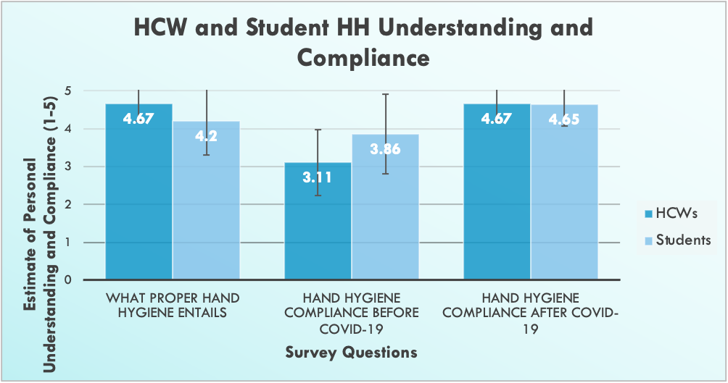

**Figure 2.** Personal understanding of HH and compliance before and after COVID-19 as estimated by 33 students and 9 HCWs. On a scale of 1-5 where 5 is perfect understanding/compliance and 1 no understanding/compliance. Data is represented as a mean +/- standard deviation (error bars, cut off above 5). HH = hand hygiene, HCW = healthcare worker

HCWs report greater understanding of HH than students, however students report higher compliance before COVID-19, with similar rates afterward. In addition, increase in HH compliance following COVID-19 among HCWs is statistically significant (student’s t-test, p=0.0002).

**Student Compliance.** It is interesting that students estimate their HH compliance to be above that of HCWs pre-COVID-19 (**Figure 2**). A US study potentiates this line of thought when applied to hospitals, primarily focused on patients and visitors, demonstrating decreased HH in hospital settings than when at home, as well as home practices strongly correlating with hospital practices (Barker et al., 1). Comparative HH rates showed marked decreases after using the restroom, before eating, patients with mobility problems, with a ten-fold increase in those barely or never washing their hands (Barker et al., 2). Patients that were immobile yet comfortable with asking for HCW assistance experienced an increase in HH in the hospital (Barker et al., 2). These results may demonstrate a predominant hospital culture does not promote patient and visitor HH, however extrapolation is limited due to the survey-based methodology, which is subject to bias (Barker et al., 3). It also points to a need for increased ease of communication between HCWs and patients. This would allow patients and visitors to be more confident when asking for HH in order to do their part in reducing bacterial spread. The survey, along with the study demonstrate a need for increased HH accessibility and communication among patients and HCW, as Dr. Srigley explains, “getting up is impractical for hospitalized and immobile patients”.

**HCW Compliance.** It is noteworthy that HCWs had lower compliance pre-COVID than students (**Figure 2**), with literature to support this**.** Among HCWs, a study in Italy was conducted among 6 ICUs where HH compliance rates were found to be highly variable, from 3% to 100% (Musu et al., E233). This variation may have been due to knowledge gaps, which could not be filled in by signage, as only 12 of the 15 required protocols and procedures were readily available (Musu et al., E232). One limitation, however, was the Hawthorne effect, as despite auditing 5 hours a day for 5 days, observation may have resulted in artificially high compliance. Although a lack of knowledge may be a contributing factor, Dr. Srigley and Fernando suggest otherwise, opting for high mental burden, lack of habituation and skepticism about HH as the cause of lower than optimal compliance in HCWs (Michalchuk).

**Most Effective HH Improvement Methodologies.**  The list of 15 methods proposed to be implemented in the campus-wide HH program were surveyed for expected effectiveness by both students and HCWs, presented from most to least effective (**Figures 3,4**).

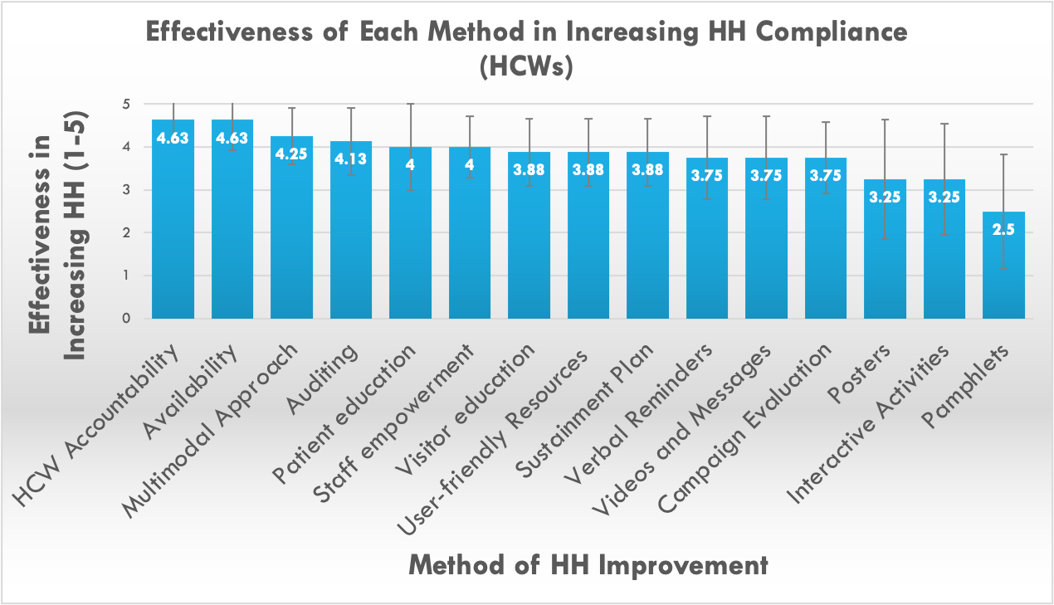

**Figure 3.** Effectiveness of proposed methodologies in increasing HH compliance according to 9 HCWs. On a scale of 1-5 where 5 is most effective and 1 is least effective. Data is represented as a mean +/- standard deviation (error bars, cut off above 5). HH = hand hygiene, HCW = healthcare worker

**HCW Opinion. Figure 3** shows HCW accountability and availability of HH to be most important in increasing HH compliance, followed by a multimodal approach, which is the overarching idea proposed in this program. Thus, within the HH program, HCWs deem it important to focus efforts on HCW accountability and HH availability, with visuals such as pamphlets the least effective in invoking cultural change.

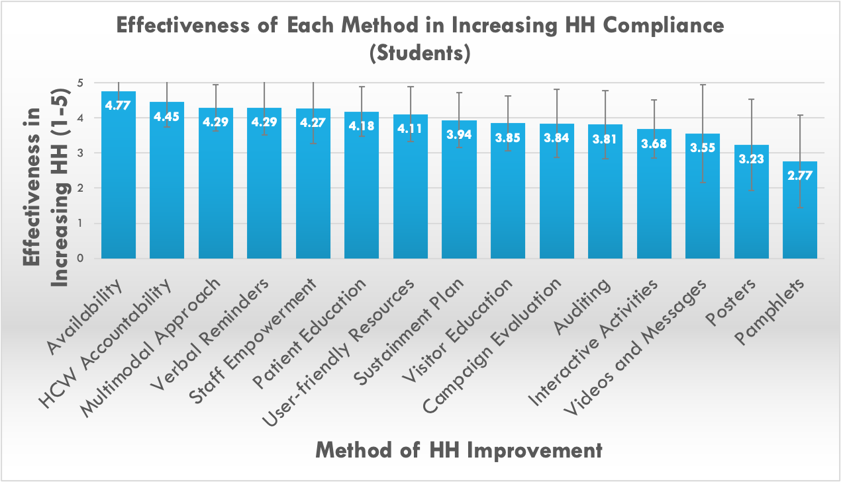

**Figure 4.** Effectiveness of proposed methodologies in increasing HH compliance according to 33 students. On a scale of 1-5 where 5 is most effective and 1 is least effective. Data is represented as a mean +/- standard deviation (error bars, cut off above 5). HH = hand hygiene

**Student Opinion. Figure 4** shows that students find availability of HH to be most important in increasing HH compliance, followed by HCW accountability, then the overarching idea of a multimodal approach. Thus, students deem it important to focus efforts on HH availability, with visuals such as pamphlets the least effective in promoting compliance.

**The Best Methods.** Both patients and HCWs deem HH availability the most important in increasing compliance, however HCWs also deem their accountability equally important, while patients do not. This is a subtle difference, suggesting that HCWs might believe that their position as a role model may have a bigger impact on patients than patients believe to be true. In addition, both patients and HCWs believe that pamphlets are the worst method for improving HH practice. Other visuals such as posters, interactive activities and videos and messages are also non-efficacious. This prevailing opinion leads one to believe that perhaps visual methods are not as successful in promoting behavioural change, as they can choose to be ignored. Two big differences in opinion concern the effectiveness of verbal reminders and auditing. While students advocate for verbal reminders as the third-most important strategy, HCWs believe it is third-least important. Perhaps the HCWs do not feel that their voices are being heard, especially due to the multitude of information that must be provided upon patient admission, or it may be a knowledge gap for HCWs (Michalchuk). For auditing, the positions are reversed, where HCWs find auditing the 4th-most effective strategy and students believe it to be the 5th-least effective. This may be due to a student knowledge gap on the advantages of auditing, and conversely, HCWs may not be aware of the Hawthorne effect, which may bias auditing results (Michalchuk).

**Possible Solutions.**

**Benefits.** The biggest benefit of the HH program is reduction of nosocomial pathogenesis, although this can be broadened once HH becomes a habit in the community, at home, at school, etc. (Michalchuk). Increasing partnership with those beyond HCWs is another benefit, providing feedback on HH from unique perspectives.

**Challenges.** Through survey and interview collection, it is clear that students believe the biggest barriers are noncompliance, apathy and complacency. This can definitely be tackled through education and stressing the importance of HH. Cost is another brought up ubiquitously, as HH budget is normally quite extraneous to that of usual hospital budget, except recently (Michalchuk). This report does not address costs, however increased enforcement through volunteering may be one method to ensure minimal costs. In the long-term, sustainment is thought to be a challenge, with competing priorities and time management with so much to audit being a large issue. This should be tackled as a part of the suggested 30/60/90-day sustainment plan, where feedback can allow for modifications to the program. Finally HCWs bring up their own awareness, as they must empower themselves and the patients, where language/culture clashes may occur, and “COVID fatigue”, where COVID-19 may negatively impact the views of HH and its benefits. This can be tackled through training sessions for staff to attend if lacking in HH knowledge, reiterating the importance of HH especially during COVID, and perhaps seeking posters/pamphlets if a language barrier met.

**Solutions.** It is integral to acknowledge, as explained by Dr. Srigley, that a multimodal approach is the best way to invoke a change in HH practice (Michalchuk). Many different methods must be used in combination in order for habituation of HH practice.   
From the data gathered, it is clear that the current approach is tackling the problem from all sides, however, certain aspects must be emphasized. As explained by Fernando, the top 3 most efficacious methods according to the survey are focused on: 1. accessibility via nurses bringing HH to the patient, 2. education/knowledge gaps of family members and patients engaged continually by nurses, and 3. HCW accountability being addressed by a checklist system (Michalchuk). However, something that may require approval, yet deemed important to consider for the future would be feedback from HCWs, patients, and visitors on what specific aspect of the multimodal program was most effective. This way, a dialogue between HCWs and patients/visitors can be maintained, ensuring that focus is adapted to meet needs, while involving the public in a previously HCW-oriented project. Of course, results can only be definitively determined through auditing, and thus it must be maintained.

**Interesting Ideas.**  Students have suggested many different methods, including frequent reminders and accessible teaching tools, while visibly placing HH products that are easy to use, or have instructions, with frequent refills and posters by the HH stations in different languages, and ensuring patient-HCW reciprocal accountability, reminding patients that they can also suggest that the HCW performs HH in case they forget. HH can be further improved by ensuring high-quality, interactive education be available, clearly laying out and enforcing HH rules once inside the hospital and mapping out key locations for ABHR and sinks. HCWs suggest similar methodologies, including their own accountability through fellow staff reminders, video/picture handouts, ensuring readily available tools even after patient-HCW contact, and HH videos playing in waiting rooms. Dr. Srigley suggested a promotional campaign with a celebrity/sports figure involved and Fernando recommended reminders of how rapidly COVID moved through the population, especially since it brought a lot of public “buy-in” (Michalchuk).

Compare literature and surveys/interviews

Survey: May be better asking people afterwards 🡪 What was most effective for you? 🡪 patients and visitors 🡪 requires approval (something to consider for the future) In addition to auditing, which specific thing changed their behaviour/was most effective 🡪 where can you continue to focus?

If different 🡪 Knowledge gap?

However results can only be definitively determined through auditing

**Lessons from Past Hygiene Initiatives.** In the BCCH, the pilot intervention determined that HCW education is more effective than passive interventions (Srigley, 11). In addition, it was found through the survey and gap analysis in 2018 that patient and family HH practice may be based on preference to soap and water (the gold standard being ABHR), and HCWs are instrumental in increasing HH awareness (Srigley, 11). Multi-media work allowed for animated videos for future initiatives, and the QI project revealed that HH is deemed unimportant compared to other admission and treatment messages (Srigley, 11). The gap analysis determined that accountability for HCWs in teaching HH is not provided, and the multimodal HH pilot in 2018 identified key elements in HH improvement: hygiene product labelling, reducing ABHR refill delays, clear poster content and patient-centred brochures, with trialling of support of the multimodal campaign at HCW huddles (Srigley, 11).

**Conclusion**

**Summary of Findings**

The pandemic situation threatens the healthcare system, and increased HH compliance plays a more important role than ever in reducing pathogenesis. Thus, it is integral that even despite the pandemic-related recent increase in HH, current levels are maintained, with the eventual goal of invoking a cultural change in the BCCH workplace (Moore et al., 1).

* In relation to HH in all populations: Ensure to remind or train HCWs that all populations need to equally follow HH guidelines
* In relation to COVID-19 impact on HH: Provide reminders surrounding COVID-19 and making HCWs and patients/visitors aware of the impact it has had on HH
* The most important elements of the proposed campaign: Increasing HH availability, checklists for HCW accountability, and a sustained multimodal approach including auditing
* HCW accountability methodologies for improvement: Approachability of HCWs in need of HH and reciprocated HH reminders among patients, families and HCWs
* How hand hygiene improvement can be maintained in the future: Surveying of HCWs, patients and families for feedback on the most efficacious strategies employed, adjusting the program accordingly

**Limitations.** This study has several limitations: the small sample size limits extrapolation, the surveying of students may not represent patients and their families accurately, and the surveying itself, which is prospective, when retrospective would be more useful in program optimization

**Recommendations**

* Consider surveying patients, HCWs and visitors after implementation of the hand hygiene program to determine efficacy of different components of the multimodal campaign
* Ensuring that HCWs are reassuring patients to feel free to communicate their HH needs
* Ultimately, the compliance results will come from progress reports and auditing. Please rely on these to definitively determine program effectiveness

**Works Cited**

Barker, Anna, et al. “Patients' Hand Hygiene at Home Predicts Their Hand Hygiene Practices in the Hospital.” *Infection Control and Hospital Epidemiology*, U.S. National Library of Medicine, May 2014, www.ncbi.nlm.nih.gov/pmc/articles/PMC4148899/.

Erasmus, Vicki, et al. “Systematic Review of Studies on Compliance with Hand Hygiene Guidelines in Hospital Care: Infection Control & Hospital Epidemiology.” *Cambridge Core*, Cambridge University Press, 2 Jan. 2015, www.cambridge.org/core/journals/infection-control-and-hospital-epidemiology/article/systematic-review-of-studies-on-compliance-with-hand-hygiene-guidelines-in-hospital-care/36AD78694A4A2BA831A598E9C935C92E.

Mathur, Purva. “Hand Hygiene: Back to the Basics of Infection Control.” *The Indian Journal of Medical Research*, Medknow Publications & Media Pvt Ltd, Nov. 2011, www.ncbi.nlm.nih.gov/pmc/articles/PMC3249958/.

Lotfinejad, N, et al. “Hand Hygiene and the Novel Coronavirus Pandemic: the Role of Healthcare Workers.” *The Journal of Hospital Infection*, The Healthcare Infection Society. Published by Elsevier Ltd., Aug. 2020, www.ncbi.nlm.nih.gov/pmc/articles/PMC7270549/.

Michalchuk, Quentin. “HH Interview with Dr. Srigley and Fernando.” 26 Nov. 2020.

Moore, Lori D, et al. “The Impact of COVID-19 Pandemic on Hand Hygiene Performance in Hospitals.” *American Journal of Infection Control*, Association for Professionals in Infection Control and Epidemiology, Inc. Published by Elsevier Inc., 18 Aug. 2020, www.ncbi.nlm.nih.gov/pmc/articles/PMC7434409/.

Musu, M, et al. “Assessing Hand Hygiene Compliance among Healthcare Workers in Six Intensive Care Units.” *Journal of Preventive Medicine and Hygiene*, Pacini Editore SRL, Sept. 2017, www.ncbi.nlm.nih.gov/pmc/articles/PMC5668933/.

Srigley, J.A., et al. “Applying Psychological Frameworks of Behaviour Change to Improve Healthcare Worker Hand Hygiene: a Systematic Review.” *Journal of Hospital Infection*, W.B. Saunders, 4 Aug. 2015, www.sciencedirect.com/science/article/pii/S0195670115002959.

Srigley, Jocelyn A. “Presentation to CW Leadership on HH_Jul15 AS.” N/A, 15 July 2020.