To: Kennedy Stewart, Mayor of the City of Vancouver and Kevin Desmond, CEO of TransLink
Increasing the use of Environmentally Friendly Transportations in Vancouver
By Barton Lui, UBC ENGL 301 Student
Barton Lui, 2702076
11-30-2020

Contents
Abstract 2
Introduction 2
Data Section 3
Key chemicals and its effect 3
Current air quality and trend 4
Factors to consider when choosing a transportation method 5
Interpretation 7
How to change the 7
If we can not completely replace the usage of personal automobiles, what can we do? 7
Recommendation 7
Conclusion 8
Summary of Findings 8
Interpretation of Findings 8
Recommendations 8
Works Cited 8

Abstract

The first objective of the report is to discuss the effects of air pollutants such as Nitrogen Oxide (NO) and Carbon Monoxide (CO) to humans and the second objective of the report aims to find solutions that can influence commuter’s behaviour into switching into more sustainable transportation methods.

As population continues to increase and the rate of urbanization grows, it is highly plausible that there will be a greater demand for transportation. The City of Vancouver and TransLink have to find different ways to adapt to the challenges that the city will face.

Personal vehicles still remain the most preferred method of transportation as per the Mode Share 2017 report and the greenhouse gases produced from vehicles is the main contributor to air pollution (Health Impacts of Air Pollution in Canada). To achieve the goal of reducing Vancouver’s emission of harmful pollutants into the atmosphere. The report will investigate how we can achieve that by asking questions listed below.

- What is the current air quality in Vancouver, BC.
- Discover what is the current main contributor of air pollution in Vancouver
- What are the choices for Vancouverites to choose from when it comes to transportation
- Why are some people reluctant to change their transporting behaviour
- How can the provincial government and TransLink encourage people to choose a lifestyle that produces less air pollution.
- Choose the options that are financially feasible, legally permissible, and physically possible in Vancouver.

Introduction

Cars and trucks are one of the major sources of air pollutants and greenhouse gases (Air Pollutant Emissions). Sometimes the impact of poor air quality is minuscule and unknown but in other cases, the consequence of poor air quality contributes to an incident of death (Causes of Poor Indoor Air Quality). According to Canadian Environmental Sustainability Indicators, transportation is the main source of nitrogen oxide and carbon dioxide. These two pollutants are one of the six pollutants that the environmental department keeps track of and they pose adverse effects on human health and the environment. Globally, around 7 million premature deaths annually are linked to air pollution (7 Million Premature Deaths). In Canada, the annual morbidity outcomes, the number of asthma symptom days reaches 2.7 million, while the count of acute respiratory symptom days amounts to 35 million. The total economic cost of the all health impacts attributable to air pollution is $114B per year (2015 currency) (Health impacts of air pollution in Canada). Officials in Vancouver should address the problem and this report will aim to investigate the possible solutions to the vehicle air pollution crisis that Vancouver officials can consider adopting.
The purpose of this report is to propose ways to encourage citizens in Vancouver to consider using a more environmentally sustainable method of transportation to reduce air pollution. In addition to that, the report will attempt to discover how people in Vancouver commute on a daily basis and how most people decide the kind of transportation. Is there a particular reason that prevents Vancouverites from choosing a more sustainable way of transport? In order to change commuters behaviour, the City of Vancouver and TransLink have to contribute together to invest in the infrastructure, technology and legislation that encourages environmental friendly behaviours that will keep the air pollution level low in Canada. To obtain information in regard to how people are transporting, a survey will be sent to the online community, friends and family. Questions about their current primary method of transportation and reasons they would not choose the more sustainable way of transportation. For example, switching from driving a gasoline engine car to an electric vehicle (EV). Secondary data such as pollution reports, demographics and other statistics will be collected from government databases.
There are a few limitations to the collection of the primary data as the sample size of the survey will not be sufficient for us to make a definite conclusion that will represent the whole city but may provide us great insights into Vancouverites opinion and habits. This information may guide the process of change that will make Vancouver a greener place to live. However, in order to see a significant positive change to the air quality and have long lasting effects to the environment, requires a large amount of resources such as capital, human and land resources from both the public and the private sector. Due to the vast geography of Canada, most Canadian cities and neighbourhoods were built to support the usage of vehicles. In 2017, 55.3%, 4.4million, of Metro Vancouver trips were private vehicles and only 923,000 trips were by transit (Mode Share). This shows that the majority of people still consider driving as their primary choice when planning for a trip. With more effort from the private and the public sector, the City of Vancouver can decrease the air pollution emission from vehicles by asking questions that may lead us to more solutions.
- What is preventing people from using eco-friendly transportation methods?
- What is the reason people do not use environmentally friendly transportation methods?
- How can we encourage people to change their behaviours to adopt greener transportation methods?
- What can be done to lower the reliance of personal vehicles?

Data Section

Key chemicals and its effect
Transportation is the main source of NOx (Nitrogen oxides) (Air pollutant emissions). Nitrogen oxides include emissions of nitric oxide and nitrogen dioxide (NO2). NOx is formed primarily from the release of nitrogen contained in fuel and nitrogen contained in combustion air during combustion processes. The NO released during combustion will oxidizes to NO2 and both NO2 and the untransformed state (NO) can have adverse effects on the environment and our health. The major issue with NO is that it damages the respiratory systems when inhaled. This chemical can also be dissolved by water vapour transforming rain into acid rain and causing damage to humans and animals. The adverse effect will magnify if NO infiltrates into the aquatic and terrestrial ecosystems and further causes damage to our society (Common air pollutants: nitrogen oxides).

Another kind of chemical that is worth mentioning is Carbon Monoxide. This chemical is colourless, odourless, tasteless and poisonous gas and is emitted directly from automobiles tailpipes (Common Air Pollutants: Carbon Monoxide). CO can affect everyone but especially persons with heart disease because when it enters the bloodstream through the lungs, it will form a compound that inhibits the blood’s ability to transport oxygen to organs.

Level of nitrogen oxide emissions have decreased since 1990, but we can still improve and do better.

Current air quality and trend
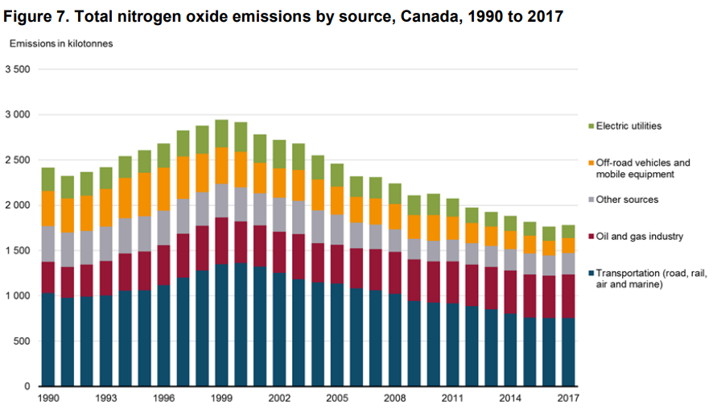
Figure: Total Nitrogen Oxide emissions by source in Canada, 1990-2017

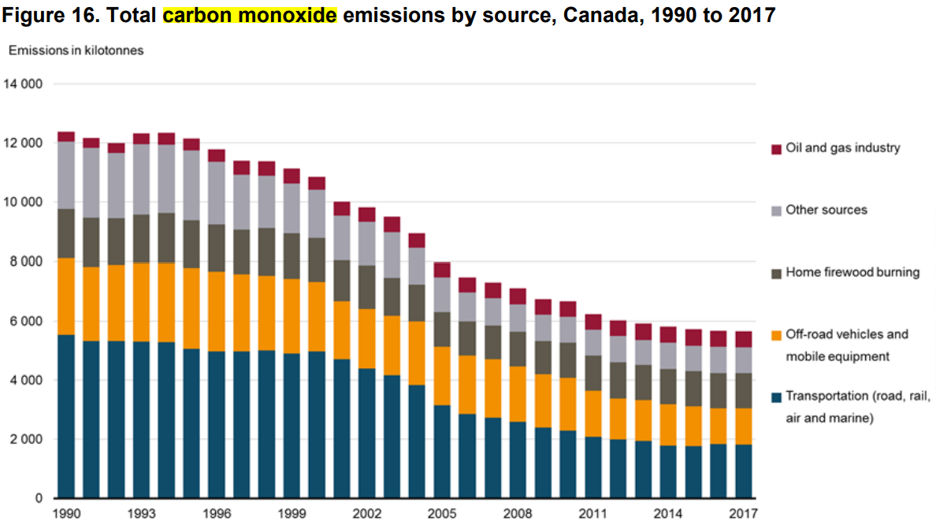
Total Carbon Monoxide emissions by source in Canada, 1990-2017

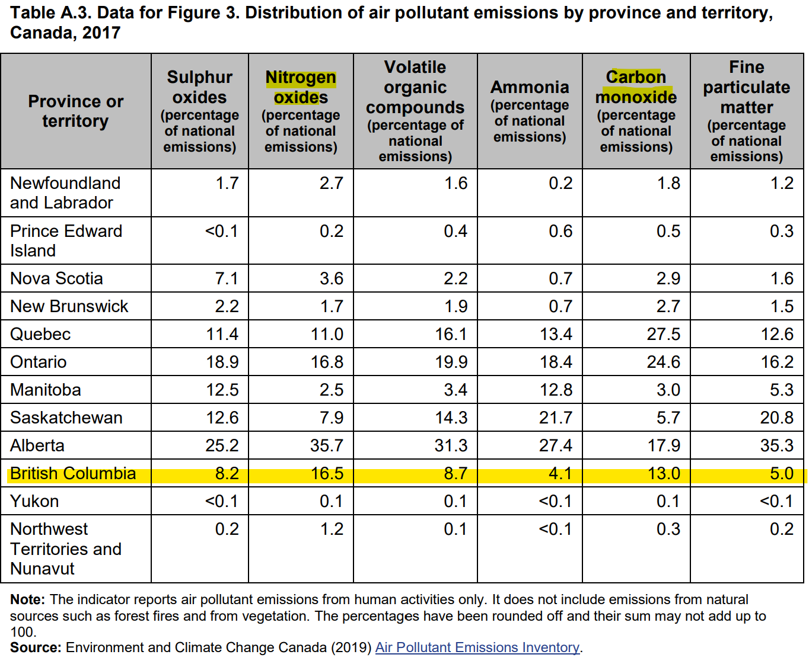

Factors to consider when choosing a transportation method

According to the results I have gathered from the survey, there are few major factors that will influence the types of transportation methods they may choose.

- Accessibility
  - This refers to the ease of getting to and from a bus stop/ skytrain station. Accessibility affects people’s willingness to take public transport and a person will be more likely to drive a car if the distance between home and the public transit.

- Cost
  - This refers to the cost of taking public transportation versus the cost of owning a personal car. If the marginal benefit of driving a car exceeds the marginal benefit of taking the public transit, then a person will decide to drive instead of taking transportation.
  - Other costs include the cost of maintenance, fuel and insurance required to own a car.
  - Few survey responses reflected that the cost of parking at UBC has made them choose to take public transit instead of driving to school.
- Speed and time
  - The time required to get to their destination is one of the biggest factors that influences how commuters pick their transportation method.

- Integration
- For longer trips that require change of mode, this factor is significant for completion of the trip.

- Reliability
- All factors will be deemed useless if that particular transportation method ceased to provide service. In general, personal vehicles have the highest reliability and public transits have lower reliability due to the nature of uncertainty.

- Comfort
- This factor refers to the comfortableness of using that particular transportation method.

- Safety.
- This free from accidents, illegal activities and now Covid-19 virus.
- 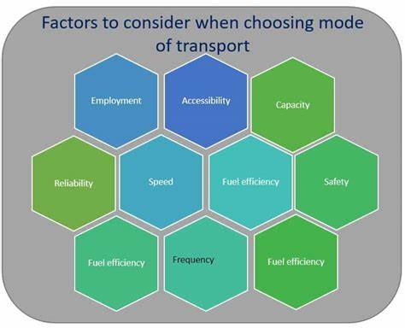

Interpretation of the consideration
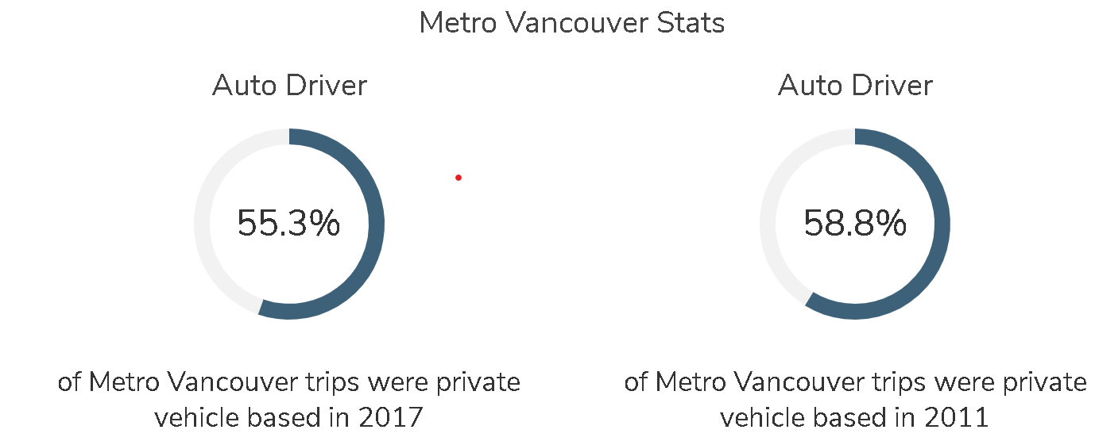

Recommendation
Increase biking storage areas to encourage people to bike to major rapid transit stations. If the storage area is not sufficient, cyclists are less likely to bike to school and work because there is not enough space to keep their bike safe. Consider building an underground bike storage. In Japan where 78% of households own a bike, there is a major problem with bike storage space but after building an underground bike storage system, the problem with massive congestion near major stations has been solved (Springer and Han).

Expand the service area for the bike sharing program to include other areas of Metro Vancouver. Currently the bike sharing stations are concentrated only in Downtown Vancouver and Broadway street between Arbutus street and Commercial Drive. There are buses available in that area already so the demand for the bikes will not be very high. Consider installing near SkyTrain stations where people can consider biking to a SkyTrain station and then switch to taking the SkyTrain. This will improve the integration of the transit system and improve public transit ridership.

Consider upgrading the service provided by the bus route 49 Metrotown/ UBC to accommodate peak hours ridership. Prior to the pandemic, it is not uncommon to be denied boarding three times because buses are too full during the morning rush hours. 49 Metrotown/UBC being the second busiest bus route in Metro Vancouver with 10.06 million annual boardings and 31,350 average weekday boardings. should have a B-Line route to increase efficiency.
Increase the marketing effort for advertising the electric vehicle purchasing rebate program.

Conclusion

Summary of Findings
- Factors that people shy away from using public transit is time and accessibility.
- People are hesitant to buy an EV because of the higher initial cost of purchasing.
- The speed of public transit needs to be increased in order to make using public transit more desirable to commuters.
- More charging stations can relief

Interpretation of Findings
- A considerable lifestyle change is required to switch to using an EV.
  - While more newer housing complexes have EV charging stations, most older residential areas do not have a shared charging station.

Recommendations
- Increase biking storage areas to encourage people bike to major rapid transit stations
- Consider implementing Rapid Bus lane
- Increase the advertising effort for the electric vehicle purchasing rebate program to speed up EV adoption rate to achieve lower carbon emission.

Works Cited
“Air Pollutant Emissions.” Canadian Environmental Sustainability Indicators, Government of Canada, 22 June 2017, www.canada.ca/en/environment-climate-change/services/air-pollution/quality-environment-economy/about.html.
“Mode Share.” Metro Vancouver, 2017, www.metrovancouver.org/metro2040/sustainable-transportation/vehicle-use/mode-share/Pages/default.aspx.
“7 Million Premature Deaths Annually Linked to Air Pollution,” World Health Organization, 25 Mar. 2014, www.who.int/mediacentre/news/releases/2014/air-pollution/en/.
Springer, Kate, and Sol Han. “Japan's Crazy Underground Bike Vaults.” CNN, Cable News Network, 19 Oct. 2016, www.cnn.com/style/article/japan-underground-bike-vaults/index.html.
Health Impacts of Air Pollution in Canada: Estimates of Morbidity and Premature Mortality Outcomes, 2019 Report. Health Canada, 2019, publications.gc.ca/collections/collection_2019/sc-hc/H144-51-2019-eng.pdf.
“Causes of Poor Indoor Air Quality.” Canada.ca, Government of Canada, 2 Oct. 2020, www.canada.ca/en/health-canada/services/air-quality/causes-poor-indoor-air-quality.html.
“Common Air Pollutants: Nitrogen Oxides.” Environment and Climate Change, Government of Canada, 24 Apr. 2013, www.canada.ca/en/environment-climate-change/services/air-pollution/pollutants/common-contaminants/nitrogen-oxides.html.
Common Air Pollutants: Carbon Monoxide, Government of Canada, 16 Nov. 2016, www.canada.ca/en/environment-climate-change/services/air-pollution/pollutants/common-contaminants/carbon-monoxide.html.

