Causal Analysis for Improving the Overall Wellbeing of Remote Students at the Kappa Sigma Fraternity

For:
Logan Deboo
President
Kappa Sigma Fraternity- Epsilon-Epsilon
Vancouver, BC

By:

Evan Ruiz
Technical Writing Student
The University of British Columbia

Table of Content

Abstract

Introduction………………………………..………………………………....……………… 2

Data Section …...…………..………………………………..……………………………….. 3
Decreased feelings of organization and structure..…………………………… 3
Increased feelings of Isolation ..……………………………………..…………… 4
Lack of physical activity ..……………………………..…………………………... 5
Decreased feelings of productivity ..………………………………...……………5
Challenges Associated with Remote Education……………………...…………...……5
Prolonged exposure to a screen……………………...…………...……………….6
Decreased Social Engagement……………………...…………...………………...6
Decrease in Physical Activity……………………...…………...…………………..6

Proposed Solution……………………...…………...………………………………………. 7
Organization……………………...…………...…………………………………….... 7
Study Groups ……………………...…………...……………………………………..8
Intermittent Physical Activity……………………...…………...…………………...8

Conclusion……………………...…………...………………………………………………....8

Works Cited……………………...…………...………………………………………………...9
Appendix A: Survey…...…………...…………………………...…………………….9

Introductory Letter (TO BE COMPLETED)
Abstract (TO be Completed)

Introduction
In the midst of the COVID-19 pandemic students, around the world, have made the transition to engage with remote, and or distance education classes. Students who are fortunate enough to continue their studies, like those in the Kappa Sigma Fraternity, are facing a whole new set of challenges. The major implications of this problem are as follows: members of Kappa Sigma are spending a majority of their time indoors; members are spending an increasingly large amount of time in a seated and or stagnant position; lastly, members are lacking any significant amount of structure within their days. With that being said, it is necessary to determine the most effective way to help members maintain physical and mental wellbeing, while operating in a remote capacity.
I propose a three-pronged solution to help students at Kappa Sigma increase their overall well being while operating in a remote capacity. Firstly, I suggest that all members create an organized, shared, schedule that lists their class times, assignment due dates, etc. Secondly, I suggest that “study groups” be made to improve peer- support and feelings of isolation. Lastly, I suggest that morning/ evening exercise groups be created; encouraging members to leave their house, bond with other members, and stay physically healthy.

Executives of the Kappa Sigma Fraternity who aspire to improve members overall wellbeing, in the midst of remote learning, need insight into the following questions:
- How are the members of Kappa Sigma affected by remote education?
- What is the degree to which intermittent physical activity is beneficial?
- How does extended exposure to a screen affect mental wellbeing?
In an attempt to answer these questions, this report will analyze information gathered from members of the Kappa Sigma fraternity, as well as secondary literature. More specifically, the analysis will address members current feelings of productivity, motivation, and physical health

Data
Member Data
Executive members of the Kappa Sigma Fraternity must understand the commonalities associated with remote education, and the feelings of their own members, prior to implementing a solution that would benefit the organization, as a whole.

Decreased feelings of organization and structure. Members are, largely, feeling a lack of organization and structure in their day-to-day. More specifically, on a likert scale, 56% of members “disagreed” with the fact that they have felt organized lately; compared to 15% of members who “agreed” with the fact that they have felt organized lately. Moreover, 37% of members “disagreed” with the fact that their days have felt structured; compared to 15% of members who “agreed” that their days have felt structured (member survey, November 26, 2020).
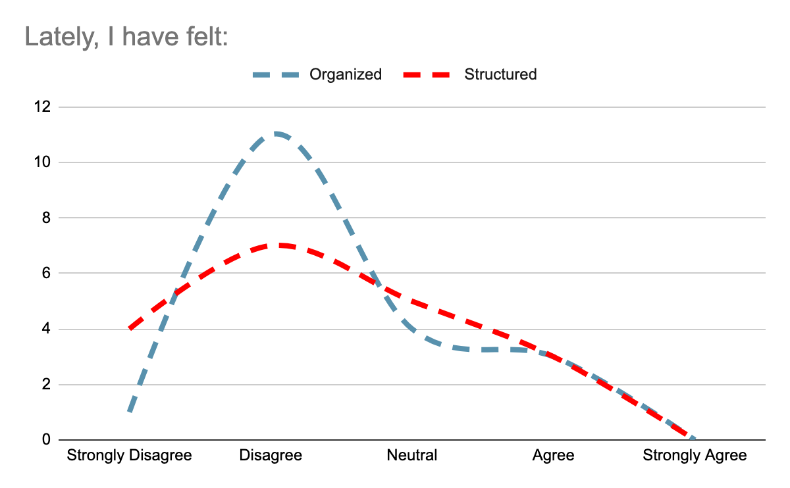

Increased feelings of Isolation. Members are experiencing a lack of connectedness with others and, as a result, are feeling increased levels of social isolation. On a Likert Scale, 52% of members “disagreed” with the fact that they are feeling connected to others. In comparison, only 5% of members “agree” that they are feeling connected to others (member survey, November 26, 2020).
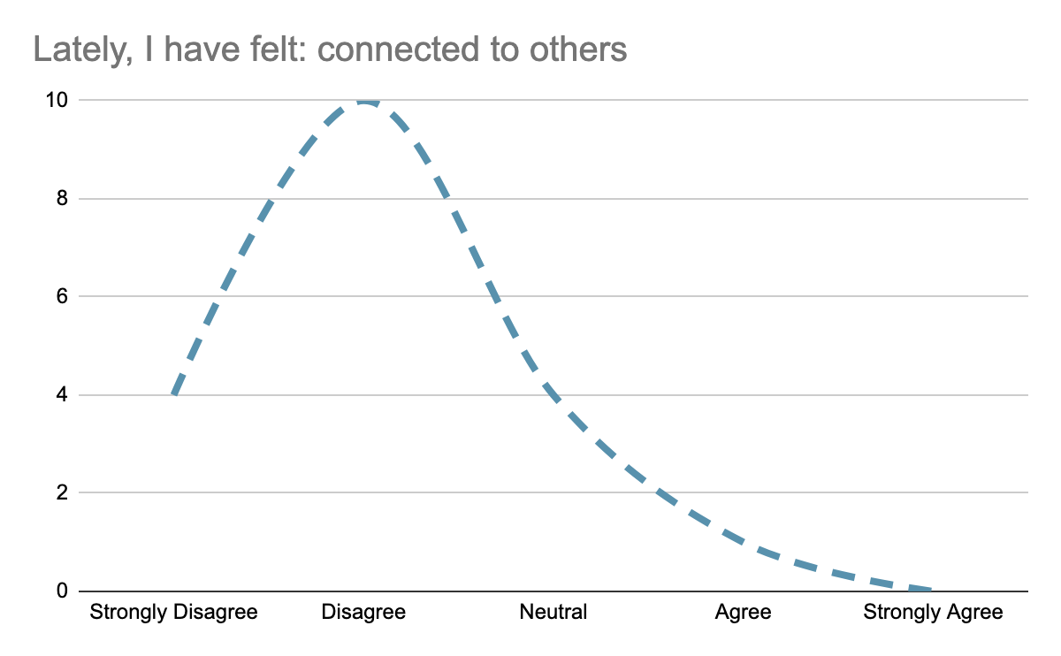

Lack of physical activity. Members are spending large amounts of time indoors and, consequently, are experiencing a lack of physical activity. More specifically, 21% of members “strongly disagreed” with the fact that they have been physically active lately; compared to 16% of members who “strongly agreed” that they have been physically active lately.

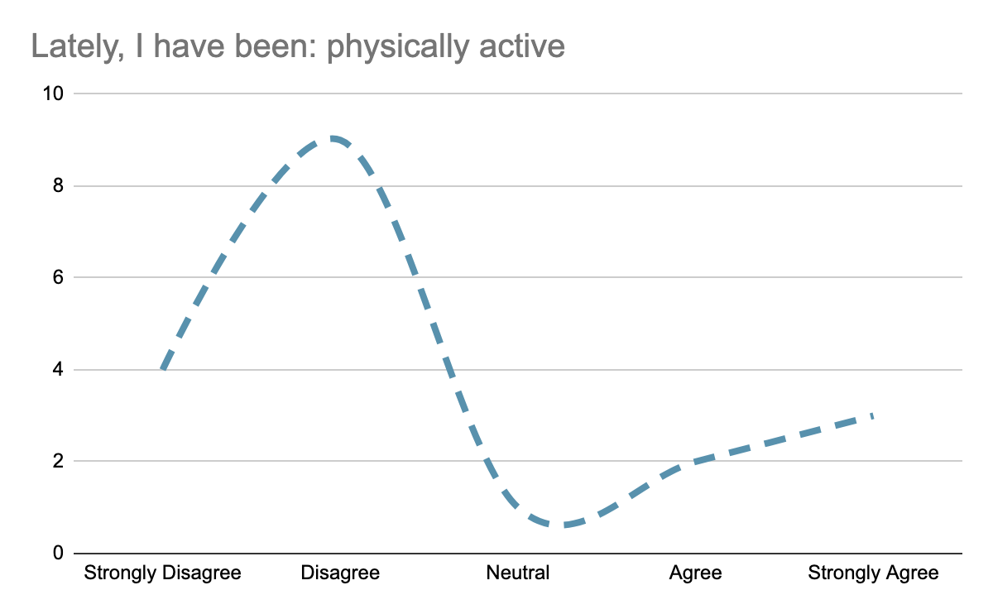

Challenges Associated with Remote Education.
Remote education, and or distance education, offers a platform for students to engage with lecture material through a technological device. This system, while beneficial for some students, offers challenges for others. These challenges include, but are not limited to, an increase in screen exposure, a decrease in attention, and a decrease in social engagement.

Prolonged exposure to a screen. Attention is often considered to be the active process by which one processes and, selectively, concentrates on information in their environment (Cherry). I, however, prefer the term ‘bandwidth’ to better understand the role of attention; one’s capacity to engage with a variety of situations. Several cross-sectional and longitudinal studies suggest that prolonged screen exposure is associated with a decreased level of attention and or bandwidth and, consequently, decreased levels of productivity. Moreover, learning processes, when operating in an online capacity, have shown to be inefficient when compared to learning via social interaction (Zivan). This can be seen by means of a positive feedback loop when working to complete an assignment. As one’s ‘bandwidth’ decreases, and distractions become more frequent, the overall time that one spends on a screen becomes longer. In turn, this results in a decrease in ‘bandwidth’ and or motivation that one has to complete a certain task. Ultimately, this is experienced by the members of the Kappa Sigma Fraternity through feelings of decreased productivity.

Decreased Social Engagement. School, for many students, is a platform whereby one can gain the knowledge necessary to live autonomously, think creatively, and develop specific skills. Arguably, however, one of the most important factors of a school is for students to develop the social skills required to become successful and functioning members of society. As humans, we are social beings, and feel compelled to build and maintain connections with others. When, for whatever reason, we are unable to connect with others we may experience feelings of loneliness or isolation. For the members of the Kappa Sigma Fraternity, these feelings are being experienced through a lack of connectedness to others. Unfortunately, as research suggests, these feelings can negatively impact our physical and emotional wellbeing.

Decrease in Physical Activity. Research suggests that physical activity has a strong, positive correlation to mental wellbeing as physical activity increases so does mental wellbeing (Harris). Remote and in-person classes are often experienced in a seated or stagnant position. For members of the Kappa Sigma Fraternity, in-person classes might offer daily structure, an opportunity to get outside, and brief, intermittent, exercise. Simplistic rituals that involve waking up at a specified time, getting dressed for the day, and spending time outside will all contribute to improving overall mental and physical wellbeing.

Possible Solutions.
Taking into account the members data, and relevant secondary research, I encourage the executive committee to emphasize the importance of organization/ structure, intermittent physical activity, and peer support when considering overall wellbeing.

Organization. Firstly, I suggest that members work to create an organized, shared, calendar that includes their class times, assignments, and exam schedule. Secondly, I encourage members to wake up at the same time every day during the week; allowing them to, at minimum, experience a high level of structure in the first part of their day. Members can take this one step further by making an effort to “get ready” for a day of online classes.

Peer study groups. With the addition of a shared calendar, members will have the opportunity to engage with others who are taking the same classes as themselves. In this regard, members can align breaks to correspond with those of their housemates; form study groups, for members who are taking the same classes; and build an academic network of support while operating in a remote capacity.

Intermittent physical activity. A morning and an evening walk group can be formed, encouraging members to “get out”, stretch their legs, and get some fresh air. Outside of offering members encouragement to stay physically active, these “groups” can offer an increased level of bonding between housemates.

Conclusion:
The COVID-19 pandemic has, undoubtedly, had an effect on the future of remote education for the foreseeable future. For the time being, however, the restrictions and conditions by which students are able to operate is extremely limited. The members of the Kappa Sigma fraternity are faced with unprecedented challenges and in order for the organization to function, the members have to maintain their overall wellbeing. This can be accomplished by offering a platform whereby they can maintain, limited, social connection with other members, create structure within their day-to-day, and maintain a base level of intermittent physical activity.
Works Cited (To be Completed)
Cherry, Kendra. "Understanding The Key Points About Attention In Psychology". Verywell Mind, 2020, https://www.verywellmind.com/what-is-attention-2795009.

Harris, Marc. "The Relationship Between Physical Inactivity And Mental Wellbeing: Findings From A Gamification-Based Community-Wide Physical Activity Intervention - Marc Ashley Harris, 2018". SAGE Journals, 2020, https://journals.sagepub.com/doi/full/10.1177/2055102917753853. Accessed 30 Nov 2020.

Zivan, Michal et al. "Screen-Exposure And Altered Brain Activation Related To Attention In Preschool Children: An EEG Study". Trends In Neuroscience And Education, vol 17, 2019, p. 100117. Elsevier BV, doi:10.1016/j.tine.2019.100117.

Appendix A: Survey Questions

I am an undergraduate student at the University of British Columbia (UBC), conducting research for a technical writing project. The goal of this survey is to obtain primary data for an investigation that aims to provide recommendations to help the overall health and wellbeing for members at the UBC’s Kappa Sigma Fraternity. The final report will be presented to the executive board at Kappa Sigma, who will pass along information to the rest of the members. The data collected from this survey, along with secondary research on intermittent physical activity and organization, will allow your executive team to provide concrete recommendations which you may choose, or not choose, to follow. The survey contains 8 questions, 7 of which are on a sliding scale. It should take less than 5 minutes to complete, and your responses are voluntary and anonymous. Thank you for your participation in my survey.

All questions operated on a Likert Scale from 1 (Strongly Disagree) to 5 (Strongly Agree):
- Lately, I have been: organized
- Lately, my days have felt: structured
- Lately, I have felt: productive
- Lately, I have felt: motivated
- Lately, I have felt: connected to others
- Lately, I have been: physically active
- Lately, I have felt: upbeat & energetic
- I would be willing to implement an organizational, physical, and academic routine in an attempt to improve my mental, physical, and social wellbeing.

