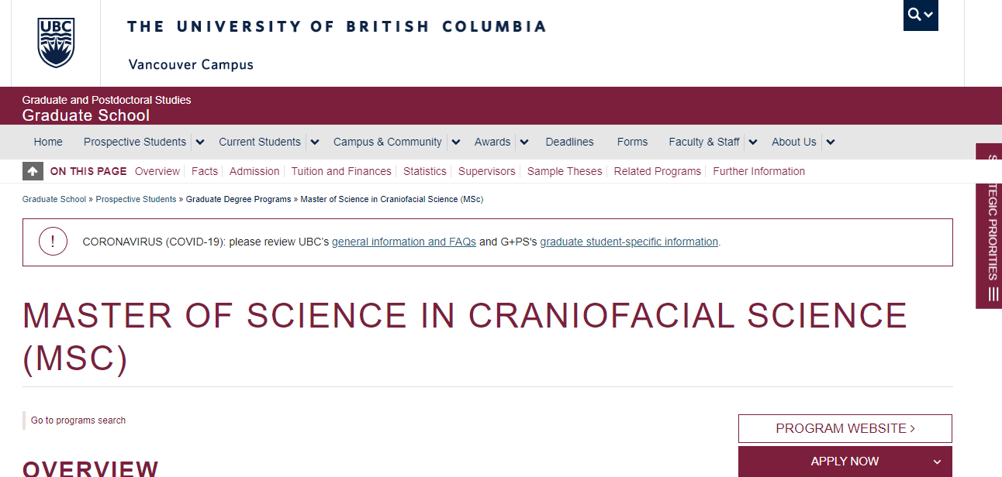
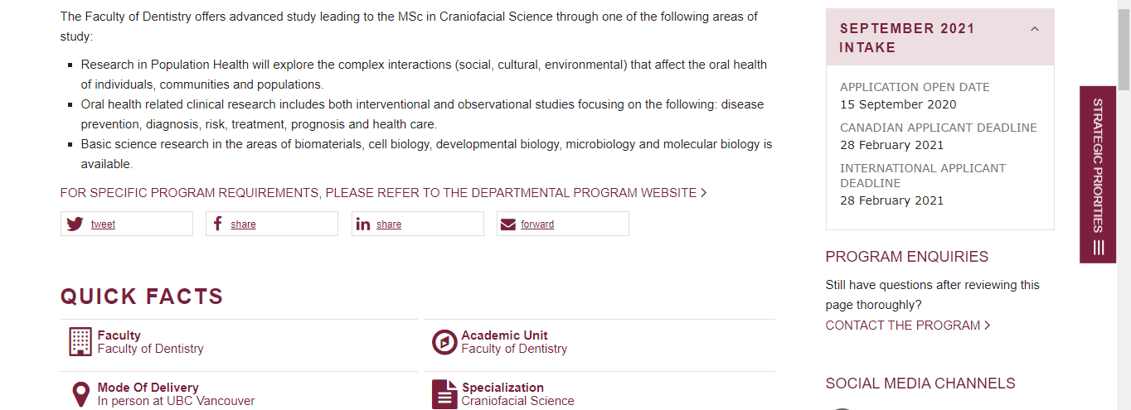
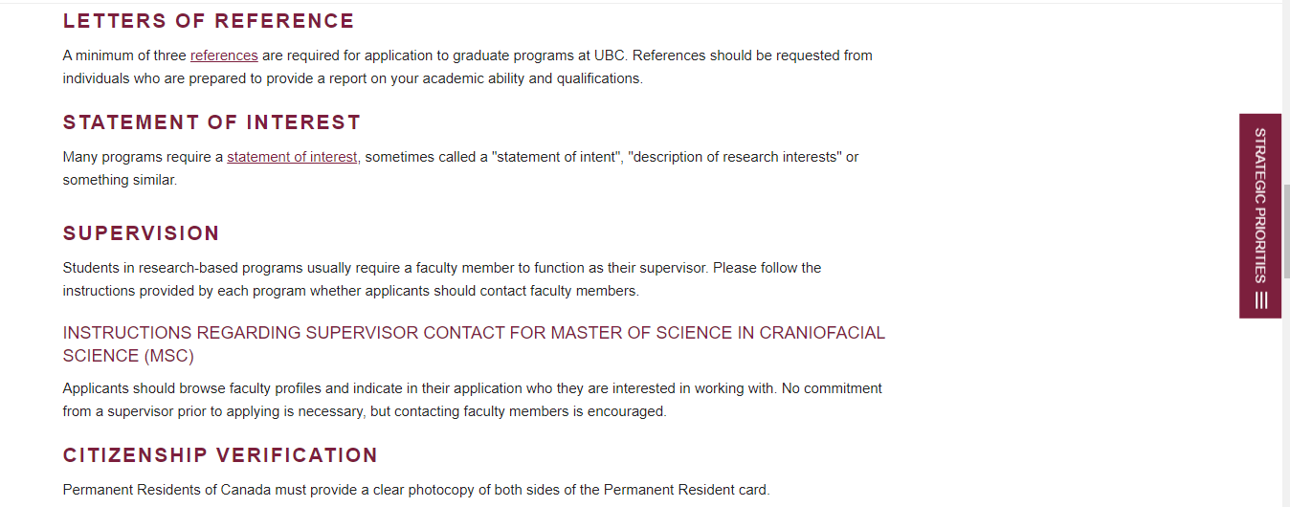

University of British Columbia. “Master of Science in Craniofacial Science.” Graduate and Postdoctoral Studies Graduate School. https://www.grad.ubc.ca/prospective-students/graduate-degree-programs/master-of-science-craniofacial-science. Accessed 11 Dec. 2020.

