How can UBC CVC increase its membership base

For:
Daniel Chen
President of UBC CVC

By:
Nicholas Jang 19431568
UBC CVC Cultural Director
ENGL 301 99A Student

December 1, 2020

6133 University Blvd
Vancouver, BC V6T 1Z1
December 1, 2020
Daniel Chen
President of UBC CVC
Vancouver, BC V6T 1Z1

Dear Mr. Daniel Chen,

Here is my report, how can UBC CVC increase its membership base. In preparing this report, I have learned a great deal about the current situation membership situation the club is facing and the characteristics of the target market. I believe my information will be beneficial when you are planning the strategic plan for the 2021/2022 school year. Thank you for your guidance and support throughout this process.

Despite being the largest social club at UBC and having over 90 years of history, CVC is facing a significant drop in membership sales. An effective strategy to combat this trend is to introduce a comprehensive marketing plan with distinct objectives and goals. This report contains additional information pertaining to the specifics of the proposed marketing plan.

I’ve enjoyed my work on this project and would be happy to answer any questions you may have. Please feel free to email at nicholasjang@outlook.com at anytime.

Sincerely,

Nicholas Jang
Contents
Abstract 4
Introduction 5
Statement of Problem 5
Methodology 7
Participants 7
Materials 7
Procedure 7
Results 8
Demographic Characteristics 8
Current Club Involvement 8
Target Market Wants and Needs 9
Discussion 11
Product 11
Place 12
Promotion 13
Price 13
Conclusion 14
Summary and Recommendations 14
Bibliography 15
Appendix A: Survey Questions 16

Abstract – In progress

Introduction
UBC CVC (CVC) is UBC’s largest social club with 500 general members and 83 executives. Founded in 1930, CVC was created to provide a social space for Chinese students on the UBC campus. This need was created by rules banning Chinese students from participating in intramural sports, thus the Chinese Varsity Club (CVC) was born. While originally centred on administering intramural leagues, the club has evolved to host a variety of social events on and off-campus (UBC CVC). The club was rebranded in 2009 from Chinese Varsity Club to UBC CVC to encourage all students to join the club regardless of their ethnicity.

CVC’s current marketing initiatives are centred around campaigns that promote three key concepts. According to CVC’s website benefits of joining the club include membership perks, networking opportunities, and an open space to socialize at (UBC CVC). These three benefits are supplemented by other specific incentives not limited to social events, parties, intramural teams, and winter/spring break trips.

Statement of Problem
The COVID-19 pandemic has greatly influenced the ways we interact and socialize. One focal aspect of the pandemic is the shift from in-person events to virtual social events. This effect has significant implications for CVC, most notably impacting their membership numbers for the 2020/2021 school year. The lack of membership numbers can be attributed to a magnitude of factors not limited to lack of
on-campus presence, inability to host flagship events, and reduced sponsorship discounts.
These factors stem from the pandemic and the social restrictions associated with them.
Despite current restrictions, vaccine research is promising with many companies estimating first deliveries in early 2021 (Jordans, Cheng and Petrequin). Assuming the 2021/2022 school year is conducted in person, CVC still faces a challenge regarding its membership numbers. CVC must take prompt action in the 2021/2022 school year to revert the decline in membership levels.

A potential solution to the problem of mitigating membership decline is to introduce a comprehensive marketing plan for the 2021/2022 school year. While the club’s offerings for a school year is loosely set at the start of the school year, a thorough marketing plan can help the club establish a specific strategy for the club. The implementation of this strategy can allow CVC to meet its objectives regarding membership levels.

Prior to establishing a marketing plan, the following questions must be answered:
- What are the characteristics of CVC’s target market?
- How can CVC differentiate itself from similar social clubs?

To answer these questions, the report will analyze data gathered from a UBC Student Engagement Survey. This survey is centred around the attitudes and characteristics of individuals within CVC’s target market. A detailed investigation of the target market’s needs, wants, demographic characteristics, and psychographic characteristics will be undertaken.

Methodology

Participants
The data analyzed in this paper is from a UBC Student Engagement Survey administered by Nicholas Jang in November 2020. The survey’s screening criteria restricted non-UBC students from taking the survey and was conducted on CVC’s target market. The survey had 37 participants with no participants being excluded from the survey. Participants were recruited from various student groups on social media. The participants were not compensated for participating in the survey.

Materials
The primary materials used in the survey are technology and internet access. Participants and organizers must have access to a computer or other personal electronic devices with reliable internet access to complete the survey.

Procedure
After participants were screened and selected, they were messaged a link to the survey. The survey was comprised of eight questions. The questions in the survey were either of qualitative or quantitative questions. All instructions regarding how to complete the survey and for individual questions were embedded within the survey. Counter balancing was not utilized in the survey, every participant’s survey was presented in the same format.

Results

Demographic Characteristics
Data obtained from the survey indicated that the year of study is relatively normally distributed. A mean value of 3.35 years for year of study indicated the dataset is right-skewed. The largest year class was third year students which accounted for 29.7% of survey responses.

Current Club Involvement
Club involvement has a positive relationship with the amount of time spent on campus. Figure 1 shows that if school was in person 78.3% of participants would be on campus 4 or more times per week.
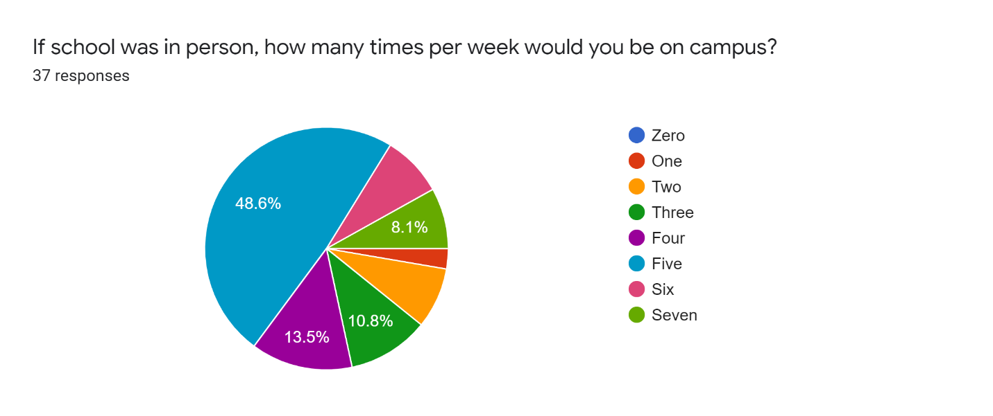
Figure 1: On-campus Presence

With the current school year being completely virtual for most faculties, most students are not on campus. The relationship between club involvement and on-campus presence is further supported by figure 2 which shows the respondents current club involvements.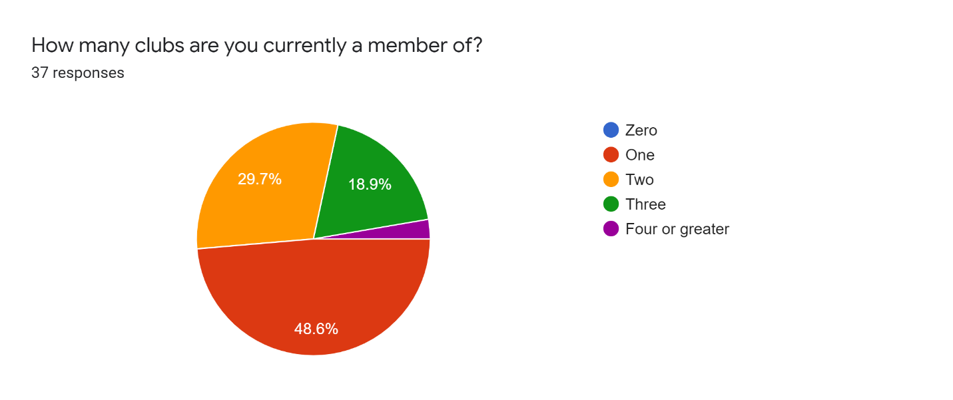
Figure 2: Club Involvement

The participants who stated they were members of clubs on campus were also asked what their motivation was for joining. Amongst all responses the three focal reasons were networking, events, and sponsorship discounts.

Target Market Wants and Needs
The needs and wants of the target market were explored in four questions within the survey. All the respondents stated that they prefer in-person events as opposed to virtual events. Respondents showed low levels of price sensitivity. As showed in the previous section, sponsorship discounts greatly motivated participants to join clubs. Restaurant discounts and nightlife discounts were the major incentives that participants desired. Figure 3 on the next page illustrates the preference of these discount types.
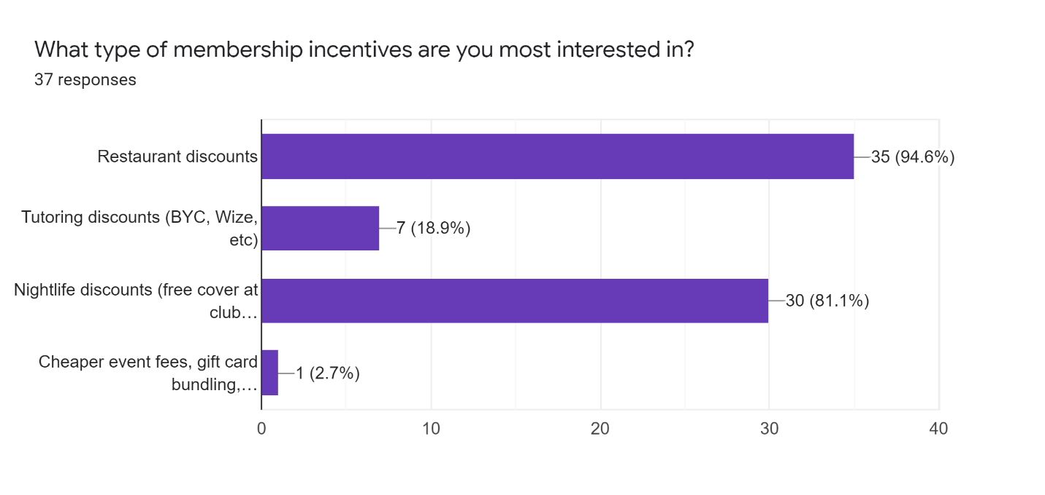
Figure 3: Membership Incentives

The platform in which individuals learn about new clubs is essential to the creation of a marketing plan as it determines the place strategy in the marketing mix. Figure 4 shows that most participants learn about clubs from UBC events 43.2% or from friends 35.1%.

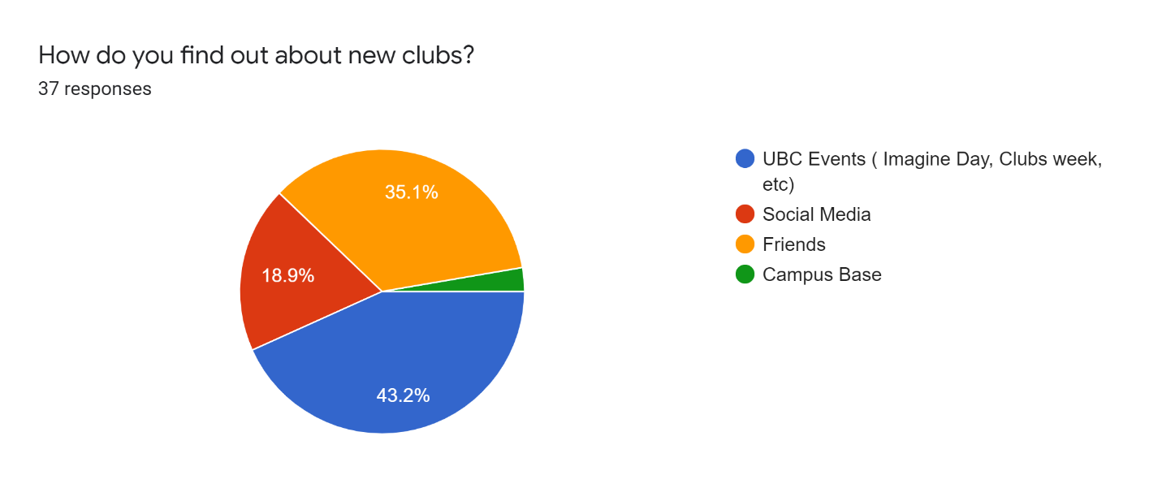
Figure 4: Exposure to clubs

Discussion
The primary data obtained from the survey can be transformed into meaningful insights into CVC’s target market. CVC’s target can now be formally identified as undergraduate students at the University of British Columbia. In terms of psychographic characteristics, the target market was segmented by individuals who are on campus at least four times per week. The target market is primarily motivated to join clubs if they are offering networking opportunities, social events, and sponsorship discounts. In terms of sponsorship discounts, discounts geared towards dining and nightlife are preferred. The target market responds well to in-person communication, word of mouth communication, and social media communication.

An established target market can be transformed to create a marketing plan that CVC can implement in the 2021/2022 school year. A marketing plan has four key elements that require distinct strategies (Kenton). The four elements work together to achieve the overall objective of the marketing campaign. The four elements which will be focused upon are product, place, promotion, and price

Product
Before defining a product, strategy CVC can employ, it should be clarified that CVC’s product is its membership and the various benefits that are associated with it. As an established club with consistent product offerings, CVC is in the maturity stage of the product life cycle. The maturity stage is characterized by consistent sales with a declining growth rate (Kopp). Despite having a declining growth rate, the club has a high level of brand awareness that can be leveraged to increase its membership base. A marketing penetration strategy aligns with the club’s needs, as it does not significantly alter the existing product.

CVC should penetrate the market by altering its membership offerings to satisfy the needs and wants of the target market. Although the club’s offerings satisfy the needs of the target market to an extent, CVC should reallocate its resources to better meet the needs of its target market. One need that is currently not met are in-person events. As in-person events are not feasible now, CVC should capitalize on the easing of restrictions to boost membership. By utilizing this strategy CVC will be better suited to satisfy the needs and wants of their target market.

Place
Place strategies which are also known as distribution strategies focus upon the method by which the consumer acquires the product. The goals when adopting a place strategy is to ensure that the strategy aligns with the other elements of the marketing mix and that the place is convenient for the consumer. The survey results illustrated that the target market responds well to in-person and digital marketing communication. A direct sales strategy best suits the marketing plan as it works in tandem with a promotion strategy based on in-person and digital communication.

CVC will remain responsible to sell membership to consumers. Memberships will be sold at all of CVC’s events as well as UBC clubs’ week, imagine day, and jump start. Additionally, memberships can be purchased online at any time throughout the year. While this place strategy is the club’s current strategy, continued use of it should increase CVC’s membership base while allowing them to focus on planning events and securing sponsorship discounts.

Promotion
A promotion strategy is an essential part of the marketing plan that is an attempt to inform, persuade or remind customers (Gitman, McDaniel and Shah). Within a promotion strategies decision must be made to select the promotional mix. A promotional mix is the combination of promotional variables that include advertising, personal selling, sales promotion, public relations, and direct marketing (Gitman, McDaniel and Shah).

A promotion strategy based upon personal selling and social media should be implemented as it works together with the price strategy defined previously. Personal selling represents a face to face presentation of the product to a consumer, this can be accomplished during CVC events and UBC events. CVC can leverage its established social media accounts to generate interest regarding the benefits of becoming a member. Social media promotion can be integrated with an online sales platform in which the consumers can purchase the product.

Price
Pricing strategies are methods that can be used to establish the best price for a product (Decker). CVC currently utilizes a value-added pricing strategy; this strategy emphasizes the product’s differentiation from competitors. Focusing on differentiation allows the club to justify a higher price point compared to competitors.

Conclusion

Summary and Recommendations
As an established club on campus CVC should take measures to ensure its membership levels. To accomplish this, they should implement a marketing plan that considers the characteristics of its target market. While CVC is currently employing adequate place and pricing strategies, their product and promotion strategies should be altered to better capture demand from the target market. Increasing the frequency and scale of in-person events and sponsorship discounts can attract new customers to the product. The marketing plan should be implemented as soon as possible to facilitate coordination and planning amongst all departments in the club.

Bibliography
Decker, Allie. The Ultimate Guide to Pricing Strategies. 13 November 2020. 1 December 2020. <https://blog.hubspot.com/sales/pricing-strategy>.
Gitman, Lawrence, et al. Introduction to Business. Houston: OpenStax, 2018.
Jordans, Frank, Maria Cheng and Samuel Petrequin. EU eyes Dec. 29 approval for 1st COVID-19 vaccine. 1 December 2020. 1 December 2020. <https://www.ctvnews.ca/health/coronavirus/eu-eyes-dec-29-approval-for-1st-covid-19-vaccine-1.5211470>.
Kenton, Will. Marketing Mix. 11 November 2020. 1 December 2020. <https://www.investopedia.com/terms/m/marketing-mix.asp>.
Kopp, Carol. Product Life Cycle. 11 May 2020. 1 December 2020. <https://www.investopedia.com/terms/p/product-life-cycle.asp#:~:text=A%20product%20life%20cycle%20is,growth%2C%20maturity%2C%20and%20decline.&text=Newer%2C%20more%20successful%20products%20push%20older%20ones%20out%20of%20the%20market.>.
UBC CVC. Join the team. 2020. 01 12 2020. <https://ubccvc.ca/join-the-team/>.

Appendix A: Survey Questions

https://forms.gle/WK6DY7ULWPSodP3H7

I am a fourth-year undergraduate student at the Sauder School of Business currently undertaking a technical writing project. The purpose of this survey is to obtain primary data to understand the needs and wants of University Students regarding their student club involvements. The final report will be conveyed to the executive board of UBC CVC. The data collected from this survey will allow UBC CVC to create an optimal strategy to satisfy the needs of UBC's student body. The survey contains 8 questions and should take no longer than 5 minutes of your time. Your responses are completely voluntary and anonymous, thank you for taking part in the survey.

- What year are you in?
- If school was in person, how many times per week would you be on campus?
- How many clubs are you currently a member of?
- If you are a member of a club what was your incentive for joining?
- How important is the cost of membership when you are deciding which club to join?
- What type of membership incentives are you most interested in?
- Do you prefer online or in-person events?
- How do you find out about new clubs?

