Establishment of a

Female Varsity Baseball Program at UBC

for:
Kavie Toor
Athletics and Recreation Director
University of British Columbia
Vancouver, BC

by:
Claire Eccles
English 301 99A Student

December 17, 2020

LETTER OF TRANSMITTAL
In progress

TABLE OF CONTENTS

LETTER OF TRANSMITTAL 1
TABLE OF CONTENTS 2
ABSTRACT 3
INTRODUCTION 4
Background of Female Baseball 4
Statement of Problem 4
Proposed Solution 5
Methods 5
Scope of Inquiry 5
DATA SECTION 6
Survey Analysis 6
Interview 9
CONCLUSION 9
Summary of Findings 9
Interpretation of Findings 9
Recommendations 9
REFERENCES 10

ABSTRACT
In progress

INTRODUCTION

Background of Female Baseball
While there are an abundance of NCAA (National Collegiate Athletic Association) and NAIA (National Association of Intercollegiate Athletes) schools with baseball programs across Canada and the USA, it is principally exclusive to men. In recent years, female sport has been gaining increased popularity which has narrowed the gaps in various dimensions of sport such as pay, airtime and competition opportunity. While the world has experienced a significant shift in gender equality within sport, female baseball has remained largely missed. In fact, almost all women who participate in baseball eventually transition into playing softball at the collegiate level or are pushed toward early retirement due to a lack of development opportunities. While the trend of transitioning from baseball to softball represents an important opportunity for females to stay involved in elite sport, the absence of baseball at the collegiate level highlights a compelling need to provide varsity programs for female baseball. This would both retain more athletes, and increase sport popularity.

Statement of Problem
For most females in baseball, playing opportunities are scarce to none after highschool. Without college playing opportunities, these athletes miss out on a pivotal period of their playing careers which has vast implications for the individual athlete, as well as the sport at large. The popularity of the sport has slowly been increasing for women, but the lack of play occurring at the collegiate level dismantles the possibility for growth.

Proposed Solution
Ultimately, it is imperative to fill the gap within the developmental pathway for female baseball athletes by implementing a female baseball varsity program at the collegiate level. In a city such as Vancouver where girls baseball has been established, UBC provides a potential starting ground. The UBC’s decorative athletic history and access to facilities would allow for development of the sport and would increase potential athletes to attend the school. If girls are aware of playing opportunities at UBC, retaining female athletes in baseball would be steadier throughout development.

Methods
A primary source of data will come from prospective, current, and retired female national team baseball players playing for Canada as well as the Baseball BC’s Girls Program. In order to understand the opinions of both sexes on female baseball, the UBC men’s baseball team will be contacted. The data will be obtained through an online survey. Additionally, my connections with the UBC Athletic department will allow me to interview the head of Athletics and Recreation to gain an understanding of what is needed for a varsity program to be considered.
Secondary sources to do with female baseball and where it currently stands will be obtained from researching literature. Finding statistics will provide a solid foundation of understanding of where women’s baseball stands in British Columbia.

Scope of Inquiry
To assess the feasibility of creating a female baseball program in post-secondary schools, I will dive into these areas of inquiry:
- At what age do the majority of girls drop out of baseball? Why?
- What motivation could be created knowing a female baseball program at the collegiate level could exist?
- What are the financial logistics of implementing another sport program at school? How would funding be provided?
- What numbers are needed to garner interest in establishing a varsity program?
- How are club teams formed and is that another opportunity for establishment?

DATA SECTION

Survey Analysis
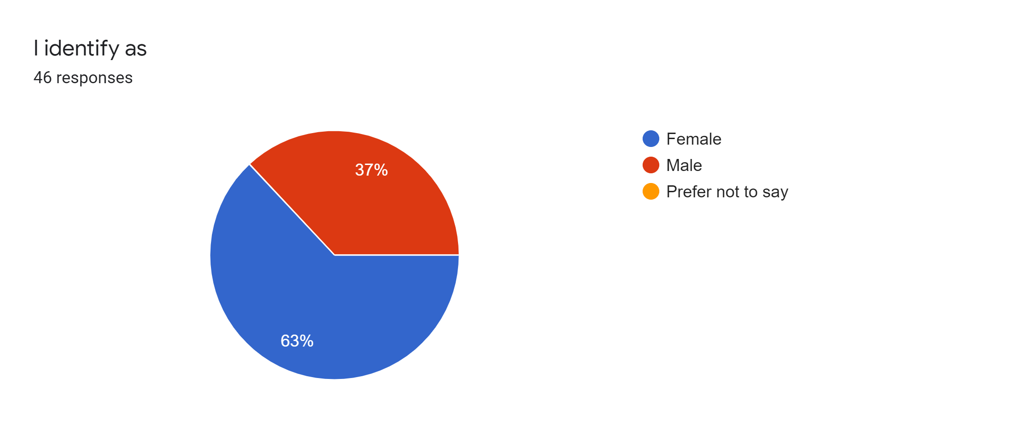
Figure 1 Sex of Survey Partipicant
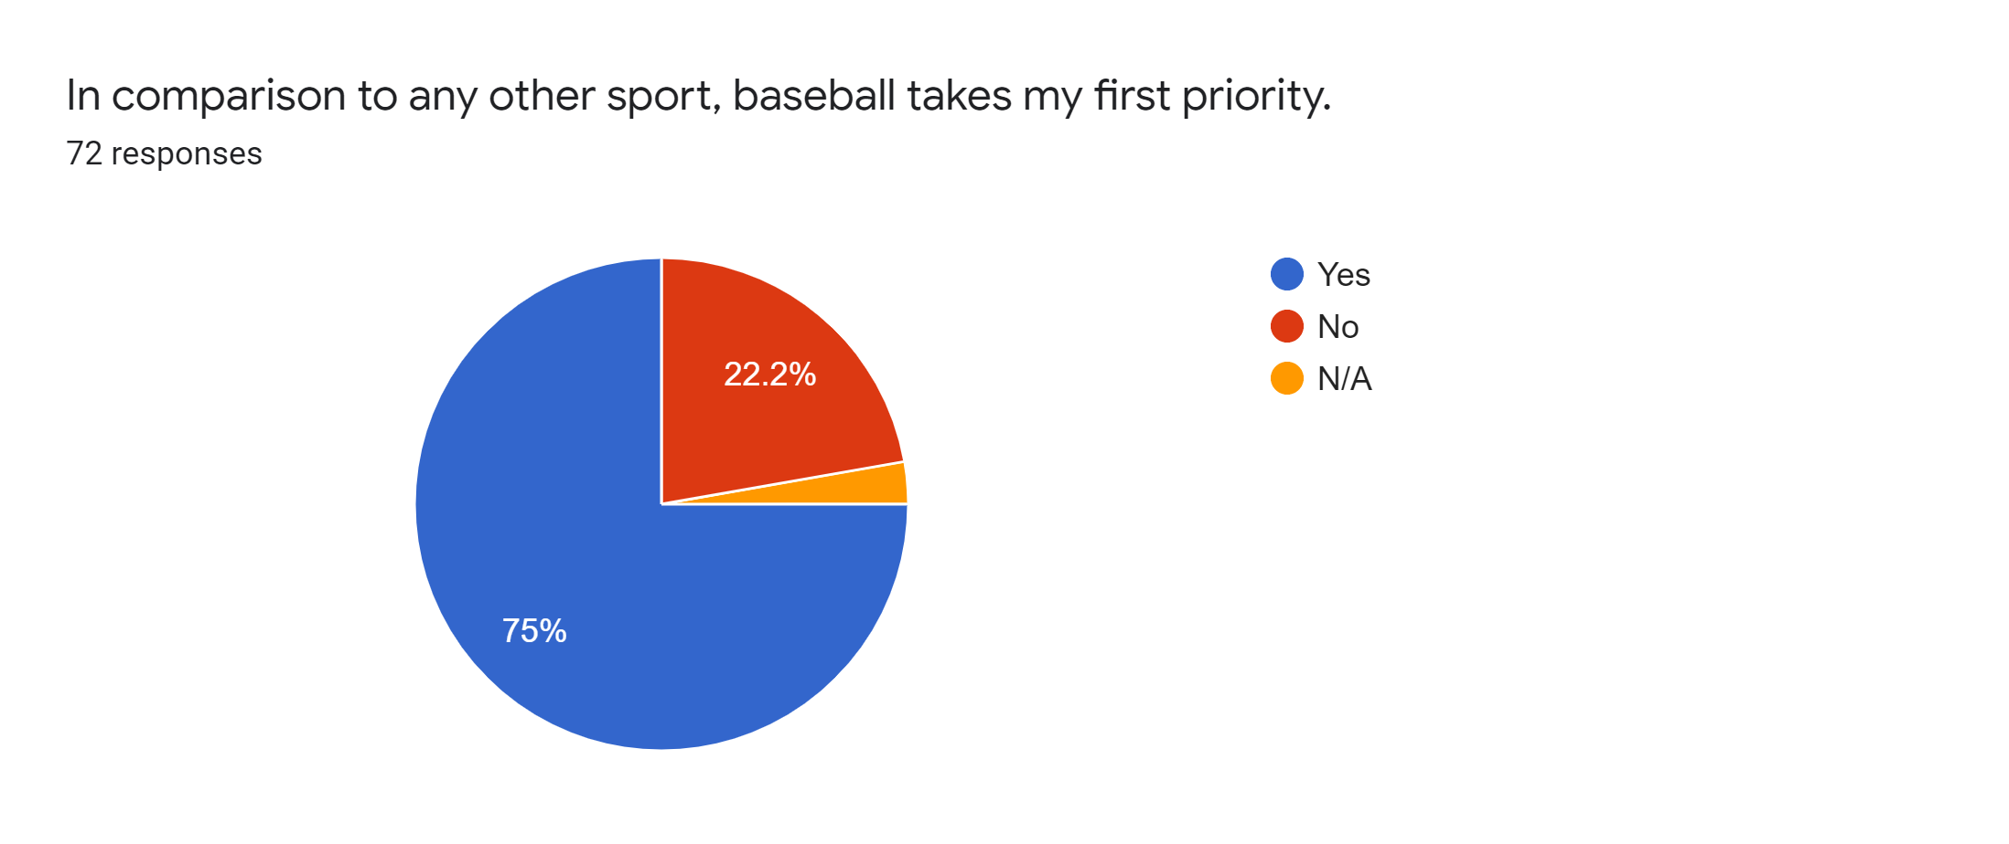
Figure 2 Importance of Baseball
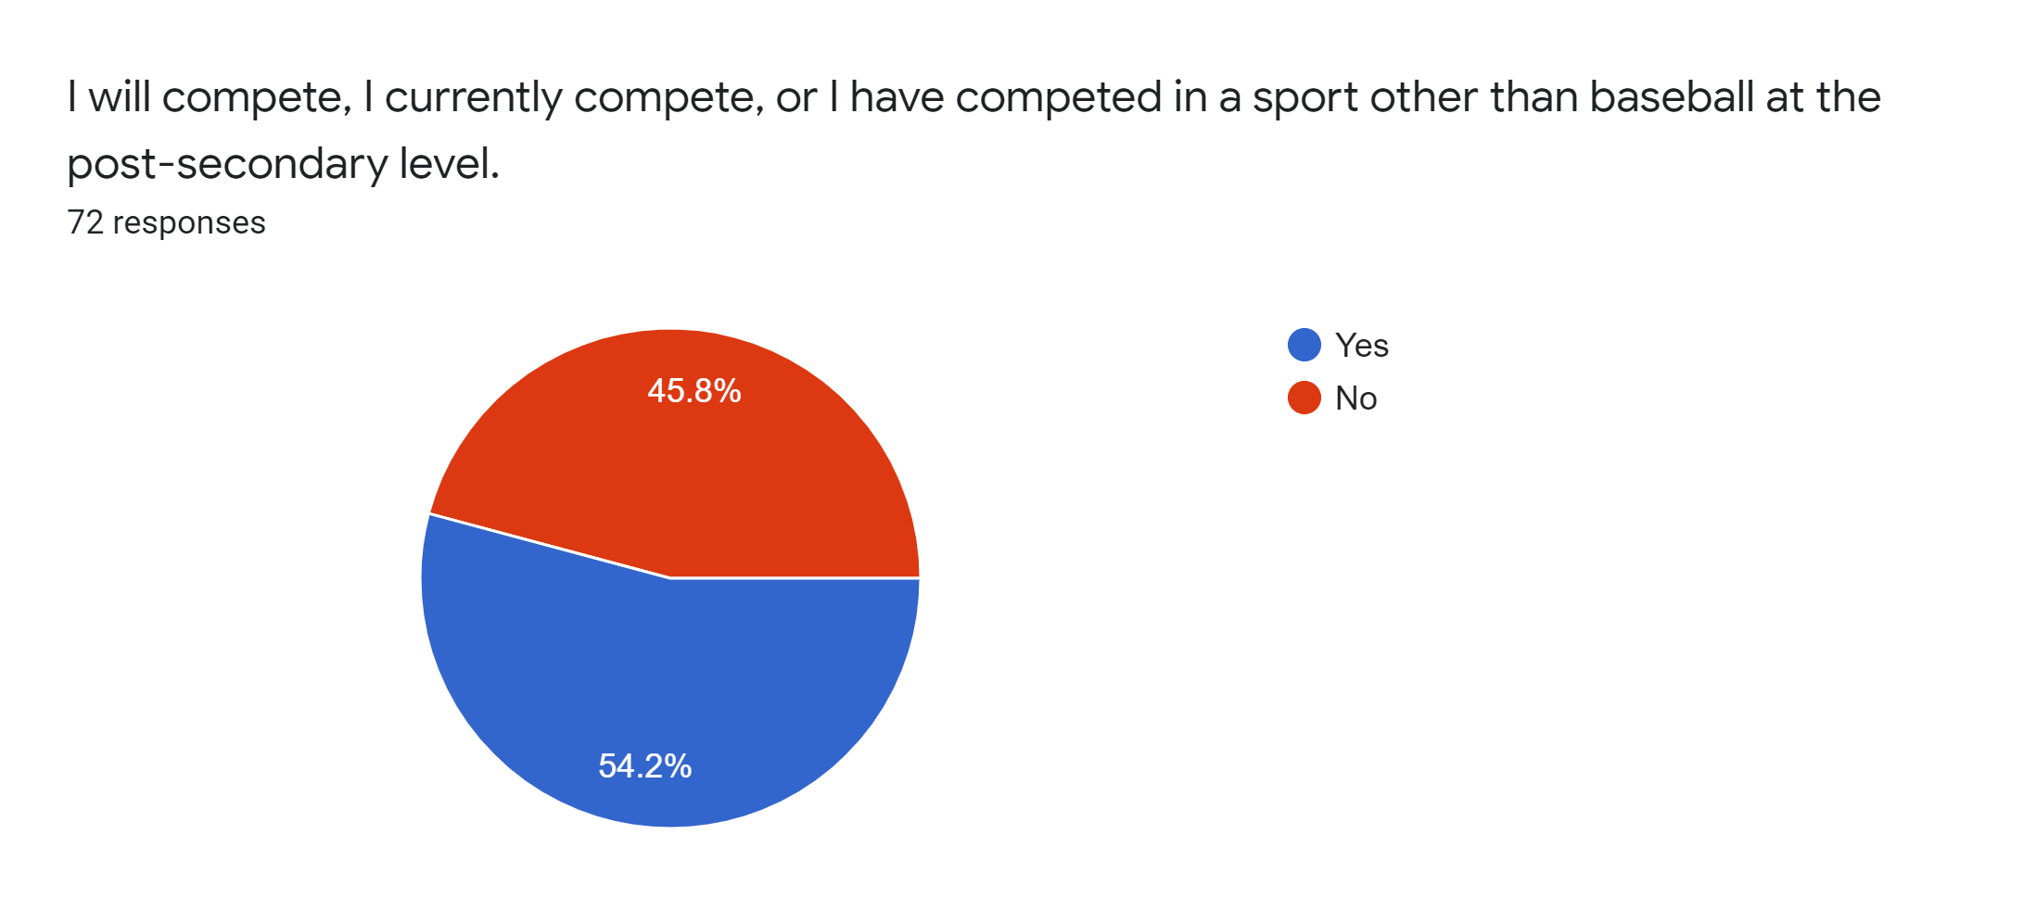
Figure 3 Athletes in Post-Secondary
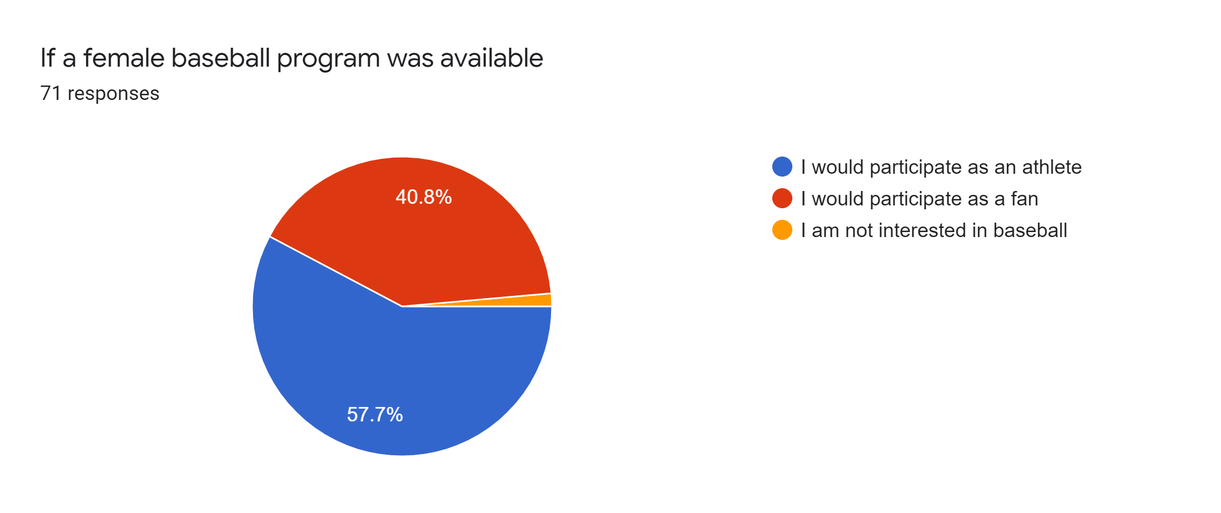
Figure 4 Interest in a Female Varsity Program
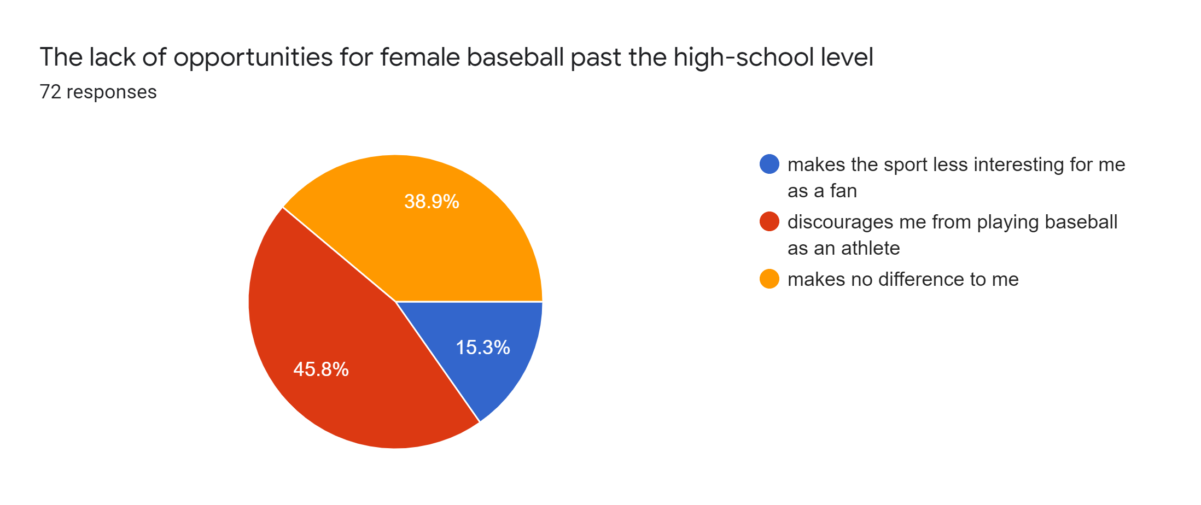
Figure 5 Lack of Female Baseball Opportunities
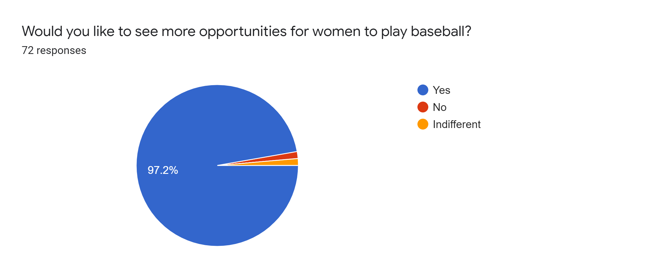
Figure 6 Opinions on More Female Baseball Opportunities

Written Question Responses

Interview

CONCLUSION

Summary of Findings
- More opportunities are in favour by both male and females
- There are several areas to establishing a varsity team
- For a varsity team to be established, it is preferred they begin as a club team
- Ideally, a program that shows it will compete successfully is preferred

Interpretation of Findings
- Growing the game for those at post-secondary age (not just grassroots) could create a ripple effect in retaining athletes throughout youth

Recommendations
- Work towards retaining athletes in the sport, establish a club and gain popularity

REFERENCES

