Formal Report on recommendations for increasing teacher morale via improved workload management at TNS Beaconhouse.

For:
Clive Barnes, Head of School, TNS Beaconhouse.
Rashid Khalid, Deputy-Head and IBDP Coordinator.
Zahra Bukhari, EY and PYP Coordinator.

By:
Syed Waqar Ahmed
UBC ID: 34471268

Date submitted: 15th December 2020

Table of Contents
Abstract 2
I. Introduction 4
A. Mission Statement of TNS Beaconhouse 4
B. Background of teacher workload on teacher performance 5
C. Background of teacher workload on student performance 5
D. Problems of intensifying teacher workload at tns 5
E. Purpose of report 5
F. Brief description of data sources 5
G. Scope of inquiry 5
II. Data Summary 7
A. Accounting for teacher workload at tns 7
B. Accounting for the hidden workload 8
C. The need for an objective measure of workload 9
D. IT resources and counselling services 9
II. Conclusion 10
A. Interpretation of Findings 10
B. Proposed solutions 10
- Calculating teacher workload
- Managing teacher overwork
- Accountability of administrators
- IT and counselling support

Figures & Tables
Figure 1 Teachers’ rating their workload 5
Figure 2 Weekly teaching hours 7
Figure 3 Work taken home
Table 1 Accounted and unaccounted sources of workload. 9
Figure 4. Number of students taught by a teacher 11
Figure 5. Equitable distribution of workload 11
Figure 6. Opinions on IT support at tns 11
Figure 7. Interest in Counselling services 11
III. REFERENCES 12
IV. Appendices 13
Survey Questions for teachers: 13
Interview Questions for adminsitration: 13
ABSTRACT

I. INTRODUCTION
A. Mission statement of TNS Beaconhouse:
TNS Beaconhouse is a pre-eminent private school located in Lahore, Pakistan that offers schooling in the International Baccalaureate program starting from Early-Years (EYP) through Primary-Years (PYP), Middle-Years (MYP) and leading up to the Diploma Programme (DP). In trying to offer the best possible education, the school supplements the high standards of the International Baccalaureate Program by implementing the philosophies of Project-Based Learning and the acclaimed Reggio Emilia Approach which is based on the principle of “Learning By Doing”. As a result, TNS Beaconhouse has its students consistently achieving the highest scores in Pakistan in their MYP and DP results, which are the two programs that have externally assessed and internationally moderated assessments. Based on these exam results, TNS ranks amongst the top 3% of all IB World Schools. However, like many other educational institutions, teachers at TNS complain about being overburdened with work which is adversely affecting teacher morale and thereby student outcomes. This goes against the ‘raison d'etre’ of the school’s existence which is to be a model school that offers the best possible education to its students.

B. Background of teacher workload on teacher performance
Teachers today are being asked to do more while budgetary pressures mean that they have fewer resources available to them. Teachers who are over-burdened report increased stress and decreased performance. The increased stress leads to health issues, absenteeism, emotional exhaustion, plummeting performance and job satisfaction (Huyghebaert). This forces many high-quality teachers to quit after a few years and forces many into an early retirement. The high turnover of teachers is a well-known problem and is especially notable at TNS. This leads to disruption to students and also other teachers who have to take on additional work responsibilities as a replacement teacher is hired. With workloads increasing, teachers are left to wonder where they will get the time to fulfill all of their responsibilities. As a result, they have to take an increasing amount of work home, and ultimately settle for “doing less” whereby they forced into cutting corners and tuning out and thus are unable to do their jobs to their own satisfaction. As teaching is becoming increasingly complex, and teaching philosophies like the International Baccalaureate programme require more from teachers to incorporate inquiry-based learning in the classroom including the implementation of a plethora of approaches of teaching and learning, teachers that don’t have adequate time to plan lessons are unable to do their jobs adequately.

C. Background of teacher workload on student performance
According to the American Federation of teachers “Teaching quality is the most important school factor in improving student achievement” (American Federation of Teachers 54). As teacher workloads increase, teachers have less time. That means less time for lesson preparation, less time to provide student feedback and office hours, less professional development, less time to report student progress to parents, and a general erosion of the ability to provide good service due to the cognitive and emotional deterioration due to a persistent work overload. It is therefore little surprise that study after study has shown an inverse relationship between teacher workload and student performance levels (The Effect of Teachers’ Workload on Students’ Academic Performance in Community Secondary Schools: A Study of Mbeya City). Furthermore, teacher preparation and certification are by far the strongest correlates of student achievement (Fong-Yee). The higher the certification the teacher has the more likely they are able to find alternative employment. Therefore, increasing workload disproportionately causes attrition of the highest qualified teachers.

D. Problems of intensifying teacher workload at TNS
TNS Beaconhouse is an IB-recognized world school which means the school “has adopted and successfully demonstrated a commitment towards meeting all the standards, practices, and requirements in developing each programme as stipulated by the International Baccalaureate Organization (IBO)” (Goodrell-Admin). The standards and practices of the IB system place very high demands on teachers to implement innovative and complex ways of teaching for e.g. by implementing the “Approaches to Teaching” and “Approached to Learning” methodologies into their everyday lesson plans. The school offers inclusive education which means that teachers face the additional challenge to meet the varied and diverse requirements of special needs students in the classroom. There is also a high degree of technology integration and implementation throughout the school with teachers expected to use smart boards, AV equipment, use online books for instruction through Kognity, use online examination software called AssessPrep and an online planning, assessment and reporting platform called Managebac. The shift to the hybrid mode of teaching during the Covid19 pandemic, the reliance on implementing technology has increased further as teachers teach in-person classes while at the same time streaming their classes through Zoom or Google Meet to the at-home audience. Teachers are expected to respond expeditiously to student and parent concerns over email and the concept of scheduled parent-teacher meetings has all been rendered obsolete. The creation of Whatsapp groups for staff matters and teacher-student groups for class coordination creates pressure to respond to queries in real-time, and the line between work and off-work hours has gotten further blurred. The morale problem due to intensifying teacher workload has been exacerbated by a poor or no increments in the last few years and a 10% pay cut that was imposed due to the Covid19 pandemic.
As the Covid19 pandemic has impacted the financial bottom-lines of all schools, TNS is no different. As a result, teachers who were already overburdened are being squeezed to do more for less.

D. Purpose of this report:
- Gauging the prevalence of low morale amongst teachers at TNS Beaconhouse that is rooted in feeling overburdened.
- Accounting for the ‘hidden’ workload of teachers.
- Determining an objective measure for calculating real teacher workload.
- Explore ways to increase teacher morale through effective workload management and access to key support services.

E. Brief description of data sources
My primary data sources will include interviews with existing and past employees of TNS. The interviews will be in person and the surveys will be anonymous. If the interviewee does not want to be identified, then the interview can be “off the record”. As the prescriptions are being developed, I will present them to school management so their feedback can help shape them, with the goal being to maximize the final report’s practicality and acceptance for all stakeholders.
Secondary sources will include publications on metrics and determinants of teacher satisfaction and their relationship to student outcomes.

F. Scope of this inquiry
The scope of this report is to find ways to increase teacher morale at TNS that require minimal or no additional budgetary allocation and is thereore sustainable at a time of shrinking budgets due to Covid19. In order to develop these prescriptions, I plan to explore the following areas of inquiry:
- What are the different factors that can create ‘hidden’ or ‘unaccounted for’ workload for teachers?
- How can we develop an objective measure of the actual workload for a teacher?
- What ways can be used to ensure that the work is as fairly distributed across all teachers as possible?
- How can the teachers be made aware of the formula that is used to assign them work responsibilities in order to create a sense of transparency and fairness?
- What is the best way to implement a system where a teacher can raise concerns about their workload?
- How can the burden of administrative tasks or staff duties be minimized on teachers?
- What IT support do teachers require?
- How can teachers best benefit from counselling services?

II. DATA SECTION
A. Accounting for teacher workload at TNS

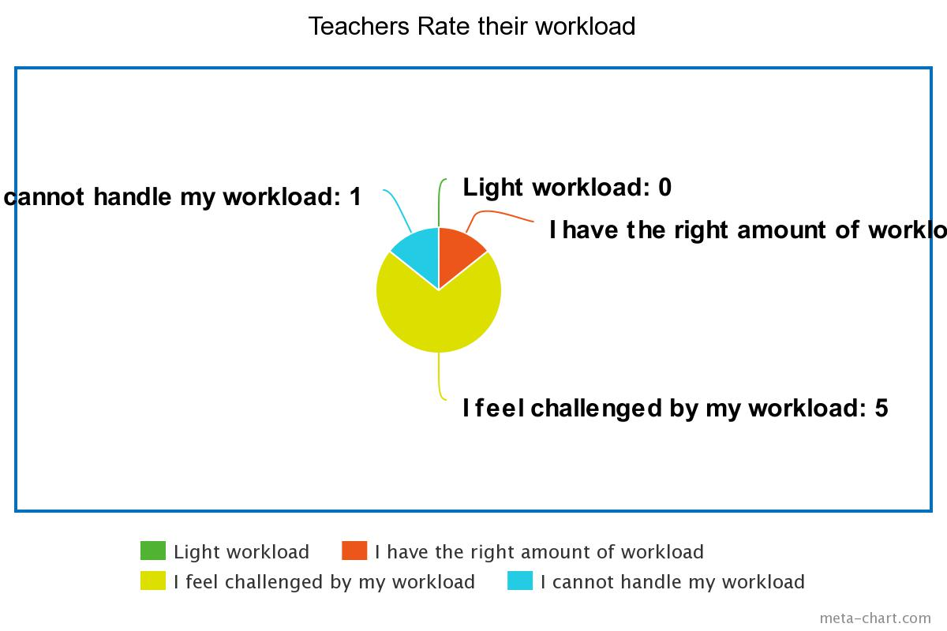
Seven teachers responded to the teacher survey (see Appendix for survey questions). As seen in Figure 1., five out of seven (71%) felt that they were challenged by their workload. One of the seven said that were not able to cope with their workload, whereas, only one felt they had the right amount of workload. This provides strong evidence that teachers at TNS believe their workl excessive.

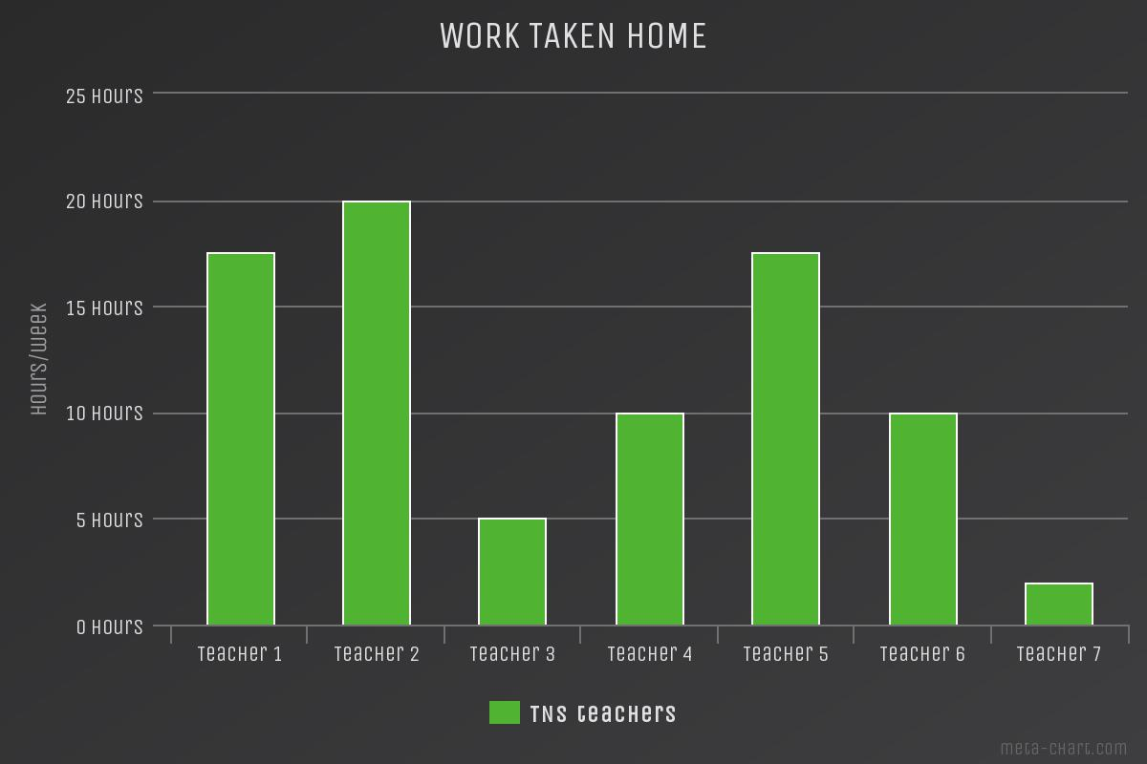
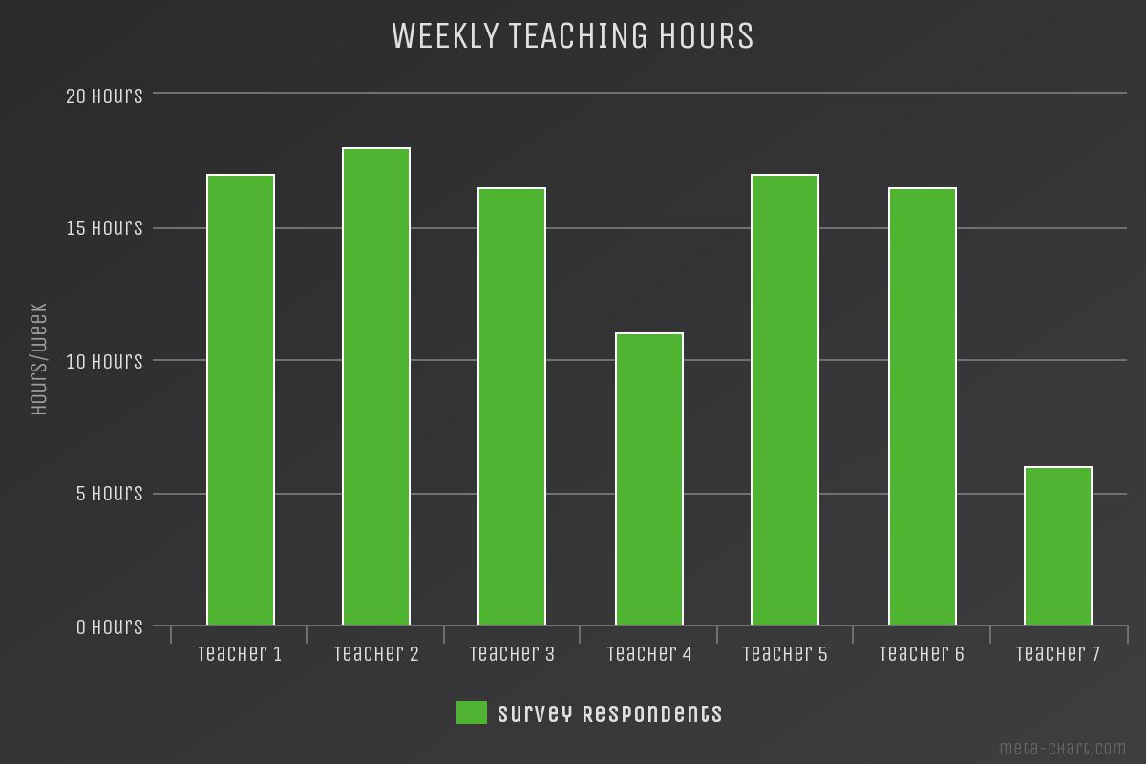
Figure 2 displays the weekly classroom teaching hours for the teachers. Most teachers seem to teach between 17-18 hours. It is clear that no teacher exceeds 18 weekly teaching hours. This is in keeping with school policies. Large differences in the teaching hours of different teachers can be seen. It is unclear if these differences are because of part-time versus full-time employment status as this data as not collected in the survey.

Figure 3 shows the amount of time spent completing work at home. This typically work that the teacher does not have time or opportunity to complete within school staff timings. For some teachers, the figures are as high as 18-20 hours which is equivalent to almost 2 extra work days. On average, teachers seem to be taking 12 hours of work home. These figures give us an indication of the magnitude of overwork on teachers and how this might be impacting their stress levels, personal lives and health.

B. Accounting for the “hidden workload”.
Table 1 provides a listing of what constitutes a “hidden” workload for teachers. These are work responsibilities that do not go into any calculation when work is being assigned to a teacher. As a result, teachers who are teaching the same number of hours on paper can end up with widely varying workload. Table 1 was compiled using the author’s own experiences as well as from responses to Question 7 on the teacher survey.

Table 1. Tasks that contribute to a teacher’s workload. The tasks are classified based on whether they are typically “accounted for” by administration when workload is assigned.
Typically accounted. | Typically not accounted: Systematic sources. | Typically not accounted:  Non-systematic sources.
Teaching hours in classroom | Large class sizes/Large number of students taught. | Simultaneous online + in-person teaching (hybrid classes)
Substitutions | Complexity of subject matter taught/Complexity of assessment models. | Student mentoring
Staff duties (cafeteria, playground, hall duty etc) | - Teaching multiple subjects Teaching multiple class levels | Returning parent phone calls
Invigilation duties | - Out-of-field teaching  - Learning new curricula | Parent-Teacher Meetings
 | Extended Essay supervision + grading | Participation in student-staff committee meetings.
 | Internal Assessment supervision + grading | CAS activity advising
 | - Lesson planning  - Laboratory preparation | Writing letters of recommendation for university admissions.
 | Unique grading and feedback requirements | Making tests and exams.
 | Homeroom teacher housekeeping responsibilities:  - Attendance checks,  - Creating softboard displays, parent notifications.  - Distributing circulars/fee challans etc  - Parent circulars | Holding student vivas
 | Workshops | Concerts/Sports Day/Event duties
 | Professional development/training | Field trips
 | Personal Project supervision | - Inclusive classrooms  - Number of students requiring individualized education plans or special needs support.
 |  | Students/Classes with disciplinary problems

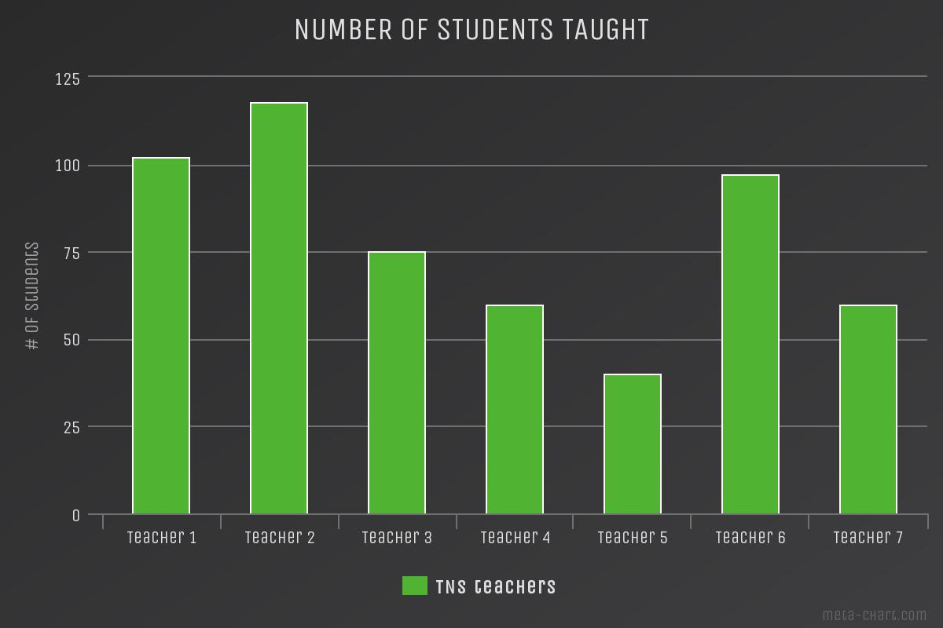
Figure 3 on the right shows the survey responses to total number of students taught by a teacher. The amount of workload for a teacher is closely tied to class size as the amount of grading and feedback scales linearly with number of students. In the International Baccaluareate Diploma Programme where there is a mandatory research project in each subject which the teacher supervises, the total work for teachers scales exponentially as the teacher takes on the supervisory role for each additional student in addition to the usual grading of tests and exams. Therefore, class size must be taken into account into any formula that seeks to assess teacher workload.

C. Need for an objective measure for assessing and assigning teacher workload
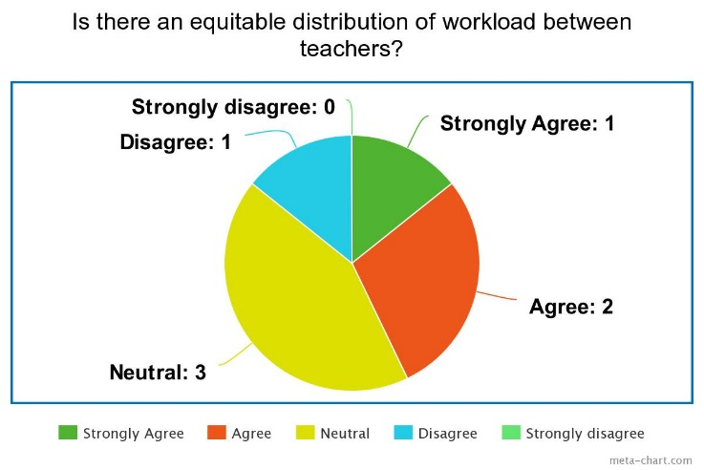
There is no formula or method for assigning teachers work currently in use at TNS, besides the policy that sets the maximum number of class hours in a week at 18. As a result, there are large differences in the workload of different teachers. This risks over-straining some teachers and likely to affect their morale. Figure 4. shows that 3 out 7 teachers agree that work distribution is inequitable.
Furthermore, in the written responses to the survey question 9, teachers indicated that although the administration was open to listening about concerns about workload, everyone is mildly cautious about taking this matter up with them. The precise reasons for this are unclear, however, the expectation of teachers to work hard and be model employees undoubtedly figured into this as well as concerns about job security as the teachers are not unionized. With the stigma and hesitation for teachers to raise their concerns, it would be ideal if the administration takes proactive steps to address the issue on their end.

D. IT resources and counselling for teachers

Almost all teachers were of the opinion that the school needs to improve its IT infrastructure and teacher support services to some degree and a majority indicated an interest in availing counselling services. Notably, the teachers that reported feeling more stressed and overworked, also expressed interest in availing both these services.
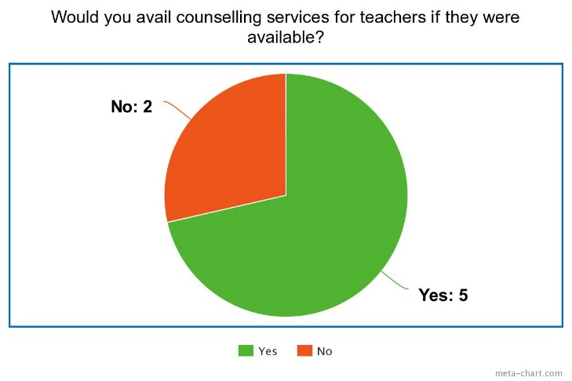
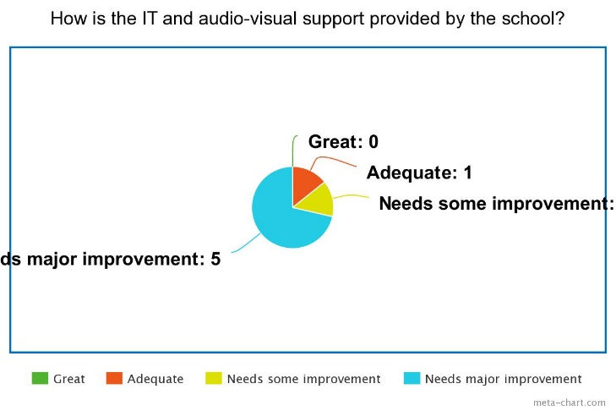

III. CONCLUSION
A. Interpretation of findings

“Critics of educators often say teaching is not rocket science and they are correct – good teaching is much more complex!” – David Dibbon (Dibbon)
The teacher survey has made clear, that teachers at TNS have an above average workload. 71% of teachers report being challenged by their workload with 1 in 7 indicating they are unable to cope with their workload. Teachers reported needing to work an average of 12 hours/week at home to meet their work obligations. More importantly, some teachers are disproportionately more affected and reported working as much as 20 hours at home. Some of the discrepenacy between the workload of different teachers comes from a large component of “hidden” work that is not accounted for when work and duties are assigned. Some of these include failing to account for class sizes, supervision of student academic projects and number of different subjects/grade levels taught by the same teacher. In interviews with the administrators, they acnoledkefd that the school has no systematic way of calculating workload other than the policy of a maximum of 18 weekly teaching hours. They were open to the idea of a more flexible and inclusive method of calculating workload, however expressed some caution regarding how that may impinge on their flecibility of assigning work.
B. Proposed solutions
It is widely accepted that happy teachers make for happy classrooms and elevate student learning outcomes. Happy and motivated teachers teach better and have more time and energy to cater to the collective and individual needs of their students (McLean, Leigh et al.). Teachers that are well rested contribute to students reporting more academic motivation and in-class satisfaction (Poon, Cyanea Yui-Sum et al.). Improving teacher morale at TNS will directly lead to improved learning outcomes for students and decreasing the high rates of teacher turnover that is a source of disruption to classroom learning. I propose the following solutions:
1. Calculating teacher workload: Use of a quantitative measure of teacher workload. Such formulae have been proposed in existing literature (Algonquin College of Applied Arts and Technology; Liang et al. 72; Affleck) but will need to be customized to the needs of TNS teachers and administrators.
2. Managing teacher overwork: The inequitable workload distribution for different teachers needs to rectified. Teachers who are overworked should receive special support and incentives to mitigate their workload and stress. A set of special considerations can be extended to them including:
- reducing their paperwork requirements,
- providing office work support that reduce paper runs,
- given easier access to early leave when classes are done.
- Scheduling their subject exams earlier to give them more time to grade.
- Decreasing substitution, invigilation, staff duties
- Additional ways to reduce the workload of these teachers can be found using the “sources of teacher workload” in Table 1.
3. Accountability of administrators: Administrators should be made accountable for creating and administering policies that reduce the problem of teacher overload. In the teacher survey, most respondents reported hesitation about taking their concerns about excessive or unbalanced workloads to the administration. This hesitation can be decreased if there is a formalized mechanism for teacher input about their workload. Teachers should be surveyed at the start of the academic year and mid-way through the year. If there is a discrepancy between assessed workload and self-reported workload, the issue should be red-flagged and automatically investigated. Issues of overwork can be resolved using the steps for “managing teacher overwork” described above. This will ensure that overworked teachers are not “falling through the cracks” of the system. It will also create a sense of transparency and fairness that is currently lacking.
4. IT and counselling support: The switch to remote-learning and hybrid models of instruction have required teachers to quickly adopt technology-intensive methods of teaching. A significant source of frustration for teachers are internet bandwidth and dropout issues at school. Addressing the IT infrastructure issues and IT support issues at this time in key to increasing efficiencies and reducing stress levels across the board for all teachers as well as directly contributing to the classroom experience of students. Given the broad interest by teachers in availing counselling services, the existing student counselling office can be asked to extend stress and coping services to teachers especially those flagged with extraordinary workloads. Along with managing teacher workloads, providing teachers the acknowledgement and support they need to weather through particularly tough times due to excessive workload will undoubtedly help schools retain well-qualified teachers who would otherwise be lost to teacher attrition.

III. REFERENCES

Huyghebaert, Tiphaine. “Effects of Workload on Teachers’ Functioning: A Moderated Mediation Model Including Sleeping Problems and Overcommitment.” Wiley Online Library, 1 Dec. 2018, onlinelibrary.wiley.com/doi/abs/10.1002/smi.2820.

American Federation of Teachers. Charting the Course: The AFT’s Education Agenda to Reach All Children. AFT, 2007.

Fong-Yee, Donna and Anthony H. Normore. “The Impact of Quality Teachers on Student Achievement.” (2013).
Goodrell-Admin. “An IB World School - What Does It Mean?” Goodrell Middle School, 2 July 2015, www.goodrell.dmschools.org/2015/07/an-ib-world-school-what-does-it-mean/#:%7E:text=To%20be%20an%20International%20Baccalaureate,International%20Baccalaureate%20Organization%20(IBO).
Dibbon, David. It’s About Time!! A Report on the Impact of Workload on Teachers and Students. NEWFOUNDLAND & LABRADOR TEACHERS’ ASSOCIATION, 2004.
Algonquin College of Applied Arts and Technology. “Standard Workload Formula (SWF).” AC, www.algonquincollege.com/hr/labour-relations/standard-workload-formula. Accessed 2 Dec. 2020.
Liang, Ong Hoon, et al. “Measures of Teachers’ Workload.” Singapore Journal of Education, vol. 7, no. 1, 1985, pp. 72–74. Crossref, doi:10.1080/02188798508548563.
Stephen B. Affleck, Marvin C. Gabert, Hahns J. Kuhr, and Donald J. Parks. "Quantifying Academic Faculty Workloads". 1998 Annual Conference, Seattle, Washington, 1998, June. ASEE Conferences, 1998. https://peer.asee.org/7379 Internet. 02 Dec, 2020

IV. APPENDICES

Teacher Survey: https://docs.google.com/forms/d/1eYuG-SA5AXjgIjci0ozH2Vnc4JJfvrtTjIPv_yn-a08/viewform?edit_requested=true#response=ACYDBNgwZ-HDkynwbKHblUe5vpeUhe91wqgil3OS9yCTwq4iGHSQdtHSKcVJvORvOCp7kYk

Interview Questions for school administration:
1. What is the current mechanism to assess teacher workload?
2. What determines how much work is assigned to a particular teacher?
3. Is there any formal mechanism for a teacher to provide feedback about their workload?
4. How important is teacher morale for the school to be successful?
5. Would you be interested in using an objective measure to calculate teacher workload?
6. What would be the advantages of using such a measure to allocate workload to teachers?
7. What would be the disadvantages of using such a measure to allocate workload to teachers?

