Feasibility Analysis of Initializing a Fatigue Risk Management Program for WestJet Airport Agents

Prepared for
Stephan Funk, General Manager, and
Trevor Gerrett, General Hub Manager, and
the management team of Operation Leads and Irregular Operations Coordinators
WestJet Airlines Ltd. (Vancouver International Airport)
Richmond, B.C.

By
Kitty Yan
English 301 99A Technical Writing 2021W Student

November 16, 2021
Table of Contents
Introduction ……………………………………………………………………………………………….. 1
Data Section ………………………………………………………………………………………………. 4
Sources of Fatigue Risk ………………………………………………………………………….. 4
Overview of Current Research by Transport Canada …………………………………... 4
Overview of Fatigue Risk Management Programs ………………………………………………. 5
Meaning of Fatigue Risk Management ………………………………………………….. 5
Current Regulations for the Aviation Industry Mandated by Transport Canada ……….. 5
Consequences on Fatigue Risk without a Proper Management Program ………………. 5
Overview of Fatigue Risk in WestJet Agents at YVR …………………………………….……... 7
Survey and Interview Analysis …………………………………………………………... 7
Current Understanding of Fatigue by WestJet Agents …………………………. 7
Current Areas Identified as Potential Source of Fatigue Risk ………………….. 8
Recommendations for Initializing a Fatigue Risk Management Program ……………………… 10
Initializing Steps to Create a Tailored Program ………………………………………. 10
Areas to Promote Fatigue Risk Awareness …….………………………...……. 10
Areas to Provide Resources …………………………………………………… 10
Current Limitations for Proposed Solutions …………………………………………… 11
Conclusion ………………………………………………………………………………………………. 12
Summary and Overall Interpretation of Findings ………………………………………………. 12
Summary of Recommendations ………………………………………………………………… 12
Final Comments ………………………………………………………………………………… 12
Works Cited ……………………………………………………………………………………..………. 13

Figures and Tables
Figure 1: Fatigue Risk on Work Performance Over Time …………………….…………………. 6
Figure 2: Survey Q46.3 "I know and understand fatigue risk" .………………………………….. 8
Figure 3: Matrix of Survey Answers on WestJet and its Current Health Program Relating to Fatigue …………………………………………………………………………………………………… 10

INTRODUCTION
Fatigue is defined as “the feeling of tiredness or exhaustion from the lack of energy or strength”. (HealthLink BC). Fatigue risk then is the possibility of adverse consequences for people and their environment that come from fatigue, especially in safety-critical industries. Like the rail and marine industry, aviation is one of the industries that require a call of fatigue awareness and a call of action in fatigue risk prevention.
There are many research studies conducted on fatigue risk, but specifically to Canada’s aviation industry, there have been sighted crew performance implications based on different fatigue hazards. Specifically, Transport Canada has noted the following where having:
- Long duty periods increases likeliness of reduced alertness, impaired attention, degraded reaction time
- Night duties increases transient fatigue, sleep deprivation, impaired or reduced sleep due to daytime rest, degraded alertness, errors, slips or lapses in performance
- Split duty increases likeliness of reduced alertness, impaired attention, degraded reaction time, decreased vigilance, impaired attention.
- Disruption and/or extended wakefulness increases transient fatigue issues, long duty day, stress and hassle leading to shortened sleep opportunity, reduced alertness, slow reaction time, task fixation, decreased vigilance errors, slips and lapses in performance.
- Long travelling time can increase transient and cumulative fatigue, extended periods of wakefulness, reduced / shortened sleep opportunity leading to reduced alertness, slow reaction times, errors in performance.
Based on these factors and other fatigue hazards, there are current fatigue risk management programs mandated by Transport Canada for the rail and marine industry as well as a large, concentrated focus on the aviation industry for flight. In particular, two approaches to fatigue management were introduced for amendments in December 2018 which can be summarized to setting requirements that define maximum hours of work, flight time and flight duty periods, as well as minimum rest periods and time free from duty for flight crew members to combat the factors as noted above.
The purpose of this report is to highlight the current fatigue risks through research conducted by Transport Canada and other government agencies and compare them to local WestJet agents at Vancouver International Airport and the importance and need of a fatigue risk management program, as like the mandated requirements for flight crew. This report is addressed to Stephen Funk, General Manager of YVR WestJet Hub, Trevor Gerrett, the General Hub Manager of YVR WestJet and also the senior management team consisting of Operational Leads (Guest Service Leads) and Irregular Operations Coordinators.
The current research conducted for this report was based on a series of 20-25 questions from an anonymous survey and a short interview with 4 agents from various duties and positions. The scope of the questions asked were based on the following:
- What are the current schedules of agents, and what are their areas of duties they complete within those hours?
- What is the average amount of overtime they have to commit over operational delays, and how regular are these operational delays that affect their hours of work?
- What are the current resources available to the agents if they are unable to continue working or become hazardous to themselves and others because of fatigue?
- Do agents recognize that they have fatigue and if they do, what ways are they mitigating this risk themselves?
- What are the senior managers doing to overcome the challenges of over-stressing their agents?
Based on the survey and interviews, the importance of a fatigue management program was severely highlighted, and there are a lot of actions needed to be enacted on for the safe wellbeing of local WestJet agents. The recommendations as provided will highlight the possible first steps to initialize a fatigue management program, which includes increasing fatigue awareness and supporting agents with better scheduling.

DATA SECTION

Sources of Fatigue Risk

Common causes of fatigue come from a multitude of factors related to sleep and the quality of sleep along with the workplace task, environment and scheduling that include repetitive or strenuous tasks, temperature, noise and light levels, vibration, night shifts or being awake between midnight and 6a.m., extended shifts or overtime, irregular shift rotation patterns and physically or mentally demanding work (WorkSafe BC). Each one of those factors influence the type of fatigue risk which is categorized in three ways:
Transient fatigue is acute fatigue brought on by extreme sleep restriction or extended hours awake within 1 or 2 days. Cumulative fatigue is fatigue brought on by repeated mild sleep restriction or extended hours awake across a series of days and circadian fatigue is reduced performance during night hours typically between 2 am to 6 am. To recover from cumulative fatigue, it has been found that having an hour less of sleep for several consecutive days requires a series of days with more than usual sleep for a person to fully recover.
Overview of Current Research by Transport. Current amendments to the AERONAUTICS ACT for flight crew duty regulations were mandated based on the 91 investigations the Transportation Safety Board of Canada conducted up from 1990 to 2018 in which 29 occurrences in the railway industry were credited to fatigue, 28 in the marine sector and 34 in aviation (Transport Canada). Outside of the 91 official investigations of incidents credited as due cause by fatigue, many more performance implications on crew also occur such as lapse in performance and mental impairment.

Overview of Fatigue Risk Management Programs

Fatigue risk management programs are set in place to address the sources of fatigue and prevent fatigue hazards.
Meaning of fatigue risk management. What then is the meaning of fatigue risk management? According to WorkSafe BC, it is a three-step process in which we need to:
- Identify workplace activities, situations or tasks where being fatigued could increase the risk of harm
- Assess the level of risk associated with each of the identified hazards and how those risks are increased when workers are fatigued
- Implement control measures such as developing shift schedules and rotations that minimize the effects of fatigue or provide education and training to workers to reduce the potential for harm
Current regulations on aviation industry by Transport Canada for fatigue risk. In the aviation industry, Transport Canada has enacted a program based on the three step process, and based on the findings and data from the program, revised flight and duty-time limitation regulations in the AERONAUTICS ACT (SOR/-2018-269) which includes a few specifics that relate to the risks seen in local WestJet agents: shift irregularity (inconsistent work times and irregular work hours), break irregularity (inconsistent and irregular break times) and long travelling times.
Consequences on fatigue risk without a proper management program. Transport Canada made revisions and is still currently working on a new publishment of regulations relating to fatigue risk as they identified fatigue as a “contributing factor in 15 to 20% of aviation accidents. The unfortunate fact is that there is also growing evidence that flight crew fatigue is prevalent in this industry, and yet the consequences can be fatal for both flight crew and passengers. Specifically, fatigue has been accounted for two significant accidents in the last 10 years within Canada: October 14, 2005 where an aircraft crashed from an attempt to take off from Halifax International Airport and seven crew members were killed, and January 14, 2011 where an Air Canada aircraft dropped 400 feet in altitude and then rose 800 feet before lowering back to its assigned attitude that results in injuries to 16 people. Many more additional incidents have also been accredited with a factor of fatigue. Some other examples of consequences of fatigue (Transport Canada):
- Missed radio calls
- Inaccurate flying
- Routine tasks being performed inaccurately or even forgotten
- Falling asleep
- Poor decision making
- Slow reaction to changing situation
- Loss of situational awareness
- Forgetfullness
These examples correlate to the graph as shown in Figure 1, where the performance of an agent begins to decrease as fatigue accumulates.
Figure 1: Fatigue Risk on Work Performance Over Time
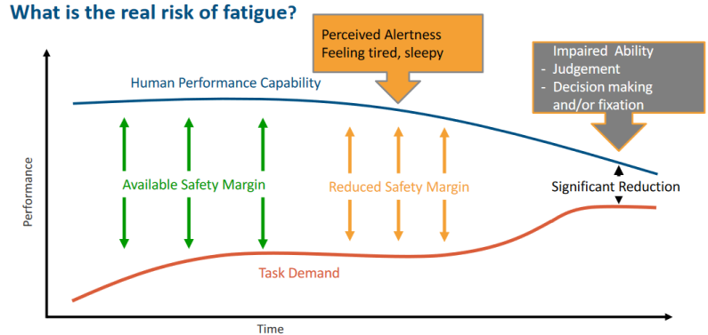

Overview of fatigue risk in WestJet Agents
Survey and Interviews Analysis from WestJet Agents.
Current understanding of fatigue risk at the local airport. From the survey data (Figure 2), fatigue was a relatively understood concept, but from the short interviews, agents did not feel that fatigue was applicable even though there were many situations of accumulative fatigue.
Figure 2: Survey Q46.3 "I know and understand fatigue risk"
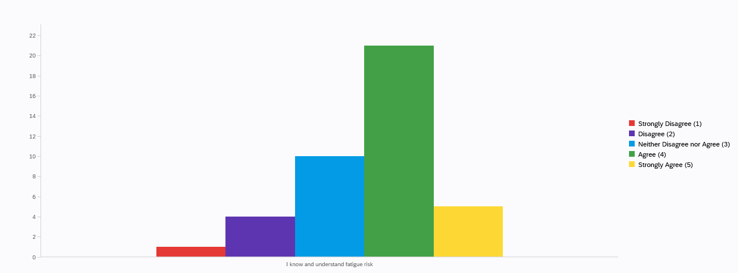
Current areas identified as a potential source of fatigue risk. From the research conducted by Transport Canada as well as other workplace organizations such as WorkSafe BC and Health BC, certain areas of concern have shown as potential sources of fatigue risk. In particular, two main areas of focus came up from the survey and interview results: scheduling of irregular break times and shift extensions caused by irregular operations.
Over 90% of survey participants responded that they extend their shifts outside of what was scheduled to cover operational needs. The most drastic example was from the interview with a BSA who mentioned he had to stay beyond the 12 hours of his shift due to the irregular disruption of a flight. There was no support he could be given as no contact was available between a BOL or DM, and as the last agent there on shift who could operate as a BSA had to stay beyond 12 hours, extending an extra 3 hours to a total of a 15 hour shift. He was also scheduled to work the day after, leaving only less than 10 hours between the start of his next shift. By context, extending beyond 12 hours was not a common yet not rare occurrence. Other CSAs with BSA relief roles have mentioned they stay beyond 12 hours to cover the last irregular flight operations. A key common issue comes up in the interviews with the participants stating that there is no available support when they must extend their shift for operational needs. The other key issue was on irregular break times, also due to operational needs, where agents have their breaks scheduled but then their breaks are moved from an earlier or delayed arrival of a flight. A common occurrence for agents that they see is having their breaks near the beginning or end of their shift, even in an 8 hour shift, sometimes causing more than 7 hours of work after a 30 min break, 30 minutes after they started their shift, until they identify it to DDC. Even then after identification of the issue, DDC may reject their request as it was “operationally needed”.
Along with the non-supportive environment for agents’ wellbeing, local WestJet agents do not have a good supportive system (Figure 3). Out of the respondents, the majority of the responses in believing that WestJet was supporting the agents on the floor was in disagreement. Only a few agreed that WestJet has good measures in place to manage fatigue, and more were in agreement WestJet has a lacking fatigue program.
Figure 3: Matrix of Survey Answers on WestJet and its Current Health Program Relating to Fatigue
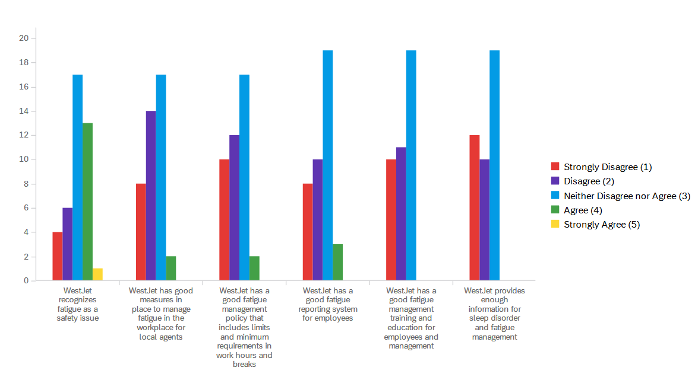

Recommendations for Initializing a Fatigue Risk Management Program
Initializing steps for creating fatigue risk management program.
Areas to promote fatigue risk awareness. Fatigue risk awareness remains exceptionally low, especially when only 1 out of the 44 current respondents have answered that they know about fatigue risk management programs. To raise awareness, one possible step to take is have a section, along with mental health awareness sections, during mandatory YVR meetings held every quarter, on fatigue risk and the management of fatigue hazards. Health and Safety Committee should also be reviewing the protocol for fatigue risk along with its meetings on mental health awareness.
Areas to provide resources. There are a few areas this could be improved on:
  - Shift work schedules, especially for consecutive work days need to be constructed to have the least amount of possible impact off duty especially for the scheduling to be changed so regularly and to account for sudden delays
    - An option to consider is to have relief roles that are already to cover operational breaks should be considered to cover for operation irregularities/be on call
    - DDC should also be trained in the program for fatigue management that is already in place for airport operators who schedule for flight crew to make sure they are able to manage over agents and scheduling of breaks
  - Enough support needs to be on the floor to be able to actively support agents
Current limitations for provided solutions. There are a few limitations for the proposed solution for these factors:
  - Beyond the fatigue program set up by the company, fatigue risk management also depends on the person to develop personal strategies which may be hard to individuals who have other commitments or cannot spare the time to rest for their livelihood.
  - Just like how we rely on data and research for the amendments to the aviation industry for flight crew, we also require more data and research on the fatigue levels and risk assessments in agents for further recommendations as this study was based on a brief and small sample size as well as:
    - Most of the research referenced is on the research compiled and conducted by Transport Canada based on findings for flight crew (which the factors considered as hazards may or may not be applicable specifically to agents on the floor)
  - The survey participants had a significant disproportional amount of agents working in the evening
  - The impact of the pandemic should also be considered as a factor that may have influenced the survey and interview participants due to the factor of limitations on agents being recalled and the changes based on the pandemic which include certain roles being removed and changed and with a shrunken workforce

CONCLUSION

Summary and Overall Interpretations of Findings
Fatigue risk is a serious issue that should be looked at for airport agents on the floor, beyond what is mandated for flight crew. The overall data from the conducted survey and interviews have highlighted two key areas of improvement for the wellbeing of local WestJet agents at YVR and to manage fatigue risk among those working on the floor.

Summary of Recommendations

The recommendations provided highlight areas of improvement and the first possible initialization steps for a fatigue management program, which include increasing fatigue risk awareness during company wide meetings and providing resources for agents on the floor and having DDC trained in the fatigue management program as airport operators.

Final Comments

This report was to highlight the dangers of fatigue and its possible negative consequences for WestJet agents based on the surveys and interviews conducted. Fatigue risk is an manageable hazard, especially by supporting agents on the floor which can help to increase the wellbeing of the individual as well as boosting morale within agents.

Works Cited
“Fatigue Management.” IATA, https://www.iata.org/en/programs/ops-infra/fatigue-risk/.
“Fatigue Risk in the Workplace.” WORKSAFEBC, 22 Apr. 2021, https://www.worksafebc.com/en/resources/health-safety/information-sheets/fatigue-risk-in-the-workplace?lang=en.
“Fatigue Risk Management ToolKit.” Fatigue Risk Managemenet Task Force, 2018.
Marcil, Isabelle, et al. “Introduction to Fatigue Audit Tools.” Fatigue Risk Management System for the Canadian Aviation Industry, Transport Canada and Edu.au, Apr. 2007, https://tc.canada.ca/sites/default/files/migrated/tp14577e.pdf.
Transport Canada. “Fatigue Risk Management - Module Two.” Transport Canada, 9 June 2011, https://tc.canada.ca/en/aviation/commercial-air-services/fatigue-risk-management/fatigue-risk-management-employees/fatigue-risk-management-module-two.
Tritschler, Kris. “Fatigue. Risk. Assessment.” Fatigue Management Approaches Symposium, Apr. 2016.
“Weakness and Fatigue.” HealthLink BC, https://www.healthlinkbc.ca/health-topics/wkfat.

