‘

Expanding Health and Wellness Education for Undergraduate Students at University of British Columbia

Written by Morgan Lorenz
November 26th, 2021
ENGL 301 99A
Business and Technical Writing
Dr. Erika Paterson

Due Date: November 26th, 2021
Extension Granted: November 24th, 2021

Table of Contents:

Introduction…………………………………………………………………………….. 2
Female Undergraduate Students……………………………………………………….. 2
University Courses……………………………………………………………………… 3
Collaborations with Administrative and Third-Party Units……………………………. 3
Mental Health and Stress……………………………………………………………….. 4
Health Guidelines ……………………………………………………………………… 4
Conclusion……………………………………………………………………………… 5
Recommendations………………………………………………………………………. 6
Works Cited…………………………………………………………………………..…. 7
Appendix………………………………………………………………………………… 8

Introduction

Health standards have evolved in the past five years due to residing through a health pandemic and a transition into a hybrid, dynamic living environment that lowered physical mobility rates across the country. As a result of the new normal, physical activity has plunged for many individuals due to the shift of the new social environment under public health safety guidelines. A unique population that is significantly impacted by this change includes undergraduate students. Starting in March of 2020, all universities across Canada shifted their academic teaching from in-person lectures in lecture halls and classrooms to an online, remote environment where students could join from the comfort of their home (Royal Bank of Canada, 2021). In universities, this led to the displacement of 1.2 million students across Canada into (Royal Bank of Canada, 2021). This new learning environment allowed for more individuals to engage in a heavily sedentary lifestyle that could have an impact on their academic life, social life and mental health than before the pandemic (Kuruganti, 2014).
University students are not meeting current public health guidelines on physical activity that support and sustain healthy living. In a study by Irwin (2007), her research surveyed populations at two universities in southwestern Ontario that illustrated through data-informed surveys the majority of this student population is at significant risk for health consequences associated with an inactive lifestyle. Exercise is essential towards improving and maintaining cardiovascular health. University students spend on average over nine hours a day in sedentary time due to preparation for assignments, lectures, and studying, which impacts their movement time during the day (Lorenz, 2021). Studies illustrate that increasing physical activity alternatives for university students resulted in lower stress levels and students felt more energized in their everyday life. Increasing movement or introducing new physical activity methods for university students in their everyday life can lead to physical and mental health benefits that can also support the student’s academic wellbeing (Kuruganti, 2014; Irwin, 2007).

Female Undergraduate Students

Studies indicate that female undergraduate students are more at risk than male undergraduate students, as female students indicated lower levels of interest in regular physical activity participation and sports than male students did. There is a significant consequence in this lack of physical activity that directly translates to a deterioration of health and development of obesity in a significant proportion of female students (Irwin, 2007). By providing increased education to this population, more female undergraduate students will be able to utilize more education and knowledge of a variety of opportunities that can be versatile and incorporated into their own lives.

University Courses

College-level wellness courses are a potential intervening point, so attention should be given to the connections between individual perceptions and health behaviors. Increasing the number of college courses available to undergraduate students that address health and wellness may positively benefit the physical and social health culture of the university at large. Additionally, by providing more open seminars or lectures available to the public may provide more opportunities for students to learn about the material but are unable to enroll in courses due to time constraints or conflicting course schedules. This would allow for more opportunities for the undergraduate students to engage with the material discussed in lectures over the course of the term and to engage with a dense overview of material that can be readily applicable and of use in their own lives.
Studies illustrate a positive impact on undergraduate student health by participating in college level courses focused on health and wellness. It is evident through research conducted that college-level wellness courses are a potential intervening point to enhance the wellbeing of undergraduate students, so attention should be made towards connections between student perceptions and their health behaviors (Cass et. al, 2020). Examining student values and priorities in regards to their health and self-efficacy may provide insight into opportunities on how to make health education more effective. This can inform how students view and process wellness education material, thus influencing their likelihood of taking action toward health-promoting behaviors.
By developing informative packages that are centred on harnessing one’s self efficacy, individuals will take ownership of their lifestyles and feel empowered to engage in a new physical activity routine. According to Cass et. al discussing informed research conducted on health related behaviours, priorities and measures of university students, one of the proposed measures that may determine an individual's activity engaging in exercise included self-efficacy, or an individual’s perceived ability to successfully accomplish a task (Cass et. al, 2020). Self efficacy was proven to be associated with “improved uptake of health-promoting activities such as exercise, decreased risk behaviors like smoking and alcohol use, and the wellbeing of college students” (Cass et. al, 2020). Through informative documentation of activities feasible for undergraduate students with a variety of different lifestyles, self efficacy can be captured by the target audience to circumvent their own lives for greater health outcomes.

Collaborations with Administrative and Third Party Units:

With an abundance of resources already present on the UBC campus, these informational packages could be easily used and distributed by a great number of individuals and generate more awareness. One key stakeholder to consider looping in includes UBC Recreation, a department at UBC centralized on increasing health and wellness opportunities available to undergraduate students across the UBC Vancouver campus. With collaborations annually in conjunction with UBC administrative units such as the UBC Wellness Centre, the opportunities available to connect with the greater undergraduate student population on health and wellness would be plentiful.
There are a variety of third-party organizations both on and off campus that generate revenue from the undergraduate student population. These include fitness centers such as Gold’s Gym or Fitness World, as well as independent studios such as Ride Cycle, Turf, and UBC Yoga Club on the UBC campus.

Mental Health and Stress

Stress, nutrition, and mental health were the topics of overwhelming personal concern to students. Introducing different modes of physical activity into one's schedule has led to a decrease in stress and boost in mental health. By increasing one’s physical activity in their everyday life, the individual may be able to develop a habit that can curb stress and address barriers in their own mental health and wellness. According to the survey conducted by Lorenz (2021), the majority of UBC undergraduate respondents are eager to find a strong balance within their current schedule- especially one that balances physical, emotional and mental health. Studies show that engaging in physical activity or more health and wellness activities can positively influence one’s mental health (Bartholomew, Morrison & Ciccolo, 2005).
Students returning back to on-campus university life or working in a hybrid model with their studies are managing the challenges of an in person or online course schedule no longer from the enclaves of their residential home. As stated by a study review performed at Colorado State University on university students, the environment can influence young people’s level of engagement, because of access to fitness centers, gyms or other recreational facilities (Dodge, 2016). During a more hybrid academic environment or needing to study for courses online, individuals are reaching their max screen time due to higher-stress environments for academic studies. This must be addressed better to provide healthy alternatives to reduce sedentary screen time outside of lecture time and encourage more movement in everyday life.

Health Guidelines

In 2020, the Canadian Society for Exercise Physiology produced holistic wellness guidelines for all Canadians that addressed daily physical activity, sedentary behaviour and sleep for different age brackets. For adults between the ages 18-64 years old, moderate to vigorous physical activity that adds up to 150 minutes a week and lowering screen time to 3 hours a day is highly recommended. For young adults attending university, these parameters can be difficult to achieve due to studying and course schedules, living conditions, and limited accessibility to fitness centers/public parks for recreational use. It is important to provide university students with accessible and low barrier methods to increase their daily physical activity and lower their sedentary behaviour taking into account their unique circumstances.
Some of these methods include addressing challenges that may be a barrier for students to participate in regular physical activity. These barriers include constraints such as “not having enough time” or “can’t afford a gym membership” or even “I don’t know where to begin”. It is important to address all of the above constraints that might cause an individual to disengage from physical activity. This will be done through the development of a comprehensive education tool that can be used and distributed across the UBC campus and available at different departments across campus. It is important that all administrative offices take a hand in supporting health outcomes for undergraduate students in order to better the academic wellbeing of the university at large.

CONCLUSION

Based on the survey conducted and the research reviewed to support this assessment, it is evident that undergraduate students would benefit from an increase in informative resources that are tailored to their unique academic and social lifestyle. With isolation from quarantine in the past and into the present, undergraduate students must venture the current times within the unique parameters set by public health standards impacting their academic schedule while also maintaining and upkeep a healthy balance within their own life. It is critical to address physical activity limitations impacting this population in order to develop foundational time management skills and cultivate more physical activity in students for postgraduate life when transitioning into the workforce. There are critical benefits impacting physical and mental health by increasing physical activity opportunities for individuals across the undergraduate population, especially in the long run for an individual’s cardiovascular health and mortality.
By providing substantive, detailed material for impacted populations, individuals will be presented with options that are feasible and accessible for their lifestyles. Through the development of these material packages, this would additionally generate more public and sociocultural awareness of physical activity and its increased importance for this population due to increased engagement and utilization of the informational material. The development of these informational packages would harness the greater Vancouver health and wellness culture and funnel it into better supporting an at-risk population that can better utilize the resources and opportunities around them. It is important more than ever to incorporate physical activity into one’s everyday lifestyle to be approachable, accessible and convenient for the individual’s abilities and everyday life structure.

Recommendations:
- Develop curated and broad healthy lifestyle guides that are uniquely tailored to undergraduate students. Create one for men and another for women to be able to address underlying differences and barriers challenging these populations from increasing physical activity in their everyday life.
- Conduct a survey on undergraduate students to better assess the time of the school day when there is more free time for relaxation of physical activity. Utilize this data to increase opportunities for physical activity across the UBC campus, including exercise classes or wellness seminars by extracurricular or third party groups.
- Collaborate with local fitness facilities and independent studios to provide suitable options for undergraduate students through deal packages or one-time passes.
- Utilize mass UBC campaigns, such as Move UBC, to distribute these informational packages and generate more awareness addressing sociocultural and physiological barriers impacting undergraduate students from decreasing their sedentary time.
- Increase the number of mobile learning opportunities within libraries across the UBC Vancouver campus. This would mean increasing the number of treadmills or stationary bikes available that have adaptations to support for mobile learning.
- Increase the amount of subsidies available for undergraduate students who require further support for their wifi connections at home, which supports both academic earning and opportunities for students to engage in the virtual fitness environment.
- Introduce collaborations between UBC Recreation and platforms such as Class Pass, engaging more students with the virtual learning environment to support with alternate modalities if studying from home.
- Providing recommendations in all undergraduate faculties to encourage undergraduate students to enroll in courses centered on health and wellness during their undergraduate career.
- Increase the number of seminars or open lectures available to undergraduate students throughout the academic year that address health and wellness barriers present in modern times. This allows for undergraduate students to engage with prevalent material and maybe utilize the material discussed in their own lives.

Works Cited

Bartholomew, J. B., Morrison, D. & Ciccolo, J. T. (2005). Effects of acute exercise on mood and wellbeing in patients with major depressive disorder. Medical Science of Sports Exercise, 37 (12), 2032-2037. doi:10.1249/01.mss.0000178101.78322.dd
Cass, A. L., Holt, E. W., Criss, S., Hunt, E. & Reed, R. (2020). Health related priorities, perceptions and values of university students: Implications for wellness education. American Journal of Health education, 52, (1), 37-47. doi:10.1080/19325037.2020.1844103
Dodge, J. (26 Sept. 2016). Study finds troubling evidence of teens’ lack of physical activity. Colorado State University. Retrieved from https://source.colostate.edu/study-finds-troubling-new-evidence-of-teens-lack-of-physical-activity/
Irwin, J. D. (2007). The prevalence of physical activity maintenance in a sample of university students: A longitudinal study. Journal of American College Health, 56 (1), 37-41. doi:10.3200/JACH.56.1.37-42
Kuruganti, U. (2014). The impact of a required undergraduate health wellness course on students awareness and knowledge of physical activity and chronic disease. Collected Essays on Learning and Teaching, 7, (2), 116-125. Retrieved from https://files.eric.ed.gov/fulltext/EJ1060234.pdf
Lorenz, M. (2021). ENG 301 99A: Health wellness of undergraduate students survey. Retrieved from https://docs.google.com/spreadsheets/d/1Y79zcunmvxI4sW0cFnch2pVTEDJhUjJgci0prGtGhkg/edit#gid=0
Royal Bank of Canada (2021). The future of post-secondary education: On campus, online and on demand. Royal Bank of Canada, Skills. Retrieved from https://thoughtleadership.rbc.com/the-future-of-post-secondary-education-on-campus-online-and-on-demand/
Silver, M. P., Easty, L. K., Sewell, K. M., Georges, R. & Behman, A. (2019). Perspectives on exercise participation among Canadian university students. Health Education Journal, 78 (7), 851-865. doi:10.1177/0017896919850206

Appendix

- Mock Draft of Informative Package for University Students

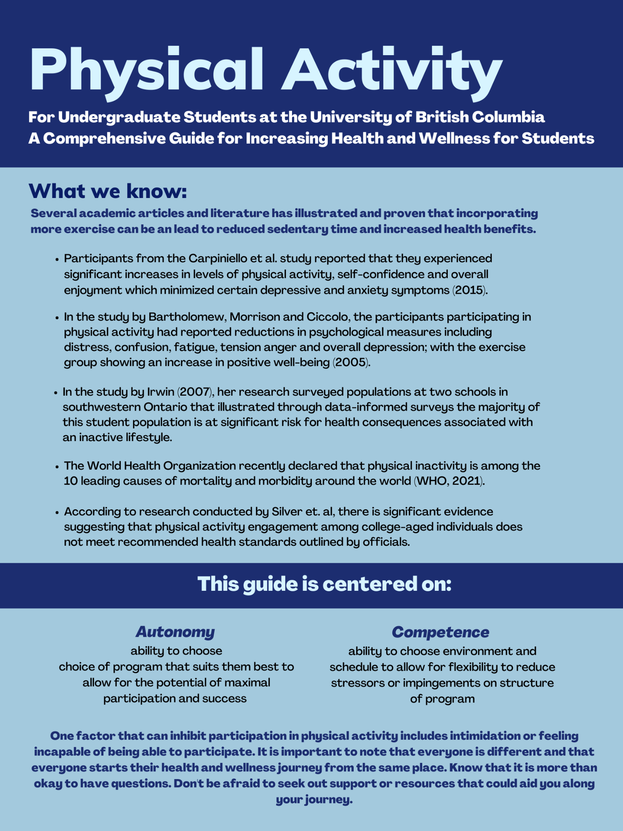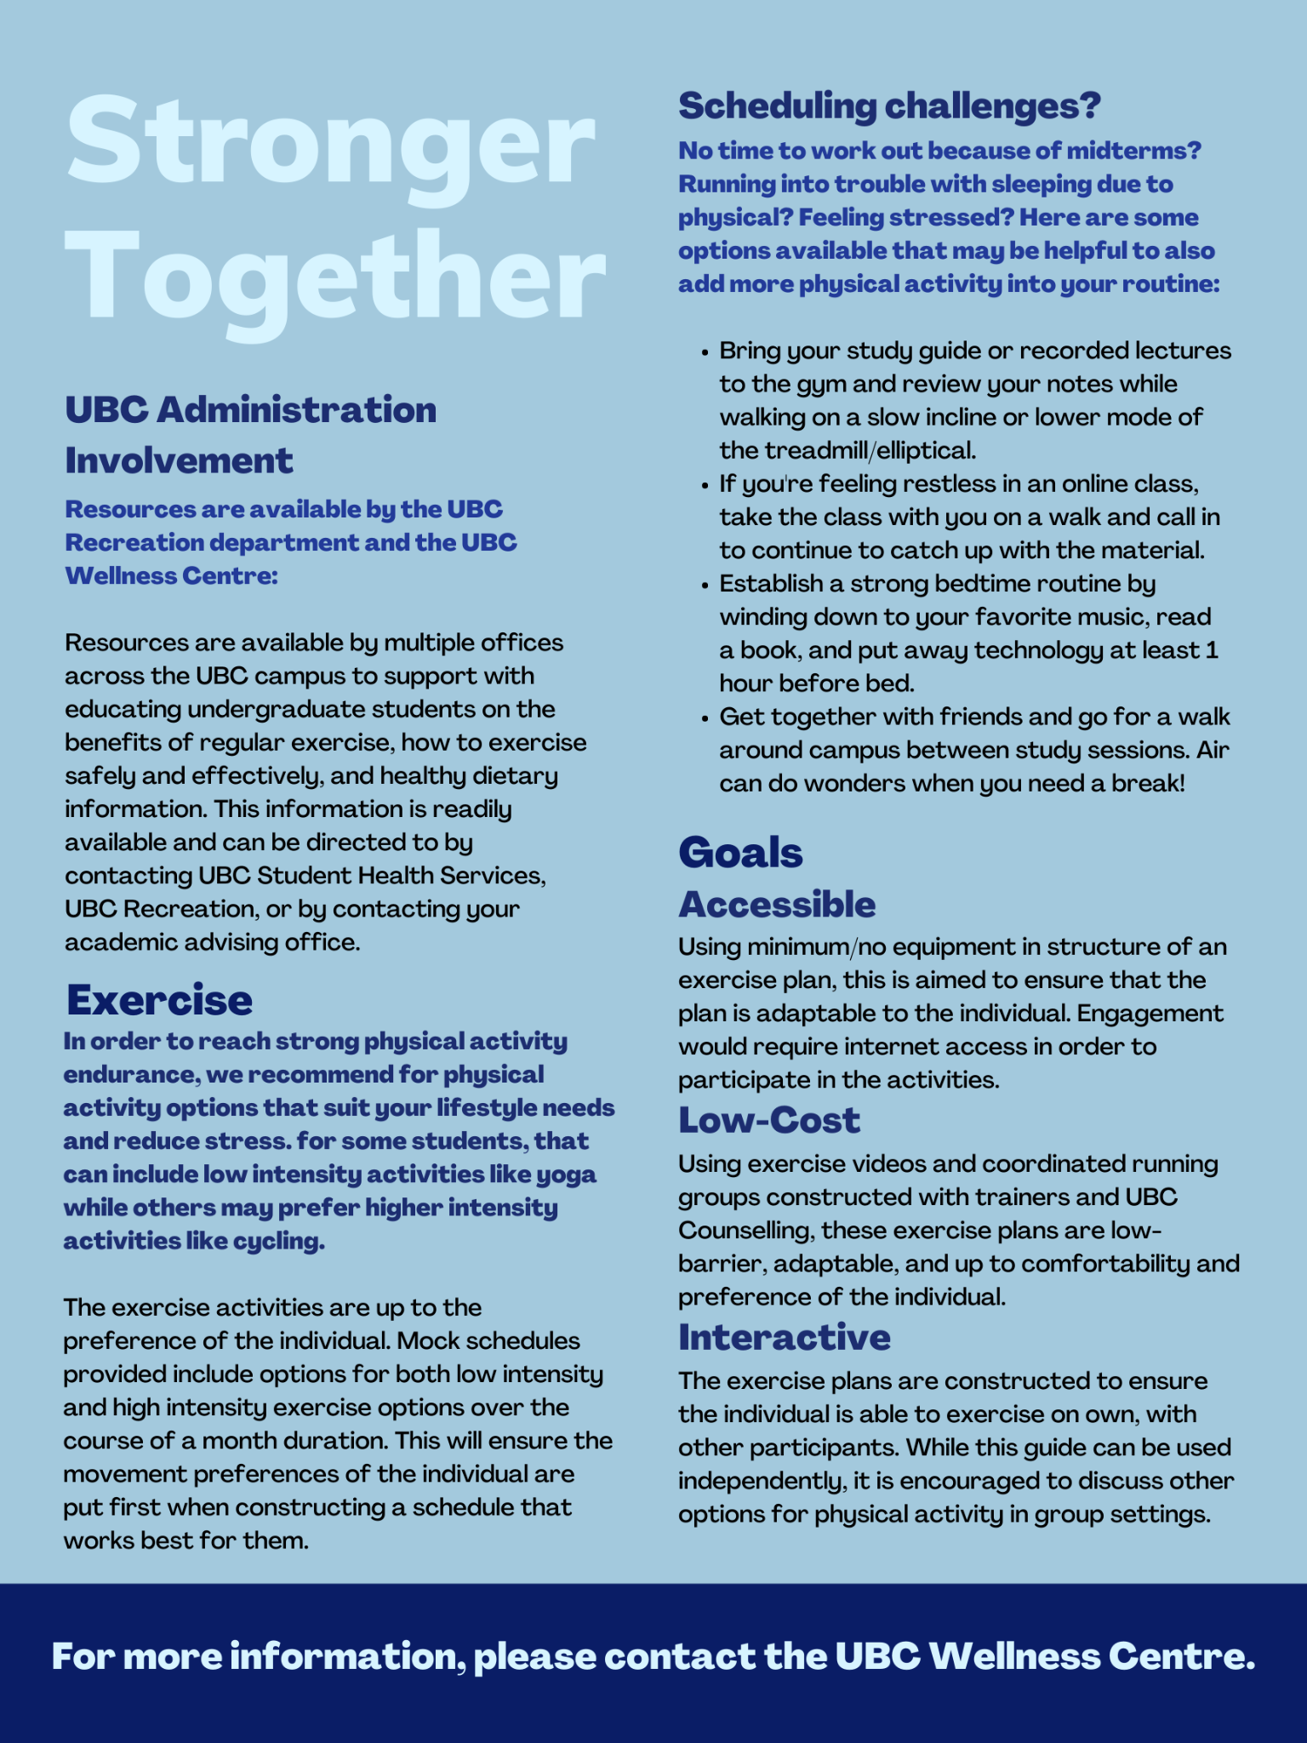
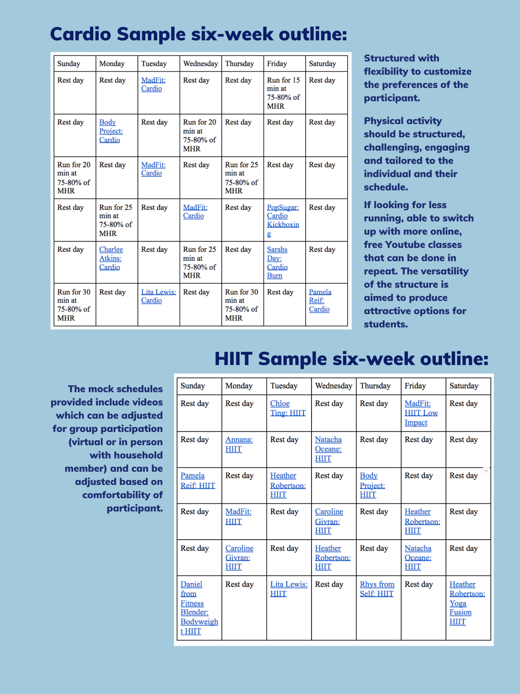

- Results from ENGL 301 99A: Health Wellness of Undergraduate Students Survey by Morgan Lorenz.

ENGL 301 99A: Health Wellness of Undergraduate Students Survey
November 26th 2021, 11:41 pm MST
Q1 - 1. Do you identify as a student enrolled in undergraduate courses at UBC?
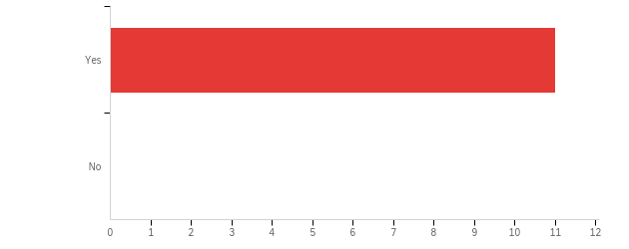

# | Field | Minimum | Maximum | Mean | Std Deviation | Variance | Count
1 | 1. Do you identify as a student enrolled in undergraduate courses at UBC? | 1.00 | 1.00 | 1.00 | 0.00 | 0.00 | 11

# | Answer | % | Count
1 | Yes | 100.00% | 11
2 | No | 0.00% | 0
 | Total | 100% | 11

Q2 - 2. What is the usual method to get to campus each day?
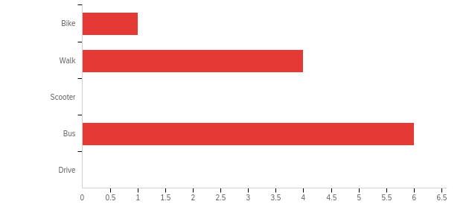

# | Field | Minimum | Maximum | Mean | Std Deviation | Variance | Count
1 | 2. What is the usual method to get to campus each day? | 1.00 | 4.00 | 3.00 | 1.13 | 1.27 | 11

# | Answer | % | Count
1 | Bike | 9.09% | 1
2 | Walk | 36.36% | 4
3 | Scooter | 0.00% | 0
4 | Bus | 54.55% | 6
5 | Drive | 0.00% | 0
 | Total | 100% | 11

Q3 - 3. Which of the following are most helpful for providing information on health and wellness?
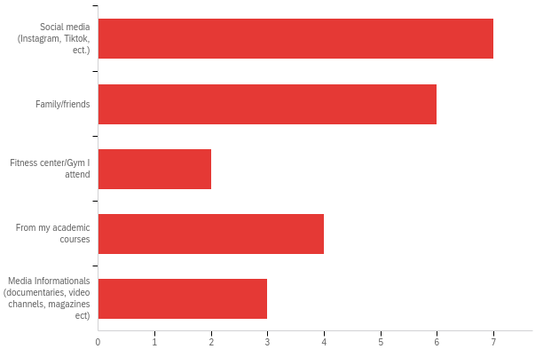

# | Answer | % | Count
1 | Social media (Instagram, Tiktok, ect.) | 31.82% | 7
2 | Family/friends | 27.27% | 6
3 | Fitness center/Gym I attend | 9.09% | 2
4 | From my academic courses | 18.18% | 4
5 | Media Informationals (documentaries, video channels, magazines ect) | 13.64% | 3
 | Total | 100% | 22

Q11 - 4. On an average day, a typical student will spend this many hours sitting down:
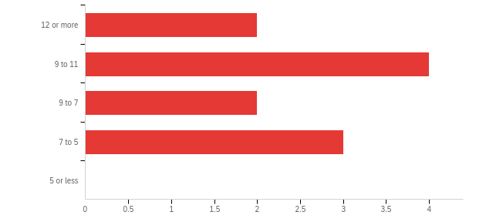

# | Field | Minimum | Maximum | Mean | Std Deviation | Variance | Count
1 | 4. On an average day, a typical student will spend this many hours sitting down: | 1.00 | 4.00 | 2.55 | 1.08 | 1.16 | 11

# | Answer | % | Count
1 | 12 or more | 18.18% | 2
2 | 9 to 11 | 36.36% | 4
3 | 9 to 7 | 18.18% | 2
4 | 7 to 5 | 27.27% | 3
5 | 5 or less | 0.00% | 0
 | Total | 100% | 11

Q4 - 5. On an average day, a typical student will spend this many hours sleeping:
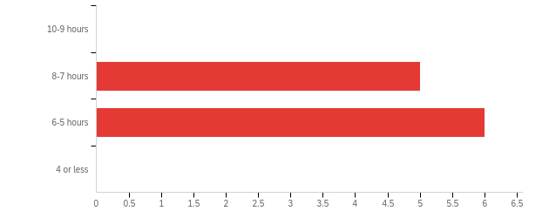

# | Field | Minimum | Maximum | Mean | Std Deviation | Variance | Count
1 | 5. On an average day, a typical student will spend this many hours sleeping: | 2.00 | 3.00 | 2.55 | 0.50 | 0.25 | 11

# | Answer | % | Count
1 | 10-9 hours | 0.00% | 0
2 | 8-7 hours | 45.45% | 5
3 | 6-5 hours | 54.55% | 6
4 | 4 or less | 0.00% | 0
 | Total | 100% | 11

Q5 - 6. What does healthy living look like?

6. What does healthy living look like?
Having balance in your life around school, social activities, exercise, eating, etc without being to rigid in what balanced means, fluctuations in everything should be expected and accepted
Happy mentally / eating well / physical activity
Balanced lifestyle, eating full meals & not being too stressed over things
Sleeping enough, eating a well balanced diet, having time to relax and enjoy yourself.
Having a balanced lifestyle
Physical, mental, and emotional health all in balance
Having a balance of social life, personal time and work life while being free of illness
Proper sleep, good diet, active living style, and good socialization.
eating well, being happy, exercise

Q6 - 7. Would comprehensive, informational packages about healthy lifestyle living for university students be helpful?
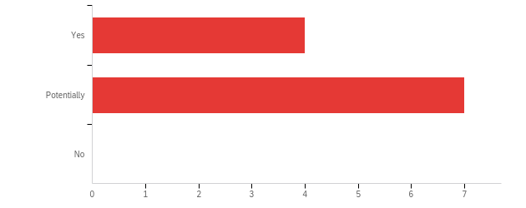

# | Field | Minimum | Maximum | Mean | Std Deviation | Variance | Count
1 | 7. Would comprehensive, informational packages about healthy lifestyle living for university students be helpful? | 1.00 | 2.00 | 1.64 | 0.48 | 0.23 | 11

# | Answer | % | Count
1 | Yes | 36.36% | 4
2 | Potentially | 63.64% | 7
3 | No | 0.00% | 0
 | Total | 100% | 11

Q7 - 8. It is hard to lead a healthy lifestyle as a student?
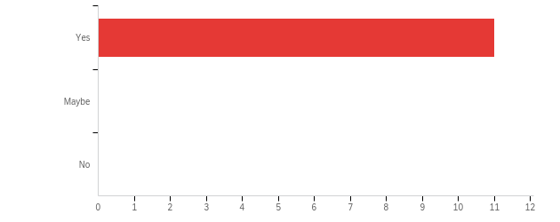

# | Field | Minimum | Maximum | Mean | Std Deviation | Variance | Count
1 | 8. It is hard to lead a healthy lifestyle as a student? | 1.00 | 1.00 | 1.00 | 0.00 | 0.00 | 11

# | Answer | % | Count
1 | Yes | 100.00% | 11
2 | Maybe | 0.00% | 0
3 | No | 0.00% | 0
 | Total | 100% | 11

Q8 - 9. If "Yes" or "Maybe", what parts in an undergraduate student's lifestyle make it hard to be healthy?
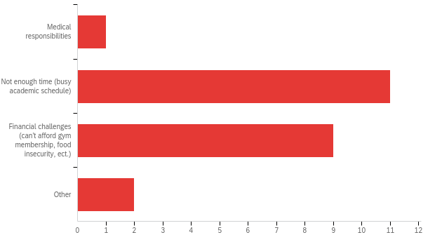

# | Answer | % | Count
1 | Medical responsibilities | 4.35% | 1
2 | Not enough time (busy academic schedule) | 47.83% | 11
3 | Financial challenges (can't afford gym membership, food insecurity, ect.) | 39.13% | 9
4 | Other | 8.70% | 2
 | Total | 100% | 23

Q8_4_TEXT - Other
Other - Text
You have a really weird schedule and lot of deadlines and financial demands, on top of a very transient lifestyle.
Struggling with mental health

Q9 - 10. What kind of fitness should undergraduate students incorporate more into their schedule?
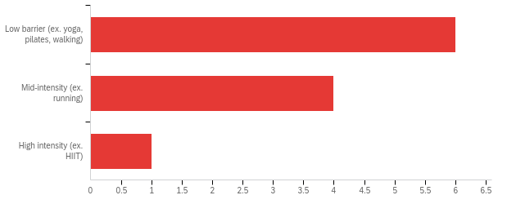

# | Field | Minimum | Maximum | Mean | Std Deviation | Variance | Count
1 | 10. What kind of fitness should undergraduate students incorporate more into their schedule? | 1.00 | 3.00 | 1.55 | 0.66 | 0.43 | 11

# | Answer | % | Count
1 | Low barrier (ex. yoga, pilates, walking) | 54.55% | 6
2 | Mid-intensity (ex. running) | 36.36% | 4
3 | High intensity (ex. HIIT) | 9.09% | 1
 | Total | 100% | 11

Q10 - 11. What are other wellness components that undergraduate students should incorporate more into their lifestyle?
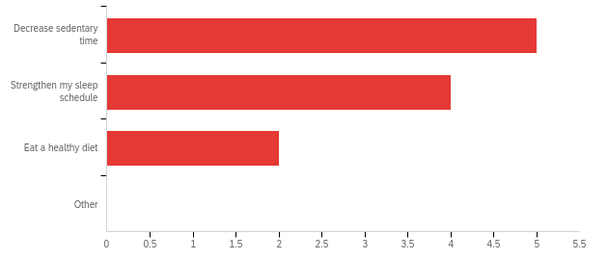

# | Field | Minimum | Maximum | Mean | Std Deviation | Variance | Count
1 | 11. What are other wellness components that undergraduate students should incorporate more into their lifestyle? - Selected Choice | 1.00 | 3.00 | 1.73 | 0.75 | 0.56 | 11

# | Answer | % | Count
1 | Decrease sedentary time | 45.45% | 5
2 | Strengthen my sleep schedule | 36.36% | 4
3 | Eat a healthy diet | 18.18% | 2
4 | Other | 0.00% | 0
 | Total | 100% | 11

