Karen Okoyomon
XXX W 18th Ave
Vancouver, BC, V6B 1B6

November 26, 2021

Matt Dolf
UBC Wellbeing Design Lab
2321-2260 West Mall
Vancouver, British Columbia, Canada, V6T 1Z4

Subject: Letter of Transmittal

Dear Dr. Dolf,

Below is my report on improving the wellbeing of UBC students with the focus on test anxiety and sleep deprivation. This report will help provide suggestions to the wellness office to add new resources for the students to use in times of high stress, especially during final exams. This report contains primary research data that gathers opinions from current UBC Vancouver students. Secondary external research was obtained from studies that show the effects of high-stress environments and their effect on academic performance.

The report focuses on what causes stressors and how they affect other areas of a student’s life. Recommendations for improvements are included to help offer solutions to the problem at hand. These improvements are designed to be easily accessible by all students at UBC Vancouver.

Thank you taking the time to review this report. For further questions or concerns, please feel free to reach me by email at karenokoyomon@gmail.com.

Sincerely,

Karen Okoyomon

Karen Okoyomon

Improving Student Wellbeing at UBC Vancouver

Feasibility analysis of anxiety management and preventing sleep deprivation amongst students

For

Matt Dolf
Director at the UBC Wellness Office

By

Karen Okoyomon
November 16, 2021
Table of Contents
I. ABSTRACT 3
II. INTRODUCTION 5
A. Background 5
B. Statement of Problem 5
C. Purpose of the Report 6
D. Research Methods 6
III. DATA SECTION 6
A. The effect of test anxiety on academic performance 6
1. Recap of interviews - anxiety 7
2. Primary source data from surveys 7
B. Studies of the effects of sleep deprivation 8
1. The impact of sleep on academic performance & nap pods 8
2. Interview recap - sleep 9
3. Sleep survey results 10
D. Mental Health Resources 12
IV. CONCLUSION 12
A. Summary of findings and interpretation 12
B. Recommendations 13
V. Works Cited 13
VI. APPENDIX 14
Appendix A. Survey questions 14
Appendix B. Interview Questions and Answers 15

I. ABSTRACT

High grades are seen as one of the most important determining factors of academic success. While striving to achieve highly is highly valued in university, student well-being can come at the expense of their studying efforts. During exam season, there are high levels of stress that lead to both test anxiety and sleep deprivation due to extreme study methods.

This report studies the effect of test anxiety and sleep deprivation on students’ wellbeing and academic performance. The students at the University of British Columbia offer insight as to how they feel during their studies in university. This report uses students’ self-reported information about their wellbeing, as well as secondary research from other institutions.

Recommendations for improvement are offered to help students reduce their stress and increase their overall sleep. These improvements include offering easily mental health counselling resources on campus to reduce anxiety, as well as implementing nap pods on UBC campus for students to refresh during their studies. These recommendations are offered to the UBC Health and Wellness office, as they have the power to implement these changes.

II. INTRODUCTION

A. Background
Student wellbeing is an important part of the university experience. Students often experience high levels of stress that interfere with other areas of their life. At a highly ranked institution like UBC, it is important that students feel well so that they can continue to excel in their studies. Test anxiety affects close to 40% of students, with 16-20% experiencing high test anxiety, and 18% with moderately high anxiety (Linan). Many students experience the stressors of school on a frequent basis. There is an immense pressure to not only pass classes, but also excel in them. Many students have a fear of failure that can push their stress levels over the edge during. This is most common exam season, where the stakes are higher – this stress can lead to unhealthy coping mechanisms and study methods. Some students turn to pulling all-nighters to stay up studying for their assessments. While studying is an integral part of academia, it is often placed in priority over student wellbeing.

B. Statement of Problem
The stress of university can leave students feeling overly exerted, especially during midterm and exam season. When courses prioritize grades over learning, students can experience feelings of hopelessness, worthlessness, or inadequacy trying to reach their academic goals. Students frequently lose sleep to study for more hours in the day, which has negative impacts on both their short-term and long-term health.

C. Purpose of the Report
The purpose of this report is to better understand how students are affected by the stressors of academic pressure. In this report, methods to reduce student anxiety and sleep deprivation is researched. This report studies the impact that anxiety and sleep have on students’ academic performance. The improvements focus on improving the mental health and sleep health.

D. Research Methods
Research on the impact of test anxiety and sleep amongst students is conducted through a mix of primary and secondary research methods. The primary source data is obtained through a survey sent to UBC students of all faculties, as well as an interview with a current undergraduate student at UBC. The secondary sources data is obtained through external research on the subject.

III. DATA SECTION

A. The effect of test anxiety on academic performance
Test anxiety is the nervousness that occurs before a test or exam. These nerves can cause people to have immense feelings of dread, worry, and fear. The American Test Anxieties (ATA) association studies the affect that school and testing have on students’ lives. According to the ATA, “students who struggle with test anxiety typically fall a half a letter grade below their peers” (Oxford Learning). The causes of this anxiety can be situational, such as the pressure of timed test and intimidation from the classroom setting, or mental such as the fear of poor grades, self-esteem, etc. According to figure 2, 60% of the students surveyed reported that their grades decrease due to test anxiety. This is discouraging, as their poor grades can confirm their previous feelings of worthlessness. As seen in figure 3, many students are unaware of the resources available for them to get better.

Recap of interviews - anxiety
In an interview conducted with a third year Psychology student at UBC, the answers to each question were as follows (see appendix B for the interview questions):
Q1: What is your Major? How many hours per week do you spend studying?
“I am a third-year psychology student, and I study every day. I spend the whole day studying, and I rarely catch a break. In one day, maybe 3-4 hours minimum, not including the time spent in class.”
Q4: Do you have test anxiety? How are some ways you deal with it?
“Yes, I do experience test anxiety from time to time. I usually try to calm my nerves during the test by doing some deep breathing when I feel stressed.”

Primary source data from surveys
See appendix A for full details of the survey questions being asked.

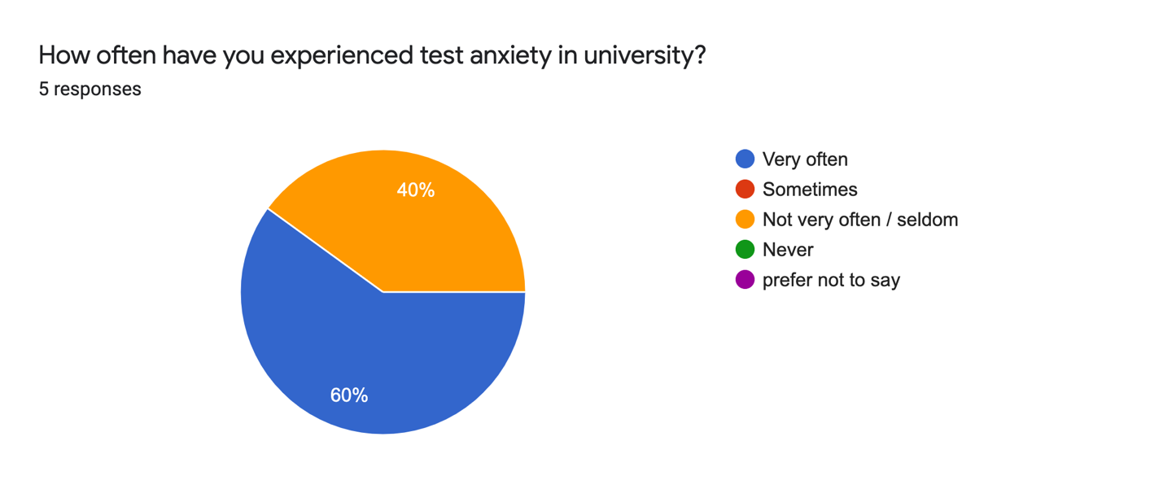
Figure 1: Survey results of test anxiety amongst university students
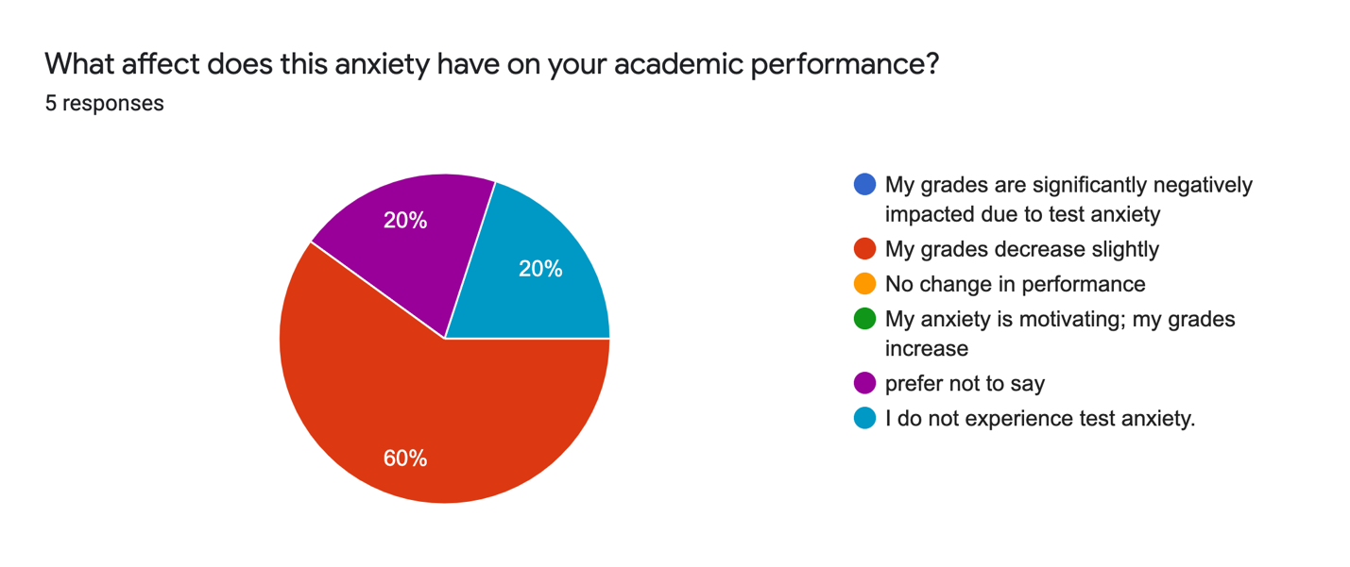
Figure 2: Survey results of the effect of test anxiety on academic performance

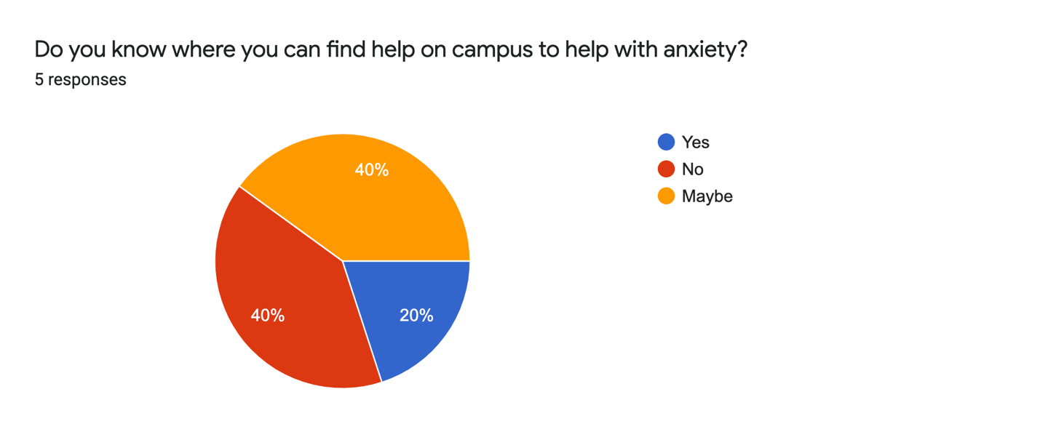
Figure 3: Survey results of places on campus to find help with anxiety

B. Studies of the effects of sleep deprivation

1. The impact of sleep on academic performance & nap pods
Sleep is an important part of life. It is important for human growth, development, and recovery, yet so many people still chose to sacrifice this vital part of living. Having enough sleep can help improve performance, concentration, and focus. The sleep foundation recommends 7-9 of sleep per night for adults (Suni), yet in the survey conducted (see figure 4), several students tend to have 6 hours or less. In a study from Kana Okano et al, it was found that “sleep measures accounted for nearly 25% of the variance in academic performance” (Okano, Kaczmarzyk and Dave). This information indicates that getting adequate sleep is an integral part of student success.
Naps are said to help people retain more information than they were previously. Some individuals report feeling more energized after a short nap rather than a long period of time. During exam season, many students like to stay up late in the library to revise. As they study for multiple hour sessions, the fatigue can set in quickly. One tool used to increase student sleep is the implementation of “nap pods”, which are “large pieces of furniture meant to offer people the quiet, comfortable privacy they need to take a refreshing nap in a busy work environment” (Shoen). In a study from Neighmond in which the implementation of nap pods was experimented at a high school, it is revealed that a short nap "can give a boost to memory and attention during the day, and it can increase school performance" (Neighmond). A nap pod implemented at UBC can help students on their study breaks so that they can relax and refresh their brains in a small yet comfortable space. These nap pods can be placed in libraries so that students can have quick and easy access to a break during their study session.

2. Interview recap - sleep
Q2: Do you think university tends to glamorize sleep deprivation?
"Yes, absolutely. I find that people tend to brag about how little sleep they get. It’s like they correlate a lack of sleep with more dedication or rigour when that is not always the case. People play it off like it’s just the culture of being in college or university, but it’s actually a huge problem because students are getting 4-5 hours of sleep per night and acting like that’s normal and healthy.”
Q3: Why do you think so many people find it difficult to get enough sleep?
“Well people have a lot of schoolwork. Sometimes there is just not enough hours in then day to get it all done. And on top of that, some people have jobs, or are trying to keep up with friends in their social life.”

3. Sleep survey results
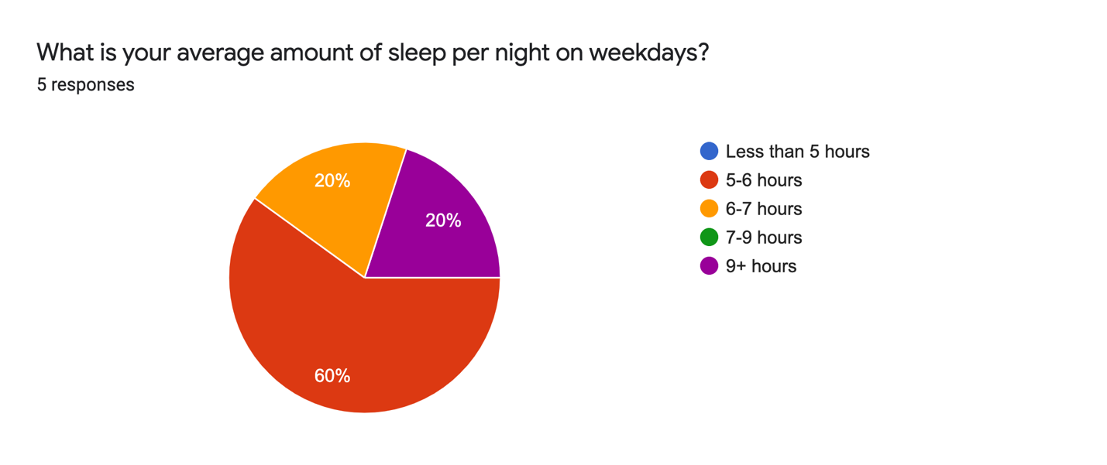
Figure 4: survey results of average sleep per night on weekdays

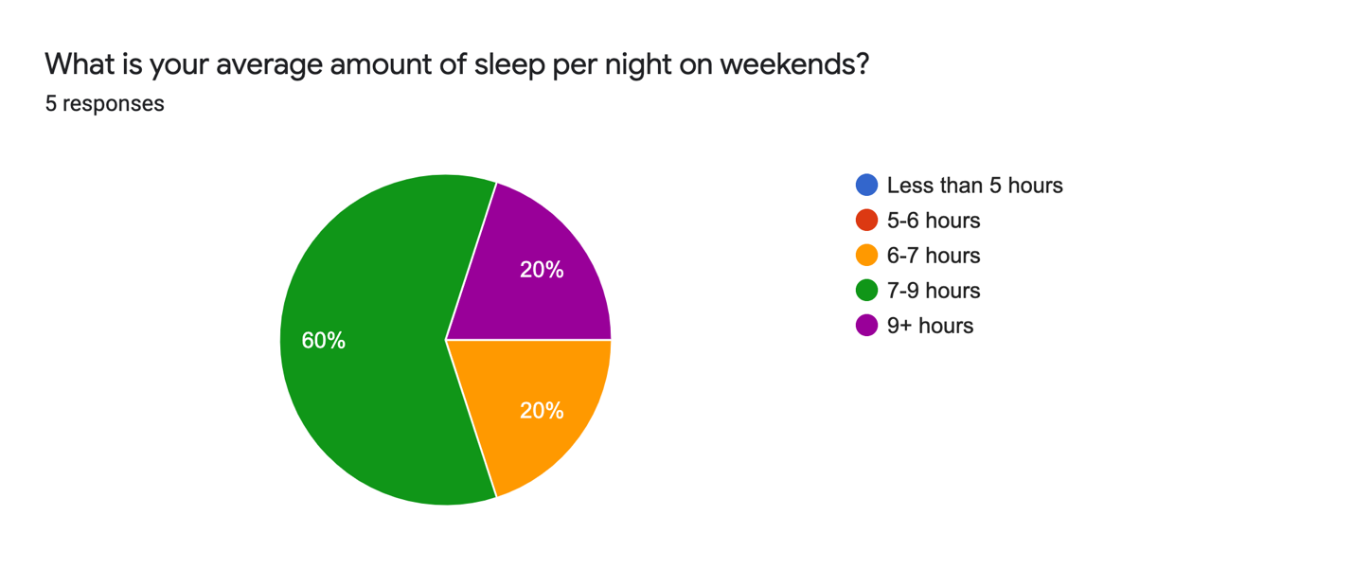
Figure 5: survey results of average sleep per night on weekends

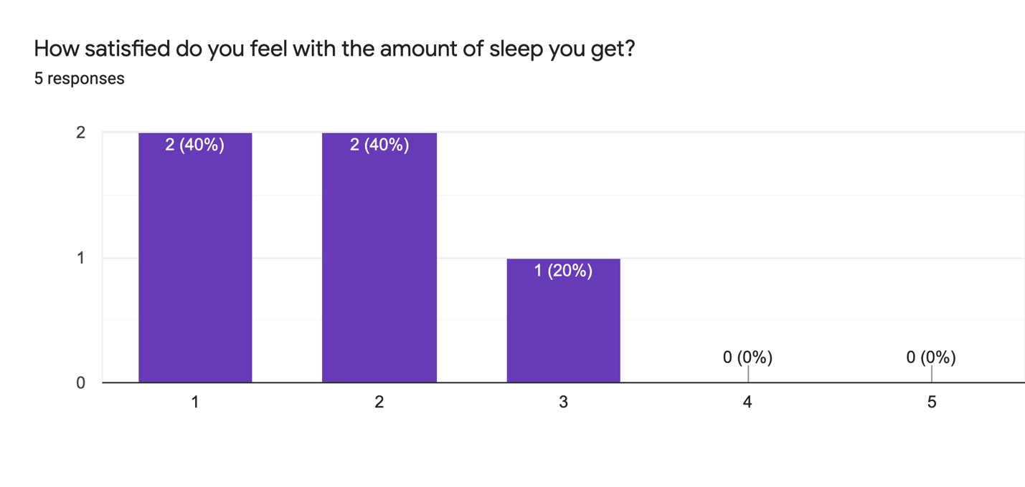
Figure 6: survey results of sleep satisfaction

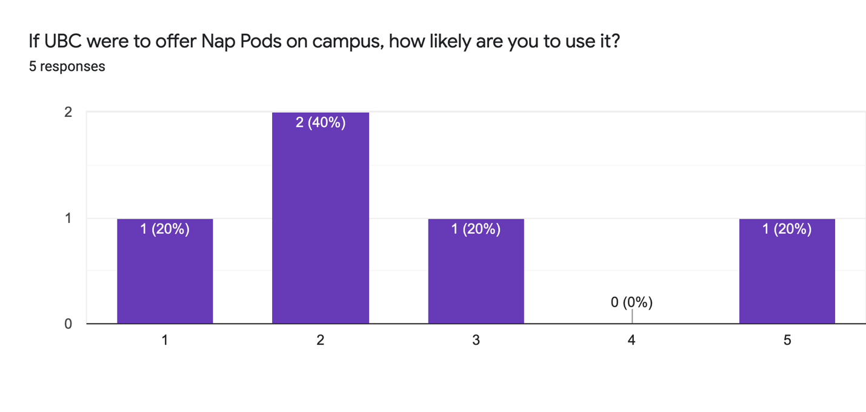
Figure 7: survey results of nap pods
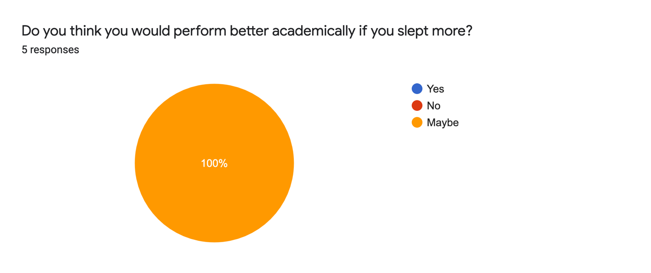
Figure 8: survey results of academic performance

D. Mental Health Resources
The survey shows that only 1 in 5 students know where they can access the resources the get the help that they need. There is an untapped market of students in search of help but who are unaware of where to go get it. The UBC Wellness can improve this by making information more available to the public about where they can find the help that they need. While the office offers counselling, students are unaware as to how they can take the steps they need to improve their mental health.

IV. CONCLUSION

Summary of findings and interpretation
Overall, test anxiety and sleep deprivation remain as prevalent issues in the world of academia. Students can feel overwhelming amounts of stress on a daily basis. The main findings were that A) many students experience test anxiety but do not know where to get help; and B) the majority of students do not get nearly enough sleep as is recommended. This is due to immense pressure placed on students to excel in their studies. Exam season is the most stressful time of year, and this should be the targeted time of implementing improvements to resolve the aforementioned issues.

Recommendations
UBC should focus more on implementing resources that students can use to reduce their anxiety and offer more accommodation to those who feel unwell in test situations. They should market their services more frequently, and in common spaces, to allow students to become aware of them. The wellness office should also include extra hours around the time of exams to accommodate for an influx of new students needing help. By implementing this, it will help students to feel better and perform at a higher level in their classes without the high stress levels. In addition, UBC should implement nap pods on campus to allow students to refresh their brains while studying. These pods should be mostly available in the various libraries on campus. With the right tools, any student can succeed, it is only a matter of providing them with the resources for success.

V. Works Cited

Linan, Ali. “Test Anxiety May Leave Some Students Unable to Achieve on Exams.” Las Cruces Sun-News, 21 Nov. 2017, https://www.lcsun-news.com/story/life/wellness/2017/11/21/test-anxiety-performance-anxiety-students-finals/800902001/.
Neighmond, Patti. Stressed-Out High Schoolers Advised to Try A Nap Pod. Washington: NPR, 2017. ProQuest. Web. 26 Nov. 2021.
Okano, Kana, et al. "Sleep quality, duration, and consistency are associated with better academic performance in college students." npj Science of Learning (2019).

Shoen, Sarah. Nap Pods. 13 August 2021. 2021, https://www.sleepfoundation.org/sleep-hygiene/nap-pods.
Suni, Eric. “How Much Sleep Do We Really Need?” Sleep Foundation, 10 Mar. 2021, https://www.sleepfoundation.org/how-sleep-works/how-much-sleep-do-we-really-need#:~:text=National%20Sleep%20Foundation%20guidelines1,to%208%20hours%20per%20night.
“What Is Test Anxiety (and How It Affects Students).” Oxford Learning, 20 Aug. 2018, https://www.oxfordlearning.com/what-is-test-anxiety/.

VI. APPENDIX

Appendix A. Survey questions

Survey on sleep and anxiety amongst students

I am an undergraduate student at UBC working on a technical writing project. This survey is intended to be used to obtain primary data to analyze how sleep deprivation and anxiety affects student's overall wellbeing and academic performance. This study focuses primarily on students at the UBC Vancouver campus. The final formal report will be addressed to The Health and Wellbeing student services office. Together with supplemental research from scholars, the data from this survey will be used to propose accessible methods for increasing the overall wellbeing of students. The survey contains 8 questions, and it should take about 5 minutes. Your responses are anonymous. Thank you for participating in my survey.

Q1: What is your average amount of sleep per night on weekdays?
- Less than 5 hours
- 5-6 hours
- 6-7 hours
- 7-9 hours
- 9+ hours

Q2: What is your average amount of sleep per night on weekends?
- Less than 5 hours
- 5-6 hours
- 6-7 hours
- 7-9 hours
- 9+ hours

Q3: How satisfied do you feel with the amount of sleep you get?
Not sufficient, I am tired all the time. Great, I feel energized.
1 2 3 4 5

Q4: If UBC were to offer Nap Pods on campus, how likely are you to use it?
Not likely at all Very Likely

1 2 3 4 5

Q5: Do you think you would perform better academically if you slept more?
- Yes
- No
- Maybe
- Other:

Q6: How often have you experienced test anxiety in university?
- Very often
- Sometimes
- Not very often / seldom
- Never
- prefer not to say

Q7: What affect does this anxiety have on your academic performance?
- My grades are significantly negatively impacted due to test anxiety
- My grades decrease slightly
- No change in performance
- My anxiety is motivating; my grades increase
- prefer not to say
- I do not experience test anxiety.
- Other:

Q8: Do you know where you can find help on campus to help with anxiety?
- Yes
- No
- Maybe
- Other:

Appendix B. Interview Questions and Answers
Elise Butcher, Interview. by Karen Okoyomon. 10 November 2021.
Interview conducted in-person.

Q1: What is your Major? How many hours per week do you spend studying?
Q2: Do you think university tends to glamorize sleep deprivation?
"Yes, absolutely. I find that people tend to brag about how little sleep they get. It’s like they correlate a lack of sleep with more dedication or rigour when that is not always the case. People play it off like it’s just the culture of being in college or university, but it’s actually a huge problem because students are getting 4-5 hours of sleep per night and acting like that’s normal and healthy.”
Q3: Why do you think so many people find it difficult to get enough sleep?
“Well people have a lot of schoolwork. Sometimes there is just not enough hours in then day to get it all done. And on top of that, some people have jobs, or are trying to keep up with friends in their social life.”
Q4: Do you have test anxiety? How are some ways you deal with it?
“Yes, I do experience test anxiety from time to time. I usually try to calm my nerves during the test by doing some deep breathing when I feel stressed.”

