Assessment of Student Ridership Efficiency on the Bus Route 49 to UBC,
as part of TransLink Metro Vancouver

for
Mr. Michael McDaniel
President and General Manager
Coast Mountain Busy Company
TransLink Board of Directors
Senior Executive Team

By
Jordan Zhao
ENGL 301 Student

November 14, 2021

TABLE OF CONTENTS
INTRODUCTION………………………………………………………………………………………………….……………………………….1
  - Background…………………………………………………………………………………………………………………….1

  - Overview of Problem and Purpose of Report………………………………………………………………….1
  - Research Methods………………………………………………………………………………………………………….1
  - Summary of Conclusions………………………………………………………………………………………………..2

DATA COLLECTION…………………………………………………………………………………………………………….………………..3
- Sources of Ridership Inefficiency……………………………………………………………………………………3
- Studies of TransLink System……………………………………………………………………………………………4
- Studies of Ridership Concerns………………………………………………………………………………………..4
- Review of Secondary Sources…………………………………………………………………………………………5
- Proposed Solutions
  - Review of Effects of Increasing Ridership Efficiency
  - Review of Effects on Student Ridership Quality
  - Assessment of Company improvements and Student Wellbeing

CONCLUSION…………………………………………………………………………………….………………………………………………..7
- Summary of Findings…………………………………………………………………………………………7
- Overview and Interpretation of Findings……………………………………………………………7
- Final Comments and Further Research………………………………………………………………7

WORKS CITED…………………………………………………………………………………………………………,………………………….8
- References to collected data……………………………………………………………………………..8
- Citation of literature and sources………………………………………………………………………8

INTRODUCTION
BACKGROUND
The Metro Vancouver Transportation Authority, TransLink, has been providing its services for many years through operations that include the subsidiary Coast Mountain Bus Company. For many years, the company has provided a valuable service to students as a direct route to the University of British Columbia (UBC) and many other students. UBC intakes roughly around 55,000 students each year for the past 5 years at all levels and program types (UBC Fact Sheet Winder 2020). Approximately 45,000 live off campus where a good majority of students among this subgroup will take public transit to arrive on campus (UBC Fact Sheet Winter 2020). These numbers represent a big proportion of students that ride transit to campus.
OVERVIEW OF PROBLEM AND PURPOSE OF REPORT
Currently, there have been reports of increased wait times and boarding complications attributed to the major bus route 49 to UBC. With current COVID-19 complications, the inefficiency seen in the ridership quality is reduced and expected to continue indefinitely. In the case that students end up missing their bus, the number of riders waiting to board a bus gradually builds up. These factors contribute to the continuous cycle of inefficiency seen in the ridership quality and is detrimental to the schedule of students. TransLink is the main provider for the transportation of students to the campus of UBC. By assessing the efficiency in the transport system for students of UBC, the overall travel accommodations can be drastically increased and reduce the level of stress for many students.
Given such constraints, students might consider planning and preparing extra travel time to arrive to campus on time. Allocating extra time may be a necessary expense of the requirements needed to go to university given the placement location of the campus.
UBC students concerned about arriving on campus need a better understanding to the current problems around travel times:
- Are there alternative solutions to arriving on campus on time?
- How much time is too much time spent preparing for travel?
RESEARCH METHODS
These questions will be answered based on a review of primary data collected via surveys and interviews, these findings will assess the issues around inefficiency and whether it is a significant problem that should result in improvements. These findings will be further paired with secondary sources that include literature review and publicly available data.
SUMMARY OF CONCLUSIONS
(Summary of conclusion and listed recommendations of solutions)

DATA SECTION
Sources of Ridership Inefficiency – Key Factors of Ridership Efficiency
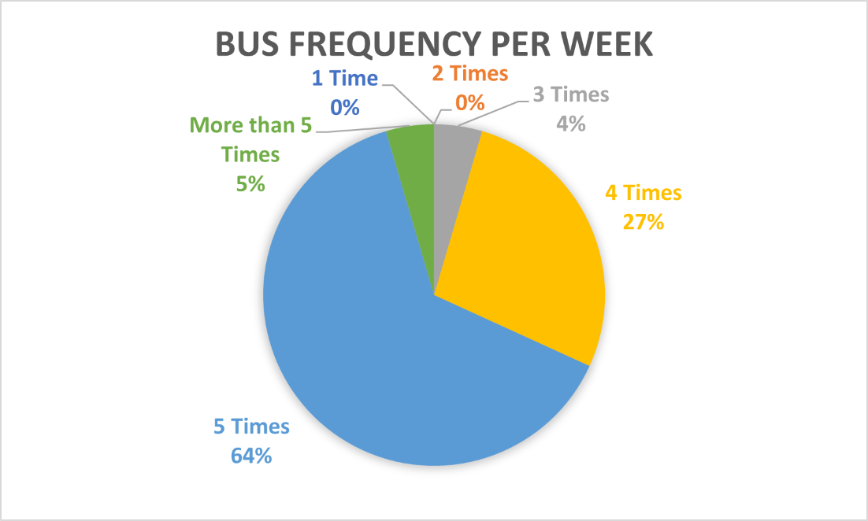
Figure 1. Survey Findings on Student Reliance of Bus Route 49 to UBC per week
Investigations on the importance of the bus system for students of UBC as their main route to reach campus.
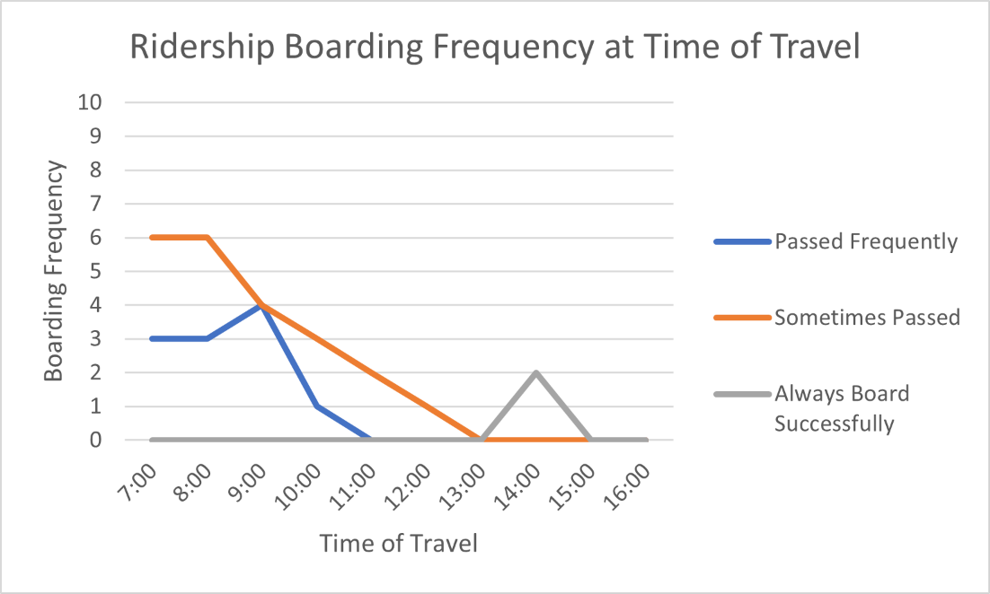
Figure 2. Survey Findings on Students Frequency of Boarding Bus Route 49 to UBC
Findings of majority of ridership boarding frequency being that students are passed.

Studies of TransLink System
(DATA)
Studies of Ridership Concerns
(DATA)
Review of Secondary Sources
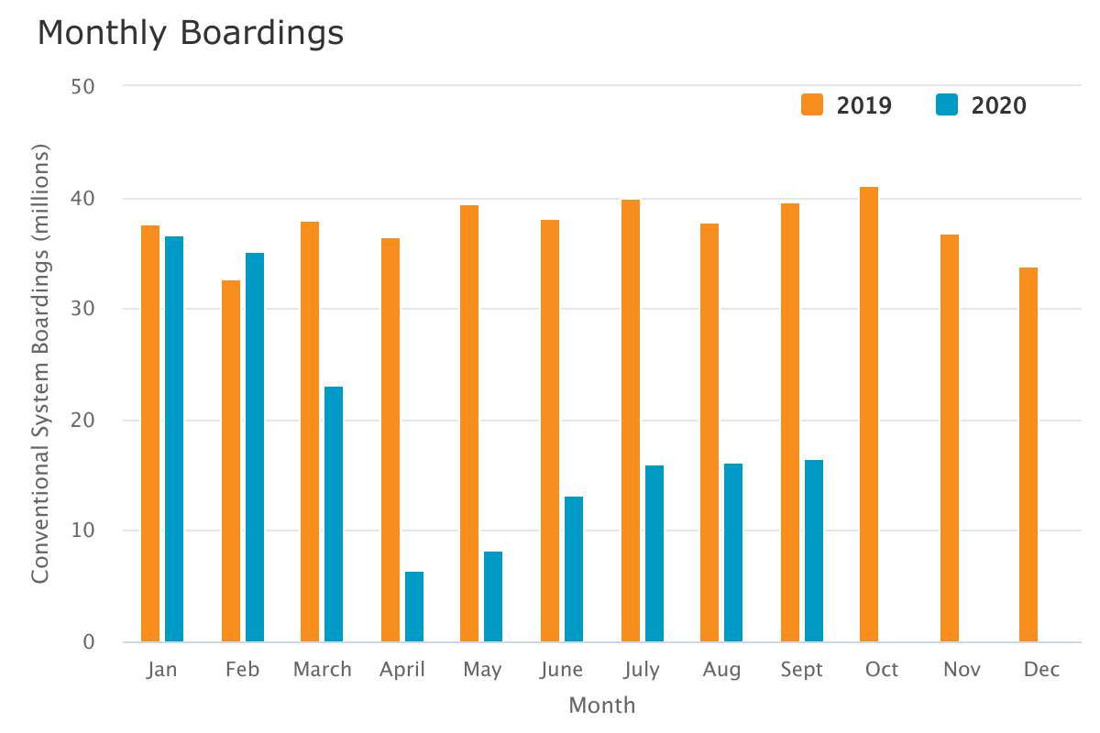
Figure 3. TransLink Public Data for All Boardings per Month (TransLink Ridership Data)
The data represents the complications that COVID-19 has resulted in the constraint of public transportation use in the year 2020. As the boardings slowly trend back up to normal boarding rates as seen in 2019, this will be problematic. As there are already boarding issues as demonstrated on the bus route 49, further ridership boarding will lead to greater inefficiencies.
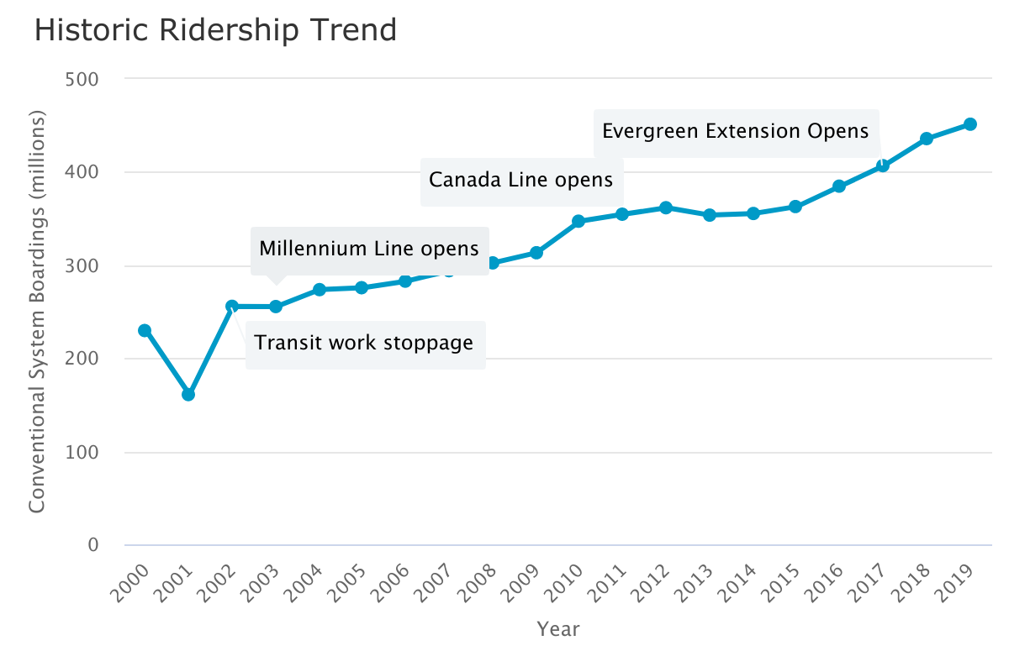
Figure 4. TransLink Public Data Demonstrating the Historic Increase in Ridership as a Result of Further Services Provided (TransLink Ridership Data)
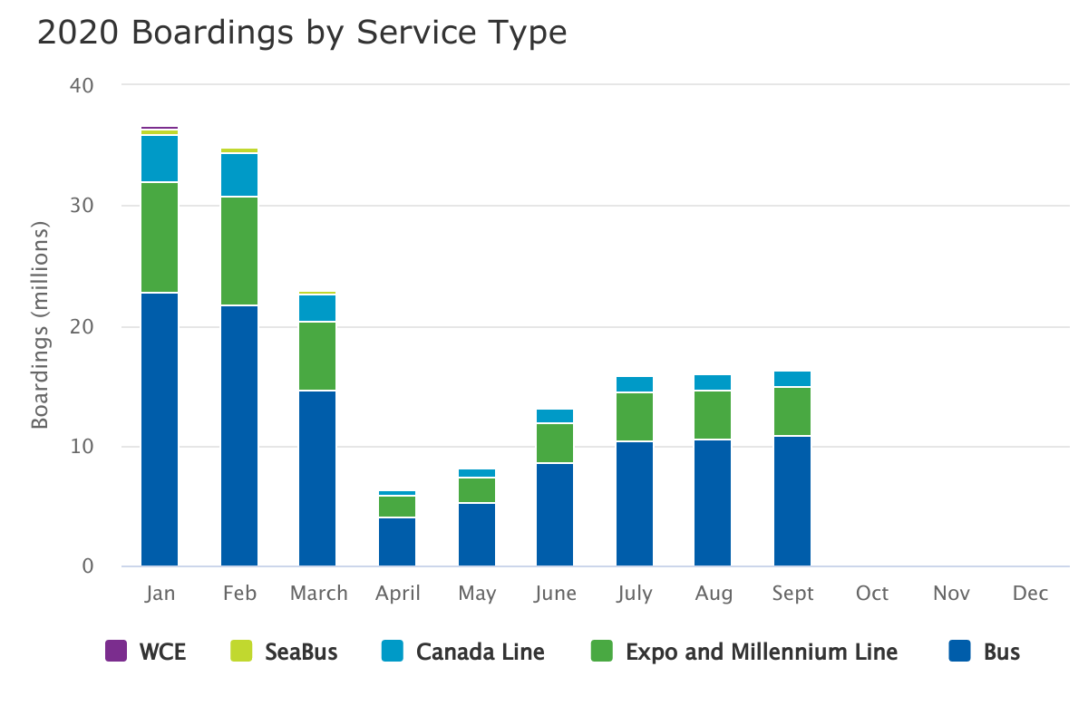
Figure 5. TransLink Public Data Demonstrates the Majority of Ridership Boarding Coming from Bus Ridership (TransLink Ridership Data)
(DATA)
Proposed Solutions
- Review of Effects of Increasing Ridership Efficiency
- Review of Effects on Student Ridership Quality
- Assessment of Company improvements and Student Wellbeing

CONCLUSION
SUMMARY OF FINDINGS
(Summary of survey and interview findings) (summary accurately and concisely reflects the report’s body section)
OVERVIEW OF INTERPRATION AND FINDINGS
(Interpretation and explanation of what these findings mean) (why it will be worthwhile for the company to improve transportation)
FINAL RECOMMENDATIONS AND FURTHER APPLICATIONS
List of conclusions:
-Majority of UBC Students survey heavily rely on the services of the bus route 49 to UBC and determined that it was also an important necessity of arriving to campus on time.
-Students are already spending a heavy portion of their day just having to transit accounting for about around an hour and a half per day one way to UBC.
-Efficiency is an important factor to students that already are committing long hours to school, the last thing they want is to be stressed out if they are potentially late to exams.
-TransLink can further bring down their costs with an increase in ridership efficiency as well

List of recommendations:
(Recommendations are clear about what the audience should think and do)
-open all door boarding to match system of other busy routes
-retrain employees to work around boarding efficiency
-increase bus frequency during peak hours

Works Cited
“TransLink Ridership.” TransLink, https://www.translink.ca/plans-and-projects/data-and-information/accountability-centre/ridership#historic-ridership-trend.
“UBC Vancouver Fact Sheets.” Planning and Institutional Research Office (PAIR), https://pair.ubc.ca/ubc-data-analytics/vancouver-fact-sheets/.
https://pair.cms.ok.ubc.ca/wp-content/uploads/sites/145/2021/04/UBCV-Fact-Sheet-Winter-2020.pdf

