Improving Green Initiatives at the Tooth Gallery Dental Office – Formal Report Draft

Karissa Garneau
ENGL 301: Technical Writing
University of British Columbia

Dr. Jill M Taylor DMD, Owner of the Tooth Gallery
November 18, 2021

Table of Contents
Abstract……………………………………………………………………………….………...…3
Introduction………………………………………………………………………...……………3
Report……………………………………………………………………………………….………4
Data………………………………………………………….……………………….....5
Figure 1…………………………………………………….……………………………6
Analysis...……………………………………………………………………………...6
Figure 2…………………………………………………….……………………………7
Conclusion and list of recommendations…………………………………………..8
Appendix……………………………………………………………………………………….….9
Works Cited………………………………………………………………………………………10

Abstract
Environmental practices of organizations and businesses are more and more scrutinized by the general public as they are expected to make efforts to remain “Green”. Often business implement green initiatives and there are efforts made towards sustainability, but in the end, they are ineffective or difficult to maintain. This report concludes that current practices need to be analysed regularly in order to find the current best environmental practice. Following the successful implementation of greener initiatives at the Tooth Gallery dental office, it is anticipated that other offices will be motivated to make conscious choices to be more environmentally friendly with the products and services they use.
Introduction
Waste management is a growing ecologic concern and dental offices are significant contributors to environmental waste (Muhamedagic, 2009). Whereas some efforts for repurposing can be made, a large portion of dental materials available on the market are not designed to be reused or recycled. Waste containing metals and hazardous substances require proper disposal due to standards and guidelines set by the ministry of health. While single-use plastics, disposable items, and plastic wraps and barriers have only increased in popularity following the COVID-19 Pandemic. Dental services involving the manipulation of oral tissues often produce moderate amounts of biological fluids such as blood and saliva and require the use of dental materials to be evacuated from the mouth. Cotton gauze and single-use plastics are the materials that account for the most significant amount of dental waste (Duane, 2019).
An important first step to improving green initiatives in a dental office is to create an individualized, environmental action plan. The office will have the best success in maintaining better environmental choices by having all members of the team following the same protocols. The services the company uses and the products commonly ordered need to be analyzed and compared with other options available on the market. Some products such as suction tubes and client protective wear have reusable alternatives instead of single-use plastics. By making thoughtful choices to order more sustainable products and consider how each product can be best utilized, the Tooth Gallery can reduce its ecological footprint. Primary sources of data will be collected by way of surveys distributed to staff members of the dental office. Open-ended questions are asked to allow subjects to provide further clarification to the questions in their own words. Secondary sources of data include background knowledge of a practicing dental hygienist and reference to publications regarding environmental waste in dental offices. The inquiry included questions regarding the office’s current use of common waste products and current waste management practices. This report aims to assess if dental offices can reduce their carbon footprint by way of implementing greener initiatives.
Report
Data collected demonstrates the need for improved green initiatives within the chosen dental office. Even though this office in particular has implemented more environmentally friendly practices, many staff are not aware of them or do not use them. The current practices include handing out bamboo toothbrushes and paper bags instead of offering plastic and turning off all equipment and lights before closing the office for the evening. The office has also purchased a personal protective equipment (PPE) recycling bin through the company Terracycle which reduces the amount of treatment gloves and face masks thrown in the regular trash. There are recycling bins in a back room and staff are encouraged to reduce and reuse paper whenever possible. The cleaning of non-treatment areas is handled by an outside cleaning company.
Data
Over 50% of participants rated the green initiatives at The Tooth Gallery a 3 or lower. The office has confirmed that certain environmentally practices are available to staff, but data demonstrates that that does not guarantee that they are being implemented. For example, many staff at the office do not dispose of their unsoiled, used treatment gloves in the PPE recycling bin. Staff are expected to recycle, but many recyclable products end up in the regular trash. There is a wasteful approach to the amount of disposable supplied ordered, especially perishable items such as polishing paste, fluorides, and some restorative materials. (Duane, 2019). These materials should be ordered on an as-needed basis, however, items that can be stored without consequence should be ordered in bulk to reduce overall costs, shipping costs, and the amount of energy from each step along the way. A majority of staff reported that they only give out take-home client supplies like toothbrushes and travel flosses if the client requests them.
All of the respondents reported properly disposing of hazardous waste and metals; these practices seem to be the most well-maintained. All of the respondents described a willingness to share responsibilities and push for better, more sustainable products. 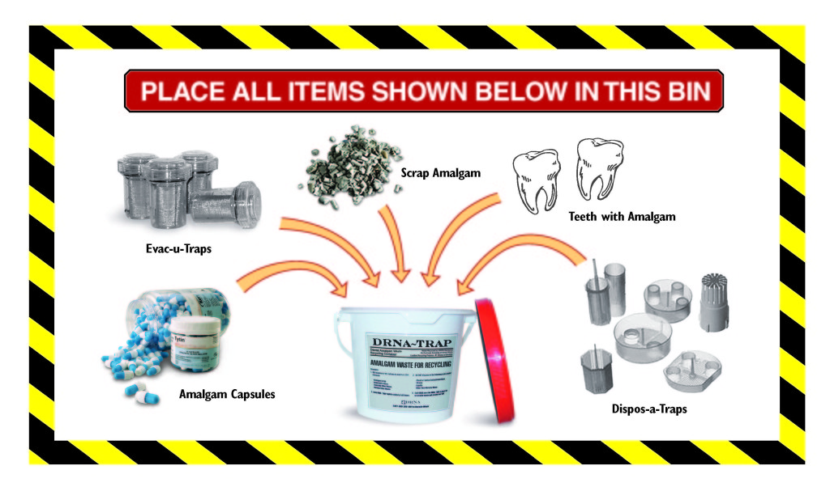
Figure 1
Analysis
Paper products and single-use plastics are the most commonly disposed of items in the dental office, and account for the largest amount of dental waste. Contaminated biomedical wastes, items that have had contact with blood or saliva, are classified as a non-hazardous substance in Alberta (Alberta Dental Association & College, 2015). Heavily soaked products should be separated from regular waste and placed in the biohazard disposal unit located in all dental offices. The options for reducing the volume of soiled paper product waste are minute, but it is possible to rely more heavily on other options for removal of the biomedical waste, such as saliva ejectors. However, plastic low-volume and high-volume ejectors and plastic air-water syringe tips are most commonly ordered due to their lower price point and assumed ease of use. Yet there are excellent reusable alternatives available on the market, such as sterilizable metal ejectors and syringe tips. Truly, the largest amount of waste in the dental office occurs related to the amount of disposable gauze and plastics used during dental treatment. For example, a reasonable amount of cotton gauze should be prepared for a client-specific treatment such as a restoration. Any extra supplies taken out during set-up must be disposed of even if they haven’t been used due to the risk of cross-contamination. Barriers used to cover commonly touched treatment areas are important infection control procedures, but they also need to be used only where they are actually needed. A smooth surface without irregularities or buttons does not benefit from the added infection control layer, instead they need to be properly disinfected following treatment, avoiding redundant extra plastic use.
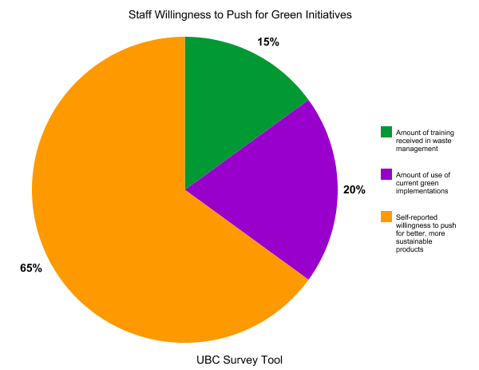
Figure 2
Staff described being willing to push for greener, more sustainable products. However, the same staff are not completely aware of current green implementations. This is why an individualized, environmental action plan is necessary in order to implement successful green initiatives within a dental office. Staff should regularly search for new or more obscure products and services that they can utilize to reduce the office’s ecological footprint.
Conclusion
It is evident that dental offices produce a large ecological footprint. There are more sustainable choices that can be made to reduce environmental waste and lower carbon emissions. By implementing a successful environmental action plan in this dental office, other dental professionals may be encouraged to make greener choices in their own offices. Dental offices can greatly reduce the amount of waste produced by employing the three main elements of waste management: Reduce, Reuse, Recycle (Alberta Environmental Protection, n.d.).
Recommendations
- As a starting point, sitting down and critiquing current environmental practices
- Being open with the general public about the office’s current environmental practices
- Determining areas that would benefit from a change
- Creating an individualized plan with environmentally friendly action items for staff to take
- Reducing the amount of supplies used, ordering necessities in bulk to reduce shipping and costs
- Periodically reassessing how implemented practices are working and modifying plan as needed/as newer and better practices come to light

Appendix
Link to survey https://ubc.ca1.qualtrics.com/jfe/form/SV_eEukMkeBhcSDV7o
Interview Questions:
- What are you currently doing to reduce environmental waste in the dental office?
- What kind of training has staff received in waste management?
- What kind of waste management/cleaning services are being used in the dental office?
- How does the dental office clean non-treatment areas: floors, waiting room, bathrooms, staff areas? Where do cleaning products get disposed of after use?
- How many garbage bags on average are removed from your dental office in a typical week?
- How does the dental office dispose of hazardous waste and silver/mercury/lead?
- How does the dental office dispose of unsoiled, used treatment gloves and masks?
- How well managed are green initiatives in the dental office?
- Describe your willingness to share responsibilities for ordering supplies and push for better, more sustainable products.
Figure 1:
Drna. “Dental Practice Waste Management Tips | Dental Recycling of North America.” DRNA, 17 June 2017, www.drna.com/blog/39/dental-practice-waste-management-tips.php.
Figure 2:
Karissa Garneau. “Current Environmental Practices of the Tooth Gallery Dental Office.” UBC Survey Tool. https://ubc.ca1.qualtrics.com/jfe/form/SV_eEukMkeBhcSDV7o.

Works Cited
- Muhamedagic B, et al. “Dental Office Waste – Public Health and Ecological Risk” Mater Sociomed. 21(1): 35–38 (2009), https://www.ncbi.nlm.nih.gov/pmc/articles/PMC3796776/.
- Duane B, et al. “Environmental Sustainability and Waste Within the Dental Practice” BDJ Team, 6, 21–29 (2019 June 7), www.nature.com/articles/s41407-019-0106-6?error=cookies_not_supported&code=5cbedfc4-b8ea-4fee-97b2-0b28efe03de0.
- “Guide for Best Practice Management of Dental Office Waste.” Alberta Dental Association & College, (2015). https://www.dentalhealthalberta.ca/wp-content/uploads/2019/11/Guide-for-Best-Practice-Management-of-Dental-Office-Waste.pdf.
- “Waste Minimization – Dentists, Dental Specialists & Denturists.” Alberta Environmental Protection. (n.d.), https://open.alberta.ca/dataset/040e170c-a42c-4f3c-8e7b-087a9ddf7524/resource/50a76870-324a-45e1-b977-e095ee62efa5/download/wasteminimization-dental-jul1999.pdf.

