Feasibility Analysis
of Improving Onboarding
for New Tech Hires at Article

for
Tahseen Fida
Engineer Director
Article, Vancouver

by
Samantha Lee
English 301 Student

November 16, 2021

Table of Contents

INTRODUCTION 1
DATA SECTION 3
Onboarding Process at Article 3
General Onboarding Activities 3
General Onboarding Strengths 4
General Onboarding Weaknesses 4
Tech Onboarding Activities. 5
Tech Onboarding Strengths 6
Tech Onboarding Weaknesses 8
Conflicting Views on Onboarding Efficiency 11
Views on Potential Onboarding Solutions 12
Revising Documentation 12
Personal Onboarding Page 12
Onboarding Checklist for Managers 13
Onboarding Social Events 13
CONCLUSION 14
Overall Analysis and Evaluation of the Onboarding Process 14
Recommendations 15

INTRODUCTION

In response to Covid-19, Article is actively hiring software engineers to work remotely from different countries. Unable to visit the office, new hires are onboarded virtually, relying on online resources to adjust to their new work environment. Onboarding tasks include receiving shipped equipment, meeting the team via Zoom, and discovering key principles and technologies that are used when working at Article.

During the onboarding period, engineers set up their computers, installing software that are required for developing Article technology. They also learn about computer programs that support the company website, including the programs’ code structure, programming practices and testing procedures (how to test new code). Without in-person assistance, new hires complete these tasks by reading online documentation and consulting co-workers online.

The current onboarding process is insufficient for remote hires, negatively impacting their productivity and mental health. Despite having online documentation, new engineers experience technical difficulties when setting up their computers, delaying their ability to develop software. Being onboarded remotely, these developers also struggle with building team connections. New hires then feel discouraged, isolated from the team, and insecure with their decision to join Article.

The report analyzes the current onboarding process for new tech hires at Article, with the ultimate purpose of providing recommendations for improvement. Three main topics are investigated:

- Strengths and weaknesses of the current onboarding process
- Feasible solutions to improve the onboarding experience
- Costs and consequences of implementing the solutions

Research methods include survey and interviews for gathering feedback from Article employees. Online publications also provide insight on key characteristics of an effective onboarding process, as well as potential onboarding solutions.

The report concludes with confirming the inefficiency in Article's current onboarding process, suggesting recommendations for improvement.

DATA SECTION

Onboarding Process at Article
Research on Article's onboarding process identifies activities that fall into two categories: general and tech. General activities are organized by Human Resources (HR) and are completed by every new employee at Article. Tech onboarding tasks are completed by software engineers and are scheduled by team members.

General Onboarding Activities. Prior to the first day of work, an onboarding package is shipped to the remote hire, providing work equipment, instructions for equipment setup, and Article swag (complimentary items for promotional purposes) such as a t-shirt, notebook and pen. An email is also sent with instructions for setting up a BambooHR account. (BambooHR is a human resources software for managing HR-related tasks). BambooHR includes details on what to expect on the official start date.

During the first day of work, remote hires meet their managers via Zoom to learn about onboarding plans for the rest of the week. They then meet the entire team at a virtual welcome lunch on Zoom, in which each team member is given a $20 Uber Eats coupon. The rest of the day is spent setting up their equipment and getting settled in.

During the first month, remote hires watch onboarding videos to learn about the role of different departments at Article. HR coordinators also schedule an online meeting to inform new employees where to go for HR information and to encourage feedback on the onboarding process. At the end of the month, new hires are asked to complete an anonymous survey on BambooHR to provide feedback on the onboarding experience.

General Onboarding Strengths. Based on feedback from the BambooHR survey, most employees mentioned that pre-onboarding events were well-organized, providing necessary information before the official start date. Positive characteristics about general onboarding activities include effectively learning about Article’s departments and feeling supported by team members. Some hires also highlighted that managers clearly explained new employees' expected roles at Article.

General Onboarding Weaknesses. Some employees suggested that the first onboarding week could be better organized, particularly activities that should be scheduled by team managers. Managers who are inexperienced or busy are unable to find time to schedule onboarding events such as training sessions and one-on-one meetings between the new hire and team members. Apart from improving organization, some employees struggled with figuring out who to ask for help on onboarding tasks.

Tech Onboarding Activities. During the onboarding period, new engineers install required software and coding projects for developing technology at Article. Some technologies are automatically installed by running a setup script (sequence of computer instructions) while others are set up manually using online documentation. Developers also require multiple credentials and permissions to access these technologies, seeking assistance from IT team, managers or team members.

After setting up the development environment, new engineers learn technical practices for software development at Article, including programming principles and testing procedures. Testing involves setting up a test version of Article's website to show newly developed features to business stakeholders and team members for feedback. Most remote engineers learn technical practices through online documentation while messaging co-workers on Slack for clarification.

Apart from technical onboarding tasks, new developers learn about the Article Way (company values and principles) and participate in social activities with team members.

Tech Onboarding Strengths. Based on survey data, most remote engineers were satisfied with the quick response to onboarding questions, as shown in Figure 1:
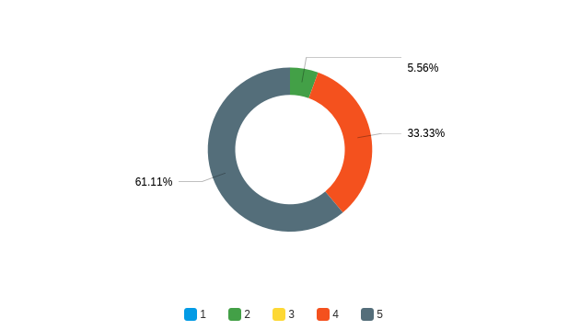
Figure 1: How quickly did you receive response to onboarding questions? (Rank 1-5, 5 being fastest)

Figure 1 suggests that online communication methods such as Zoom and Slack are successful for resolving onboarding issues. Some tech teams also provide new hires with an onboarding buddy who is the first point of contact for questions.

Apart from quickly resolving issues, most employees gained a clear understanding of company principles and values, as shown in Figure 2:
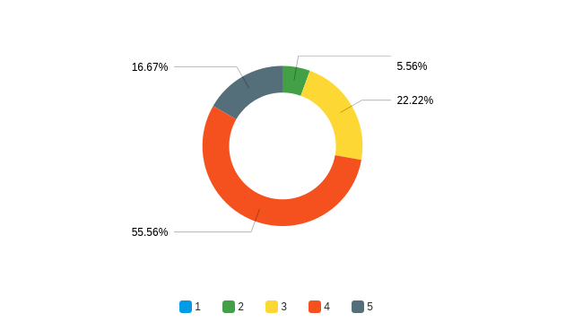
Figure 2: How efficient was the onboarding process for learning company principles and values? (Rank 1-5, 5 being most efficient)

Figure 2 demonstrates the efficiency of current onboarding methods for describing company principles and values. This includes reading online documentation, watching onboarding videos, and discussions with co-workers via Zoom.

Tech Onboarding Weaknesses. Most engineers ranked the environment setup process as either 3 or 4, as shown in Figure 3:
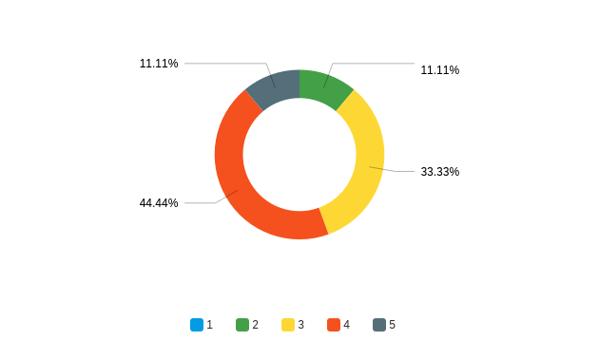
Figure 3: How efficient was the onboarding process for environment setup? (Rank 1-5)

Although the setup script is useful for automatically installing some software, developers struggled with following the online documentation for manually installing other technologies. The level of detail is more suited for intermediate or advanced developers who have experience with using Mac computers. Some employees mentioned that the documents are overwhelming to view at glance. Information on how to obtain credentials is also outdated, creating back and forth communication between new joiners and employees before installation.

Apart from the environment process, most remote hires ranked the efficiency of understanding technical practices and testing procedures as 3 or 4, as shown in Figure 4:
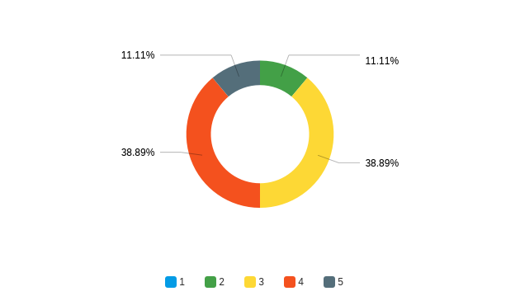
Figure 4: How efficient was the onboarding process for learning technical practices and testing procedures? (Rank 1-5)

Similar to the environment setup process, comments were made on documentation for technical practices, suggesting improvements on document structure and level of detail.

Lastly, most engineers ranked the organization of the onboarding process as 3 or 4, as shown in Figure 5:
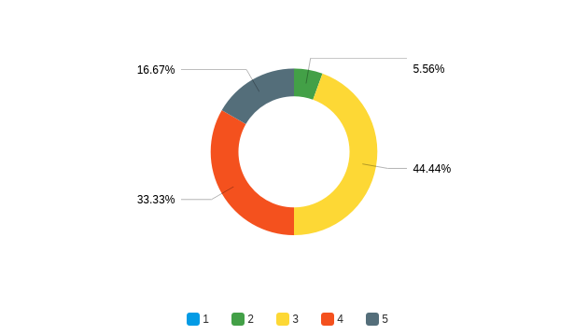
Figure 5: How organized was the onboarding process? (Rank 1-5)

Similar to HR studies, the above data suggests that onboarding schedules and resources could be better organized for new employees.

The above findings demonstrate the importance of revising the onboarding process for improving the productivity of new tech hires.

Conflicting Views on Onboarding Efficiency. Survey data revealed mixed responses towards the onboarding process' efficiency for building team connections, as shown in Figure 6:
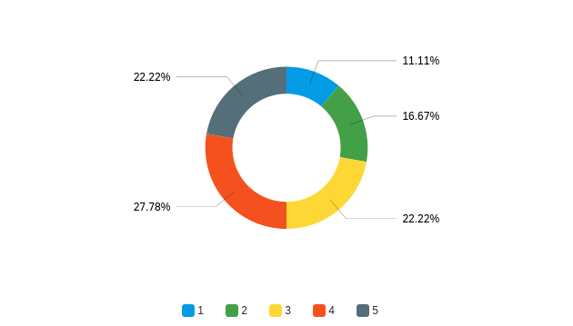
Figure 6: How efficient was the onboarding process for building a connection with your team? (Rank 1-5)

The above chart shows that employees ranked team connections between 1 and 5 inclusive. Those who engaged in team social activities once or twice during the onboarding period ranked team connection between 1 and 3 inclusive. Others who met the team more frequently provided a rank of 4 or 5. This demonstrates the importance of social activities for building team connections and reducing isolation from working remotely.

Views on Potential Onboarding Solutions

Revising Documentation. Based on survey and interview data, revising current documentation is beneficial for improving productivity. Adjusting the level of detail allows beginner developers to easily follow documents on the setup process, technical practices and testing procedures. Frequently updating documents’ credential information provides new hires with faster credential access. Some employees also suggest creating a new document with tips and troubleshooting advice for using Mac computers.

The above changes will reduce time spent on technical onboarding tasks by new hires, requiring minimal assistance and clarification from team members. Potential costs involve the amount of time required by developers to create and update online documentation.

Personal Onboarding Page. Buying Experience Team (BX) at Article creates personalized documents for their new joining engineers, providing checklists with onboarding tasks. This allows new hires to see all activities at a glance while giving BX a sense of what tasks have been completed. Studies show that customizing "the onboarding experience to best meet each employee’s unique needs and preferences" improves the productivity and job satisfaction of new hires (Nouri).

Creating an onboarding page template costs 8 hours of one developer per team. The template is then used to create personalized pages for new engineers within 30 minutes.

Onboarding Checklist for Managers. HR coordinators suggest providing managers with a checklist of tasks to be completed prior to the new hire's first work day. Tasks include obtaining credentials for new hires and scheduling training sessions and meetings in advance. Creating a formal agenda supports managers with organizing onboarding events despite having busy schedules. This encourages a more consistent and organized onboarding experience for new hires. The primary cost for this solution is the time spent by HR coordinators to develop the checklist.

Onboarding Social Events. Customer Service Experience Team (CSX) has a weekly gaming event where team members play online games together for an hour. Planning regular team socials during the onboarding period "help new remote employees feel like a part of the team" (Robinson). Organizing virtual socials are cost-effective through Zoom meetings and free online games such as Codenames, scribbl.io, and Among Us.

CONCLUSION

Overall Analysis and Evaluation of the Onboarding Process
Remote employees are overall satisfied with general onboarding activities, effectively learning about Article while feeling supported by team members. Common suggestions for improvements include better organization of activities scheduled by managers and clearer information on who to contact for assistance on onboarding tasks.

Positive features of technical onboarding activities include quick response to onboarding questions and an effective explanation of company principles. However, research suggests that some tasks are less efficient, particularly setting up the development environment and learning technical practices. Organization of tech activities could also be improved, being ranked 3 out of 5 by most engineers.

Employees had conflicting views on the onboarding process' proficiency in creating team connections. Remote engineers who participated in more team socials built a stronger connection towards team members during onboarding. Planning regular socials during onboarding are therefore necessary for eliminating isolation from working remotely.

The above findings demonstrate the importance of revising Article's onboarding process for improving the productivity and mental health of remote hires.

Recommendations
Below are cost-effective suggestions for addressing the above issues, improving the onboarding process for new engineers at Article:

- Requesting HR coordinators to construct an onboarding checklist for managers
- Encouraging teams to organize weekly socials using Zoom and free online games
- Asking one developer per team to create a template for personal onboarding pages
- Creating a document with tips and troubleshooting advice for using Mac computers
- Updating technical documentation with additional details to ensure efficient knowledge transfer for junior developers
- Updating documentation for environment setup with latest information on where to obtain credentials for development
- Revising structure and layout of onboarding documents to improve readability

