Table of Contents

Introduction 3

Literature review 4

Method 5

Data Section……………………………………………………………..6

Analysis 7

Recommendation 11

References

**Introduction**

The Chinese language program in UBC offers a platform for Chinese-learning students to connect and communicate with people who also appreciate Chinese culture. The oral practice sessions are part of this program, the OP organizer Victoria Ni would recruit volunteers every semester, the role of the volunteer s to help UBC students dealing with varied challenges in learning Chinese. One online OP session consists one volunteer and one student who is currently taking Chinese courses at UBC. The session usually lasts about 50 minutes, volunteers and students were provided with an OP sheet, which outlines new vocabulary and grammar that students needed to study.

The OP session does not have an assessment system that allows volunteer to monitor students’ learning process. One volunteer usually team up with just one student throughout the semester, if there’s an assessment system in place, the volunteers can have enough information on what skills students have and have not mastered, in this way they can add modification to the teaching content and provide students with better OP experiences. Therefore, introducing a 10- minute quiz after 50 minutes of OP session. Since the OP sessions are all online, volunteers can use technology such as Digital Quiz Maker on [typeform.com](http://typeform.com) to create quizzes for the students. The website is very accessible and easy to use, the quiz provide a great opportunity for the students to review what they learned, and acknowledge what they need to learn in the next session.

This paper aims to assess the feasibility of the quiz as apart of UBC’s OP sessions, I plan to pursue five areas of inquiry :

1. How many volunteers know how to create a quiz using online website?
2. Will hands-on workshops improve volunteer’s ability to create quizzes？
3. What kind of quiz will make students more engaged (eg.multiple questions? short paragraphs questions?)
4. What are some limitations of introducing the quiz in OP sessions?
5. What are some barriers preventing students to complete the quizzes?

The primary data source will be surveying UBC Chinese language program members to determine their perspectives on quizzes in OP sessions.Surveys will be distributed virtually and data will be collected anonymously. Secondary sources will include research articles on assessments, which will help me to understand the pros and cons of having assessments in one’s learning process.

Literature Review: The importance of assessment in Education

A typical lesson plan involves: learning objective, content & lesson activity, and assessment. Each OP session works like a lesson and should be having all the necessary component in a lesson. There are many learning design model out there, and for this particular proposal, I picked the Backward design as the design model. Backward design model suggests that when educator teach their students, they should start from the students’ needs. Thus, learning objective should be determined at first.

In OP sessions, volunteer and students will be given an OP sheet which outlines the learning objectives, and the materials (the topics that will be covered in the session), but there’s no assessment designed. Whereas in the backward design model, the component that should be considered after the learning objectives is the plan assessments. It shows that assessment is closely related to the learning objectives.

Figure 1: Copy rights: University of Rochester. Image retrived from <https://www.rochester.edu/college/cetl/faculty/online/backward.html>

There are many types of assessments out there available for teachers to take and use, they are usually divided into two categories: formative assessment and summative assessment. Formative assessment 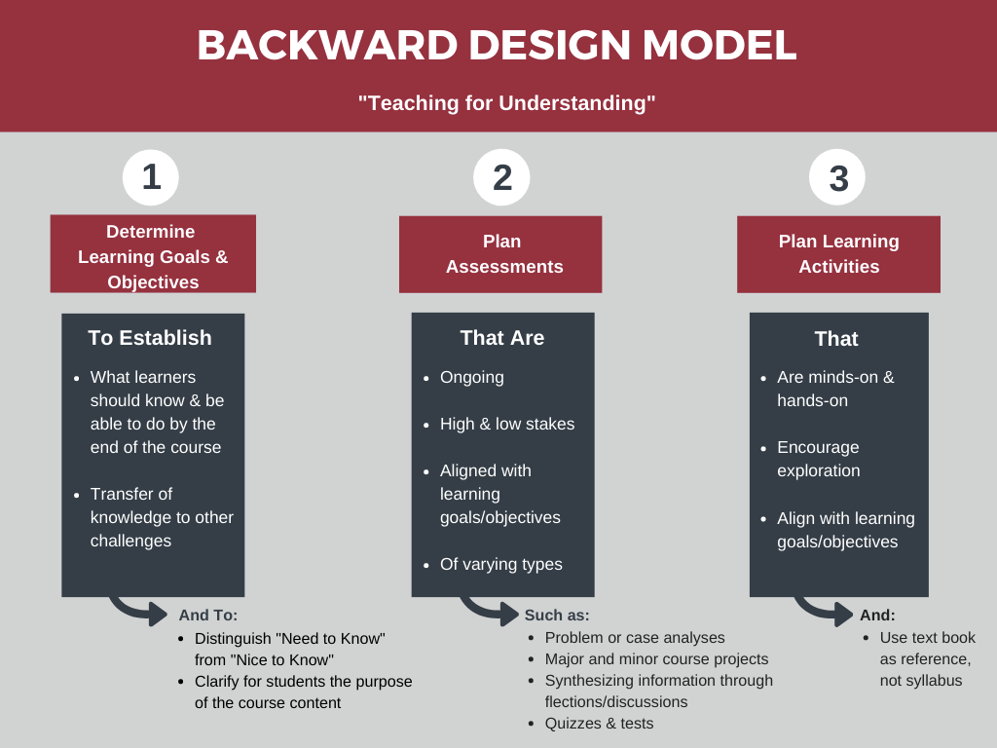refer to assignments such as paper, collaboration work sheet, reading reflection etc. The goal for formative assessment is to help the teachers to know how well students learned, and formative assessment is usually distributed throughout the class to monitor students’ learning process. Summative assessment, on the other hand, is usually distributed at the end of a module/ a course, like quizzes, midterm exam and final exam. Summative assessment allows teachers to see how much and how well students learned, the results of summative assessment is more direct, and does not need the test distributor to think much about how students were graded, because the rubrics have already been outlined.

Therefore, summative assessment is more suitable for the Volunteer to use, they don’t need to have much education experience to grade the students.

**Method**

The method for calculating the response is done by manually writing people’s multiple choice.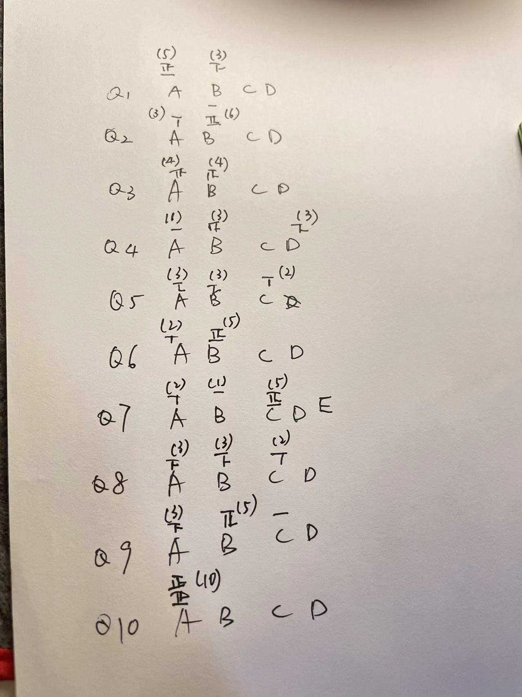 This is because the survey platform does not allow me to generate graphs based on the responses, so what I did is that I recorded their response, and then put into an Excel sheet, the below section is the graphs that I made —in order to visualize the responses.

**Data Section**

Up until November 17, this report got 13 responses. The survey will keep continue to receive responses until November 26th. The below section are some organizations of the survey results. Please visit this website to see the entire survey questions: https://ubc.ca1.qualtrics.com/responses/#/surveys/SV_2fylWyCmaPW4JnM

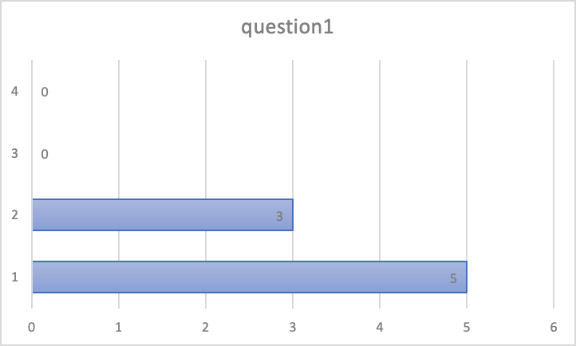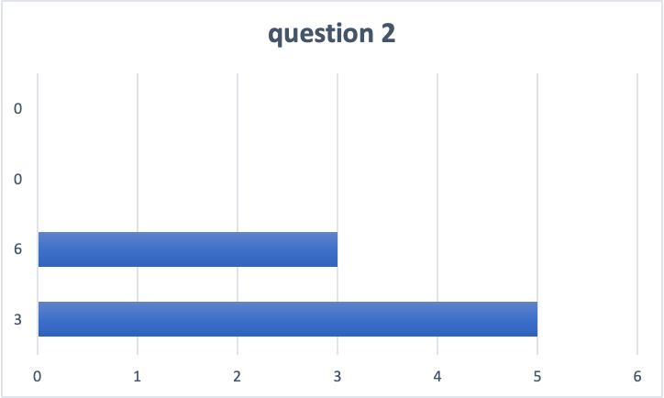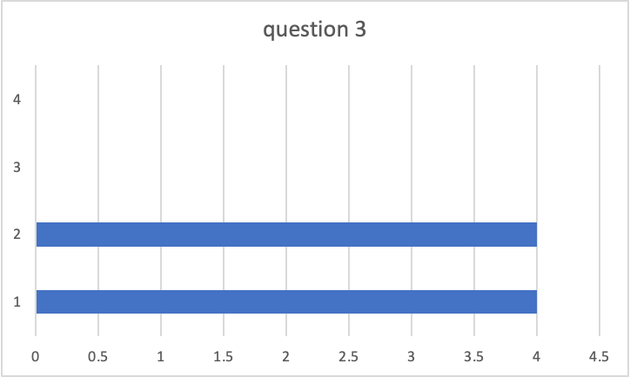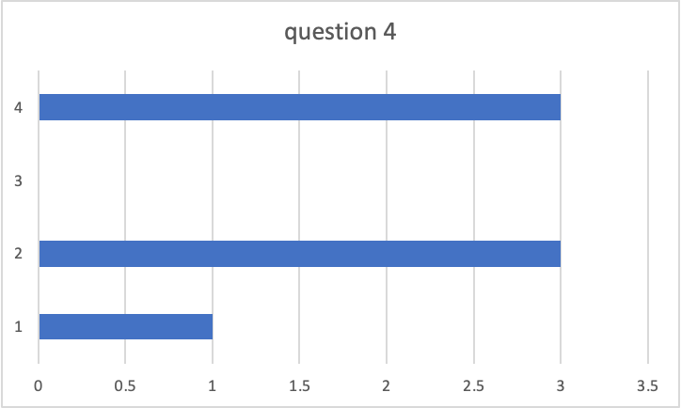

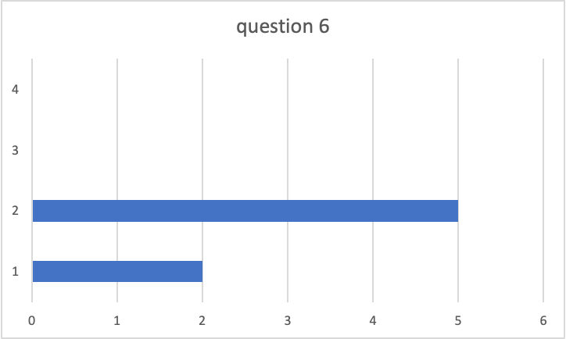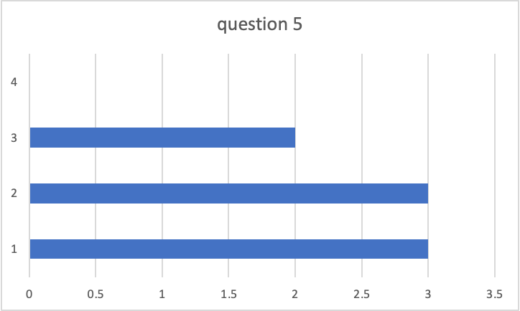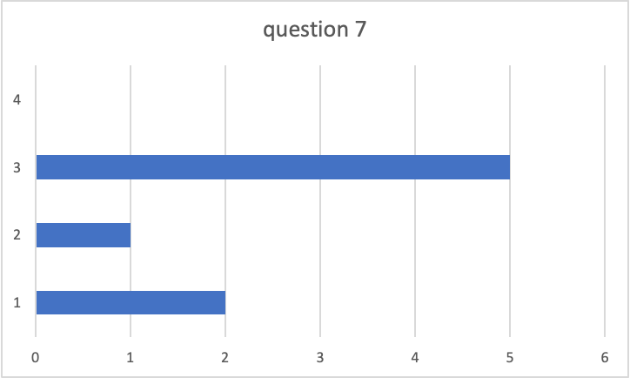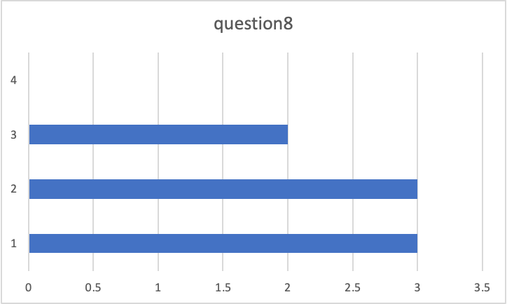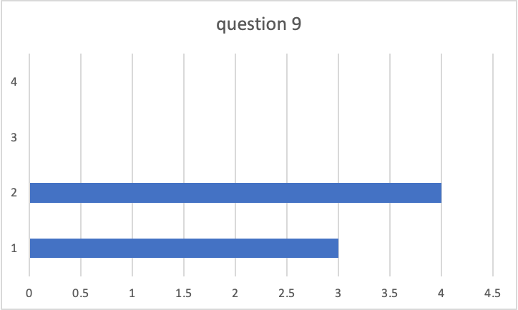

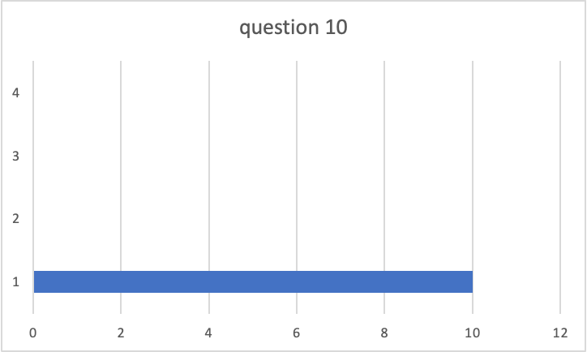

Analysis (Primary Findings)

The first thing that need to be analyzed is the type of assessment that volunteer and students want to have in OP session. All 13 responses have reported that they think assessment will help them learn/teach better, but they have different opinion on what type of assessment:

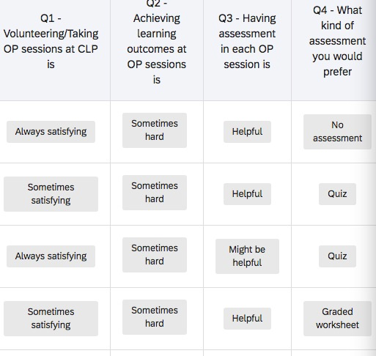

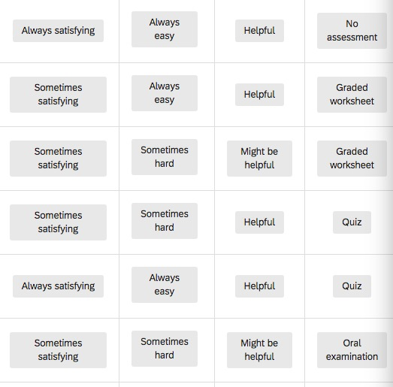

From these two figures above, we can see that people are wavering between graded worksheet and quiz. Graded worksheet is a good assessment if the grader is a professional educator, and if it is for a typical traditional lesson plan. This is because graded worksheet require volunteers to put a lot of work into it, and most of the volunteers are also students in UBC, therefore, they might not have time for developing worksheet every week. The quality and professionalism of the graded worksheet is also without control, moreover, students and volunteer already have a oral practice sheet, which means another worksheet might not improve their learning and teaching process. Quiz, on the other hand, are much easier to produce, and volunteers can also participate in the quiz. For example, we know that Cahoot! is an amazing tool for in class activity, it engages students and allow students and teachers to see the results immediately. In this way, volunteers can go over the quiz while the student is taking it, it won’t take them much time after the OP session to grade the student. Both student and the volunteer can see the result immediately, and able to know how well they did in the OP session.

Another surprising result that I got from the survey is the time for the quiz. Most of the responses say that a 10 minute quiz is too long. Only 2 response I got reported that they think this time length is acceptable. An additional 10 minute OP session is not accepted by the participants in CLP.

Recommendation (Primary)

1. The first recommendation is that we should take quiz as the assessment of the OP session
2. As for the time lengths of the quiz, here are two solutions:

a. Skip the vocabulary section, which usually take 10 minutes.

b. Shortening the length of the quiz to 3 minute.

The rational is that, the vocabulary section is not very much informative, some students just repeat after the volunteer, and not contributing to real learning. Students will use these vocabulary sooner or later in the OP sheet questions, if students did pronounce the words wrong, the volunteer can adjust their pronunciation afterwards. Skipping this section will not impede their learning. The second option is not very desirable, if we shorten our quiz time, then students will have less time to reflect, and volunteer cannot assess everything that the students learned in the OP sheet.