Expanding the ‘Lift the Lip’ Fluoride Varnish Program at

for
Michael MacAulay
Manager of Allied Health, Interior Health
Kelowna Community Health Services Centre, Kelowna BC

by
Helene Tran
ENGL 301 Student

November 16, 2021

Table of Contents

Introduction……………………………………………………………………………………….3
Background Information………………………………………………………………….3
Purpose of Report…………………………………………………………………………4
Methods…………………………………………………………………………………...4
Data Section……………………………………………………………………………………….5
Conclusion………………………………………………………………………………………...8
Summary and Interpretation………………………………………………………………8
Recommendations…………………………………………………………………………9
Works Cited……………………………………………………………………………………...10
Appendix A: Survey Questions………………………………………………………………….11
Appendix B: Interview Questions……………………………………………………………….11

Introduction

Background Information
‘Lift the Lip’ is a fluoride varnish program offered by Interior Health. It is a free program that is available for children 12-47 months of age and provides preventative education and fluoride varnish applications for children that meet the eligibility requirements. Currently, children are referred to the program through public health nurses, dental offices, and self-referrals.
Fluoride is commonly used in dentistry to prevent cavities by strengthening enamel, which is the outer layer of the teeth. When bacteria in the mouth break down sugar and carbohydrates, they produce acids that remove minerals in the tooth enamel. This loss of minerals is called demineralization. Weakened tooth enamel leaves teeth vulnerable to bacteria that can cause cavities. Therefore, fluoride helps to re-mineralize tooth enamel, which can prevent cavities and reverse early signs of tooth decay. As a result, fluoride varnish applications can help to prevent early childhood caries (cavities).
Early childhood caries (ECC) is a complex and multifactorial chronic disease that is influenced by diet, bacteria, and social determinants of health. The disease is infectious, transmissible, diet-dependent, and may progress rapidly. It has a lasting detrimental impact on both baby and adult teeth. In fact, ECC is the most common childhood disease and dental surgery for ECC under general anesthesia is the most common day surgery procedure at most pediatric hospitals in Canada. Some of the potential consequences of ECC are acute and chronic pain; interference with the child’s eating and sleeping; tooth loss and misaligned teeth; increased expenses for dental care throughout life; and compromise of general health. The prevalence of ECC in Canadian preschool children is a growing concern.
Purpose of Report
The purpose of this report is to propose the solution of expanding the ‘Lift the Lip’ fluoride varnish program to include daycares and preschools. ‘Lift the Lip’ is currently available to children 12-47 months of age; however, the referral sources are limited. By offering the program to more locations and facilities, the program will be able to garner increased attention and hopefully, this will entice families to participate. More parents will have access to oral health information and more children will have the opportunity to have fluoride varnish applied, which will ultimately lower the overall risk of ECC.

Methods
One of the methods utilized was the distribution of surveys to parents of children attending daycare and preschool in order to gauge the interest in expanding the fluoride varnish program. Additionally, interviews from dental program staff at Interior Health also serviced as a source of data. Secondary research comprised of studies comparing fluoride efficacy in reducing ECC and reference to publications regarding the effectiveness of fluoride varnish programs.

Data Section
According to the survey distributed (Appendix A), Fig.1 indicates that all of the respondents had children that were attending daycare or preschool.
Fig. 1
Q1 - Do you have a child currently in daycare or preschool?
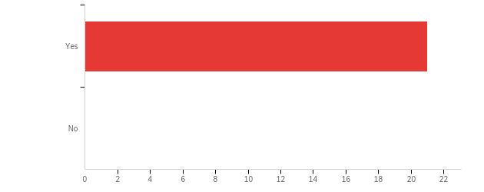

# | Answer | % | Count
4 | Yes | 100.00% | 21
5 | No | 0.00% | 0
 | Total | 100% | 21

According to Fig. 2, the majority of the survey respondents (76.19%) did not have a family dentist.

Fig. 2
Q2 - Do you have a family dentist?
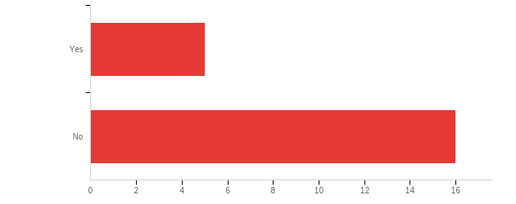

# | Answer | % | Count
1 | Yes | 23.81% | 5
2 | No | 76.19% | 16
 | Total | 100% | 21

In Fig. 3, the majority of survey respondents have not heard of the ‘Lift the Lip’ fluoride varnish program offered at Interior Health.

Fig. 3
Q3 - Have you heard of the 'Lift the Lip' fluoride varnish program at Interior Health?
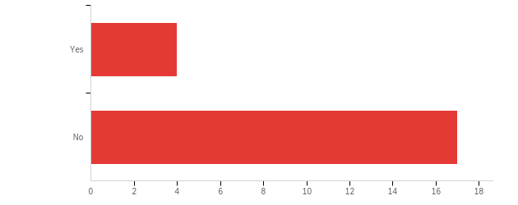
# | Answer | % | Count
1 | Yes | 19.05% | 4
2 | No | 80.95% | 17
 | Total | 100% | 21

In Fig. 4, the majority of the survey respondents indicate that their children are not currently in a fluoride varnish program.

Fig. 4
Q4 - Is your child currently in a fluoride varnish program?
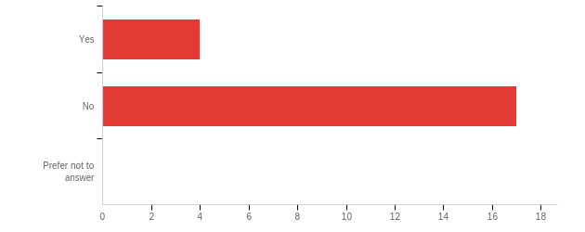
# | Answer | % | Count
1 | Yes | 19.05% | 4
2 | No | 80.95% | 17
3 | Prefer not to answer | 0.00% | 0
 | Total | 100% | 21

In Fig. 5, the majority of survey respondents (47.62%) do not know if their children have cavities. 33.33% report that their children do not have cavities and 19.05% report that their children have unrepaired cavities.

Fig. 5
Q5 - Does your child currently have unrepaired cavities?
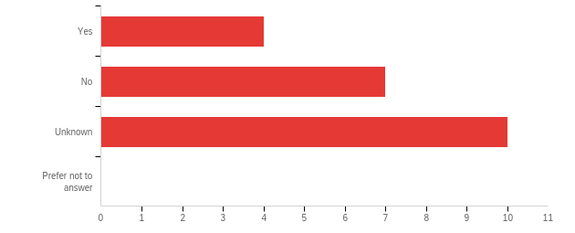
# | Answer | % | Count
1 | Yes | 19.05% | 4
2 | No | 33.33% | 7
3 | Unknown | 47.62% | 10
4 | Prefer not to answer | 0.00% | 0
 | Total | 100% | 21

*Staff interview results will be added later

Conclusion

Summary and Interpretation
According to the survey results, it was shown that:
- The majority of the survey respondents (76.19%) did not have a family dentist
- The majority of survey respondents (80.95%) have not heard of the ‘Lift the Lip’ fluoride varnish program offered at Interior Health
- The majority of the survey respondents (80.95%) indicated that their children were not currently in a fluoride varnish program
- The majority of survey respondents (47.62%) did not know if their children had cavities. 33.33% reported that their children did not have cavities and 19.05% reported that their children have unrepaired cavities
Therefore, it can be concluded that children of daycare and preschool age are a critical group that is at risk for ECC, however the majority of parents of these children are lacking the resources or information to ensure prevention of ECC.

Recommendations
Cavities are the most common chronic childhood disease in Canada, with more than 50% of children between the ages of 6 to 11 having had a cavity. Cavities are also increasing in toddlers between the ages of 2 to 4 years. Prevention is a key component to reducing the risk of ECC. Therefore, providing more resources such as oral health education and expanding fluoride varnish programs to include daycares and preschools will help to achieve this goal.

Works Cited
*references still need to be added

Appendix A: Survey Questions
- Do you have a child currently in daycare or preschool?
  - Yes
  - No
- Do you have a family dentist?
  - Yes
  - No
- Have you heard of ‘Lift the Lip’ fluoride varnish program at Interior Health?
  - Yes
  - No
- Is your child currently in a fluoride varnish program?
  - Yes
  - No
  - Prefer not to answer
- Does you child currently have unrepaired cavities?
  - Yes
  - No
  - Unknown
  - Prefer not to answer

Appendix B: Interview Questions
  - What is your position at Interior Health?
  - What is your opinion of the ‘Lift the Lip’ fluoride varnish program?
  - What are some positive and negative aspects about the program?
  - Do you believe that this is a necessary program at Interior Health?
  - Are there any changes to the program that you would like to see implemented?

