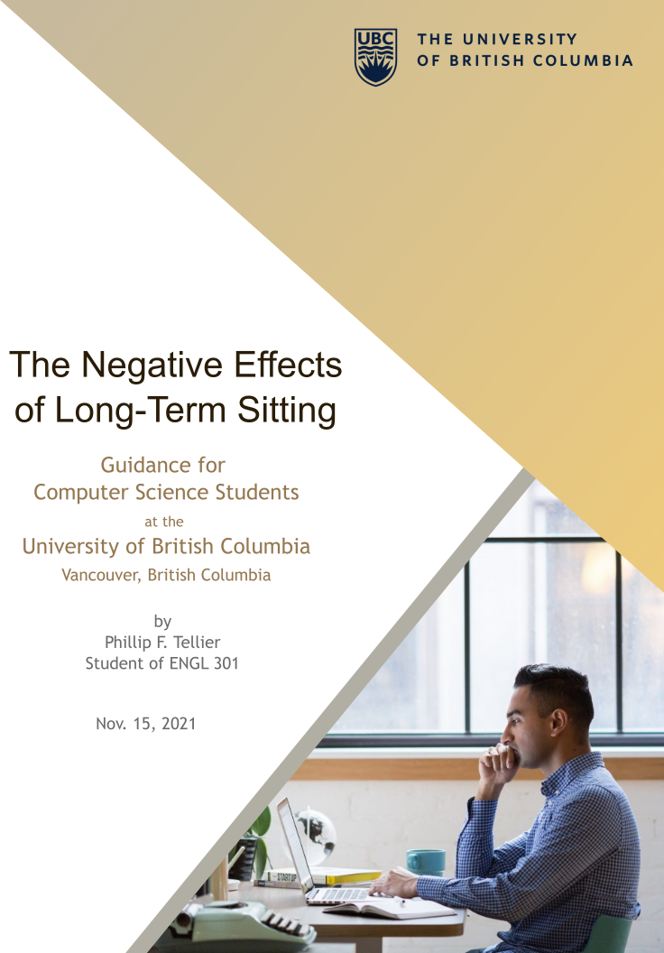

Table of Contents
ABSTRACT 2
INTRODUCTION 3
Which types of people sit for long periods? 3
Suspected health issues caused by sitting 3
Scope of health issues explored 3
Methods 3
DATA SECTION 4
Effect on back health 4
Common Interventions and their effectiveness 4
Improving Posture 4
Standing desks 5
Exercise 6
Opinions of computer science students on sitting too often 6
CONCLUSION 8
Summary of negative health effects of sitting 8
Recommendations to protect health 8
Recommendations for the education of students 8
WORKS CITED 9

Figures and Tables
Figure 1. 5
Figure 2. 7
Figure 3 8

ABSTRACT
Most computer science students at the University of British Columbia (UBC) will work in careers where they sit for long periods of time. Primary research shows this causes long-term back pain. Sitting can also contribute to obesity, but only when there is no exercise outside of work. Risk of back pain is only slightly mitigated by exercise outside of workplace sitting. Both good posture and desks that transition between sitting and standing somewhat reduce the risk of back pain.
The following health interventions are recommended based on this research:
- Take one or two minutes to walk, stretch, or be active after sitting for 30 minutes.
- Sit with good posture and proper support:
  - Sit upright with your upper back resting firmly against a back rest.
  - Support the lower back with a cushion placed against it and the chair.
  - Support the forearms with arm rests
- Use an activity permissive work station.
- Get regular exercise. Ideally this is 3-5 times per week.
Computer science students at UBC were surveyed about their opinions on how sitting affects their health. All students surveyed understood that sitting too often is bad for their health and can cause back pain. Most (83%) understood that it can cause obesity. 75% of students correctly answered that good posture partially reduces the detriments of sitting, 66.67% correctly said the same for desks that can transition between standing and sitting (activity permissive desks), and only 45.83% correctly said the same for exercising regularly.
Based on the survey results, some students still need to be taught that regular exercise, good posture, and an activity permissive workstation are helpful, but not perfect at reducing the detriments of long-term sitting.

INTRODUCTION

Which types of people sit for long periods?
At the University of British Columbia and other academic institutions, computer science students are required to sit for long periods of time to complete coursework. Many graduates will reach a career in software development, data analytics, and information technology where most work is done at a sitting desk. Even in the roles that aren’t directly applicable to computer science which students might fill, sitting is common. Administration, and management jobs are examples.
Thorpe et al. (132) has corroborated this by showing that people at work tend to sit more than when they are not work.

Suspected health issues caused by sitting
It is commonly thought that sitting for too long, too often will eventually lead to long-term (chronic) back problems and back pain. It’s also thought that bad posture like slouching worsens this problem. Many people also believe that living a sedentary lifestyle is associated with obesity. They think that since sitting is sedentary, too much sitting at work will lead to obesity.

Scope of health issues explored
One research review estimated that at any one time 18.3% ± 11.7% of the population suffers from back pain and 38.9% ± 24.3% will suffer from back pain in their lifetime (Hoy et al. 2030). This highlights the importance of avoiding activities that put back health at risk. Hence this report investigates a major cause of chronic back pain, i.e., sitting for long periods of time regularly. Particularly, it explores sitting for a long time at work, which will happen to most computer science students in their future careers. The report also checks for viable countermeasures to back pain caused by sitting. Specifically, it looks at improving posture, regularly exercising, and the use of a standing desk.
11.5% of British Columbians older than 18 years old were obese in 2007 with BMI greater or equal to 30. 29.7% were overweight (Statistics Canada) with BMI between 25.00 and 29.99. Unfortunately, being overweight can cause a wide range of chronic health issues, even more so for obesity (Vanasse et al. 677). It is important to know whether sitting too long exacerbates this problem and what students should do if it does. In this report, the association of sitting at work and obesity is explored. Regular exercise is tested as a preventative measure to obesity caused by too much sitting.
Some individuals tend to sit for lengthy periods in their leisure time. Also, computer science students will need to sit often to complete course work. In contrast, this report only focuses on sitting at work. One justification is that almost all students will spend much longer in their career than in university, so the contribution of sitting in school in negligible. Sitting in leisure time is not a specific and inevitable problem to computer science students.

Methods
To ascertain what they know about how sitting affects health, computer science students were asked to participate in a survey that collects their opinions. 24 surveys were completed. Peer reviewed research publications were reviewed to answer the questions on health effects and possible solutions. Additionally, publicly available health care guidelines were reviewed to discover the best postures for sitting.

DATA SECTION

Effect on back health
An accelerometer (a device that measures acceleration) can be used to objectively monitor when workers are sitting since no bodily acceleration occurs when workers remain sitting. This was applied in a study by Lunde et al. (272-274) when healthcare worker’s level of activity was measured by accelerometer. After 6-months they were asked to self-report their back pain. It was found that back pain was associated with the workers that sat longer over-all. There was no detectable association for construction workers since their jobs involve almost no sitting.

Common Interventions and their effectiveness

Improving Posture
Sitting for long periods of time is bad for the neck and back. This is true even when posture is perfect. For this reason, medical institutions recommend the sitters stand and walk or stretch for at least a couple minutes every 30 minutes (UCLA Health). However, it is still much healthier to sit with good posture (UCLA Health). One study by Baker et al. (1689) examined the angle of participants’ lower back and their pelvic movement overtime as a proxy for measuring posture. They found increased discomfort in the hips, thighs, buttocks, and back when participants had a low back angle. This angle occurs when slouching, i.e., when hunching forward and not sitting upright. The greatest discomfort was found in the lower back. This is evidence that assuming better posture leads to better back health. Pelvic movement was measured to determine when participants were active, in other words, when they took a break from sitting to stretch or walk. Since participants that had regular pelvic movement also reported having less discomfort in their lower back, the current guidelines from medical institutions to be active once every 30 minutes are sound.
The mechanism by which posture affects back health was explored by Andersson et al. (105) in a study. Pressure was measured in the disks of the lower back while sitting in different postures and with different supports. When sitting with supports, a backrest lowered pressure the most. Lumbar support (a cushion placed against the lower back) and arm rests also helped reduce the pressure.
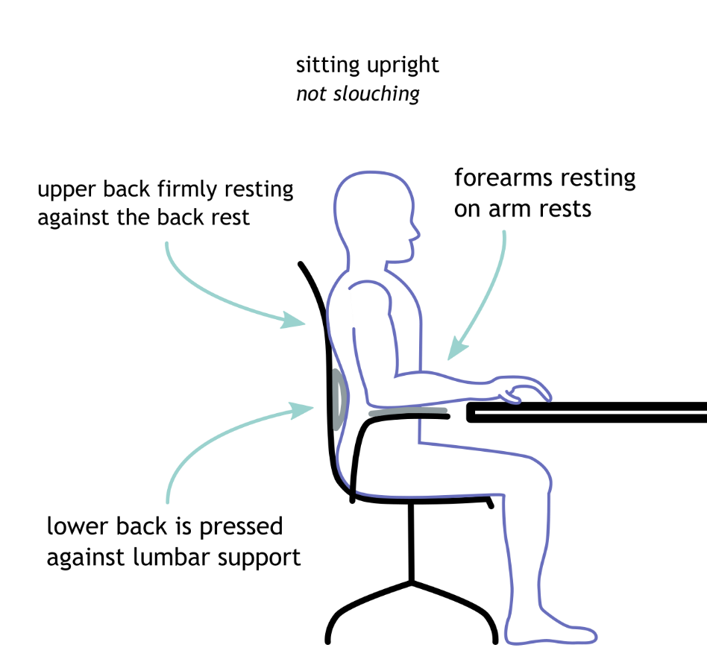
Figure 1: Posture and Support when sitting that puts the least pressure on the discs of the lower back.

Standing desks
One systematic review by Neuhaus et al. (833) explored activity-permissive workstations, i.e., desks that can transition between sitting and standing. It compared studies that measured health outcomes after more than 3 months (long) to those less than 3 months (short). One outcome that was explored is musculoskeletal health. This includes back pain. Interestingly, while the pooled data for short studies showed negative, positive, and neutral patient outcomes, the long studies showed only neutral or positive outcomes for back health. 16 participants worsened, 56 did not change, and 32 improved in the short studies. In the long studies 15 did not change and 8 improved their musculoskeletal health. This could indicate that changes in health are only detectable after a long enough period of using the activity-permissive desks.
Another two health outcomes Neuhaus et al. explored were weight and body mass index, which are indicators of obesity. Unfortunately, 4 out of 5 of the studies reviewed showed no change in body mass index and 7 out of 9 showed no change in weight. All but one of these studies were long studies. This makes it clear that simple activity-permissive workstations can not be used to reduce obesity. Furthermore, another systematic review compared standing-sitting desks to treadmill desks and found that the former was ineffective while the latter had inconclusive results when comparing between 3 conflicting studies. Body mass index decreased very modestly in only one of the three studies (MacEwen et al. 54). Considering that the cheapest treadmill desks are $500 CAD, it is not a pragmatic way to fix obesity given the small effect size.

Exercise
A cross sectional study surveyed participants about their exercise habits, how often they sit, and their back and neck pain. One of groups surveyed self reported sitting for 75% of the time ane exercising 3 to 5 times per week. 14% of this group reported they had back and neck pain “often” or “very often”. They experienced slightly less pain than another group that sat 50% of the time during work and exercised 2 to 3 times per week. 18% of this group reported they had neck and back pain “often” or “very often” (Ekblom-Bak et al. 6-7). This supports that exercise can reduce the association between sitting often and experiencing back and neck problems, even if only by a small margin. The study in question attempted to statistically control for obvious confounding variables like smoking, sex, and age. This allows for inference that exercise is the cause of this rescuing effect.
Unlike back and neck pain, obesity is not associated with sitting at all, only exercise. That is, one group self-reported exercising “sometimes” and “never” sitting at work. 22% of these individuals were obese, i.e., they had a body mass index above 30. Another group exercised the same amount but sat 75% of the time at work. This group was also 22% obese. Finally, to illustrate that exercise is the sole factor in obesity, a third group exercised 3-5 times per week and sat 75% of the time. Only 1% of this group was obese (Ekblom-Bak et al. 6-7).

Opinions of computer science students on sitting too often
According to the survey answers (Fig. 2), computer science students at UBC unanimously agree that sitting for long periods of time is at least somewhat bad for health. The majority (75%) of students thought it was “bad for your health”. Since current research shows that sitting contributes to many negative health outcomes, the students understand that sitting too often is hazardous.
The other survey answers were less agreed upon. When asked to compare a standing desk to a sitting desk, most students (66.67%) thought they were “healthier, but still problematic”. This is correct since the positive effect of standing desks on back health is small (Ekblom-Bak et al. 6-7). The last third (33.33%) of students mistakenly believe it is a “great solution to the problem”.
75% of students were correct in choosing “proper posture while sitting will reduce the negative effects of sitting for too long”. Thus, the 12.50% that thought it would “not reduce the negative effects” were not aware of the research on bad back health caused by bad posture. Additionally, a combined 12.50% answered that good posture could “prevent any negative effects”. This includes 8.33% that thought this was possible with “enough exercise”. Unfortunately, back health still suffers even with perfect posture and exercise.
Opinions on exercise’s effect on too much sitting were the most divisive. Less than half (45.83%) selected correctly that exercise can “reduce the negative health effects of sitting”, but not completely prevent them. Indeed, 54.17% thought exercise would “prevent any negative effects”. This includes 29.17% that thought this was possible with “enough exercise”. It’s worth repeating: back health still suffers even with perfect posture and exercise. No students selected that exercise would not reduce the negative effects.

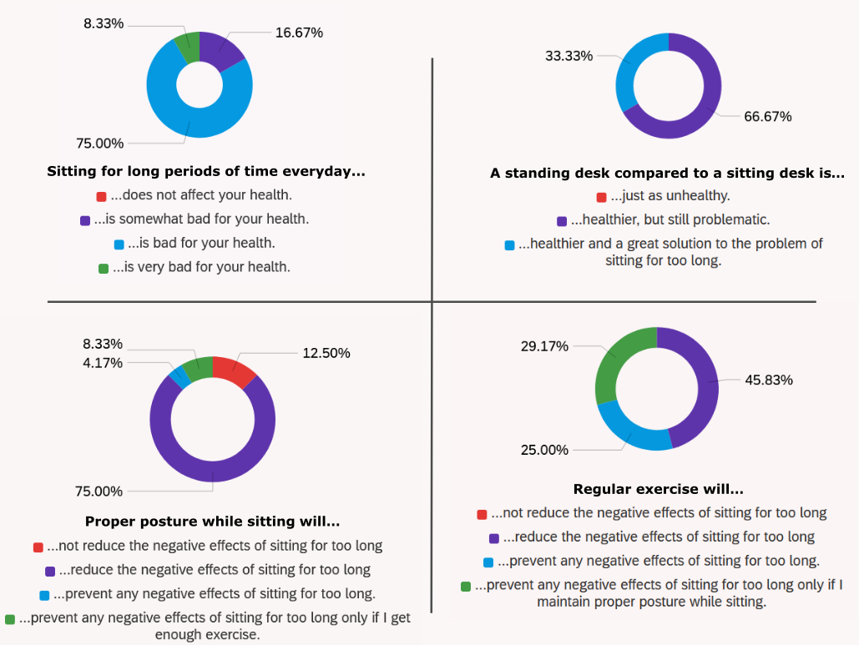
Figure 2: Responses of computer science students at UBC to whether they think sitting for too long is bad. Responses to three questions regarding ways to reduce negative effects of long-term sitting.
The last survey question asked which diseases sitting causes (Fig. 3). The answers relating to deep vein thrombosis, asthma, and Parkinson’s disease are ignored since they are not in the scope of this report. Every student correctly selected that sitting too often is a cause of back pain. 83% correctly selected that it is also a cause of obesity.
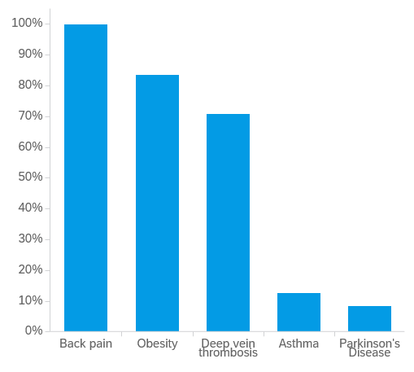
Figure 3: Survey results for the percent of UBC computer science students that think long-term sitting can cause various health effects.

CONCLUSION

Summary of negative health effects of sitting
Sitting for too long at work is a major contributor to chronic back pain. Taking a short break from sitting at work to stretch or walk every 30 minutes lessens the risk of developing back pain. Under particular circumstances, sitting constantly at work will contribute to being overweight or obese. Namely, people who exercise regularly outside of work are not at risk unlike people who are usually sedentary.

Recommendations to protect health
Consider these interventions to reduce the negative effects of Sitting:
- Take one or two minutes to walk, stretch, or be active after sitting for 30 minutes.
- Sit with good posture and proper support:
  - Sit upright with your upper back resting firmly against a back rest.
  - Support the lower back with a cushion placed against it and the chair.
  - Support the forearms with arm rests
- If it is within your budget or available, use an activity permissive work station.
- Get regular exercise. Ideally this is 3-5 times per week.

Recommendations for the education of students
- Stress to students that regular exercise, good posture, and an activity permissive workstation is helpful to reduce the risks of sitting for too long.
- Teach students that even with these interventions back problems can still occur if they sit (or stand) for too long.

WORKS CITED

Andersson, B J Gunnar et al. “The Sitting Posture: An Electromyographic and Discometric Study**.” Orthopedic Clinics of North America 6.1 (1975): 105–120. Web. <https://www.sciencedirect.com/science/article/pii/S0030589820312050>.
Baker, Richelle et al. “The Short Term Musculoskeletal and Cognitive Effects of Prolonged Sitting During Office Computer Work.” International journal of environmental research and public health 15.8 (2018): 1678–1694. Web. <https://pubmed.ncbi.nlm.nih.gov/30087262>.
Canada. Statistics Canada. Body Mass Index (BMI). 2007 Canadian Community Health Survey - Annual Component. 13-10-0488-01. Ottawa: Statistics Canada, 2008. Statistics Canada. Web. 10 Nov. 2021. <https://doi.org/10.25318/1310048801-eng>
Ekblom-Bak, Elin et al. “Latent Profile Analysis Patterns of Exercise, Sitting and Fitness in Adults – Associations with Metabolic Risk Factors, Perceived Health, and Perceived Symptoms.” PLoS One 15.4 (2020): 1–13. Web. <https://www.proquest.com/scholarly-journals/latent-profile-analysis-patterns-exercise-sitting/docview/2394532972/se-2>.
UCLA Health. “Ergonomics for Prolonged Sitting.”, n.d. Web. 6 Nov. 2021. <https://www.uclahealth.org/spinecenter/ergonomics-prolonged-sitting>.
Hoy, Damian et al. “A Systematic Review of the Global Prevalence of Low Back Pain.” Arthritis & Rheumatism 64.6 (2012): 2028–2037. Web. <https://doi.org/10.1002/art.34347>.
Lunde, Lars-Kristian et al. “Associations of Objectively Measured Sitting and Standing with Low-Back Pain Intensity: A 6-Month Follow-up of Construction and Healthcare Workers.” Scandinavian Journal of Work, Environment & Health 43.3 (2017): 269–278. Web. <https://www.proquest.com/scholarly-journals/associations-objectively-measured-sitting/docview/1903811553/se-2>.
MacEwen, Brittany T, Dany J MacDonald, and Jamie F Burr. “A Systematic Review of Standing and Treadmill Desks in the Workplace.” Preventive medicine: 50–58. Web. <https://go.exlibris.link/z1GkYQ4R>.
Thorp, Alicia A et al. “Prolonged Sedentary Time and Physical Activity in Workplace and Non-Work Contexts: A Cross-Sectional Study of Office, Customer Service and Call Centre Employees.” International Journal of Behavioral Nutrition and Physical Activity 9.1 (2012): 128–137. Web. <https://doi.org/10.1186/1479-5868-9-128>.
Vanasse, A et al. “Obesity in Canada: Where and How Many?” International Journal of Obesity 30.4 (2006): 677–683. Web. <https://doi.org/10.1038/sj.ijo.0803168>.

