

Feasibility Analysis for Reducing the Environmental Footprint at Keller Williams Realty VanCentral

*Formal Report Draft*

for

Siobhan Lidder

Realtor Services Coordinator at the Keller Williams Realty VanCentral office

&

Connie Buna

Managing Broker at the Keller Williams Realty VanCentral office

Vancouver, BC

by

Tamara Oman

English 301 Student

**November 16, 2021**

Table of Contents

Introduction **3**

Data Section **4**

Causes of Deforestation **4**

*The Growth and Involvement of the Pulp and Paper Industry* **5**

*Irresponsible harvesting* **6**

*Interaction with agricultural activities* **6**

Sources and Volume of Paper Consumed **6**

*Use of Paper by Realtors* **7**

*Use of Paper by Market Center Administrators and Office Management* **8**

*Certifications of Paper Products* **8**

*Use of Paper by Client Care***9**

*Use of Paper in the Kitchen* **9**

Analysis of Document Storage Solutions **10**

*Document Management and Storing Solutions* **10**

*Costs of Producing and Storing Documentation* **11**

*Cost Comparison of using Virtual Platforms* **11**

Attitudes Towards Converting Daily Business Practices to Virtual Platforms **11**

*Training* **13**

*Security* **1**3

*Binding and Enforceability of E-Signatures on Legal Contracts* **14**

*Technological Malfunction* **14**

*Probability of Conversion* **1**4

Motivation Regarding Reducing the Environmental Footprint **15**

Conclusion **16**

Summary and Overall Interpretation of Findings **16**

Recommendations **1**7

References **1**7

Figures

Figure 1 Causes of Deforestation in Canada (2016) **5**

Figure 2 Average Annual Consumption of Paper per Realtor **7**

Figure 3 Average Annual Cost of Printing Paper **11**

Figure 4 Concern for Impacting the Environment **15**

**Reducing the Environmental Footprint at Keller Williams Realty VanCentral**

Tamara A. Oman

# **Introduction**

Trees are a renewable resource that is critical for habitation by filtering harmful air pollutants, providing habitats to support biodiversity and the preservation of soils. Unfortunately, trees are the primary raw material for the paper industry which come from managed forests and farms; where four million trees are planted each day, 300-400% more are harvested for the production of paper which in turn intensifies the issue of deforestation. Global deforestation may cause climate change, desertification, soil erosion, reduced crops and flooding. The issue also contributes to greenhouse gases in the atmosphere, where on average 12% of the global greenhouse and gas emissions are caused by deforestation.

Real Estate offices use a substantial amount of paper to file transaction documentation. Traditionally, these documents are printed and filed in boxes, where they are stored in the event of an audit from the Real Estate Board. With over 130 Realtors, Keller Williams Realty VanCenral office produces a high level of printing volume.

Upon the analysis of surveys to office Realtors and interviews with office administration, this report will assess the potential options for minimizing the environmental footprint of the Keller Williams Realty VanCentral office by (a) identifying sources of paper consumption, (b) identifying alternative solutions, (c) cost analysis of converting to virtual solutions, and (d) identifying the motivation and probability of conversion to reduce the impact on the environment.

This report covers six major topics: a study of the effects the pulp and paper industry has on deforestation, areas of paper consumption in the office, a study on the volume of printing, an analysis on alternative solutions and cost comparison, a study on the attitudes towards using virtual platforms, and the motivations concerning reducing the environmental footprint.

This report concludes by acknowledging the contribution to deforestation and by recommending an affordable alternative to printing documentation.

# 

# **Data Section**

# **Causes of Deforestation**

Deforestation is caused by several factors including agriculture, unsustainable forest management, mining, infrastructure and increased fire incidences. Of these causes, agriculture has the highest effects on deforestation (WWF). Although the majority of this category includes the clearing of forests for the expansion of farm or ranch lands, it also includes forest plantations used by pulp and paper companies (Rosoman). Figure 1 illustrates causes of deforestation in Canada alone.

**Figure 1** Causes of Deforestation in Canada (2016)

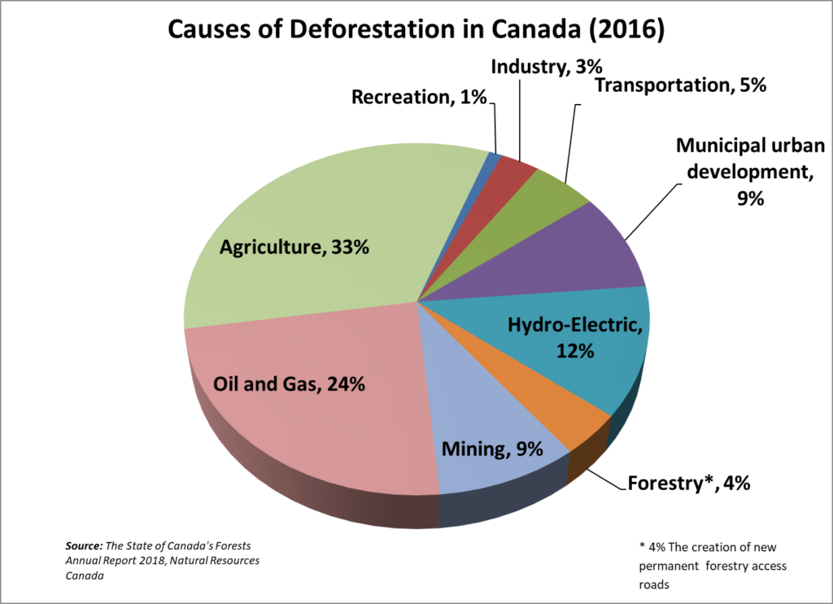

(Mullinder)

# 

# **The Growth and Involvement of the Pulp and Paper Industry.** The global consumption of paper has quadrupled over the last fifty years, consequently the pulp and paper industry increased exponentially (Vermeer). This industry contributes to global deforestation in two major ways:

1. Irresponsible harvesting from natural forests and the establishment of pulp plantations on converted natural forests (WWF).
2. Interaction with agricultural activities (Vermeer).

# **Irresponsible harvesting**. Pulp companies not only harvest trees in temperate regions where forests thrive, they also harvest in tropical and boreal forests (Matthews). Deforestation of natural forests not only contributes to the global emissions of greenhouse gases, but also threatens ecosystems and species. Examples of endangered species due to deforestation for the pulp industry include the African Forest Elephant, the Tapanuli Orangutan and the Sunda Tiger (WWF).

# **Interaction with agricultural activities**. Farmers and pulp companies will trade by clearing land for agricultural purposes while infrastructures are built to process the lumber. In turn the land value increases due to the additional infrastructure and eventually sold by the farmer. Often, the farmer will purchase a larger area of land with the proceeds and the process repeats itself (Vermeer).

# **Sources and Volume of Paper Consumed**

Sources of paper consumption in the office varies by department, and the costs of using paper products for each department varies significantly. Below are the five main sources of paper use at the Keller Williams Realty VanCentral office:

1. Realtors
2. Market center administrator office
3. Office management
4. Client care
5. Kitchen

# **Use of Paper by Realtors.** 68% of Realtors and unlicensed assistants said documents were printed and stored in filing boxes for each transaction. The average Realtor conducts 7 transactions per month, additionally an average of four offers are placed before receiving an accepted offer for a buyer.

* A full transaction requires approximately forty to fifty pages which include listing contracts, disclosure documents, purchase contracts and addendums.
* A purchase offer has approximately twenty pages.

Realtors who print documentation for each transaction on average produce about four hundred and thirty pages per month.

**Figure 2** Average Annual Consumption of Paper per Realtor*

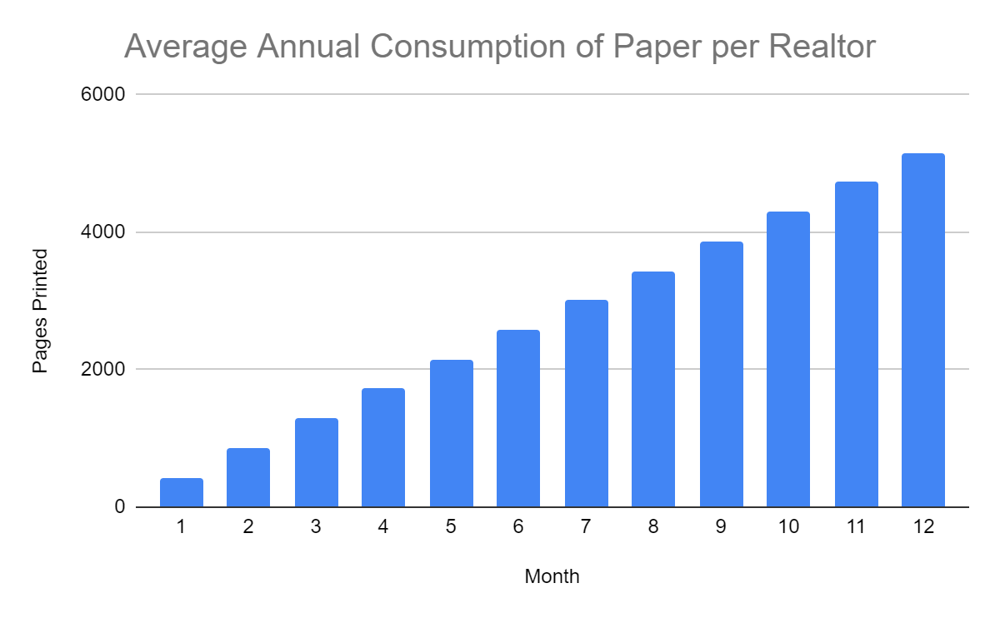

*For Realtors who print documentation for each transaction

# **Use of Paper by Market Center Administrators and Office Management.** Sources of printing from the market center administrators involve business administration including human resource contracts, accounts receivable, accounts payable, remittance and other necessary areas of physical documentation. The processing and conveyancing of transactions already involves using one of two virtual platforms which include DotLoop and Command. Zero pages are printed for transactions from the market center. Realtors who do not have memberships with these websites must scan each page of their transaction and email it to the market center administrators for processing. Sources of document printing from office administration were found to be excellently minimal as the majority of management systems are already used virtually.

# **Certifications of Paper Products.** Although completely eliminating the amount of paper printed in the office is not a realistic approach, ethical paper brands are available. The following are examples of certifications for the ethical production of paper products:

* Forest Stewardship Council
* Programme for the Endorsement of Forest Certification
* Rainforest Alliance Certified
* Green Tick

The purpose of these organizations is to certify that the product or ingredient was produced by farmers, foresters and other companies in a sustainable way and promotes the responsible management of our global forests (FSC). Using certified paper products not only encourages responsible manufacturing of paper products, but also encourages ethical business practices in the pulp and paper industry globally.

# **Use of Paper by Client Care.** Currently, cards or invitation postcards are ordered via vistaprint on virgin paper. A study by Bucks Digital, a printing company based in Philadelphia, found that in general recycled paper is cheaper than virgin paper and is often impossible to distinguish apart.

Recycled paper products are available at many printing companies including Vista Print and UPS which are suppliers already being used by the office. Converting stationary orders to recycled paper does not have any detrimental effects on the environment, and has the potential to decrease the total cost of stationary.

# **Use of Paper in the Kitchen.** Sources of paper use in the kitchen stem from the following areas:

* Paper cups
* Paper plates
* Paper towels

The office kitchen is currently set up to have the necessary tools and appliances to cater events including cabinetry and a dishwasher. Office administration has confirmed there is currently 1 empty base cabinet and 2 empty wall cabinets.

Empty cabinets have the potential to be converted to storing plastic serveware or personal cups rather than providing Realtors with paper products. Not only does offering serveware reduce the cost of supply for the office in the long term, garbage and waste is also decreased daily.

# **Analysis of Document Storage Solutions**

This section will analyze the costs of printing and storage fees versus online alternatives.

# **Document Management and Storing Solutions.** Following is a description of three document management solutions and three document storage solutions:

* **Physical Printing and Filing Boxes**: Consists of physically storing documentation.
* **DotLoop**: This alternative is a Real Estate transaction management software that connects Realtors and Buyers virtually for instant e-signatures. The documents are stored on the interface once the transaction closes, therefore offering a bonus storage solution (DotLoop).
* **Command**: Created by Keller Williams, this interface is offered to all agents for free. Command provides database management, document management, task management and marketing solutions. Command is still in creation for Canadian brokerages however the software is currently available with limitations until it has been fully released (KW).
* **Google Drive**: Is a cloud-based storage solution that allows a user to save files online and access them anywhere from any smartphone, tablet, or computer (Google). This option only supports Mac and Window users (Alghini).
* **Dropbox**: Is a second cloud-based solution that is similar to Google Drive, however it is based off a desktop application and supports earlier versions of Mac OS, Windows as well as Linux (Alghini).

# **Costs of Printing and Storing Documentation.** For the scope of this report, only Realtor printing consumption is used to analyze the volume of paper vs. costs. 68% of Realtors said transaction documents were printed and stored in filing boxes. The cost of printing a black and white document is $0.10 per page. Using the volume of pages printed explained above, the average Realtor spends approximately $43.00 per month on printing fees, $516 annually, assuming black and white. This fee can triple monthly if printing in color.

**Figure 3** Average Annual Cost of Printing

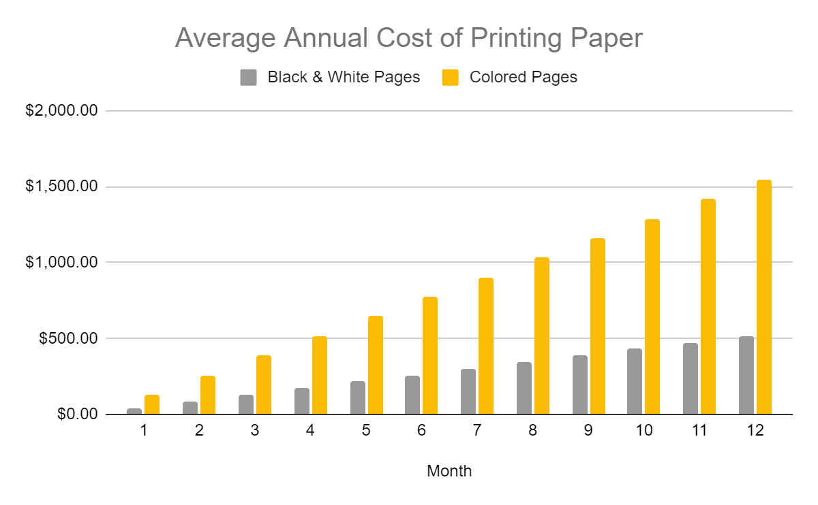

In addition to printing fees, filing boxes and folders are on average an additional $100.00 per year for each Realtor and require 1 cubic foot per box.

# **Cost Comparison of using Virtual Platforms.** The four virtual solutions are compared to printing fees below:

* Dotloop: Costs an agent $29.00 per month. Assuming black and white printing, this alternative is $14.00 less per month saving $168.00 per year.
* Command: Is offered by Head Quarters to all Keller Williams agents for free. This option has the potential to save Realtors 100% of their annual printing costs.
* Google Drive:
  + Option 1: $30.00 per year for one hundred gigabytes of space saving Realtors an average of over $400.00 annually. If combined with Dotloop, a Realtor is still saving over $130.00 per year.
  + Option 2: $140.00 for a terabyte, saving Realtors an average of over $350.00 annually. If combined with DotLoop this option is close to the current cost of printing fees.
* Dropbox:
  + Option 1: $150.00 per year for two thousand gigabytes of space, saving Realtors an average of over $350.00 annually. If combined with DotLoop this option is close to the current cost of printing fees.
  + Option 2: $280.00 per year for three terabytes, saving Realtors an average of over $350.00 annually. If combined with DotLoop this option is $100.00 more than the current cost of printing fees.

The benefits of printing documentation for storage purposes is access to the documents in the event of a technological crash, or cancellation of a membership. However, physically storing documents requires a substantial amount of space and is generally more expensive than the virtual alternatives. Each of the virtual solutions offer affordable cloud based storage which offers increased security and accessibility. The cost analysis confirms the feasibility of both DotLoop and Command in terms of affordability.

# **Attitudes Towards Converting Daily Business Practices to Virtual Platforms**

The following section will identify four areas of concern identified for using virtual solutions as well as the probability of conversion.

# **Training**. The most frequent critique for converting businesses to virtual software was the concern for retraining. When asked if re-training would deter a Realtor from considering converting, 17% responded with a definite aversion if retraining was required.

Although new software is intimidating and may be initially frustrating, long term productivity and efficiency is increased. Both DotLoop and Command have extremely user-friendly interfaces and require very little training on functions.

# **Security.** The second most popular concern for using virtual software was the issue of security and privacy for keeping confidential documentation online. The issue of public accessibility and potential hacking identified a strong aversion to the concept.

Both DotLoop and Command require several components to passwords when signing up for an account. Control over documents accessibility is very high and the probability of hacking into one of these accounts is extremely unlikely. The accessibility to Google Drive or Dropbox offers two-step verification options which only allow approved devices to have access to content. That said, control over the security and accessibility of documents stored in filing boxes is very low.

# **Binding and Enforceability of E-Signatures on Legal Contracts.** A third critique was the enforceability of e-signatures on listing or purchase contracts.

The Electronic Signatures in Global and National Commerce Act is a federal law that validates electronic signatures. Real Estate transactions are specifically covered under this act (DotLoop). It is also common practice to include a clause regarding e-signatures in the terms and conditions of purchase contracts.

# **Technological Malfunction.** The final critique referred to losing or accessing information in the event of a technological crash or a power outage. A strong concern for losing information was detected in 23% of respondents.

Although power outages do happen and are not controllable, DotLoop and Command are available through applications on phone and tablets. In the event of a power outage, assuming reception is still available, documents are still accessible. The issue concerning losing information is very unlikely, as all options offer cloud-storage with full-time IT departments.

# 

# **Probability of Conversion.** When asked about the probability of converting business practices from printing to using virtual solutions, 53% of surveyors responded a high likelihood of conversion if the interface is user-friendly and the property training is offered for little cost.

# 

# **Motivation Regarding Reducing the Environmental Footprint**

When asked about the concern regarding the environmental impact of printing documents, 60% of surveyors responded with a high concern for the environment, 37% responded with a lower concern and 3% responded with no concern.

**Figure 4** Concern for Impacting the Environment

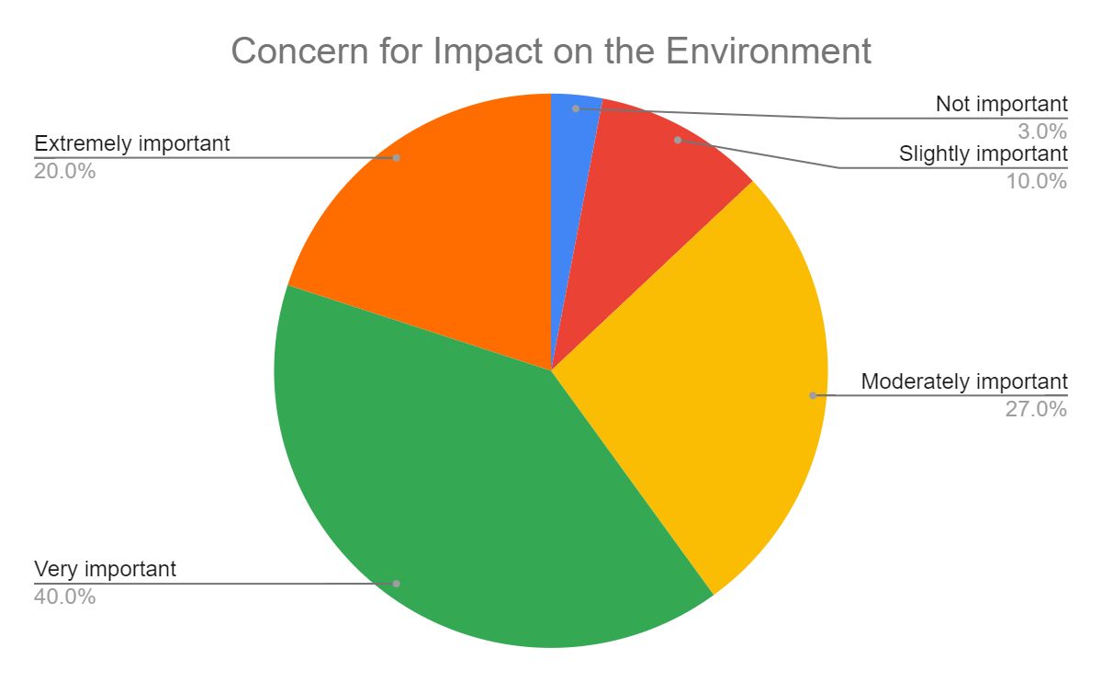

Although 37% of Realtors have a lower concern for impacting the environment with business practices, there is a clear concern for the environment on the majority of surveyors. Motivation for converting business practices to virtual solutions are enforced by this impact, as well as increased administration, space required and the expenses associated with printing documents.

# **Conclusion**

# **Summary and Overall Interpretation of Findings**

Deforestation is a serious global issue and is largely caused by agricultural purposes. Forest plantations for the pulp and paper industries are a portion of these actors. An increase of paper demand has caused the industry to grow exponentially. Of the four million trees that are planted each day, 300-400% more are harvested for the pulp industry. The cover of forestry on our planet is decreasing daily and severely contributing to environmental concerns including increasing greenhouse gases, climate change and endangered species.

There are five sources of paper consumption at the Keller Williams Realty VanCentral brokerage. Of these five sources, only three have the potential to have a reduced impact on the environment. These sources include paper consumption from Realtors, client appreciation and the office kitchen.

The office has already implemented the first steps of converting the office conveyancing systems to entirely virtual platforms for data management. Two platforms are being used to process transactions; DotLoop and Command, which are offered at extremely affordable costs to Realtors. Currently, Realtors without memberships have the option of emailing their documents to the market center administrators which are then uploaded to one of the two platforms for processing. Results from respondents identified 68% of Realtors do not currently use a virtual platform to manage their documentation.

The majority of critiques and concerns regarding virtual platforms include misinformed conclusions on technological software and have the potential to be surpassed. The probability of conversion is over 50% if easy and affordable training was encouraged, and the motivation to protect the environment was high in 60% of respondents.

# **Recommendations**

In attempt to decrease the environmental footprint regarding the consumption of paper products, please consider the five areas of improvement:

* Mandating the memberships of either DotLoop or Command for submitting transaction documentation.
* Offering free or low cost personal training sessions for both virtual platforms.
* Using certified paper products from ethical brands for printing.
* Using recycled paper for stationary.
* Offering reusable serveware in the kitchen.

Although completely eliminating our impact on the environment is unrealistic, these options are a step towards reducing our involvement in the deforestation of our planet.

# **References**

Alghini, Christopher (2013). Four Differences Between Google Drive and Dropbox. APPSADMINS. https://www.appsadmins.com/blog/four-differences-between-google-drive-and-dropbox

Matthews, Daniel (2016). Sustainability Challenges in the Paper Industry. AiChE. <https://www.aiche.org/chenected/2016/10/sustainability-challenges-paper-industry>

Mullinder, John (2019). PPEC. <https://ppec-paper.com/setting-the-record-straight-on-deforestation-in-canada/>

Vermeer, Karen (2020). Two sides of the same coin: How the pulp and paper industry is profiting from deforestation in the Amazon rainforest. Environmental Paper Network. <https://environmentalpaper.org/2020/09/two-sides-of-the-same-coin-how-the-pulp-and-paper-industry-is-profiting-from-deforestation-in-the-amazon-rainforest/>

[www.bucksdigital.com/resources/greenpage/recycled.html](https://www.bucksdigital.com/resources/greenpage/recycled.html)

[www.dotloop.com](http://www.dotloop.com)

[www.greenpeace.com](http://www.greenpeace.com)

[www.outfront.kw.com](http://www.outfront.kw.com)

[www.wwf.com](http://www.wwf.com)