**Help UBC CS Students Better Prepare for Career**

A Feasibility Analysis for Extending Current Functionalities of CSSS

For

Mr. Leonard Wang

President

UBC CSSS

By

Yifan Wang

November 15th, 2021

Table of Contents

1. Introduction 3

1. Background 3

2. Statement of the problem 3

3. Purpose 4

4. Audience 5

2. Research Methods 5

1. Survey 5

2. Secondary sources 6

3. Data Section 6

1. Analysis of survey result 6

4. Proposed Solution and Feasibility Analysis 9

1. Proposed Solution 9

2. Feasibility Analysis 10

5. Conclusion 11

References 12

Appendix 13

Appendix A 13

# Introduction

## Background

The Computer Science (referred to CS hereafter) department of the University of British Columbia is ranked high among other CS faculties in the world, and it is well-known for providing high quality CS education. However, like many research universities in the world, the CS education it provides focuses on theoretical fundamentals. While having a solid foundation is important, a lot of students lack preparation for their career, be it Co-op or first full-time job after graduation.

## Statement of the problem

The lack of preparation is mainly reflected in the following three aspects.

First, the courses students take at school does not adequately prepare them for behavioral and technical interviews. Although the CS Co-op office does provide mock behavioral interview to students, it is usually not in enough depth, and most of the time they are unable to provide mock technical interviews to students. As a result, students do not have chance to practice before going to the real interviews and always performs poorly in their first few interviews. However, these “first few interviews” might be all the interviews they could get in their job seeking term.

Second, school does not teach students most of the tools used at work. Although it is a common belief that if someone has a good grasp of all the CS fundamentals, they will be able to pick up these tools needed by work quickly. However, most of the mid to small size companies gives preference to candidates who already have experience with those tools, as this lowers the training cost. A students best bet would be to make personal projects that use those tools. However, they might get overwhelmed by the wide-array of technologies to choose from.

Third, most students do not know what companies do, and sometimes may not know what to expect in their daily work. It would be greatly beneficial if any alumni who is working in the industry could share about the typical days at their work, the scope of their work, and what skills are demanded. Actually, according to Clare McDonald (2018), barriers such as “employers requiring a specific programming language, a certain amount of experience in a certain field” are barring students from entering the industry. In this case, the knowledge sharing between working professionals and students is important.

## Purpose

As a research university, UBC focuses on theoretical computer science, teaching computer science fundamentals. It would too much of a burden for UBC CS to fully undertake the responsibility of preparing students for job market, so this has to be done by student organizations. Currently, the major student organization in the CS department is Computer Science Student Society (referred as CSSS hereafter). The services it provides include hosting technical career fair, place for tutors to advertise themselves, and a student lounge, etc. CSSS seems to be a good fit to provide such service. Because it is well-known among students, and it is funded by the CS department.

The purpose of this report is to bring attention to the disconnection between CS education and actual career. Also, we want to make more career training resources available to CS students.

In order to achieve this purpose, one possibility is to extend the current functionalities of CSSS. Including providing regularly updated guides on how to prepare for job seeking on the website, in-person mock interview and personal project workshops, and Q&A session with UBC CS alumni working in different industries.

This report aims to evaluate whether UBC CS students requires additional career coaching, and determine what kind of activities students are most interested in. In addition, we also evaluate the feasibility for UBC CSSS to extend their current functionalities to cater students’ need for career coaching.

## Audience

This report is intended for the management team of UBC CSSS, led by Leonard Wang. The team has the capability of allocating resources necessary to extend the current functionalities, and request necessary funding from the CS department if needed.

# Research Methods

## Survey

An important primary source would be conducting a survey that targets all CS students. The survey mainly asks about CS students’ attitude on if the CS education they had was directly helpful in job hunting, and what, if any, could be done to improve it. The data will be used to determine the feasibility of extending CSSS’s functionalities, and what exactly needs to be provided. To evaluate the feasibility of providing more activities, there are few questions to be answered by UBC CS students:

* How many students feel that there is a disconnection between CS education and actual job.
* How badly does the disconnection affect their first job seeking.
* What kind of activities should the club provide to bridge the gap.
* In what format should some of the activities be.

## Secondary sources

We will also refer to the website of many other renowned CS faculties in the world and see what kind of activities they have in order to better prepare their students for job market.

# Data Section

## Analysis of survey result

We handed out 60 surveys in total. After taking out incomplete surveys, we had 56 valid samples. Below is the analysis of each question.

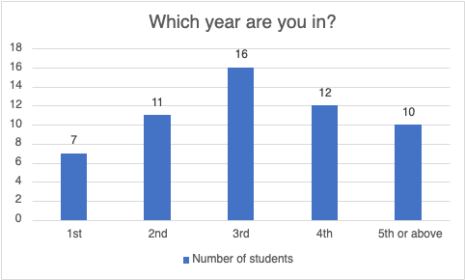

The first question asks the year level of students. From the result we can see that there are more respondents in upper level than those in first year and second year. A lot of students would enter the Co-op program and start looking for their first Co-op placement in their second year or third year. Students who are not in the program might also look for summer internships at around that time. In addition, students in their fourth year or above might start looking for full-time positions after graduation. As a result, there might be a lot of students who have job seeking experience.

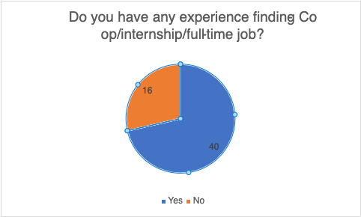

The answer to this question is consistent with our guessing from last question. The majority of the respondents have experience looking for jobs, and this means we can get more accurate results from the following questions.

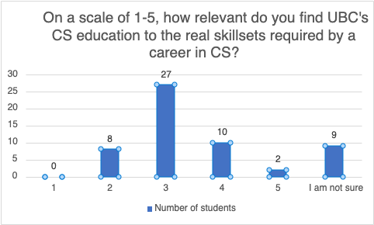

Based on the students’ answer, there is indeed a mismatch between UBC CS’s education and the real skillsets demanded by employers in the IT industry. There are 47 people think there is more or less some disconnection (2 – 5), and more than half people think the mismatch is average or more than average (3 – 5).

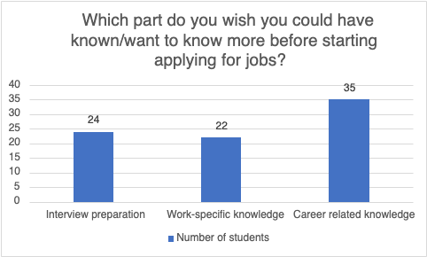

This question allows each respondent to have more than one answer. Based on the result, we can see that knowing more career related knowledge is the most popular among our respondents with 35 votes. Interview preparation and work-specific knowledge, although not as popular, are also considered to be important, with 24 and 22 votes respectively.

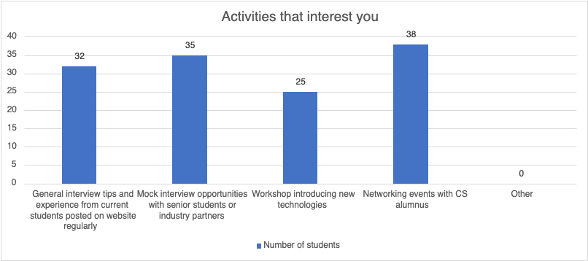

The information we get from this question conforms to our last question. With most number of students willing to attend networking events with CS alumnus to ask about more career-related questions. Interview-related activities are also popular. Workshops are not as popular, but still demanded by a lot of students.

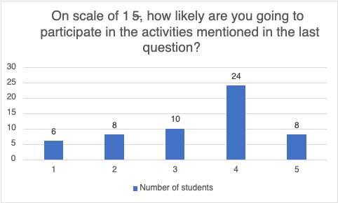

We have 32 students that are very interested, and 10 students that are moderately interested. About 14 students are not very motivated in participating. Overall, we can see that students are fairly interested in participating in the activities if they are to be held by CSSS.

# Proposed Solution and Feasibility Analysis

## Proposed Solution

Based on the survey, we can conclude that a lot of students definitely feel they are underprepared for job market, and they have interest in participating events that better prepare them for a career.

Actually, it is not rare that student-ran organizations take on such responsibilities. For example, at Cornell University, the Association of Computer Science Undergraduates is responsible for holding educational events such as introductory web programming lessons, mentorship program that connects alumni to students, and compiling resume books that will be sent to over one hundred top corporations. This is a great example that CSSS could refer to.

Since CSSS only has limited resource for extending functionalities, a reasonable approach is to prioritize events based on students’ demand. Given the survey result, CSSS should focus more on holding career-related events, namely mentorship programs, experience sharing from alumnus, etc. Also, there should be more mock interview opportunities provided. If there is any additional resource, it could be allocated for technical workshops.

## Feasibility Analysis

Currently, UBC CSSS has nine executives, and a lot of the daily affairs are carried out by volunteer officers. In a lot of services CSSS currently provides, it acts like a platform and liaison, and this should be maintained given that it experiences fluctuation in available volunteers.

Facilitating experience sharing between alumnus and current students is relatively easy, one feasible approach is to have a dedicated column on CSSS’s website, and invite alumnus to share their experience. Experience could range from tips for job hunting to work experience at their current/former companies. Small gifts such as gift cards could be given to show gratitude. In this solution, the cost would just be the small gifts and the time needed to make changes to current website. Also, there won’t be too much liaison needed. In contrast, holding mentorship programs involves contacting multiple alumnus, managing student registration, kicking off the event (with possibly more than 100 participants). Given the current manpower, it would be less realistic.

It would be relatively easy to hold interview preparation workshops. A few alumni from different companies could be invited, volunteers could be drawn from participating students, and they will do mock interview with alumni. In this way, the cost is relatively low, and it is not very hard to manage, since there will be less alumni invited. Similarly, tech workshop requires same amount of resource, and could be held provided that there is enough interest from students.

# Conclusion

In general, many Computer Science students at the University of British Columbia are not well-prepared for job markets because of all the theory-heavy courses being taught, even though a solid foundation would benefit them in the long run. To address this issue, the Computer Science Student Society could undertake the responsibility and extend their functionalities to better support this cause.

* Provide dedicated columns on website for graduates to share their stories and provide their tips for current students.
* Hold interview workshops and tech workshops to help current students get familiar with technical interview questions and expectations as well as get started on widely-used technologies and tools.
* Events with larger scales such as mentorship program could be arranged once CSSS has more available volunteers.

# References

McDonald, Clare. “Tech has ‘disconnect’ between the skills students are taught and the abilities firms need”. Computer Weekly,

https://www.computerweekly.com/news/450433416/Tech-has-disconnect-between- skills-students-are-taught-and-what-firms-want-says-panel. Accessed 8 Nov, 2021.

Cornell ACSU. <https://acsu.cornell.edu/>. Accessed 8 Nov, 2021.

# Appendix

## Appendix A

Survey Questions

1. Which year are you in?
2. 1
3. 2
4. 3
5. 4
6. 5 or above
7. Do you have any experience finding Co-op/internship/full-time job?
8. Yes
9. No
10. On a scale of 1-5, how relevant do you find UBC’s CS education is to the real skillsets required by a CS career?
11. 1
12. 2
13. 3
14. 4
15. 5
16. (Choose 0 or more answers) Which part do you with you could have known more before starting applying for jobs?
17. Interview preparation (Interview tips, mock interview, etc.)
18. Work-specific knowledge (Programming Languages, Tools, frameworks, etc.)
19. Career related knowledge (Experience sharing, networking opportunities, etc.)
20. (Choose 0 or more answers) CSSS (Computer Science Student Society) is a student organization ran by CS students. If they were to provide more career-related resources, what kind of resource would you like to see?
21. General interview tips and experience from current students posted on website regularly.
22. Mock interview opportunities with senior students or industry partners.
23. Workshop introducing new technologies.
24. Networking events with CS alumnus.
25. On scale of 1 – 5, how likely are you to participate in the activities mentioned in question 5?
26. 1
27. 2
28. 3
29. 4
30. 5