Proposal for the Construction of a Towing Tank at the University of British Columbia
Samuel Martin Kobierski
University of British Columbia

Table of Contents
Summary 3
Purpose of this Report 3
Background 3
Current Availability of Towing Tanks 4
Stakeholder Requirements 4
Alternate Uses 4
Economics of a Towing Tank 5
Conclusion 5
References 5

Table of Figures
Figure 1 - ??? [PDF] 5
Figure 2 - ??? [?] 5
Figure 3 - ??? [?] 5
Figure 4 - ??? [?] 5

Abstract
Towing tanks are common place at educational institutions that perform research and education in the field of ship hydrodynamics, however, the University of British Columbia does not currently have a towing tank, leaving faculty and students without a critical piece of equipment. This proposal will provide an argument for the construction of a towing tank at the Point Grey Campus of the University of British Columbia, quantifying the immediate need for a towing tank.

Purpose of this Report
The purpose of this report is to provide an argument for the construction of a towing tank at UBC through the research of existing towing tanks and feedback received from the UBC Naval Architecture and Marine Engineering (NAME) program staff. The NAME program was recently created

Background
The University of British Columbia (UBC) Pont Grey campus, located in Vancouver, British Columbia, Canada has been without a towing tank for 12 years, limiting research opportunities for faculty and students and limiting the availability of towing tanks for industry use. UBC was previously was home to the BC Ocean Engineering Centre (OEC) [1], which housed two 67 metre long towing tanks [3] that were constructed in 1976 [3]. While the OEC towing tanks were smaller than those of the larger institutions, they were a cost-effective towing tank compared to the towing tanks operated at larger institutions [2]. The BC OEC was in operation for 31 years before being closed in 2007, with the facility deconstructed to make way for housing [3].

Current Availability of Towing Tanks
Towing Tanks are common place throughout academia and government organizations, however Canada is only home to one towing tank, located at Memorial University (MUN) in St. John’s Newfoundland, operated by the National Research Council of Canada (NRC) [2]. The NRC towing tank is a large towing tank at 200 metres in length and is capable of testing ship models up to 10 metres in length [4]. The United States is home to two towing tank facilities, one at the University of Michigan and another in Maryland at the Naval Surface Warfare Centre.
Globally, towing tanks are common place at research universities, with the International Towing Tank Conference listing fifty plus towing tanks worldwide [5].

Stakeholder Requirements
I met with the co-chair of UBC’s Naval Architecture and Marine Engineering program, Dr. Chris McKesson, to discuss my proposal in detail. Dr. McKesson’s background as a Naval Architect who spent the first 27 years of his career in industry before undertaking graduate studies and joining UBC as a professor in 2014 positions him well as a subject matter expert for this report [6]. Dr. McKesson was happy to hear of my proposal as he saw a large need for a facility that would be available to both academia and industry, suggesting other possible uses such as the movie industry. He described his experiences using towing tanks as part of his work, and remembered spending large sums of money travelling to towing tanks.

Alternate Uses
As Dr. McKesson suggested, towing tank’s have been used in the movie industry in films such as Titanic and Life of Pi. With this new information, I was able to locate several tanks that are used in the film industry world wide including the Louisiana Wave Studio in Shreveport, Louisiana, USA [7], and the Mediterranean Film Studios in Malta [8], an island nation in the Mediterranean. Other large tanks have been built for movies, such a Baja Film Studios, which was constructed in 1996 for the film, Titanic [10]. These tanks are much larger than any tank that would be required for UBC’s needs, however, constructing our tank with this possible use in mind would open up the possibility of an additional revenue generating stream.

Economics of a Towing Tank
After researching many towing tank facilities, I have concluded that a towing tank would bring in approximately one million dollars in revenue annually from industry, greatly offsetting the operating cost of a towing tank. As Dr. McKesson stated, industrial clients would spend multiple hundreds of thousands of dollars purchasing time at towing tanks to perform the testing required when designing a new vessel.

Conclusion
To conclude, I urge you to strongly consider this Proposal for the Construction of a Towing Tank at the University of British Columbia, a critical piece of equipment for UBC Naval Architecture and Marine Engineering. This towing tank would bring valuable income to the university in addition to supporting research projects.

References
[1]
[2] https://www.mun.ca/people_departments/
[3] https://search.proquest.com/openview/0b20c23df144ca97ae50181ef41ecdf8/1?pq-origsite=gscholar&cbl=29734
[4] https://www.nrc-cnrc.gc.ca/eng/solutions/facilities/marine_performance/towing_tank.html
[5] https://ittc.info/about-ittc/
[6] http://mckesson.us/
[7] https://www.louisianawavestudio.com/
[8] http://www.mediterraneanfilmstudios.com/
[9] https://www.thelocationguide.com/2015/11/for-sale-the-world-renowned-film-water-tanks/
[10] https://www.bajafilmstudios.com/

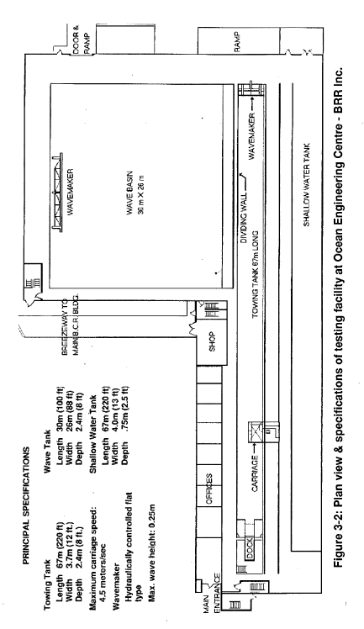
Figure 1 - ??? [PDF]
Figure 2 - ??? [?]
Figure 3 - ??? [?]
Figure 4 - ??? [?]

