**Impostor Syndrome in the BCS Program: A Formal Report on Helping BCS Students Transition**

For:

Professor Steve Wolfman

BCS Director

University of British Columbia

Vancouver, British Columbia

By:

Madeleine Leroux

57518888

March 14, 2019

Table of Contents

Abstract iii

Introduction 1

Data Section 2

Key Concerns to Address to New BCS Students 2

Course Scheduling 2

Personal Projects 3

Learning Resources 3

Considerations in Welcoming New Students 4

Cost 4

Time 4

Level of Accessibility 4

A Comparison of Welcoming Methods 5

Option One: Peer to Peer Support Groups 5

Option Two: Online Crash Course 5

Option Three: In Person Information Session 6

Conclusion 7

Summary and Interpretation of Findings 7

Recommendations 7

References 8

Figures and Tables

Figure 1 The Main Reasons Why Students Feel Overwhelmed 2

Table 1 The Relative Advantages among the Three Options 6

**Introduction**

The University of British Columbia’s Bachelor of Computer Science (BCS) is a twenty-month intensive program for students that already have a Bachelor’s degree in a field unrelated to Computer Science. The program is intended to help university graduates transition from their original field of study to a career involving information technology. However, it is not uncommon for BCS students to question their competencies and abilities while enrolled in the program. Many of the students suffer from Impostor Syndrome.

Impostor Syndrome was first defined in 1978 by psychologists Pauline Clance and Suzanne Imes. It is described as a feeling of “phoniness in people who believe that they are not intelligent, capable or creative despite evidence of high achievement (Richards par. 6).”

In order to help students deal with these feelings of being overwhelmed, the BCS might consider creating a way to deliver more information about the program to help new students feel more confident and to transition smoothly into the program. Over 70% of BCS students said they would’ve liked more information about the program before starting (personal survey, March 2019).

What information would the students have liked? New BCS students need answers to the following basic questions:

* What courses are the most important to take? And what are their prerequisites?
* How to learn a new programming language?

To help answer these questions, this report analyzes information gathered from BCS student interviews as well as from the literature. After defining the contents of a welcome package, the analysis examines considerations in creating the package, and methods of delivering the information.

**Data Section**

**Key Concerns to Address to New Students**Anyone creating information to welcome new students, needs to consider the student’s interests, abilities and concerns. When interviewed, BCS students identified three main reasons that we often feel overwhelmed: the competitiveness of the program, the pace of the degree, and feeling like we lack knowledge compared to our peers. The percentage of students that identify each issue as a reason for feeling like an impostor can be seen in Figure 1.

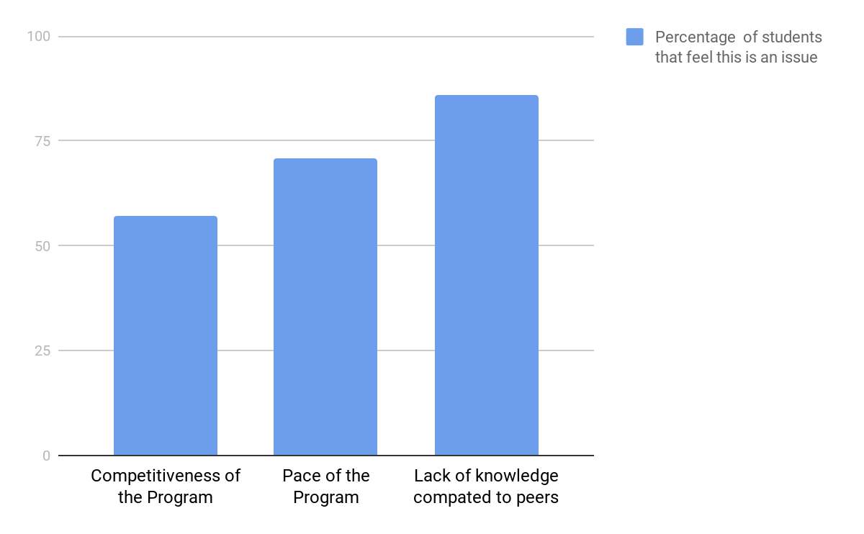

**Figure 1** The percentage of students that feel like the identified issues cause us to feel to like impostors.

To address these three reasons, students identified the following information we believe should be sent to newly admitted BCS students.

**Course Scheduling.** Many of the BCS students interviewed, identified scheduling as the most difficult and overwhelming part of enrolling in the program. One student said: “I had to do most of the digging myself, and felt generally lost trying to plan out the degree”. The program is condensed, so students are expected to take more courses in a shorter amount of time than the average Computer Science undergraduate. Unsurprisingly, 85% of BCS students surveyed identified the pace of the program as being overwhelming (personal survey, March 2019).

Providing new students with information about: what paths previous students took, the most important courses to take before co-op, and which classes we can challenge to be exempted from will help students plan our education better. An anonymous first-year student in BCS says knowing which classes we can challenge for credit will allow us to to take more courses before our co-op begins, and will make us more confident in finding a co-op position (personal survey, March 2019).

**Personal Projects.** In the BCS program, a strong emphasis is put on creating personal projects in order to successfully find a co-op position or a job after graduation. A “personal project” is a computer program, app, internet extension etc. created outside of class time and researched independently. Students often find starting a new project overwhelming because there is so much to learn before creating one. Students frequently requested to learn what upper year or past students made for their project to get a better idea of what was is expected from us (personal survey, March 2019). Letting students learn about past students’ experiences and projects will provide us with context about expectations. And providing suggestions for resources to learn new design frameworks for personal projects will help alleviate the stress and help students create higher quality projects.

**Learning Resources.** Computer Science degrees teach students how to learn, rather than how to program. However, to new students (especially from other disciplines), this can be surprising (personal survey, March 2019). There is a wealth of information, but it can often be hard to understand or to find the appropriate resource to use. 81% of students feel like impostors because we feel that we know less about computer science than our peers (personal survey, March 2019). Giving incoming students access to the appropriate learning resources will help us feel like the field has levelled.

**Considerations in Implementing a New Method to Welcome BCS Students**

**Cost.** Selecting a cost-efficient delivery method is important as we have a limited budget. The costs may include: the time needed by staff and volunteers to plan the event, material costs, and the cost to maintain servers if we decide to use a digital or online platform.

**Time.**  The time to implementing different methods to deliver information to students may differ widely. For example, interactive online courses take more time to develop than in-person sessions (Defelice par. 9). Choosing the correct method to deliver welcome information to new students depends on us having enough time to plan an effective course, and to deliver it.

**Level of Accessibility.** A large amount of students come from outside of Vancouver, and many are working before enrolling in the program. As a result, we need to consider that students may be living in different time zones and could have time constraints in terms of availability due to working. Claire, a first-year BCS student from Ontario, says it would be important for her to be able to access the information at her own specified time.

**A Comparison of Delivery Methods**

**Option 1: Peer-to-Peer Support Groups**Dr. Kevin Cokley, who has written papers about Impostor Syndrome, recommends joining or creating a network of similar people in order to combat imposterism (Wong par. 23). Similarly, Justin Kruger, a professor at New York University School of Business who researches impostor syndrome, says talking to others helps put our anxieties in perspective (Laursen par. 16). Survey participants frequently wished to learn what “personal project previous alumni did” and “resources they used” . In fact, learning about previous students’ experiences was the most popular request when surveyed (personal survey, March 2019)

When BCS students are first accepted, we could be grouped with upper year students to learn about their experiences, and with students in the same year to help give different perspectives. A Peer-to-Peer support group offers a free or low-cost option to help transition new students into the program, however it depends on the students being willing to participate.

**Option 2: Online Crash Course**Many of the Computer Science courses as at UBC use EdX, a massive open online course (MOOC) provider, as a learning platform. Content can be delivered in the form of videos, readings and participation on a discussion board. Claire, a BCS student, says “[the discussion board] is nice because you can ask questions anonymously” which we might not otherwise ask (personal interview, March 2019). As the content is digitally stored, students can refer to the course frequently instead of it being a one-time use.

An online EdX information course would allow non-BC students to learn remotely and meet other students be moving. The course also provides data about how students performed which would help pinpoint the areas where they needed the help the most. However it would be the most expensive method to implement. When the University of Alberta created their first MOOC, they planned for ten months and then hired “graphic designers, editors, make-up artists, even an acting coach” (Tamburri par. 10). Mcgill University spends $200, 000 on average creating a MOOC, which is considered in the higher range (Tamburri par. 8)

**Option 3: In Person Information Sessions**Kyle, a BCS student, said talking to upper year students in person would be the most desirable way to learn about the program (personal interview, March 2019). In person information sessions allow students to ask questions and receive real time responses, and are a relatively low cost option. However, many students come from outside BC and would not be able to attend any information sessions before the school year starts. Also due to time constraints, only the most important topics could be discussed.

**An overall comparison by relative advantage**. Table 1 compares the three delivery method options on the basis of two criteria: cost to implement, and level of accessibility for students to access.

**Table 1** Relative Advantages Among the Three Options

|  |  |  |
| --- | --- | --- |
| Option | Cost | Level of Accessibility |
| Peer-to-Peer Support Group | Low or Free | High |
| Online Crash Course | High | High |
| In Person Information Session | Relatively Low | Low |

**Conclusion**

85% of BCS students have admitted to feeling like an impostor at some time due to feeling overwhelmed by the pace of the program, not feeling as feeling as knowledge as our peers, and the competitiveness of the program (personal survey, March 2019). However, we can alleviate the feelings of inadequacy.

Possible methods to help new BCS students transition into the program include: (1) a peer to peer support group, (2) an online crash course, and (3) an in person information session. Each option has benefits and drawbacks based on ease of access, cost and time.

**Interpretations of Findings**If we decide incoming BCS students require more information about the program, there are a variety of ways of delivering it:

* For students confident about learning on their own and just need support from other students, peer-to-peer support groups is the logical option
* For those who live outside of Vancouver or desire anonymity when asking questions, an online course is the best option
* For learning just the key points about the program, an in person information session is the most desirable.

**Recommendations**

1. Providing students with more information regarding: course scheduling, learning resources and personal projects to help alleviate out stress.
2. Before settling on a method of delivery, consider its benefits and drawbacks and decide whether this option best coincides with the needs of the students.

Works Cited

Da Silva, Kyle. Interview. Mar. 2019.

Iacono, Claire. Interview. Mar. 2019.

Laursen, Lucas. "No, You're Not an Impostor." *Science*, 18 Feb. 2008, www.sciencemag.org/careers/2008/02/no-youre-not-impostor. Accessed 14 Mar. 2019.

Leroux, Madeleine. “BCS Survey”. Questionnaire. March 2019

Richards, Carl. "Learning to Deal With the Impostor Syndrome." *New York Times*, 26 Oct. 2015, www.nytimes.com/2015/10/26/your-money/learning-to-deal-with-the-impostor-syndrome.html?_r=0&fbclid=IwAR2QY-T3oMBhkOLanpT9QliRfViZz3Tja4FfECCKEVd_FVA3LpztnTrYdMY. Accessed 14 Mar. 2019.

Tamburri, Rosanna. "Universities experiment with their own MOOCs." *University Affairs*, 8 Oct. 2014, www.universityaffairs.ca/news/news-article/universities-experiment-moocs/. Accessed 14 Mar. 2019.

Wong, Kristin. "Dealing With Impostor Syndrome When You're Treated as an Impostor." *New York Times*, 12 June 2018, www.nytimes.com/2018/06/12/smarter-living/dealing-with-impostor-syndrome-when-youre-treated-as-an-impostor.html. Accessed 14 Mar. 2019.