PROPOSAL FOR INCREASING PARTICIPATION
OF THE VANCOUVER PUBLIC LIBRARIES’
CHILDREN AND INFANT LITERACY PROGRAMS

For
Christie Menzo and Mairin Kerr
Head of Child and Teen Services and Marketing Lead
University of British Columbia
Vancouver, British Columbia

By
Jenny Bachynski
English 301 99C Student

March 15, 2019

Table of Contents
Abstract……………………………………………………………………………………..iii
Introduction ………………………………………………………………………………. 1-2
Data Section………………………………………………………………………………..3
Surveying Families………………………………………………………………...3
Young Families’ Participation……………………………………………………. 3
Rate of Attendance………………………………………………………………....3
Factors that Prevent Participation………………………………………………...5
Branch Attendance………………………………………………………………....5
Branch Numbers……………………………………………………………………5
Factors that Promote Branch……………………………………………………....7
Providing Social Programs in the DTES…………………………………………...7
Interview with Servane Phillips…………………………………………………….7
Promoting Attendance in the DTES………………………………………………...8
Vancouver’s DTES Branch………………………………………………………….9
Marketing the VPL Programs……………………………………………………....9
VPL’s Promotional Channels……………………………………………………….9
How Often Channels Change……………………………………………………...10
Children’s Literacy………………………………………………………………...12
The Benefits of Children’s Literacy………………………………………………..12
The Benefits of Libraries for Young Children and Their Parents…………………12
Conclusion………………………………………………………………………………...13
Summary of Findings……………………………………………………………...13
Recommendations…………………………………………………………………14
References…………………………………………………………………………………14

Figures
Figure 1 Do Families Know About the VPL Programs.......................................................3
Figure 2 Families’ Program Usage………………………………………………………..3
Figure 3 How Families Find Out About Programs………………………………………..4
Figure 4 Outside Promotional Channels…………………………………………………..4
Figure 5 VPL Annual Branch Program Attendance……………………………………....6
Figure 6 VPL Website Banner…………………………………………………………….9
Figure 7 Website Promo…………………………………………………………………..10
Figure 8 VPL Instagram Account………………………………………………………...11
Figure 9 VPL Poster……………………………………………………………………...11
Figure 10 VPL Poster…………………………………………………………………….11
Abstract

The Vancouver Public Library (VPL) has wonderful and diverse infant and youth programs for the public. These programs are free and accessible to anyone, at all library locations across the city. The library programs are extremely important for Vancouver as they provide positive long-term impacts for the city by having literate, educated citizens. Infants also benefit greatly from being read aloud to - it increases brain development and other forms of literacy: phonological awareness, letter knowledge, and vocabulary.

The VPL does a fantastic job in offering programs that will help youth excel, but everyone would benefit by increasing the promotion of these programs to new parents, people unfamiliar with library culture, and most importantly, low-income families.

The final recommendations to the VPL in order to increase attendance are:
- Use outside resources to promote the infant programs outside the library.
- Through the use of pamphlets and posters in locations where new parents spend time (doctor’s offices, transit)
- Have pamphlets sent home from the hospital with new parents in the same way the BC Health services sends out information of infant health.
- Connect librarians at the DTES nə́c̓aʔmat ct Strathcona branch with other social services in the DTES such as SheWay or the DTES Women’s shelter.

INTRODUCTION
Library Background
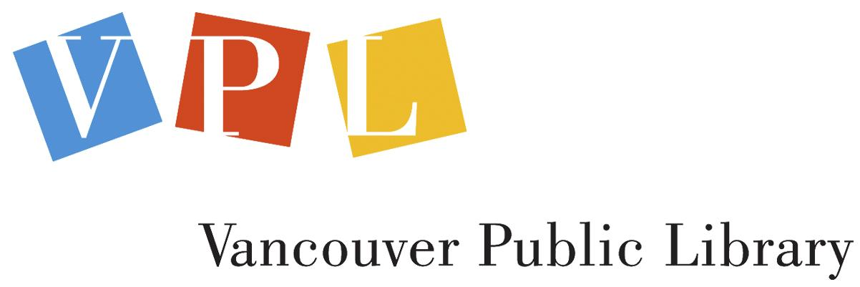
The Vancouver Public Library (VPL) is an invaluable institution used by a diverse group of people throughout the city of Vancouver. Across all of the 21 branch locations in the city, the VPL is the most-visited major urban library per capita in Canada. At first glance, libraries are primarily used for borrowing books, but there are many other opportunities offered that can be overlooked: access for people of all backgrounds to exercise their right to learn, create, communicate, use resources, and meet like-minded people. One way to engage in these opportunities is through the VPL events and programs. Library programs are run throughout the week at all locations across the city - varying in schedules, class sizes, and coordinators - but all programs are free and many are drop-in. For the purpose of this proposal, I will be focusing on the infant and youth programs.
Types of Programs and their Importance
Classes offered for infants and youth include: baby story-times, children’s book clubs, technology programs, teen/children mentoring programs, writing camps, bilingual programs, as well as other excellent curriculum. Many of these programs are founded on the importance of reading aloud and face to face conversation - both practices that promote literacy and language in young children. Prioritizing the success of these programs is extremely important for two specific reasons. Firstly, children’s literacy greatly benefits children, but also provides positive long-term impacts for the city by having literate, educated citizens. Secondly, libraries will thrive if these programs are being used, but more importantly the longevity of library usage will be determined by the next generation’s interest in reading.
Purpose of Report
The VPL does a fantastic job in offering programs that will help youth excel, but everyone could benefit the programs’ attendance increasing. As a parent in the community, I see many young families unaware of the excellent, free resources available. There are three important questions:
- Is there a strong correlation between family income and library attendance?
- Do families understand the importance of reading aloud to young children in order to promote literacy and language?
- How is information about these programs being spread and how can we extend the reach of that information?
Scope of Research
The primary data has been collected from three specific avenues: VPL’s Acting Manager of Children’s and Teen Services, Christie, Menzo, has provided stats on branch attendance and variations between branch programs. The VPL Content Marketing Lead, Mairin Kerr, has provided detailed information on the marketing channels. I have collected data from families pertaining to how they utilize the programs and know about them. I have also interviewed Servane Phillips, a woman who helped bring a free children’s music program to Vancouver’s Downtown Eastside. This data and feedback helps conclude that there are ways in which to connect more with families who are unfamiliar with the VPL programs. It will be up to the VPL to decide if these recommendations work within their budget and resources.

DATA SECTION A: SURVEYING FAMILIES
Young Families’ Participation
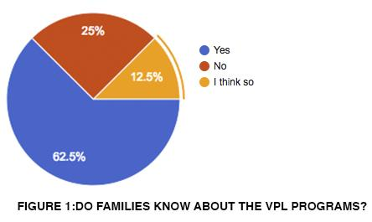
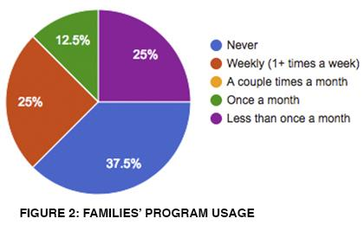
A short survey was sent to different Vancouverite families across the city with young children (preschool age or younger). The goal of the survey was to gain insight into how informed new parents are about the VPL children’s programs, their usage of the programs, and what factors prevent participation. Of the people interviewed, 72% of them knew about the programs and 28% had not heard about them or seemed conflicted about their knowledge of them. Interestingly, everyone who knew about the programs also stated that they use, or have used the programs. Even families who have children in full-time childcare, still use the programs on weekends, or encourage their caregivers to attend. These statistics highlight how the VPL is fulfilling a specific need for young families in the city, and that many parents have a strong interest in early literacy for their babies
and children.
Rate of Attendance
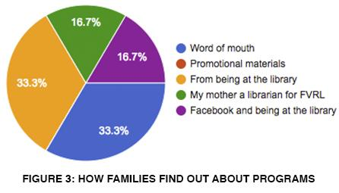
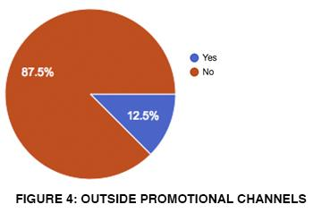
As suspected, the 37.5% of the families who haven’t ever used the programs are not using them because they don’t know about them. The survey found that 25% of families had their child/children attending a VPL program on a weekly basis, another 25% attended less than once a month, and 12.5% attended at least once a month. So, how are families finding out about these programs? A considerable amount of the participants - 67% of them - stated that they found out about the programs through word of mouth. The most common way being through friends and family, but also knowing people who work at the library, as well as Facebook parent groups. The other 33% stated that they found out about the programs from already being at the library: through librarian’s suggestions, or promotional materials in the vicinity. While 12.5% of the participants stated that they have seen outside advertising of the programs, none of them used this as a reason for finding out about the programs. It seems necessary to highlight that 87.5% of participants haven’t ever seen any promotional advertising throughout the city for these children’s programs.

Factors that Prevent Participation
It is clear that the first year of maternity/paternity leave taken by many parents in Canada allows for a higher attendance at the beginning of a child’s life. Attendance becomes more complex as new babies are added to the family, children head off to preschool, or parents go back to work. Of the participants, 14% of them completely stopped using the programs once they went back to work or a child started attending school. Some parents stated that when they returned to the workforce they established that their child care provider would take their child to the VPL programs. It was also shown that certain preschools and daycares have librarians visit the schools to provide similar programs to the children. The primary reason for not attending was because of scheduling. Every single participant said that they would attend more if their schedules allowed for it - this was the case for parents who were working out of home jobs, as well as parents who were working as full-time parents. Over 50% of the participants said that they pick other paid activities for their children because they fit better into their schedules. The second most common reason - as 25% of the participants declared - was smaller class sizes. A less common but voiced reason was having the desire for programs where young children can attend without mandatory parental attendance.
DATA SECTION B: BRANCH ATTENDANCE
Branch Numbers
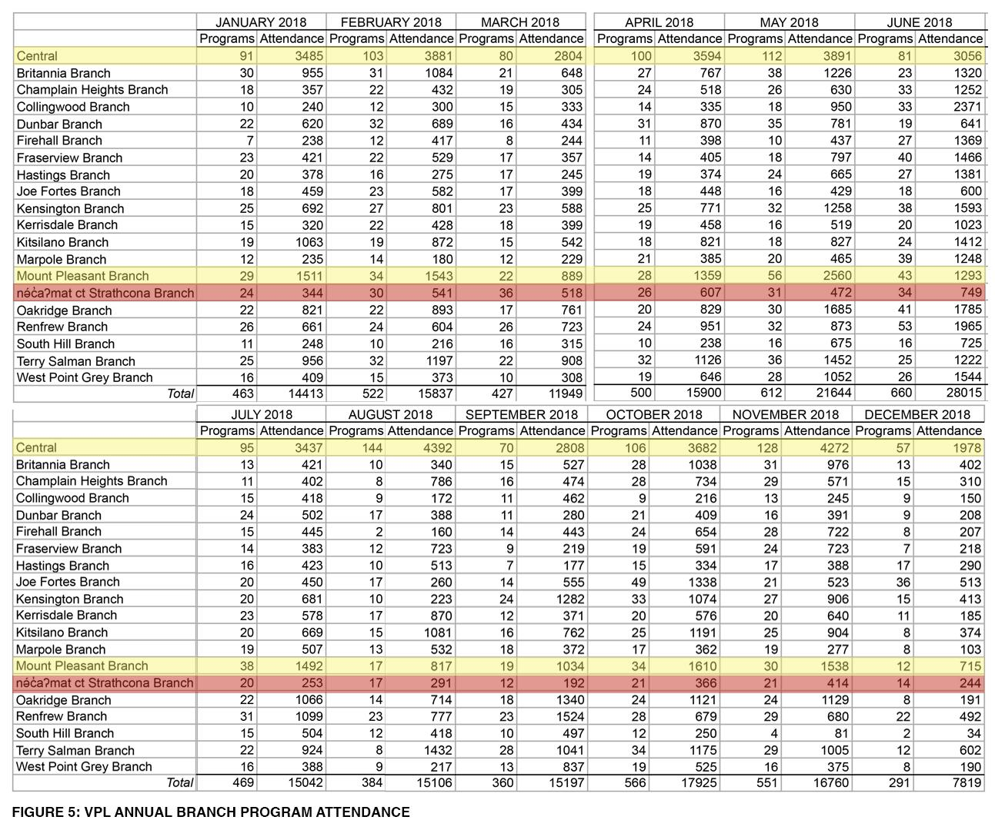
The VPL takes monthly stats for the branch programs offered and the attendance of those programs. The two branches that consistently have the the highest branch attendance are the Central Library (located in central downtown Vancouver) and the Mount Pleasant branch (located on Vancouver’s populated Main street). Besides these findings, there seems to be a large fluctuation on a monthly basis of branch attendance, which would make it inaccurate to rank the branches by popularity. There seems to be two correlations that can be made: the first, that the branches that offer more programs have higher attendance (a great testament to the quality of the programs), and secondly, that areas of higher population density seem to have higher attendance. This conclusion seems valid because the Central Library (which has the highest attendance) is in a population dense centre, as well as the Mount Pleasant area.
Factors that Promote a Branch
We can dig deeper into these ideas using information from our survey. In terms of branch usage, the family’s location almost always determined which branch they were attending. The study showed that 100% of the participants’ primary reason for choosing a location was proximity to their home, or their child’s daycare. While proximity is clearly the most important factor, there were others as well; 33% of the families had secondary reasons that included: avoiding busier branches, attending for a beloved librarian, or being in a different part of the city for the day. Interestingly, the Mount Pleasant branch and the Central Library branch were the two branches that were singled out as branches people would travel to visit. There is not a strong enough correlation in the branch attendance numbers to conclude that income levels affect the programs success: what seems important is that young families know about the programs and they have a library close to where they live.
DATA SECTION C: PROVIDING SOCIAL PROGRAMS IN THE DTES
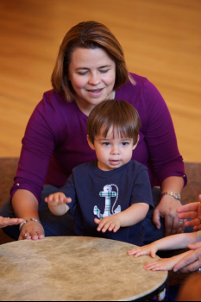
Interview with Servane Phillips
Servane Phillips is a lawyer who has worked in the DTES and has also helped organize a free Music Together program in the DTES for single mothers. Music Together is a program built on the foundation that children learn best when parents are immersed with them in a musical environment of singing, imitation, and play. For the purpose of this report, I was interested in hearing from Ms. Phillips about the attendance of the music program, what specific challenges or successes were experienced, and how word was spread about the program. When the program was put in place, one of the concerns was the consistency of attendance. The program had handpicked women and their children who would attend on a weekly basis - this was not a drop in program and one that usually cost $170 per semester per child. Ms. Phillips expressed that while there were women who initially signed up then didn’t attend, most of the women who attended the first class did continue to participate in the whole semester.
Promoting Attendance in the DTES
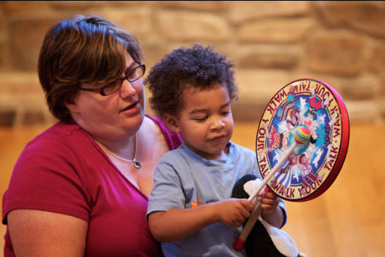
What was the driving factor in creating an enjoyable and effective class for all the participants? According to Ms. Phillips, it was having a teacher who was open minded and didn’t make assumptions about someone’s situation or home life. Everyone needed to feel that they were in a safe space to ensure continued participation. While there was an array of different ages and abilities of the children attending, Ms. Phillips said that every child made social, musical, and behavioural leaps, and many of the mothers felt new connections with their children. How did the women find out about this program? Ms. Phillips believes that the success of this program was due to having help from other institutions in the DTES (in this case the YWCA) to connect the right people together. The people at the YWCA already worked with these families and knew what programs would suit them best, and if they had stable enough lifestyles to attend regularly. There was no need for other promotional channels because of the nature of the program and demographic
Vancouver's DTES Branch
When studying the usage of the Vancouver’s Downtown Eastside branch (the nə́c̓aʔmat ct Strathcona Branch, highlighted in red in Figure 2) we must understand that this is an area with different challenges in terms of drawing attendance: a higher concentration of citizens struggling with addiction, mental health issues, and poverty. The nə́c̓aʔmat ct Strathcona branch is below average in terms of attendance, but is not glaringly lower than many of the other branches. The data does however show a significant difference in the nə́c̓aʔmat ct Strathcona branch and the Mount Pleasant branch: for example, in August 2018, both of the branches offered 17 programs that month, and the nə́c̓aʔmat ct Strathcona branch had 291 participants while the Mount Pleasant Branch had 817 attend. Due to demographics of the DTES, the VPL offers Cantonese baby storytimes as well as all the other storytimes offered at all other locations. We can use information from Ms. Phillips to understand that instability in the community can affect attendance and that perhaps different strategies may be necessary to promote the VPL programs.
DATA SECTION D: MARKETING THE VPL PROGRAMS
VPL’s Promotional Channels
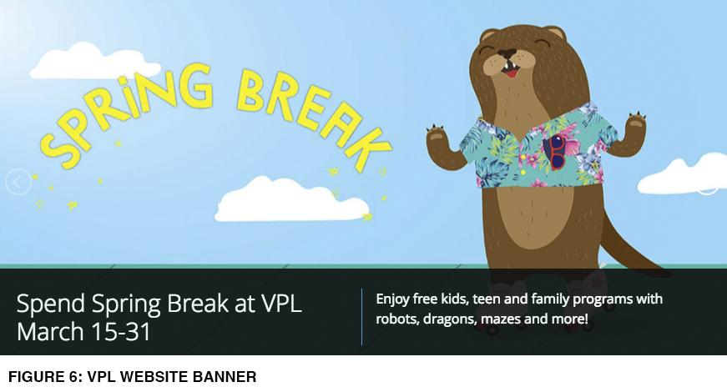
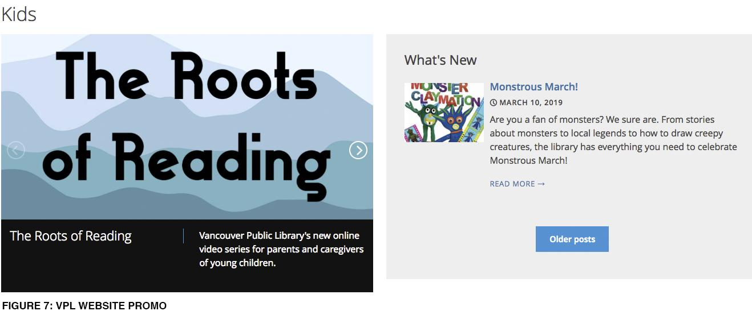
The VPL already has diverse promotional channels that are in place to spread information about the library children’s programs. I spoke with Mairin Kerr - VPL’s Content Marketing Lead - better understand the scope of these channels. The two main channels are brochures and posters. There are brochures that summarize the children and teen programs for that period and posters for each individual program and series. These are distributed across all 21 branches, as well as community centres. There are also homepage sliders for VPL.ca, which promotes events when people are visiting the website. A handful of other channels are offered for people who already use the library: weekly e-newsletters which highlight the programs and targets caregivers and parents, a monthly e-newsletter sent to subscribers about teen programs, and wonderful social media accounts (Instagram, Twitter, and Facebook). In terms of outside promotional tools, teens run their own accounts to target other teens, and many of the programs have partners so that networks can expand (for the VPL as well as the partnering businesses).

How Often Channels Change
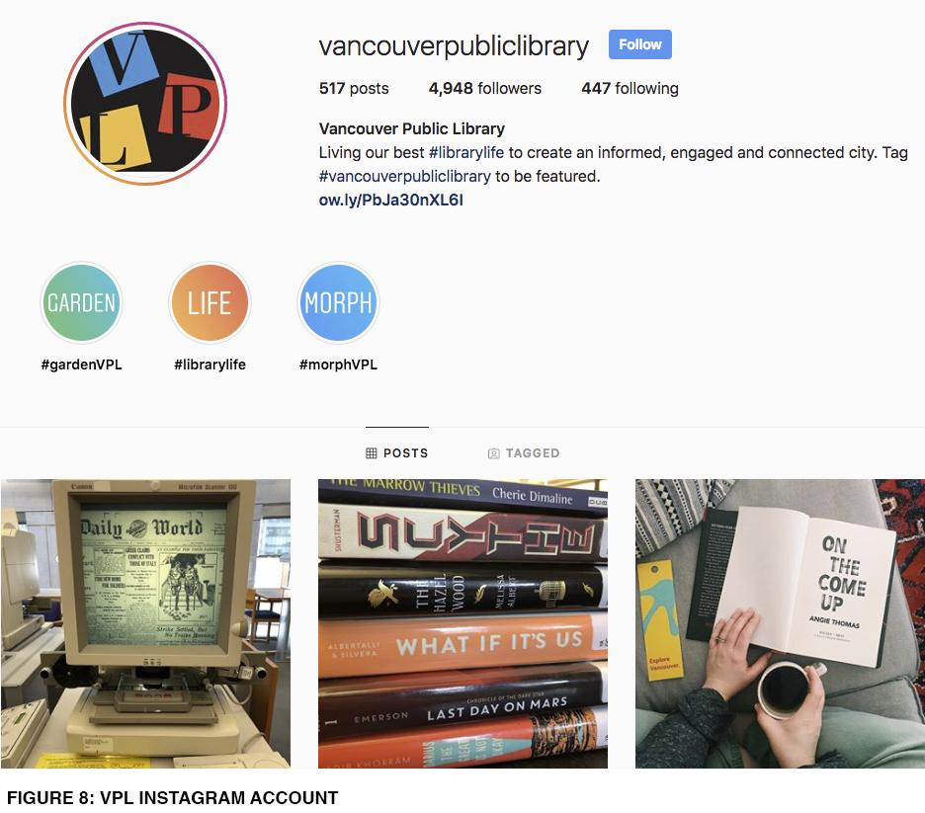
Ms. Kerr explained that brochures are refreshed quarterly, the posters get updated annually, and the social media techniques change more regularly - depending on the trends and what is working best. What about the any differences of promotional channels per branch? It seems there is consistency throughout the branches. The main difference is they do work with local partners in order to target specific areas - this being the example given when asked about specific ways they promote the children’s programs in the DTES.

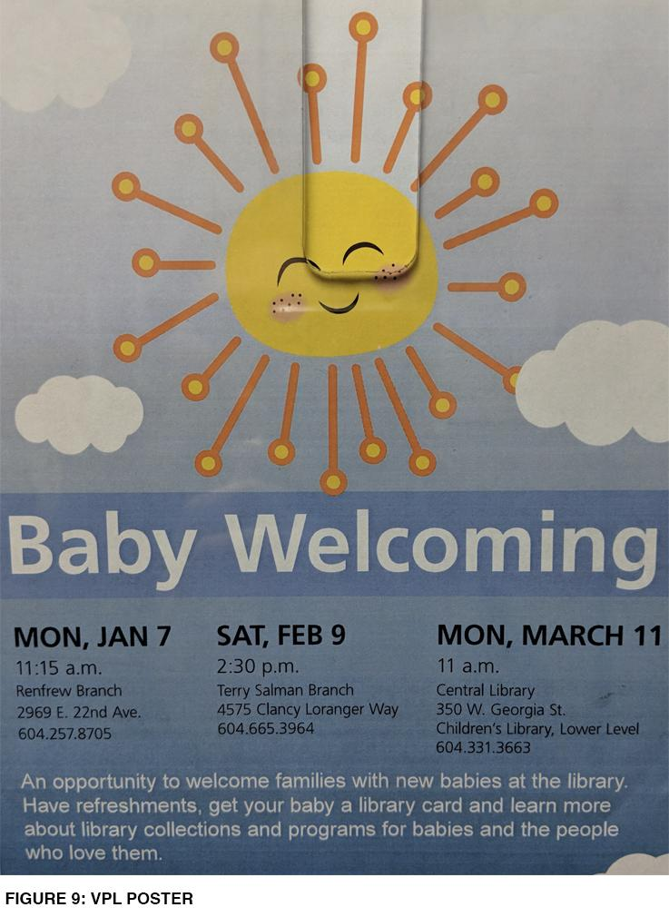
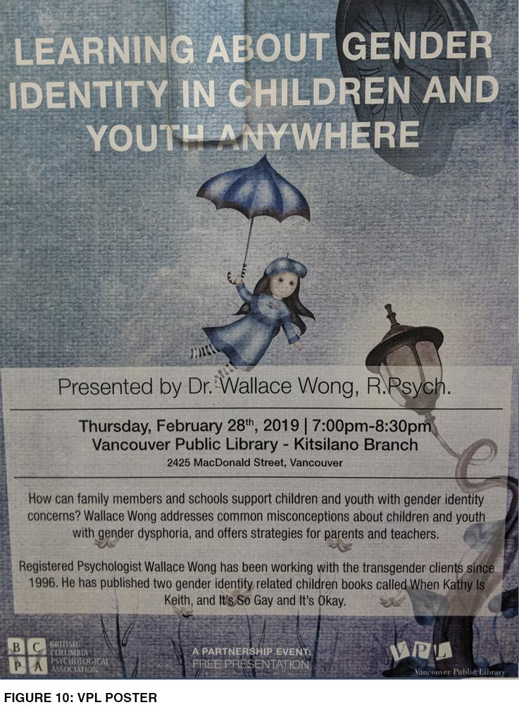
DATA SECTION E: CHILDREN’S LITERACY
The Benefits of Children’s Literacy
As thoroughly discussed, there are an array of reasons as to why the library is such an important institution. Pamela Chen’s “Associations between Public Library use and Reading Aloud among Families with Young Children” demonstrates the strong correlation between reading aloud and a child’s brain development. People may think that because a young baby or child is too young to read, that literacy is not important, but emergent literacy proves otherwise, This type of literacy includes phonological awareness, letter knowledge, and vocabulary (221). The strongest predictors of emergent literacy is ready aloud between children and adults - this doesn’t only provide linguistic benefits but cognitive and social ones as well (221). According to Chen, parents who had taken their 6-18 month of child to the library, felt they were better informed about the library programs for children. Thus, adding evidence that people who are immersed in library culture tend to have children who are read aloud to more, and as a result have higher emergent literacy skills (223).
The Benefits of Libraries For Young Children and their Parents
Libraries offer different value than reading at home. Firstly, libraries give children a chance to be their own gatekeepers. In “World Book Day: Without libraries we are less human and more profoundly alone” Nicola Davis shows when children are very young, their book options come to them through their parents; they are already domesticated. Libraries allow children to seek out their own interests and secure a sense of agency. Secondly, Davis offers that libraries and the people who work within them provide humanity. They create a human experience, which makes us (and children) feel more alive and less alone - something that is invaluable for new parents.
CONCLUSION
Summary of Findings
The findings show that people who know about the library programs have used them or are using them. There seems to be some drop off in attendance of the infant programs as children hit the one-year mark and many parents go back to work. While this does seem unfortunate, it is important to highlight that reading aloud in the first year of a child’s life increases emergent literacy, and also builds library habits in young parents. Another finding is that there wasn’t a clear correlation between family incomes and attendance, but more so proximity to a library. The DTES branch (the area of the city with arguably the most poverty) still had consistent attendance numbers, although below average. In terms of promotion, it is clear that the VPL does an outstanding job in promoting the library, and people who use the library are taking advantage of the wonderful programs offered. The only issue is that people who are fully unaware of the VPL programs aren’t finding out about the library through outside promotional channels.
Recommendations
Upon reflection, there is one thing that is clear: the quality of the VPL programs are fantastic - the only criticism found was that class sizes could get a bit large, which only solidifies the need for these programs. The promotional channels that target people who are in the library or are already immersed in VPL culture (through social media or other outlets) are effective and informative. As a result of my findings, my two main recommendations would be as follows:
- Use outside resources to promote the infant programs outside the library. Ideally, this would include targeting all people who have just had a child and may not be deep enough into parenthood to receive word of mouth about the programs. For example, when a parent comes home from the hospital in BC, they are given educational materials from BC Health Services which offers resources. The VPL could consider this type of strategy for getting parents attention early on. If this wasn’t possible, even having pamphlets distributed in places where people with children frequent: doctor’s offices, or transit.
- To create more attendance at the DTES nə́c̓aʔmat ct Strathcona branch the VPL could consider connecting with other social services in the area, such as SheWay or the DTES Women’s shelter. If resources allowed, librarians could hold a promotional story-time class at these locations to offer women and children a safe and familiar space to learn about the importance of literacy, as well as creating healthy library habits.

References
Chen, Pamela, et al. "Associations between Public Library use and Reading Aloud among Families with Young Children." Journal of Paediatrics, the, vol. 173, 2016, pp. 221-227.e1.

Davis, Nicola. “World Book Day: Without Libraries we are Less Human and More Profoundly Alone.” The Guardian. 02 March 2017, www.theguardian.com/voluntary-sector-network/2017/mar/02/without-libraries-and-librarians-we-are-less-human-and-more-profoundly-alone

Music Together at the YWCA Crabtree Corner. Chimp, www.chimp.net/groups/music-together-at-the-ywca-crabtree-corner. Accessed 01 Feb. 2019.

Vancouver Public Library. The Vancouver Public Library, www.vpl.ca. Accessed 01 Feb. 2019

