A Call to Introduce a Charity Program in
Order to Give Back to Our Community
by Utilizing Food Waste in the Kitchen

For:
Milestones Upper Management
Kirsty Labeck (GM)
Connor Sheary (Assistant GM)
Chad Pollock (Regional Manager)

By:
Taylor Smith
Kitchen Manager
ENGL 301 Student

March 15, 2019
Table of Contents
Abstract……………………………………………………………………………………….......iii
Introduction………………………………………………………………………………………..1
Data Section……………………………………………………………………………………….2
The Financial Yearly Average of Food Waste at Milestones Bar and Grill………………2
Overview of What Products are Wasted the Most………………………………...3
Description of Which Products Lose the Company the Most Money………….....3
Months of the Year That Show the Most Waste…………………………………..3
Waste Management Program……………………………………………………………...4
Observation of Current Practices When Dealing With Wasted Product………….4
Survey Questionnaire Explained………………………………………….4
Discussion on Interview Results………………………………………….7
Critique on Current Waste Management Practices…..…………………………...5
Argument/Description for/of a Revised Waste Management Program…………..6
How the Community is in Need………………………………………………………….7
Statistics on how Many People in Vancouver go Without Food………………...8
Benefits for Engaging in Charity Work………………………………………………...10
Cons of Engaging in Charity Work and how These Issues can be Managed…………..11
Conclusion……………………………………………………………………………………...12
Summary and Recommendations………………………………………………………12
References………………………………………………………………………………………13

Abstract
To be completed in Final Draft

Introduction
The following is a proposal for a new waste management program to be implemented in our restaurants, which will serve to give back to the communities we are a part of, while also utilizing the food product we do not use.
It is no secret that the restaurant industry can be very difficult to predict. At times, our restaurant is overstocked with product as our predictions for busy periods may have been off, resulting in a great deal of product that reaches its expiry date. The end result is the product must be thrown away. Perhaps, just as common at our restaurant is food waste through instances of cooking preparation that do not meet the specifications of Milestones Bar and Grill. For example, when a steak is overcooked and cannot be served to the guest Milestones’ policy is to throw that piece of protein away and start a fresh one. While these instances are unpredictable and unavoidable, we can still look for a new way to utilize that product before it has to be thrown away.
By implementing a new waste management program, one that involves charitable donations, we can utilize our discarded product by cooking large batches of soup, stew, or other related dishes, and help provide soup kitchen’s in our community with food for the hungry and homeless. The amount of hungry mouths in our community is staggering, and any help that we can provide will go a long way. Not only would we be giving back to the community we are a part of, we would also be strengthening our business as others look upon this kind of community engagement favourably.
This proposal consists of an analysis of the average yearly food costs involving food waste in our restaurant. An overview of what products are wasted the most, which wasted products cost the company the most money, and which months have the most recorded food waste. Next, I will discuss our current waste management program, while also proposing a new one. In this section I will also discuss a series of survey and interview questions that I distributed to selected employees at Milestones Bar and Grill. After that, this proposal will look at how our community is in need, while also examining a number of other charity organizations in our community that deal with feeding the hungry. In conclusion, I will end this proposal by discussing any cons that might come from engaging in charity work, and how these difficulties can be managed. Finally, I will close on the benefits that may arise from giving back to the community we are a part of.

Data Section
The Financial Yearly Average of Food Waste at Milestones Bar and Grill
The amount of food waste that Milestones Bar and Grill goes through daily may not seem important, however, when looking at costs on a yearly basis one can agree that the dollar amount warrants some attention. With an average of over $10,000 in food waste costs per year our restaurant can absolutely look to improve on this number by being more diligent about how we order and what we throw away. However, it is not fair to suggest that we can eliminate food waste completely, and given this average yearly cost it is clear that we have enough wasted product that we can save and utilize in order to provide food for those in need.
Even though this number is large, it is not an uncommon occurrence throughout restaurants in Canada. In fact, as explained by CBC News reporter Pete Evans, food waste in Canada costs restaurant an estimated $31 billion dollars every year (Evans). It is clear that food waste in restaurants within Canada is a national occurrence, however, Milestones can feel good about our yearly average, as our numbers have dropped significantly in recent years. We seem to be doing a better job, as our numbers have decreased while the nations overall food waste costs have increased since 2010 from $27 billion dollars to $31 billion dollars in 2014, at the time Evans’ article was written (Evans). Nicole Mortillaro of Global News It should be noted, that restaurants only contribute approximately 9 percent to this growing number, however, this does not mean that food waste should be ignored within the restaurant industry. This number is represented in the pie graph below (Figure 1), which shows the restaurant industry’s contributions to food waste in Canada.
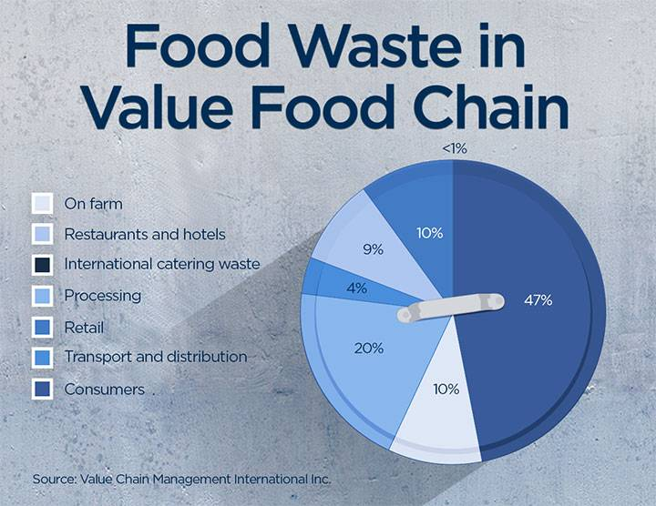 Figure 1: Food Waste in Canada: Percentage Representation
Source: Global News, https://globalnews.ca/news/2952243/food-waste-5-graphics-that-show-just-how-much-food-we-throw-away/

Overview of What Products are Wasted the Most
When it comes to which items are wasted the most at Milestones I have come up with a list detailing the top 8 products. They are: Potatoes 47%, Lettuce 41%, Onions 33%, Milk/Cream 27%, Eggs 23%, Seafood 18%, Beef 12%, and Poultry 9%. On this list we see a couple of items’ waste percentage, like potatoes and eggs, as being high due to the large batches of brunch potatoes and poached eggs we make in anticipation for our often busy brunch services. As a result of batch cooking, product is not always used during service, and once its hot hold time has expired the product must be thrown away. Most concerning on this list is the proteins listed in the latter part. Whatever the reasoning behind the wastage of protein is, the cost of wasting such products is very high, as these products cost the most to order.
Description of Which Products Lose the Company the Most Money
As stated above, proteins are the most expensive item to order, and as a result are often the products that cost the company the most money. Last year, seafood resulted in the most amount of lost profit due to the wastage of the product. Even tough it only the sixth highest wasted product, it is the cost of the protein that affected profit margins for our company. Coming in second and third to seafood was beef and poultry, for the same reason as above; the higher cost of protein versus the lower cost of produce.
Months of the Year that Show the Most Waste
This is entirely based on the season and national holidays/events. December consistently is the month that holds the top spot for most waste recorded. This is simply due to the sheer volume of costumers that come to our restaurant, as the holiday season often brings in large parties celebrating Christmas. Last years report shows December contributing to 44% of the year’s wastage alone. A close second is January at 32%, which is also to be expected, as the increase in product ordering throughout December sometimes carries over into January when all the anticipated food that was ordered is not consumed throughout December and has to be wasted in the New Year. September is third on the list, at 12%, due to the decrease in sales, as September signals the end of summer, and the starting of school often decreases the amount of guests frequenting our restaurant.
Waste Management Program

Observation of Current Practices When Dealing With Wasted Product
Currently in place at Milestones our waste management program consist of the “Three Bucket Protocol”, which is our attempt at separating organics, recyclables, and waste. We have multiple locations throughout the restaurant for these bins, and it is the employees’ responsibility to ensure the proper disposal of each item. Also, posted around the restaurant are “Waste Sheets” that are intended for kitchen staff to use when they need to throw away a product. It is expected that the cook lists the date, product, reason for wasting it, and the amount they are wasting, to ensure proper tracking of the product we are using and throwing away.
Survey Questionnaire Explained
Prior to this proposal I posted a short survey, consisting of 5 multiple-choice questions, within out restaurant for employees to take part in anonymously. These questions do not account for everyone, as the questionnaire was only filled out by 27 of 59 employees, however the do account for a large percentage of employees and should be taken into account when deciding if a new waste management program is right for our company. The following is the questionnaire that was posted:
- Approximately, how many times a week have you witnessed a protein cut (salmon, chicken, steak) thrown away because the protein was ordered incorrectly, or the protein was over/undercooked?
  - Once or twice a week
  - Under five times a week
  - Over five times a week
  - Over ten times a week
  - Never
- Have you been notified of the amount of waste Milestones goes through in a single year, and how much it costs the company?
  - Yes
  - No
- Are you aware of the statistics surrounding the number of people that go without a meal everyday in Vancouver?
  - Yes
  - No
- If Milestones could help out more in the community would you rather see the company engage in…
  - Donations in the form of money
  - Volunteer work
  - Donations in the form of food
  - Do not wish to see Milestones engage in charity work
- Would you be open to a new waste management program that looks to utilize food waste in order to give to those in need?
  - Yes
  - No
  - Undecided

Question 1, regarding the witnessing of an individual or themselves throwing a way a protein cut due to the item being ordered incorrectly or over cooked, 59% of employees answered “C”, over five times a week.
Question 2, regarding whether or not an employee has been notified of the amount of food waste Milestones goes through each year and its costs, 87% of employees answered “No” they have not been informed of these numbers.
Question 3, regarding whether or not an employee is aware of hunger rates within Vancouver, 93% of employees answered “No” to having any knowledge on the matter.
Question 4, regarding an employees’ standpoint on how Milestones could engage in charity work, or their desire to have Milestones not engage in charity work, 72% of employees answered “C”, donations in the form of food, while 11% answered “A”, donation in the form of money. Interestingly enough zero percent of staff answered “D”, which shows an active interest amongst employees to engage in some sort of charity work within our community.
Question 5, regarding an employees’ openness to the implementation of a new waste management program, 74% of employees answered “Yes”, while the remaining were undecided.
What we can pull from this information is that there is a general consensus amongst employees that they would support Milestones’ endeavours in charity work within our community. Furthermore, we can tell from this information that employees within Milestones have not been adequately informed on how food costs are currently affecting our restaurant. Perhaps we can use the information this survey gathered and put it towards conversations surrounding a new waste management program; a program that will seek to inform employees better, while contributing to charity organizations as well.
Discussion on Interview Questions
On the topic that involves waste management at Milestones Bar and Grill I conducted three interviews with Robin Marley (Chef), James Thompson (Sous Chef), and Front of House manager Samantha Spehl. Each participant was asked the same questions, however, only those providing the most information per question will be discussed in detail. The following is a list of questions that were asked:
- Is there active communication between management that is concerned with food waste and how the costs affect the company? If so, how often are these conversations had?
- What is the current plan that is in place that deals with food waste? Is there an adjusted plan that will take place in the future?
- Are you open to the idea of implementing a waste management plan that helps to give back to hungry individuals in our community? Please explain your answer whether yes or no.
- What would the pros and cons be if Milestones used their food waste to put towards meals that would feed those in need?
- Are there any other Milestones’ that you know of that give back to their community in the form of charity? If so, in what way are they giving back?
- Do you see it a feasible option to implement a plan that reduces waste being thrown away by taking this waste and turning it into meals that can be given to those in need?

Overall, each participant explained that management meets at least once a month to talk about profit margins, which include food costs and the cost of wasted product for the previous month. Head Chef, Robin Marley, noted that at the end of every month he gathers the waste sheets together and adds up all of the product that was recorded and converts the total weights to dollar amounts and brings this information to head office. Sous Chef, James Thompson, explained in detail the current plan that is in place, explaining that it his and Robin’s duty to inform all cooks of waste management practices, ensuring that all employees practice the same methods on a daily basis. James explained that Milestones uses the “Three Bucket Protocol”, as organics, recyclable, and waste are deposited into their proper bins. He also confirmed that there are waste sheets posted throughout the restaurant, although, he did admit that they are often left blank or at the very least rarely used. As for a new plan in place, all interviewees confirmed that there are no future plans of changing the current system.
When it came to the third question about whether or not these senior individuals would be open to the idea of implementing a plan that better serves the community, all were very eager to express their opinion, agreeing that a waste management program that seeks to give back to the community is something that they would support. Head Chef, Robin Marley, stated that he has been a part of events in the past that help to feed those less fortunate in our community, explaining further that he felt a great deal of happiness knowing he is providing for someone who otherwise cannot provide for themselves. Robin Marley also noted that there are many ways that the restaurant industry could donate their wasted product, as he explained that livestock could eat particular food that has been wasted, as well as our organics could be donated to use as compost in order to help fertilize and replenish the soil our fruits and vegetables already come from. Figure 2 is an illustration by Hiba Amim, a writer at www.toasttab.com, which supports Robin’s claim of a multitude of ways our food waste can be donated.
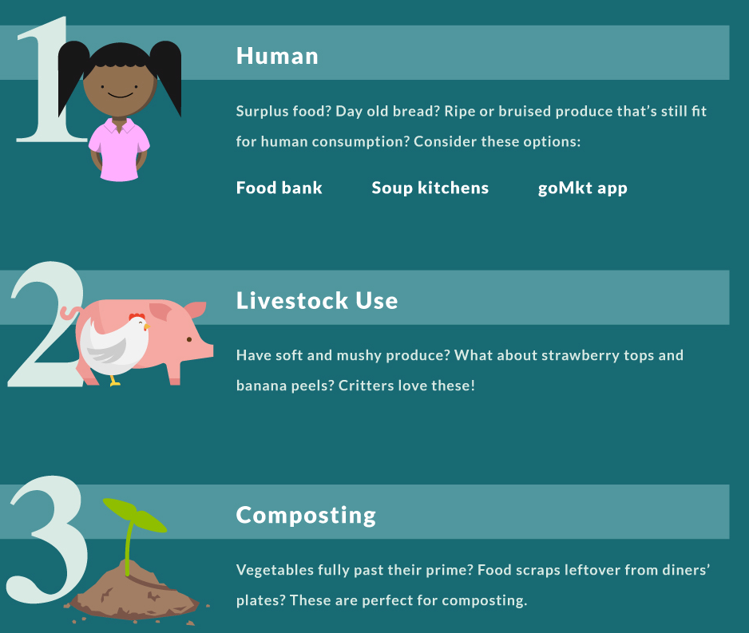
Figure 2: Illustration that represents the different ways in which food waste can be donated
Source: https://pos.toasttab.com/blog/restaurant-waste-statistics

When discussing the pros and cons of implementing a charity program within Milestones all agreed that doing so would result in a heightened level of happiness amongst those taking the time to help feed the hungry. However, even though Front of House Manager, Samantha Spehl, knew the joy charity work could create within an individual she also noted that this type of work could cause some anxiety or depression, as one could feel quite bad when faced with the hardships other people struggle with in life. Samantha also noted that, with the many food allergies individuals could have it is important that Milestones protects itself from any potential legal issues that might come about if someone has an allergic reaction to a product that is given to them.
As for other Milestones Restaurants engaging in this kind of community work, our Milestones would be the first to do so. Each interviewee is well aware of the activity conducted at other locations, and all confirmed that there are no related waste management programs in place that resemble the one being proposed here. However, Robin Marley and James Thompson both explained that there are other Milestones that run annual barbeques, which are established in order to feed the homeless.
Lastly, while all agree that a new program put in place would undoubtedly benefit the community while also benefiting the business, as it shows a strong sense of appreciation towards the community we are a part of, they all agree that implementing a new plan would take some work. Robin Marley says that he is all for change and giving back to the community, but it is not a change that can happen overnight. In fact, Robin believes that this type of plan would take months to formulate, when considering devising a coherent plan, proposing it to head office, making recipes, implementing and training staff to abide by the new plan, and distribution of the product. A plan that Robin says would take some work, but one he would be willing to take on.
Critique on Current Waste Management Program
The current plan in place serves its purpose, as the separation of organics, recyclables, and waste is a strong start when it comes to helping save the environment. However, I believe that much more can be done. Furthermore, after reviewing the survey questions and conducting interviews it has come to my attention that the waste sheets, for example, are not being used to the best of their abilities. The three-bucket system is good, and is a system that should stay in place, however, from my own personal experience I see that it is a system that is not always followed, as staff either do not know how to use it, or they simply neglect to follow the rules. Of course, with a new system put in place the same ill regard could occur, which makes me believe a stricter program needs to be put in place to ensure proper management of waste.
Argument/Description for/of a Revised Waste Management Program
I believe that it is extremely important for Milestones to engage in charity work, especially if we can utilize the amount of wasted product we get rid of every year. The main point here is, if we paid for the product we might as well put it to good use rather than throwing it into the garbage. Of course, we as a business should always seek to cut costs as much as possible, and we can do so by taking added care when we order product, or when we prepare a dish, ensuring that the dish is cooked properly and does not need to be thrown out and restarted. However, eliminating food waste completely is not possible, and given the amount of hungry individuals within our community it would be very beneficial for our business to give back and help feed these individuals whenever we can.
How the Community is in Need
When it comes to thinking about who in our community faces the most difficulty, when it comes to providing themselves with an adequate amount of daily nutrition, there may be a number of different answers, as some people might suggest that the homeless need the most help, or others suggesting that it is the children in our community that need the most attention. In reference to the latter, Daphne Bramham of the Vancouver Sun writes that, in a study conducted in 2015 it is shown that the Vancouver school district feeds approximately 5000 elementary and secondary students breakfast and lunch, however, over 2000 students are left going hungry (Bramham). An easy option for helping out those in need of food might be to donate to food kitchens; however, it may be worthwhile to look into charity organizations that deal with elementary and secondary schools.
Statistics on how Many People in Vancouver go Without Food
A study conducted by Daphne Bramham of the Vancouver Sun suggests that approximately 97,000 people in British Columbia depend on food banks, while one-third of these people are children (Bramham). When looking at this in a broader sense, a study conducted in 2016 shows that within Canada there are close to 900,000 people in Canada that depend on food banks, a number that has increased 28% from the previous study conducted in 2008 (Food Banks BC). It is now 2019 and surely this number has increased some more.
Benefits for Engaging in Charity Work
The community that which we are a part of will undoubtedly be a better place if we are able to create a waste management program that is geared towards helping the hungry get the nutrition they need. By giving back to our community we will improve on the already great reputation Milestones has. Community members will look favourably upon us, and we can feel good knowing how many people we will be helping. At the very least, we can have a piece of mind knowing that instead of throwing out our wasted product for no reason, our excess product can be utilized and made into something great.
Cons of Engaging in Charity Work and how These Issues can be Managed
As noted above, front of house manager Samantha noted one important detail that we must be cautious of when entering into a situation that deals with preparing food for a wide variety of people. Food allergies can be a very dangerous thing, and we must protect ourselves from getting into a situation where a receiver of our food has a serious allergic reaction. We must take the legal steps to protect ourselves. As well, we can be cautious on our end by making sure we know exactly which ingredients are used when preparing our food.
Conclusion
Summary and Recommendations
We at Milestones deal with waste on a daily basis. Every employee is faced with how to deal with waste properly, from the bussers clearing plates all the way up to the managers imputing data having to do with the costs of every item that is wasted. Throughout this proposal I have outlined our current waste management program, and supplied current information on the statistics that involve the costs of wasted product, which products have been wasted the most, and what months seem to have the most waste recorded. After outlining our current waste management program I critiqued portions of this plan where I feel it falls short. The interview and survey portions of this proposal was intended to show how our fellow employees feel about our current program and if they would be open to the idea of engaging in charity work within our community. The answers heavily favoured supporting this notion, a move that I feel would make our team even stronger. After detailing a new proposed waste management program, one that serves the purpose of helping those in need of food, I outlined any cons that could come to light when engaging in charity work, while also showing how these cons can be managed and alleviated.
I recommend that we start immediately in implementing a new waste management program here at Milestones Bar and Grill. Our community needs us, and even though the current waste management program we have in place right now is working, it can be a lot better. It is important to give back to the community we have been a part of for so long. I am dedicated to seeing this plan through, and if approved I an guarantee my full attention will be given to this change.

Recommendations
I recommend that in order to deal with the steady wastage that is put out by our restaurant we must:
- Create a new program that accumulates usable waste for creating large batches of food that can be donated to soup kitchens within our community.
- We create a program that can be taught to every staff member, while also education each staff member on the costs of waste and how our restaurant is impacted by these costs on a yearly basis.
- We take the necessary steps to ensure we are protected legally from any instances, such as allergies, that might come back and hurt our business

References
Evan, Pete. “Food Waste Costs Canada 31B a Year, Report Says”. CBC News. . https://www.cbc.ca/news/business/food-waste-costs-canada-31b-a-year-report-says-1.2869708. December 11, 2014. Web.
Mortillaro, Nicole. “Food Waste: 5 Graphics That Show Just How Much Food We Throw Away”. Global News. https://globalnews.ca/news/2952243/food-waste-5-graphics-that-show-just-how-much-food-we-throw-away/. September 25, 2016. Web.
Bramham, Daphne. “Who Will Feed Vancouver’s 2000 Hungry School Kids?”. Vancouver Sun. http://www.vancouversun.com/business/Daphne+Bramham+will+feed+Vancouver+hungry+school+kids/10884867/story.html. March 13, 2015. Web.
Food Banks BC. “Hunger Count 2016”. Food Banks Canada. https://www.foodbanksbc.com/wp-content/uploads/2016/11/2016-Hunger-Count.pdf. Web.

