**Feasibility Analysis of Transitioning Biology Lab Courses to an Ungraded Approach at UBC**

for

Dr. Meigan Aronson

Dean of the Faculty of Science

University of British Columbia

Vancouver, British Columbia

by

Kashish Garg

English 301 Student

March 26, 2022

**Table of Contents**

1. **Introduction …………………………………………………………………………... 1**
   1. Background on the Prevalence of Grades in Education ……………………….. 1
   2. Overview of Issues With the Traditional Grading Approach ………………….. 1
   3. Purpose of Report ……………………………………………………………… 1
   4. Background on the Ungraded Approach ………………………………………. 2
   5. Research Methods ……………………………………………………………… 2
   6. Limitations of the Study ……………………………………………………….. 3
   7. Scope of Inquiry ……………………………………………………………….. 3
   8. Conclusions of the Inquiry …………………………………………………….. 4
2. **Data Section A: Instructor Opinions on the Ungraded Approach ……………….. 4**
   1. Transitioning a Course From a Graded Approach to an Ungraded Approach … 4
   2. Amount of Work for Instructors: Graded Approach versus Ungraded Approach 4
   3. Applicability of the ungraded approach for all biology lab courses at UBC …... 5
   4. Overall Experience and Preference …………………………………………….. 5
3. **Data Section B: Student Opinions on the Ungraded Approach ………………....... 6**
   1. Impact on Learning ……………………………………………………...…….. 6
   2. Amount of Feedback …………………………………………………...……… 6
   3. Applicability to Other Biology Lab Courses ……………………………...…... 6
   4. Overall Experience …………………………………………………………….. 7
   5. Preferences ……………………………………………………………………... 8
4. **Data Section C: Summary of Secondary Research ………………………………… 9**
   1. Research for the Ungraded Approach ………………………………………….. 9
   2. Research Against the Ungraded Approach …………………………………….. 9
5. **Conclusion …………………………………………………………………………… 10**
   1. Summary and Interpretation of Findings ………………………………...…... 10
   2. Recommendations ……………………………………………………………. 11
6. **References …………………………………………………………………...……… 12**

**Figures**

**Figure 1** Students Create Learning Goals and Reflect on Their Work for Each Lab Session in BIOL 342 …………………………………………………………………………...……...…... 2

**Figure 2** Student Opinions on the Ungraded Approach: Impact on Learning, Amount of Feedback, and Applicability to Other Biology Lab Courses ……………………………...…… 7

**Figure 3** Student Opinions on the Ungraded Approach: Overall Experience and Preferences 8

**Introduction**

**Background on the Prevalence of Grades in Education**

The traditional grading approach known today can be defined as receiving a percentage and/or letter grade throughout a course, and this approach has become an important part of the education system. Getting a percentage or a letter grade allows students to get a snapshot of the proficiency of their work throughout a course. The graded approach is used to measure academic success and helps to inform decisions of whether to accept or deny students for post-secondary education programs. Furthermore, grades help to distribute scholarships to hard-working students and can provide information to employers about an individual’s work ethic and competency. There are many reasons why grades and the traditional grading approach have now become ingrained in the education system.

**Overview of Issues With the Traditional Grading Approach**

Most biology lab courses at UBC follow the traditional grading approach as it is useful for the aforementioned reasons. Although the graded approach serves important functions, it is not necessary for students to receive quality education, and can actually hinder certain aspects of learning. Grades can cause avoidance of challenging work (Harter, 1978) and lead students to cheat (Anderman, 1998). Furthermore, grades can increase anxiety and competitiveness, along with reducing interest and enjoyment of class work (Schinske & Tanner, 2014). The traditional grading approach is associated with numerous drawbacks to education.

**Purpose of Report**

The purpose of this report is to determine the feasibility of transitioning biology lab courses at UBC to an ungraded approach, and to provide recommendations on which learning approach is best suited for biology lab courses at UBC. This report is an important step towards improving the quality of education in the biology program and Faculty of Science at UBC.

**Background on the Ungraded Approach**

The ungraded approach (or ungrading) is a learning model in which students receive written feedback throughout the course as opposed to a letter grade or a percentage. Then, at the end of the course, students write a self-assessment, evaluating their own learning and justifying a final grade (in the form of a letter grade or percentage), which is reviewed by the instructor and adjusted accordingly (if need be). The ungraded approach emphasizes that students reflect on their own work and learning (Guberman, 2021). This emphasis on reflection can be found in BIOL 342, a biology lab course at UBC that currently follows the ungraded approach. In BIOL 342 students create their own learning goals before each lab session and time is dedicated to reflect on their work after each lab session. (Figure 1).

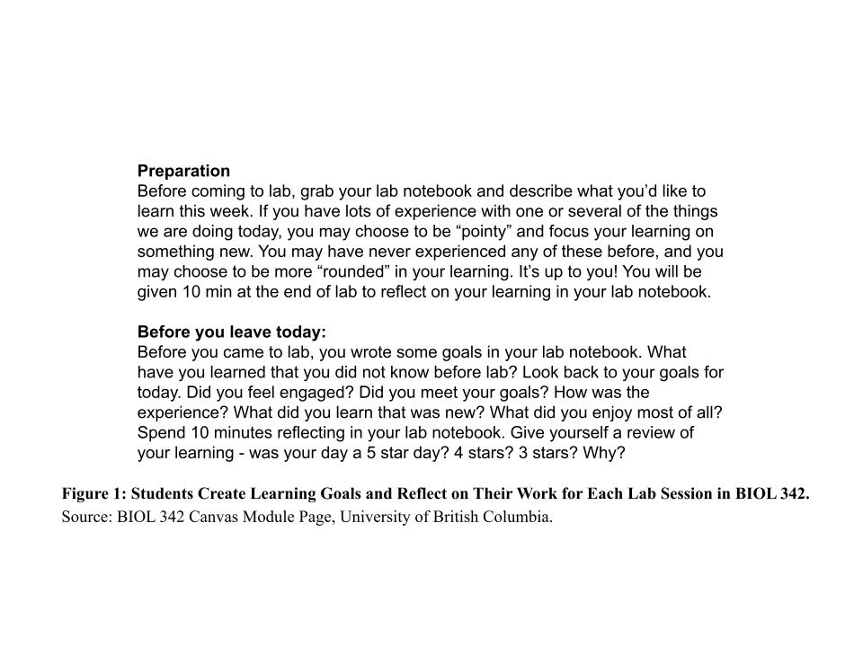

**Research Methods**

Primary sources of data include an interview with Dr. Celeste Leander, a UBC instructor who has experience teaching BIOL 342 with both a graded and ungraded approach. The interview collected instructor opinions on the ungraded approach, and the full list of questions can be found in Appendix A. Another primary source of data includes an online survey targeted to current and past students of BIOL 342, via Facebook group “Biol 342, 2021.”. The survey collected student opinions on the ungraded approach, and the full list of questions can be found in Appendix B. Secondary sources include peer-reviewed research that discusses the benefits and drawbacks of both the graded and ungraded approaches to learning.

**Limitations of the Study**

The main limitation of this study is the small range of primary data. By only interviewing one faculty member there is potential for bias regarding instructor opinions of the ungraded approach. Furthermore, as the student survey is targeted only to current and past students of BIOL 342, the sample size of respondents may not be large enough to accurately represent student opinions of the ungraded approach. Further research may be required to obtain a larger range of primary data and collect more accurate representations of instructor and student opinions of the ungraded approach.

**Scope of Inquiry**

This report will address the following questions:

1. What are instructor and student opinions on the ungraded approach?
2. How difficult is it for instructors to transition a course from a graded approach to an ungraded approach?
3. Does teaching with an ungraded approach require more work for instructors?
4. Would an ungraded approach work well for all biology lab courses at UBC?
5. What are the benefits and drawbacks of the graded and ungraded approaches?

**Conclusions of the Inquiry**

The report concludes by acknowledging the various benefits associated with an ungraded learning approach and by recommending select biology lab courses to make full or partial transitions to an ungraded approach.

**Data Section A: Instructor Opinions on the Ungraded Approach**

**Transitioning a Course From a Graded Approach to an Ungraded Approach**

When asked how much work was required to transition BIOL 342 from a graded approach to an ungraded approach, Dr. Leander stated: “It took some work, but not more than starting any other term. Ungrading a course requires trusting students. In the spirit of trusting students, I took out a lot of small items (pre-lab quizzes, etc). This really forced me to identify the most meaningful contributions to learning. I met with the TAs about providing meaningful feedback without grades. Finally, I designed the 5 page self-reflection document where students could justify their own grade in the course.” Dr. Leander’s response shows how transitioning and designing a course to an ungraded approach requires roughly the same amount of work as would preparing for any other graded course. Not only that, but the process of transitioning a course to the ungraded approach created many meaningful changes to the course itself. As the ungraded approach is built on a foundation of trusting students, Dr. Leander made BIOL 342 more streamlined and created new opportunities for students to receive feedback and reflect on their learning.

**Amount of Work for Instructors: Graded Approach versus Ungraded Approach**

When Dr. Leander was asked how she would compare the amount of work required as an instructor of BIOL 342 using the graded approach versus the ungraded approach, she stated: “It would likely take a bit more design work before the course starts, but it takes less work throughout the term because no grading! Feedback is critical, but this is more fun to do without assigning marks.” Dr. Leander’s statement illustrates how there is no significant difference between the amount of work required by instructors using a graded approach versus an ungraded approach, as the extra design work is balanced out with the absence of grading. Her response also shows how the work itself is more enjoyable, as she is able to provide feedback without having to assign grades.

**Applicability of the ungraded approach for all biology lab courses at UBC**

After she was asked whether the ungraded approach would work well with all biology lab courses at UBC, Dr. Leander stated: “I think it would [work] well with some, but not all. Creative courses such as Biol 140 would be excellent choices. Organismal courses would be more difficult without major re-thinking, but I would still try pieces of the course. There are different ways to incorporate ungrading without fully committing the whole course.” Dr. Leander introduces a middle ground between the graded and ungraded approaches, mentioning how biology lab courses with a creative emphasis would work well using the ungraded approach, and that more structured, organismal lab courses can still benefit by partially incorporating the ungraded approach. Her response makes clear that courses need not be fixed to one particular learning approach, but that blended approaches are also possible.

**Overall Experience and Preference**

When Dr. Leander was asked how she would describe her overall experience with teaching using an ungraded approach, given the options of ‘Excellent’, ‘Good’, and ‘Poor’, she selected ‘Excellent’. Dr. Leander was also asked which learning model she preferred after teaching BIOL 342 with both a graded and ungraded approach, to which she stated: “I definitely prefer ungrading, especially for [BIOL 342]. I hope we can expand ungrading through the years so that students can experience this in first year - even for a piece of a course.” Dr. Leander showcases strong positive feelings and a strong preference for teaching using the ungraded approach. Furthermore, she is passionate and confident about the ungraded approach to the extent of hoping that students are able to experience the learning model earlier in their academic careers, if even for a small portion of a course.

**Data Section B: Student Opinions on the Ungraded Approach**

**Impact on Learning**

Out of 33 respondents, 81.8% of BIOL 342 students state that the ungraded approach impacts their learning positively, while the other 18.2% state the impact is neither positive nor negative (Figure 2a). None of the respondents described the ungraded approach as having a negative impact on their learning. These results suggest that the ungraded approach largely has a positive impact on student learning, with no evidence of negative impact.

**Amount of Feedback**

When asked how they would describe the amount of feedback they receive with an ungraded approach, 51.5% of BIOL 342 students indicate the amount as ‘excellent’, while the other 48.5% indicate the amount as ‘good’ (Figure 2b). None of the 33 respondents described the amount of feedback as ‘poor’. These results imply that there are mixed opinions among students regarding how sufficient the amount of feedback is, however there is a consensus that amount is not insufficient.

**Applicability to Other Biology Lab Courses**

BIOL 342 students were asked how an ungraded approach would work in other biology lab courses at UBC, to which 60.6% state it would work ‘very well’, 30.3% state it would work ‘adequately’, and 9.1% state it would work ‘poorly’ (Figure 2c). These results suggest that the majority of students believe in the success of implementing the ungraded approach to other biology lab courses, but a significant minority of students do not have the same amount of belief in the ungraded approach.

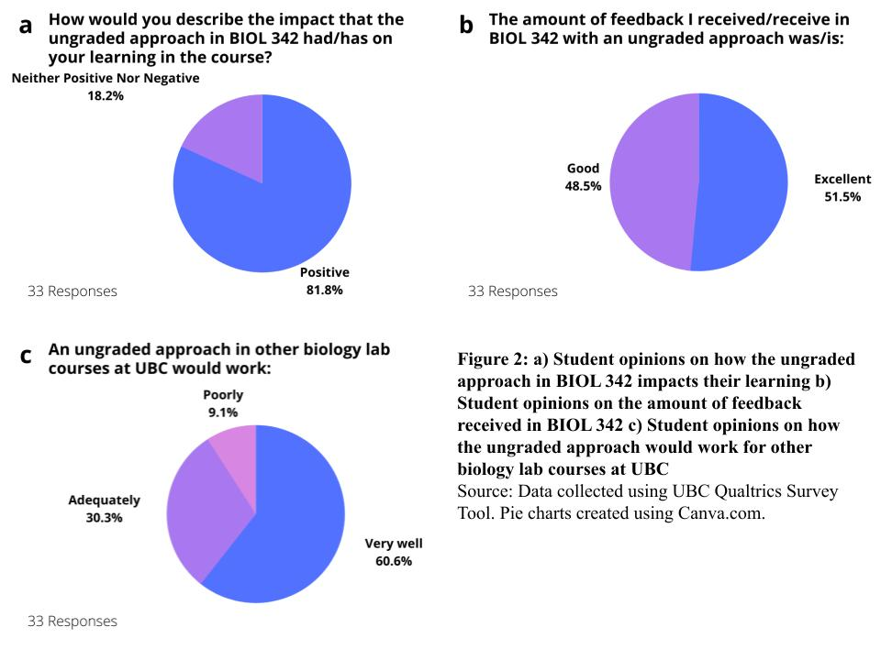

**Overall Experience**

Out of 33 respondents, 87.9% of BIOL 342 students described their experience with the ungraded approach in the course as ‘excellent’, while 12.1% described their experience as ‘good’ (Figure 3a). None of the respondents reported their experience with ungrading as ‘poor’. These results imply that a significant majority of students enjoy learning with the ungraded approach, and that there is no evidence of negative student experiences with this model.

**Preferences**

When BIOL 342 students were prompted with the statement that they prefer an ungraded approach for BIOL 342 over a graded approach, 84.8% indicated that they agree with the statement, while the other 15.2% stated that they neither agree nor disagree (Figure 3b). None of the 33 respondents indicated disagreement with the prompt. Furthermore, when the students were prompted that they would prefer if other biology lab courses implemented an ungraded approach, 75.8% stated that they agree with the statement, and the other 24.2% indicated they neither agree nor disagree (Figure 3c). The respondents never indicated disagreement with the prompt. These results suggest that most students favor ungrading, both in BIOL 342 and if incorporated into other biology lab courses. However, there are some students who do not feel strongly about bringing the ungraded approach into other biology lab courses.

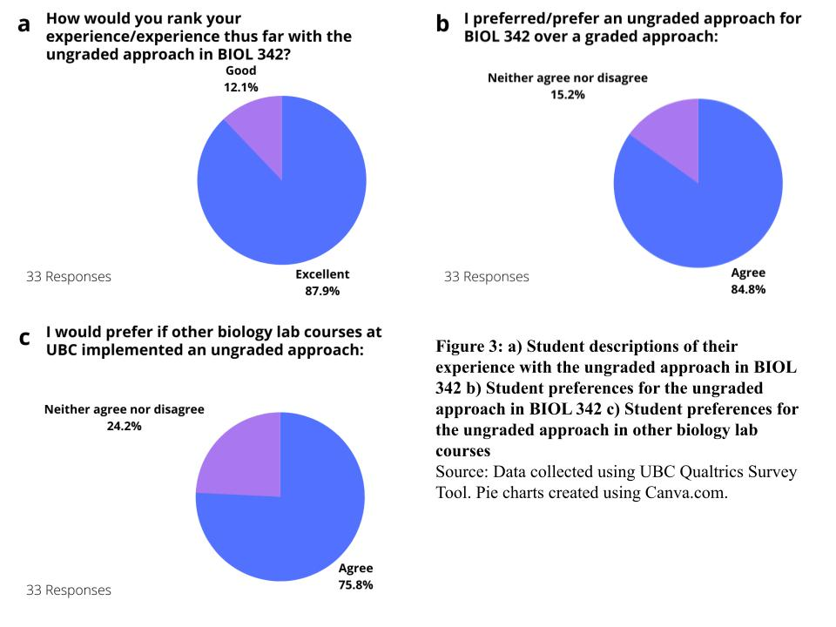

**Data Section C: Summary of Secondary Research**

**Research for the Ungraded Approach**

The research literature indicates many drawbacks of the graded approach, and how these drawbacks can be resolved with an ungraded approach. Grades can be a source of anxiety for students (Pulfrey et al., 2011) and lead them to cheat (Anderman, 1998). Grades cause students to be extrinsically motivated, whether that be by performance-avoidance goals (a desire to avoid poor performance due to a fear of failure) or by desiring to outcompete their peers (Pulfrey et al., 2011). With extrinsic motivation students engage with their work out of fear or competition, as opposed to being intrinsically motivated by interest or a desire to learn. Competitive environments reduce retention of information and learning in science students (Humphreys et al., 1982). An ungraded approach helps students with these issues by reducing stress and their motivation to cheat in the absence of grades, while promoting intrinsic motivation as students are able to focus on learning as opposed to getting a high grade (Blum et al., 2020). Furthermore, grades are not an effective form of feedback due to their simplicity (Blum et al., 2020). The ungraded approach focuses on providing descriptive feedback, which students prefer over grades (Butler & Nisan, 1986). Moreover, grades can cause students to avoid challenging work (Harter, 1978), while in the absence of grades students are more likely to seek more challenging work (Deci et al., 1996) and more creative work (Blum et al., 2020). The literature exhibits many examples of the disadvantages associated with the graded approach and the benefits associated with ungrading.

**Research Against the Ungraded Approach**

Although numerous research suggests the benefits of ungrading, a paper by Tyner & Petrilli (2018) states the opposite, highlighting the importance of the extrinsic motivation that comes from a graded approach. Tyner & Petrilli (2018) state that student academic success is largely determined by student effort, which is itself determined by student accountability for their learning. Tyner & Petrilli (2018) state that students become more accountable with external motivators such as standardized testing (which affect their graduation status and/or transcript), or cash incentive programs, as these motivators raise student stakes and therefore their effort. Tyner & Petrilli (2018) cite how countries that implement standardized tests outperform countries that do not, and imply how the trend of teachers not being able to assign low grades leads to lower student effort and to students ‘gaming the system’. According to Tyner & Petrilli (2018), external motivation to achieve high grades facilitates higher student academic success by increasing student effort.

**Conclusion**

**Summary and Interpretation of Findings**

A biology lab instructor interview implies no significant difficulties in transitioning a course to an ungraded approach, nor any major disparity in the amount of work required for an instructor using this approach. Not only that, but the ungraded approach is an enjoyable experience that is preferable to traditional grading, and has allowed opportunities for students to engage in meaningful self-reflection. Furthermore, ungrading is well-suited for creativity-focused lab courses, but less so for organismal-focused courses.

Student opinion on the ungraded approach is largely positive in regards to the impact on learning, overall experience, and preference. However, opinions vary as to how sufficient the amount of feedback is, but no evidence of negative opinion was found. Also, there are mixed opinions regarding the applicability of ungrading to other lab courses, however a majority of students believe in the success of further implementation of the ungraded approach.

Research literature suggests several drawbacks to the graded approach including increased anxiety, cheating, extrinsic motivation, competition between students, simplistic feedback, and an avoidance of challenging work, all of which can be decreased with an ungraded approach. However, conflicting literature indicates the importance of extrinsic motivation to promote student effort and success.

Though still slightly conflicting and low on sample size, most of the various findings convey a similar message that the ungraded approach is favorable in regards to education.

**Recommendations**

In light of slightly conflicting findings and the low sample size, a full transition for all UBC biology lab courses to the ungraded approach seems inadvisable. Despite this, adjustments can still be made to tailor UBC biology lab courses to their best-suited learning approach. Please consider the following recommendations:

* Inform and educate biology lab faculty on the ungraded approach and its benefits
* Introduce the ungraded approach to creative-focused lab courses such as BIOL 140
* Introduce the ungraded approach to particular segments or projects of organismal-focused lab courses
* Adjust newly ungraded lab courses / course segments by placing more emphasis on receiving descriptive feedback and self-reflection

Introducing the ungraded approach to biology lab courses at UBC can allow instructors and students to work in a more preferred learning environment, create opportunities for students to deepen their learning through meaningful feedback and reflection, and avoid the numerous drawbacks associated with a graded approach.

**References**

Anderman, E. M., Griesinger, T., & Westerfield, G. (1998). Motivation and cheating during early adolescence. *Journal of Educational Psychology*, *90*(1), 84-93. <https://doi.org/10.1037/0022-0663.90.1.84>

Blum, S. D., Kohn, A., Saffel, T., & ProQuest (Firm). (2020). *Ungrading: Why rating students undermines learning (and what to do instead)* (First ed.). West Virginia University Press.

Butler, R., & Nisan, M. (1986). Effects of no feedback, task-related comments, and grades on intrinsic motivation and performance. *Journal of Educational Psychology*, *78*(3), 210-216. <https://doi.org/10.1037/0022-0663.78.3.210>

Deci, E. L., Ryan, R. M., & Williams, G. C. (1996). Need satisfaction and the self-regulation of learning. *Learning and Individual Differences*, *8*(3), 165-183. <https://doi.org/10.1016/S1041-6080(96)90013-8>

Guberman, D. (2021). Student perceptions of an online ungraded course. *Teaching and Learning Inquiry*, *9*(1), 86-98. <https://doi.org/10.20343/teachlearninqu.9.1.8>

Harter, S. (1978). Pleasure derived from challenge and the effects of receiving grades on children’s difficulty level choices. *Child Development*, *49*(3), 788-799. <https://doi.org/10.1111/j.1467-8624.1978.tb02382.x>

Humphreys, B., Johnson, R. T., Johnson, D. W. (1982). Effects of cooperative, competitive, and individualistic learning on students’ achievement in science class. *Journal of Research in Science Teaching*, *19*(5), 351-356. <https://doi.org/10.1002/tea.3660190503>

Pulfrey, C., Buchs, C., & Butera, F. (2011). Why grades engender performance-avoidance goals: The mediating role of autonomous motivation. *Journal of Educational Psychology*, *103*(3), 683-700. https://doi.org/10.1037/a0023911

Schinske, J., & Tanner, K. (2014). Teaching more by grading less (or differently). *CBE Life Sciences Education*, *13*(2), 159-166. <https://doi.org/10.1187/cbe.CBE-14-03-0054>

Tyner, A., & Petrilli, M. J. (2018). The Case for Holding Students Accountable: How extrinsic motivation gets kids to work harder and learn more.. *Education Next*, *18*(3), 26-32. Retrieved from: <https://www.educationnext.org/case-for-holding-students-accountable-how-extrinsic-motivation-gets-kids-work-harder-learn-more/>