Feasibility of Enhancing COVID Protection

for
On-campus Dining at UBC

for Celene Fung
Senior Policy Planner
UBC Community Planning and Programming
&
Gabriella Scali

Community Programs and Outreach Manager
UBC Community Planning and Programming

By
Han Li
ENGL 301 Student
University of British Columbia

March 16, 2022

TABLE OF CONTENTS

PAGE
INTRODUCTION 3-4
DATA AND ANALYSIS 5-9

On-campus Indoors Dining Areas 5

Current COVID-19 Protocols 6

Surveys 7

Other Universities 8-9
CONCLUSION 10-11
Summary and Overall Interpretation of Findings 10
Recommendations 11
Works Cited 12

FIGURES
Figure 1 Weekdays 15:00 at AMS Nest 5
Figure 2 Weekdays 15:00 at Life Building 5
Figure 3 Robotic Delivery Fleets 9
Figure 4 Anti-droplet isolation boards 9

INTRODUCTION

On December 31, 2019, Wuhan first reported viral pneumonia, later officially identified as the novel SARS-CoV-2 virus, also known as COVID-19. As of March 15, 2022, the international pandemic has infected more than 458 million people and caused more than 6 million deaths (WHO). The sudden outbreak caught countries off guard, and people's studies, work, and lives came to a standstill. It also posed an unprecedented challenge for universities. University campuses are buzzing cultural hubs where students from all over the world study and live close to each other. However, the rapid spread of the coronavirus impacted the foundations of this unique ecosystem.
In response to the outbreak of the coronavirus, UBC transited to online learning. Fortunately, as vaccination rates rise, UBC resumes back to campus again. However, coronavirus is challenging to end soon, with the BC Centre for Disease Control and Prevention reporting 236 confirmed new cases in a single day yesterday. UBC students participate in various campus activities, including lectures, club activities and daily activities. Therefore, there is a high probability of rapid transmission if someone is tested positive. Hence, it is vital to enhance COVID-19 protection on campus.
To prevent the spread of COVID-19, UBC has implemented several measures, including masks compulsory during indoor activities and regular seating for each class during the semester. However, on-campus dining has many risks, especially indoors. Coronavirus spreads mainly through two aspects. One is through respiratory droplets from an infected person; the other is by touching something with the virus, then touching the mouth, nose or eyes with unwashed hands. Besides, certain environmental conditions facilitate the transmission, such as re-circulated air (Government of Canada). Therefore, many students gather in confined spaces during mealtimes without wearing masks for a long time, putting students at high risk of getting coronavirus. There are two main reasons: First, students remove their masks to eat and talk in confined spaces where they cannot keep their distance. Second, students must wait in line for long periods to order or heat their meals due to the similarity of mealtimes.
Based on a review of crucial research as well as surveys with UBC students, this report is to (a) determine the extent of student satisfaction with on-campus dining, (b) confirm the feasibility of having acrylic transparent anti-droplet isolation boards in confined dining areas and (c) provide practical recommendations on enhancing student safety for on-campus dining.
This report covers five major topics: what are UBC’s current on-campus indoor dining areas and how is the environment, what action does UBC take presently sticking to students’ on-campus dining, what are UBC students’ attitudes towards current indoor dining environment, how many students agree to have isolation boards and what actions are being taken worldwide to mitigate risk.
The report concludes by acknowledging the limitations of the survey samples, the adjustments of BC’s current policy on coronavirus and by recommending practical suggestions for our campus.

DATA AND ANALYSIS

On-campus Indoors Dining Areas

UBC offers a variety of dining options for students, including restaurants, quick service, cafes, dining halls, and bring meals. Excluding the above options with their own separate dining spaces, AMS Student Nest and UBC Life Building are the two most popular indoor dining areas among students. They are student-centered activity hubs that house cafes, restaurants, tables, and quiet study spaces. Here are two pictures of Life and Nest taken around 15:00 on weekdays.

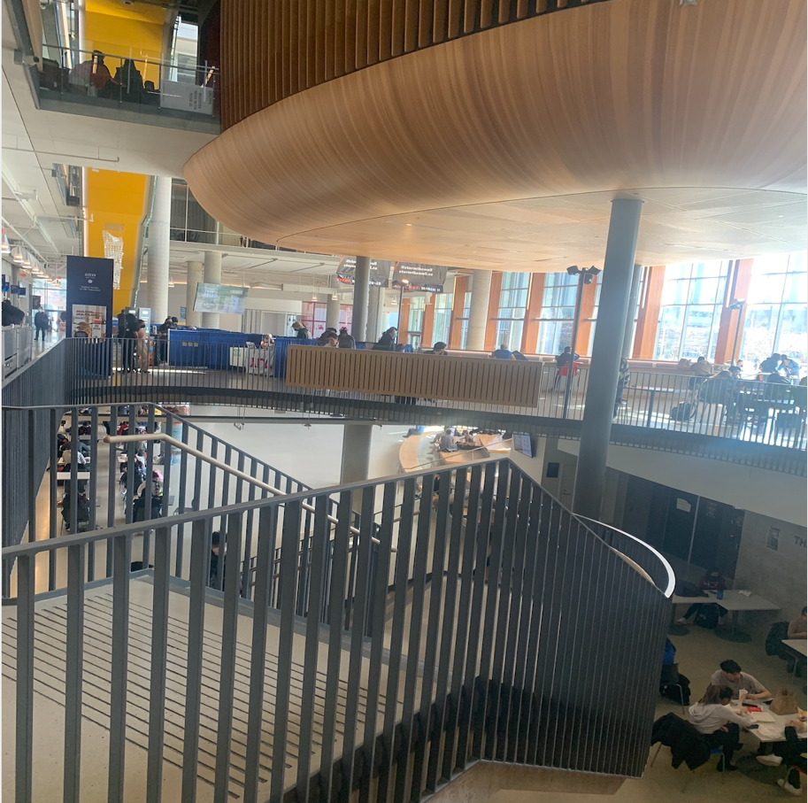

Figure 1: Weekdays 15:00 at Nest

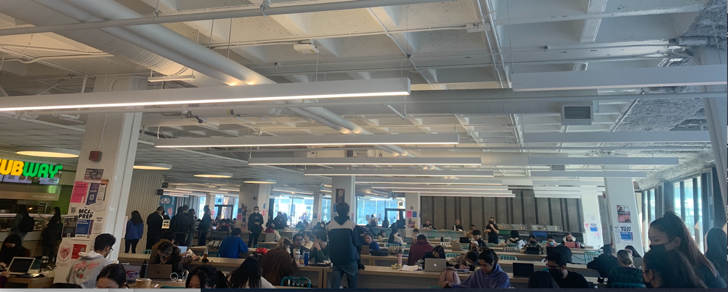

Figure 2: Weekdays 15:00 at Life Building

Even if it is not the peak mealtime, many students eat and chat with their friends without keeping distance. This kind of dining environment increases the risk of coronavirus transmission.

Current COVID-19 Protocols

The table below summarizes the protocols of UBC food services:
What UBC is Doing | What Students can do
1.Masks are mandatory except when sitting at tables and eating or drinking. | 1. Wash hands frequently for 20-30 seconds using soap and water, or an alcohol-based hand sanitizer
2.All guests are required to sanitize when entering the dining hall. | 2. Abstain from touching eyes, nose, and/or mouth, especially with unwashed hands
3.Increased frequency of cleaning in high-touch areas. | 3. Sneeze or cough by covering mouth and nose with the crease of elbow, then wash hands
4.Hand sanitizer stations are available in all major locations. | 4. Don’t come to dining hall when you are uncomfortable. Contact the housing front desk for help.
5.Staff are reminded to wash hands frequently with proper hand-washing techniques. | 5. Bigger spaces, fewer faces. Keep hang-outs small and give space to people outside your bubble.

6.Staff are asked to stay home if they are ill or have flu symptoms.

Source: UBC Food Services

UBC follows all requirements outlined by the Provincial Health Orders and Interior Health. However, both “What UBC is doing” and “What Students can do” are highly reliant on students’ self-consciousness and not detailed enough like “masks are mandatory except when sitting at tables and eating or drinking”. Nevertheless, it does not specify that students should put their masks on if they chat with their friends during eating or drinking. As mentioned before, droplets from an infected person are the primary means of transmission. Therefore, UBC should focus more on how to effectively prevent students from being exposed to each other’s droplets. Besides, some of them are hard to follow under the UBC context. For example, UBC suggests students keep social distance, it is impossible to guarantee effective social distancing as most students have similar mealtime.

Survey

Thirty-seven university students complete a short survey designed to understand students’ current dining habits, obtain opinions on UBC’s dining environment in pandemic and their attitude towards setting acrylic transparent anti-droplet isolation boards. The survey consists of eight multiple-choice questions and sends to volunteers to participate.

There are thirty-two valid surveys. The first four questions of the survey are to collect frequency, location preferences, habits of students dining on-campus. Nearly 60% of them prefer to dine indoors with friends in common areas on campus, which is in line with previous expectations and demonstrates that UBC students are still at a relatively high risk of dining indoors on-campus. However, as the weather warms, some students may prefer to eat outside.

Questions five to seven focus on students’ opinions towards the current indoor dining environment. It is worth noting that 75% of students believe that “Dining in UBC is sometimes unpleasant and/or uncomfortable”. More than half of the students think the dining space is adequate, but the waiting time is long.

The last question collects students’ opinion towards having acrylic transparent anti-droplet isolation board in confined dining areas. 43.75% of students strongly agree with having baffles, 21.88% are ok with it, 15.63% of students choose neither agree nor disagree and 18.75% of them disagree. Therefore, most students are in favor of the installation of baffles.

Other Universities

COVID-19 is global, so it is necessary to understand and learn how the other world’s universities respond to on-campus dining during the pandemic.

Virginia Commonwealth University, located in Richmond, Virginia (Elliott):

All campus dining locations are cashless.

No more buffets on campus

Strict cleaning and sanitation procedures

Expand ordering through its “Bite” app and implement “to-go” dining

North Carolina Agricultural and Technical State University (Elliott):

Use of personal protective equipment

Timed sanitizing procedures

Rearrange tables and seating to offer at least six feet of space between students

University of Houston (Fischer):

Robotic delivery fleets to let students get their food without having to step into crowded dining halls
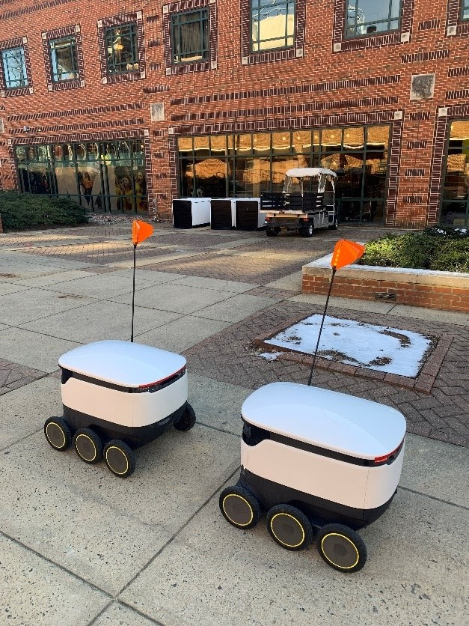

Figure 3: Robotic delivery fleets at University of Houston

Source: EAB

Hokkaido University, Japan & Gyeongsang National University, Korea have acrylic transparent anti-droplet isolation boards in dining halls:

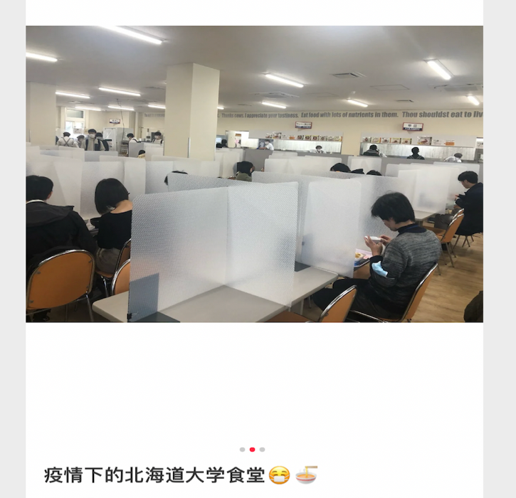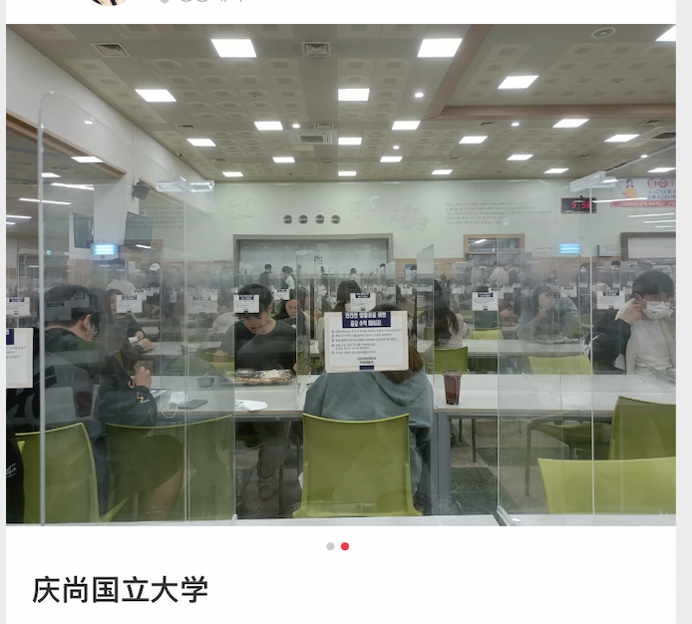
Figure 4: Anti-droplet isolation boards

Source: RED
CONCLUSION

Summary and Overall Interpretation of Findings

Coronavirus has posed a significant challenge to daily life and work in the past few years and greatly affects UBC students’ campus life and studies. UBC students spend a significant amount of time on-campus, and many students gather, causing a high possibility of transmission.
To prevent the spread of COVID-19, UBC is always in action. However, UBC has not paid enough attention to the indoor dining. Current protocols meet the standard of the official health departments without incorporating UBC’s situation. It is vital to have more detailed protocols to guarantee student safety. If coronavirus continues to spread on campus, it causes panic among students and affects UBC’s reputation.

Though the BC health departments believe the coronavirus is under control, it is not the time to relax. According to the survey, many UBC students think dining in UBC is not always comfortable and the waiting time is long.

Affected by the pandemic, world universities make changes on students’ on-campus dining.The main principle is to maintain social distance and reduce contact.

Recommendations
Although people under 25 years have the lowest risk of severe disease. However, students’ activities can be key to persistent ongoing community transmission. UBC community still can take some immediate and inexpensive steps to mitigate the risk. Please consider the following recommendations:
- Update UBC Vancouver COVID-19 food protocols.
- Courage students to dine outdoors.
- Unified entry and exit routes of popular dining areas.
- Consider a contactless operating system.
- Design UBC’s ordering app to avoid waiting time.
- Plan specific dining areas in AMS Nest and Life Building and set acrylic transparent anti-droplet isolation boards.

As a UBC student, I hope the COVID-19 will go away soon. Our campus gets better and safer.

WORKS CITED

BCCDC. “BC COVID-19 Dashboard.” BC Centre for Disease Control, 2022, http://www.bccdc.ca/health-info/diseases-conditions/covid-19/data#COVID-19Dashboard March 15th
Elliott, C. “College Food Safety 101: How Do You Safely Feed Students During the Pandemic?” Forbes, 2020, https://www.forbes.com/sites/christopherelliott/2020/08/14/how-will-americas-universities-safely-feed-students-during-the-pandemic/?sh=366e2ed62df0
March 10th.
Fischer, M. “Gen Z was already transforming campus dining. Then COVID-19 happened.” EAB, 2020, https://eab.com/insights/expert-insight/facilities/gen-z-was-already-transforming-campus-dining-then-covid-19-happened/ March 10th
Government of Canada. “COVID-19: Main modes of transmission- How COVID-19 spreads.” Government of Canada, 2019, https://www.canada.ca/en/public-health/services/diseases/2019-novel-coronavirus-infection/health-professionals/main-modes-transmission.html Feb 15th
UBC Food Services. “Current COVID-19 Protocols.” UBC Food Services, 2022, https://food.ok.ubc.ca/covid-19/ March 10th
WHO. “WHO Coronavirus (COVID-19) Dashboard.” WHO, 2022, https://covid19.who.int/ March 10th

