**Feasibility Analysis**

**of Increasing Rubbish Bins to Reduce Littering on Campus**

for

Jacquie Kwok

Programme Coordinator

UBC Sustainability

by

Leo Kim

English 301 Student

read by

Ben Maxfield

Member of Jake’s Friends

March 16, 2022

**Table of Contents**

I. Introduction …………………………………………………………………………………... 2

1. Background on UBC Vancouver Campus ………………………………………………. 2
2. Statement of Problem …………………………………………………………………… 2
3. Purpose of Report ……………………………………………………………………….. 2
4. Methods …………………………………………………………………………………. 2
5. Scope ……………………………………………………………………………………. 3

II. Data Section …………………………………………………………………………………. 3

1. Observations …………………………………………………………………………….. 3
2. Survey …………………………………………………………………………………… 5
3. DO-NOT-LITTERING Sign …………………………………………………….. 6
4. Easiness Finding Rubbish Bins ………………………………………………….. 7
5. Enoughness of Bins ……………………………………………………………… 8
6. Appropriate Distance Between Bins …………………………………………….. 9
7. Intention for Public Campaign …………………………………………………. 10

C. Other Solutions …………………………………………………………………………. 11

D. From Research ………………………………………………………………………….. 11

III. Conclusion ………………………………………………………………………………… 12

1. Summary and Interpretation of Findings ………………………………………………. 12
2. Recommendations ……………………………………………………………………… 12

Works Cited ……………………………………………………………………………………. 13

Figures and Tables

Figure 1: Five Roads on UBC …………………………………………………………………… 4

Figure 2: Thought on DO-NOT-LITTERING Sign ……………………………………………... 6

Figure 3: Easiness Finding Rubbish Bins Outside of Buildings ………………………………… 7

Figure 4: Opinion for Enoughness of Bins ……………………………………………………… 8

Figure 5: Thought on Appropriate Distance of Bins ……………………………………………. 9

Figure 6: Intention for Public Campaign ………………………………………………………. 10

Figure 7: Other Opinions ………………………………………………………………………. 11

Table 1: Current Condition of UBC Main Five Roads Bins …………………………………….. 4

**I. Introduction**

**A. Background on UBC Vancouver Campus**

The University of British Columbia Vacnovuer campus is known for having a beautiful campus landscape. This place is a heritage from our ancestors and will be bequeathed for future generations, but it is threatened by littering. As a group member of UBC Vancouver campus, rubbish littering is always a major concern. It is not just creating unscenic problems, but also causing serious environmental problems of campus nature. Specifically outside of academic buildings, littering is significant on the road and grass. Despite staves’ effort to clean, littering is becoming more serious day by day.

**B. Statement of Problem**

Taking action is needed to keep UBC Vancouver campus nature clean and beautiful as it is. There are two major reasons that lead to the littering problem with our paritication: first, lacking rubbish bins on the campus roads in comparison to the inside of buildings. Second, a clear DO-NOT-LITTERING sign is required on campus roads and grass fields.

**C. Purpose of Report**

One possible solution to solve this problem is increasing rubbish bins and DO-NOT-LITTERING signs on required places on campus. These could awaken the necessity of littering on campus roads and grass fields, and also increase the probability of non-littering. The objective is to call upon the university department to solve this problem.

**D. Methods**

My primary data sources will include the survey of UBC members including students, staves, and professors. Surveys can help to identify and broaden the approach to solution. Also as an informal observation, I can search the amount of rubbish bins and DO-NOT-LITTERING signs on campus by walking around the campus. Secondary sources will include the articles and papers for university rubbish problems and other cases.

**E. Scope**

To assess the feasibility of reducing littering on campus, I plan to pursue six areas of inquiry:

1. How many rubbish bins and DO-NOT-LITTERING signs are outside of buildings on campus?
2. How far is the distance between rubbish bins outside of buildings?
3. How are other universities doing?
4. How could we select the locations for rubbish bins if we put them more?
5. How many people could be engaged if there is a campaign for littering?

**II. Data Section**

**A. Observations**

Identifying the number of rubbish bins and signs is the beginning point of this problem. I observe five main vertical streets of UBC Vancouver campus: Lower Mall, West Mall, Main Mall, East Mall, and Westbrook Mall.

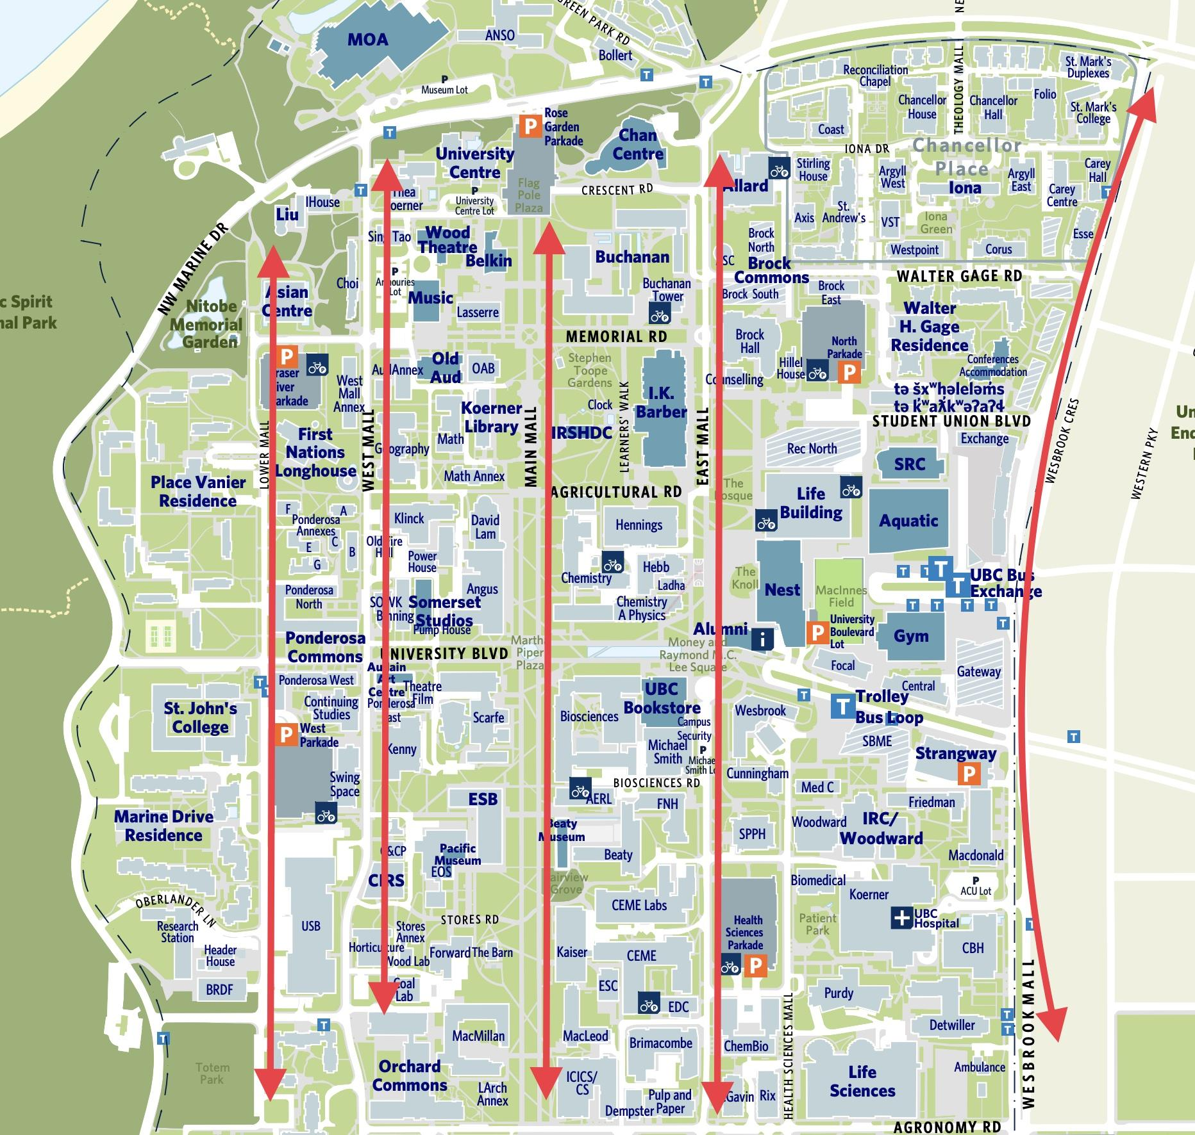

*Figure 1. Five Roads on UBC*

Figure 1. Illustrates the location of five main roads of UBC. Starting from Lower Mall, the total distance is 900m and there are 3 small rubbish bins. On West Mall, the length is 1700m and total bins are 3 small bins and 1 recycling bin. In Main Mall case, it is 1700m and bins are 2 small bins and 3 recycle bins, but most of them are located around the academic building or restaurants. East Mall is 2000m, it has 1 small bin and 3 recycle bins. The last Wesbrook Mall is 2200m and there are 4 small bins. Each road has a different condition, but still the total number of bins are significantly lacking.

| **Categories** | Small Bin | Recycling Bin | Littering Sign | Distance | Distance / Total Bins | Characteristic |
| --- | --- | --- | --- | --- | --- | --- |
| Lower Mall | 3 | 0 | 0 | 900m | 1 Bin / 300m | Low floating population |
| West Mall | 3 | 1 | 0 | 1700m | 1 Bin / 425m | Mainly car road |
| Main Mall | 2 | 3 | 0 | 1700m | 1 Bin /  340m | Heavy floating population |
| East Mall | 1 | 3 | 0 | 2000m | 1 Bin / 500m | Mainly car road |
| Wesbrook Mall | 4 | 0 | 0 | 2200m | 1 Bin / 550m | Mainly car road |

*Table 1. Current Condition of UBC Main Five Roads Bins*

Table 1 shows how UBC on campus rubbish bins are located. The point is that there is no littering prevention sign on campus by officials. The average distance for 1 bin is 423m and it can be translated to at least 4 bins should be located in 4553.13 square feet (178.929 square metre). But as the *Characteristic* column indicates, those places are under different population conditions. So except the roads have relatively low population, Main Mall seems to have a heavy lack of bins on the road. Also, Main Mall’s bins are mostly skewed on the both edge sides and the middle grass field part is non-bins area.

**B. Survey**

Analysing the result of UBC members' thoughts and to make the decision of UBC, I send out a six-questionnaire survey with 5 multiple-choice questions and 1 short writing question. I use several social media, messengers, and private connections to send a survey link to get a result. In total, 22 answers are collected with 6 criteria: 1. Thought about DO-NOT-LITTERING sign on campus, 2. Thought about on campus rubbish bins, 3. Opinion about enoughness of rubbish bins on campus, 4. Opinion of appropriate distance between bins, 5. Intention of participation about public awareness campaign, and 6. Any other examples of other cases.

**1. DO-NOT-LITTERING Sign**

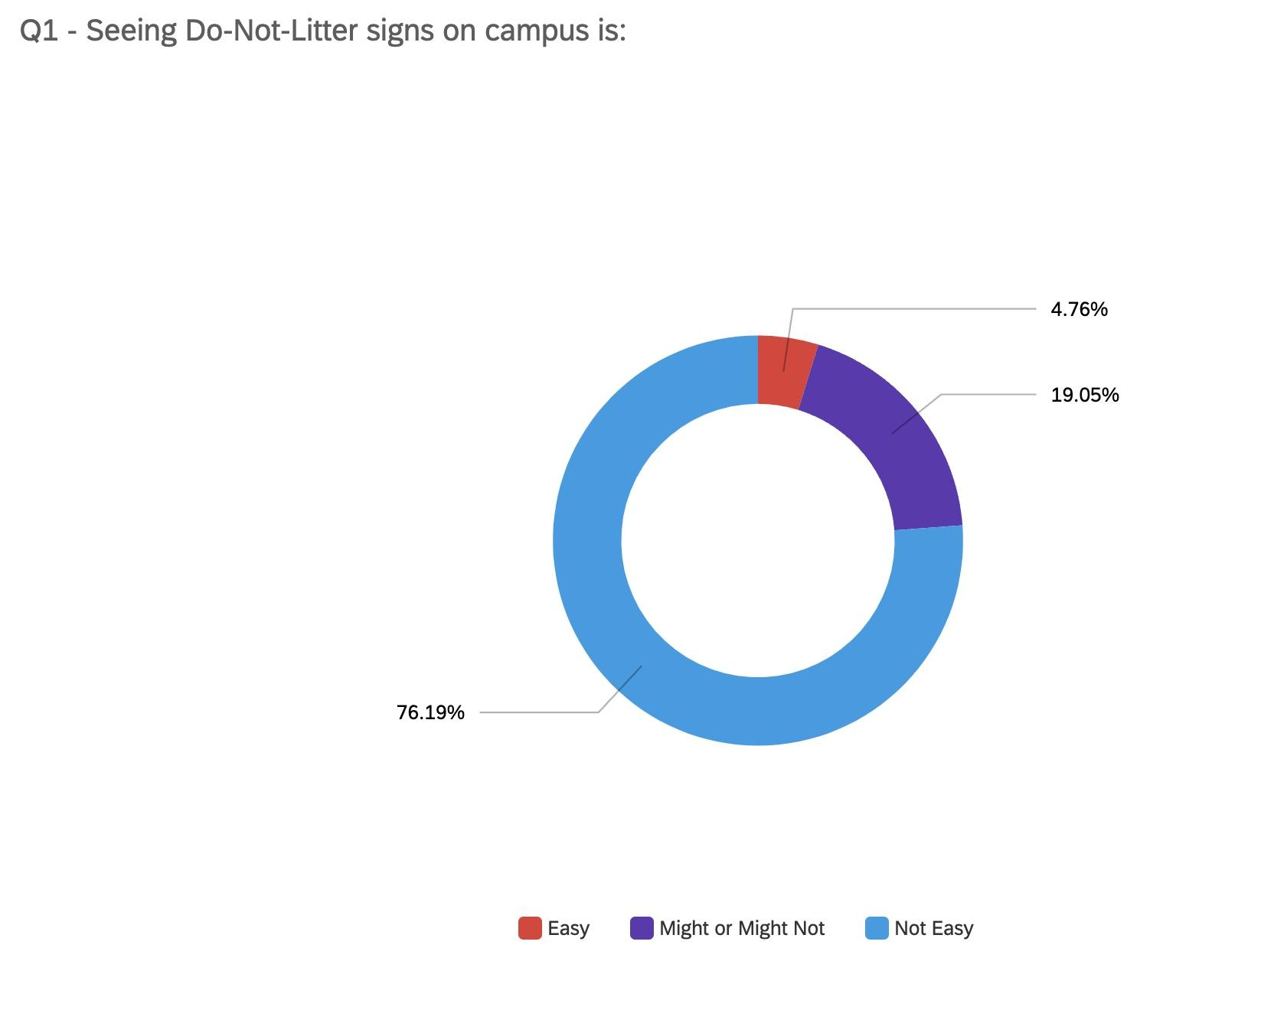

*Figure 2. Thought on DO-NOT-LITTERING Sign*

Figure 2 illustrates how UBC members think about DO-NOT-LITTERING signs. As I observed from Table 1, the answers on *Not Easy* are significantly at least 4 times higher than other options. Some respondents answer that observing littering signs is *Might or Might Not* and *Easy.* This indicates at least some privates or groups try their own campaign for littering occasionally. In short, this question shows that UBC has not littering preventing sign officially.

**2. Easiness Finding Rubbish Bins**

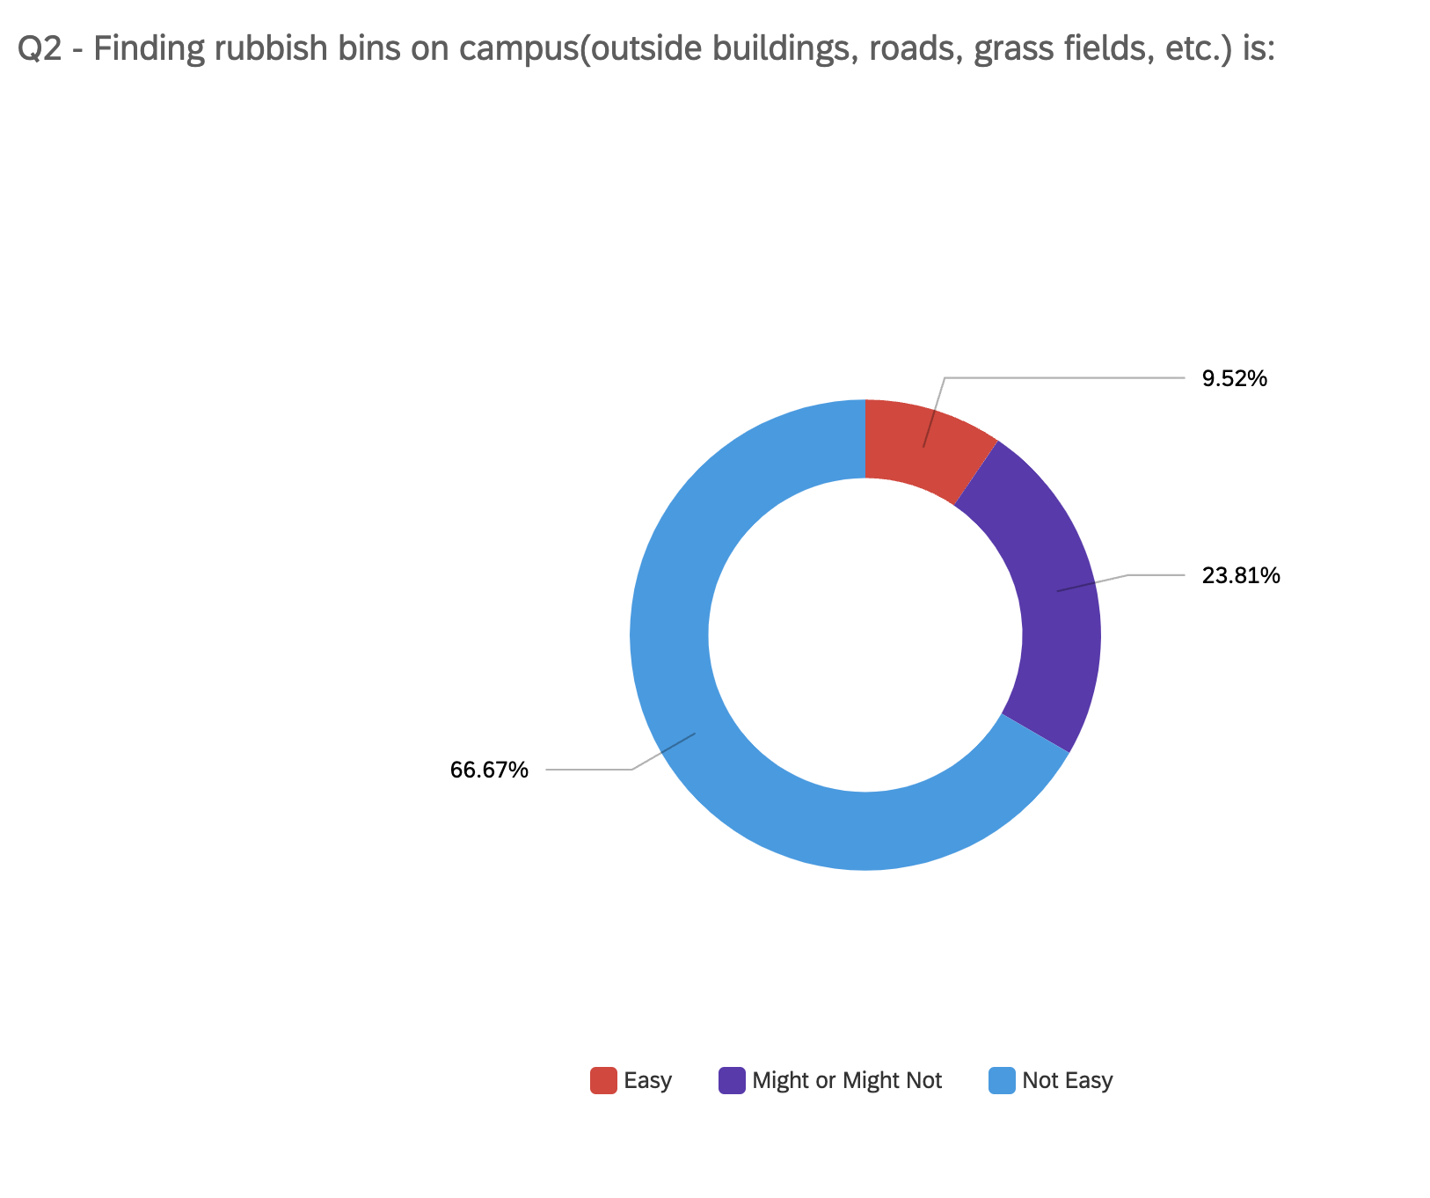

*Figure 3. Easiness Finding Rubbish Bins Outside of Buildings*

Figure 3 shows how easy it is to find rubbish bins on campus for UBC members. Only 9.52% of respondents say it is easy to find a rubbish bin on campus specifically outside of buildings. UBC has enough bins and recycling containers inside of the building. so most of the people of UBC should get into the building when they do rubbish disposal. This causes littering as well.

**3. Enoughness of Bins**

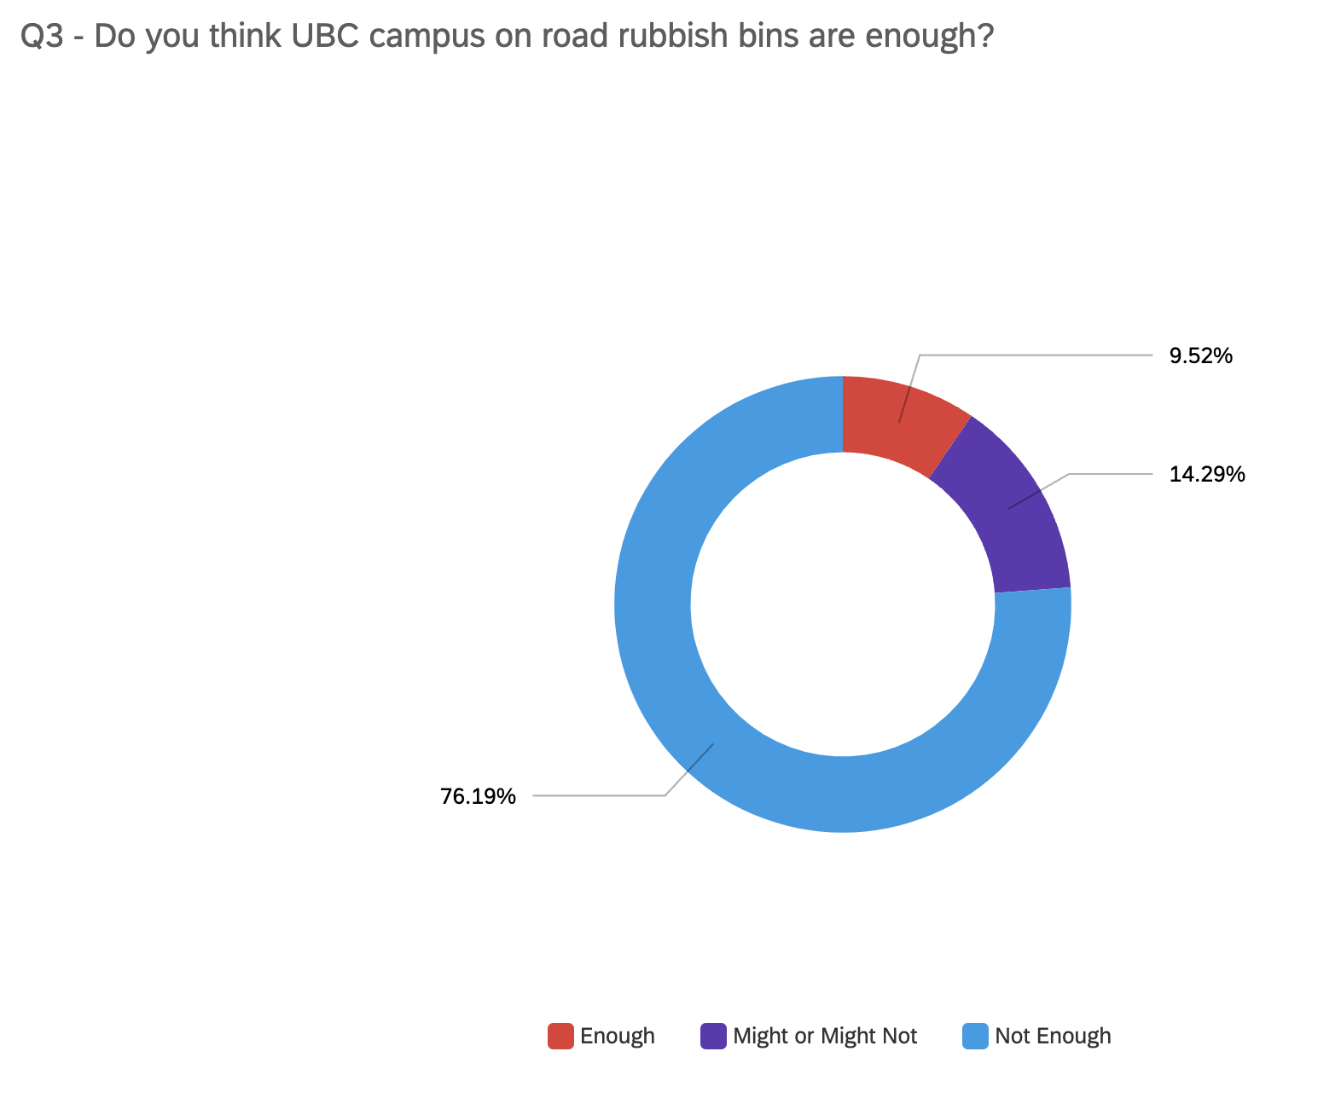

*Figure 4. Opinion for Enoughness of Bins*

Figure 4 says the opinion of UBC members that on campus bins are enough on the road. *Not Enough* has 76.19% of respondents, so significant members think increasing rubbish bins are needed. But *Might or Might Not* portion is continuing to change through the above 3 questions. It means such a portion of people do not care about littering or litter prevention signs on campus.

**4. Appropriate Distance Between Bins**

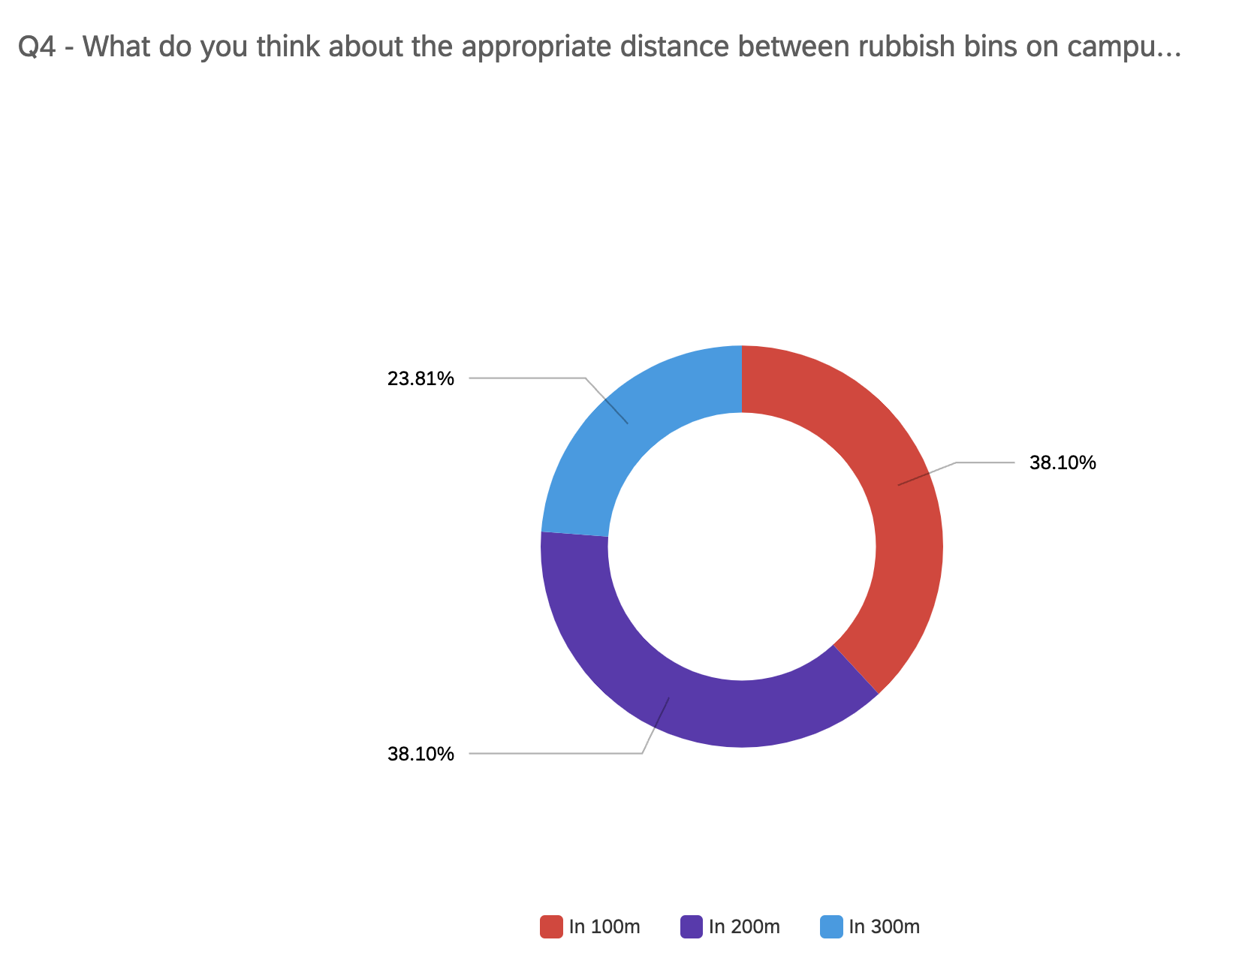

*Figure 5. Thought on Appropriate Distance of Bins*

As Table 1 tells us, the 5 main roads’ average distance between bins is 423m. Figure 5 shows 2 same portions of answers *100m* and *200m.* This question shows how 423m is far to the people who are looking for the bins. Most people want the rubbish bins to come after 100m or 200m and they do not want to keep it in their hands. This result illustrates the importance of the distance between bins, since people are not willing to keep moving to find bins for 423m. In short, the distance 4 times longer than people want can be a result of littering.

**5. Intention for Public Campaign** 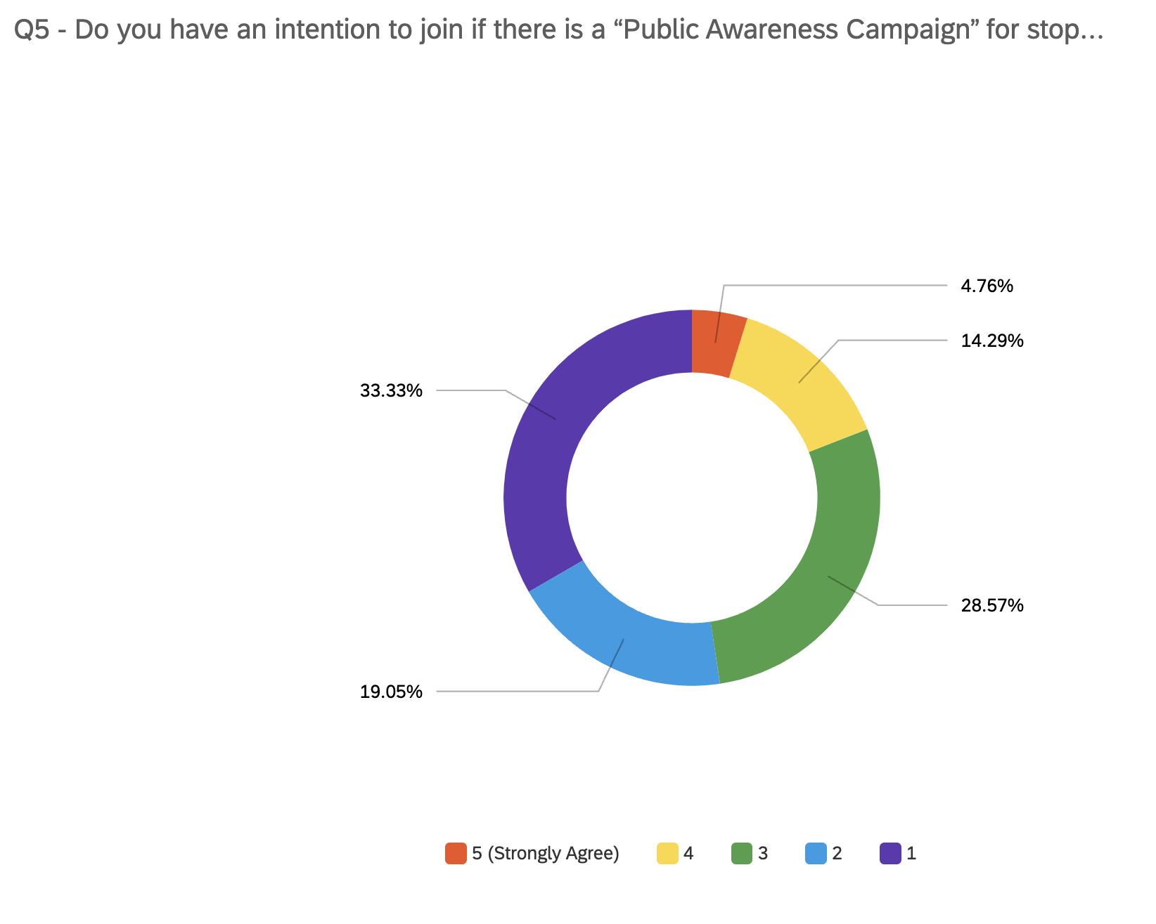

*Figure 6. Intention for Public Campaign*

Figure 6 shows how many people have an intention to join the public campaign to prevent littering, if there is. Only 4.76% of respondents have a strong agreement, and 33.33% have the lowest agreement. If we divide this result in two sections from anser *3,* only 19.05% of respondents are willing to be engaged in the public campaign. As we can combine the results from Figure 3 and Figure 6, we conclude that roughly 50% of respondents do not care about littering on campus or regarding that it is serious.

**C. Other Solutions**

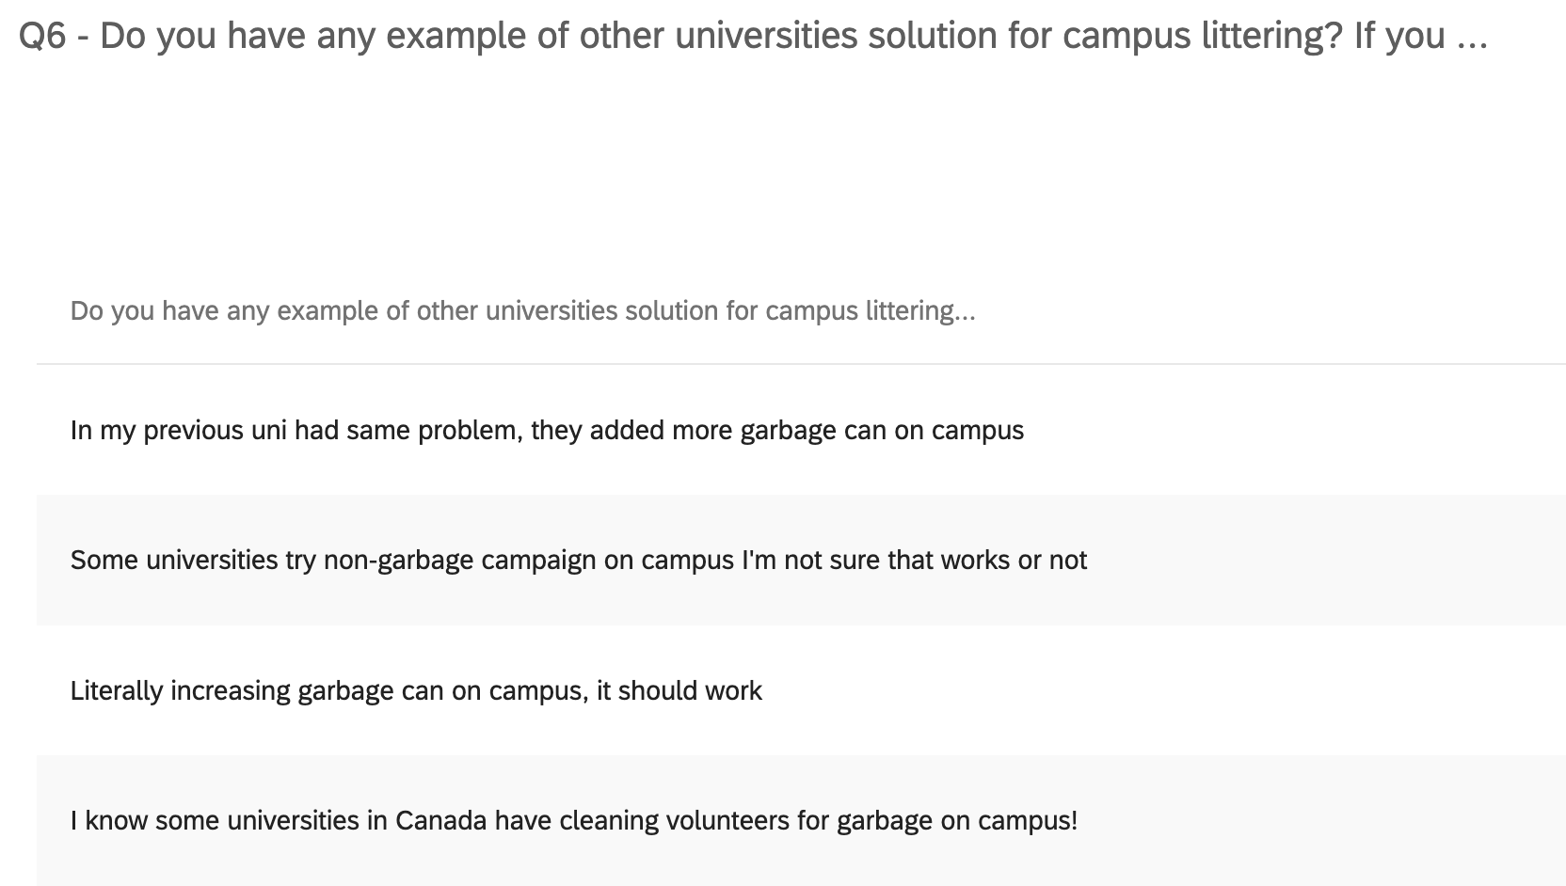

*Figure 7. Other Opinions*

Figure 7 shows how respondents answer if there are other opinions or solutions based on their experiences. As we can see from Figure 6 result, public campaigns are not attractive to most people and they do not want to be involved. Also increasing cleaning volunteers might be a one good alternative solution.

*Simon Fraser University* starts portable rubbish bins which are called “Bin Buddies”, literally a small rubbish bin can move everywhere (Simon Fraser University). This would be applied to UBC to rescue littering. Also UBC is trying to reduce rubbish on the campus road by more frequent waste collecting by the UBC in-vessel Composting Facility (The University of British Columbia).

**D. From Research**

From the study about Canadians, Canadians will generally walk roughly *12 steps* in search of a trash can before giving up (“The Impact”). It shows that we need to set rubbish bins at least every 12 normal steps to reduce littering. Also According to the Journal of Environmental Psychology, over 65% of the population grab attention when it comes to processing information on signage to decide their action change (“The Impact”). This shows how increasing rubbish bins and DO-NOT-LITTERING signages are important.

**III. Conclusion**

**A. Summary and Interpretation of Findings**

Lacking rubbish bins and prevention littering signages are significant on UBC Vancouver campus. UBC has a one bin by 423m for the five main vertical roads, but current research says it has to be set in every 12 steps to prevent littering. Also people are familiar with visual centred signages, so increasing littering prevention signages would be effective to stop littering on campus. From the survey, over 70% of respondents say it is *not easy* to find rubbish bins and signs on campus roads. Furthermore, over 50% of respondents say we need to put bins in every 100m.

**B. Recommendations**

Based on the survey and researches, this report would suggest following options to UBC:

1. Increasing on campus rubbish bins at least in the interval of 100m on the main roads of the Vancouver campus.
2. Setting DO-NOT-LITTERING signages on the places where people do littering frequently.
3. Following SFU's example, make the portable rubbish bins on the campus roads and hidden sides to be noticed by people who are attempting littering.

**Works Cited**

“The Impact of Commercial Trash Cans for Reducing Litter.” *PlayPower Canada*, 23 January 2020, https://playpowercanada.ca/blog/how-commercial-trash-cans-help-prevent-littering/. Accessed 17 March 2022.

Simon Fraser University. “Bin Buddies - Sustainability.” *Simon Fraser University*, https://www.sfu.ca/sustainability/projects/zero-waste/bin-buddies.html. Accessed 17 March 2022.

The University of British Columbia. “Recycling and Waste Operations | UBC Campus & Community Planning.” *UBC Campus & Community Planning*, https://planning.ubc.ca/sustainability/sustainability-action-plans/zero-waste-action-plan/recycling-and-waste-operations. Accessed 17 March 2022.