**Feasibility Analysis of the Implementation of a Diversified Menu at Lynn Valley Care Centre**

for

Betty Wills

Director of Care

Lynn Valley Care Centre

North Vancouver, BC

Dylan Flach

Student ENGL 301 99C

March 16th,2022

**I. INTRODUCTION**

Populations in long-term care (LTC) facilities are often at an increased risk of malnutrition and low quality of life (QOL) due to the preexisting conditions that result in their admission. Malnutrition arises in part due to food insecurity, which “exists when all people, at all times, have physical, social and economic access to sufficient, safe, nutritious food to meet their dietary needs and food preferences for an active and healthy life” (Food and Agriculture Organization). In LTC, social and economic access are of limited concern as facilities allocate funds to the procurement and provision of food, and social issues are mitigated as provision is equal across the range of clientele. However, there is concern for issues of physical access. LTC clients may have an impaired ability to self-feed, especially those with cognitive or physical impairments (Vucea). As such, clients may require the assistance of a Registered Care Aide during mealtimes. LTC facilities must be adequately staffed and trained to assist a range of clientele with limited feeding abilities as a result of dementia, dysphagia, stroke, and other disabilities. The purpose of this paper will focus primarily on the subset of food security pertaining to “dietary needs and food preferences” (Food and Agriculture Organization). There is evidence in the literature suggesting that menus in LTC facilities do not adequately fulfil the client's nutrient requirements and dietary preferences. Malnutrition assessment is a useful tool for indirectly determining the nutritional adequacy of a diet, with unplanned weight loss acting as an important indicator of morbidity and mortality among populations in LTC (Black et al.). This circumstance occurs due to the interaction between diet quality, macro- and micro-nutrient intake, and disease progression. Moreover, the likelihood of becoming malnourished tends to be higher when food dissatisfaction is high, as LTC clients are less likely to consume sufficient quantities of food when palatability and appearance are perceived negatively.

Individualized Nutrition Care Plan (NCPs) direct the provision and distribution of food in accordance with the seasonal menus in LTC facilities. NCPs are designed and implemented by the on-site Registered Dietitian as a means of ensuring that the unique dietary needs of clientele are met. This may include reduced sodium intake for clients with hypertension, increased protein to help treat pressure ulcers, or restrictions on fluid intake to balance electrolytes in the body. Further, modified texture diets (MTDs) are often prescribed among LTC clients with feeding impairments and as a means of reducing incidence of dysphagia (Vucea). As such, the menu design must allow for variations to accommodate the diverse needs of clientele.

Dietary preferences are influenced by a wide range of factors, with socio-cultural influences seen as particularly crucial (Das & Priya). Analyzing how socio-cultural influences affect food choice can increase understanding of the impact of fundamental social relations on nutritional food security (Das & Priya). In the context of LTC, a lack of emphasis on individual preferences, including cultural and familial factors, could result in reduced interest in mealtimes, decreased QOL, and malnutrition.

A. Purpose and methods of this report

Based on a review of key research and primary data collection from clients of Lynn Valley Care Centre, this report assesses whether the current menu promotes food security. Secondary sources will include researching culturally-relevant food practices, and best long-term care nutrition practices. Recommendations will be provided as necessary for diversification of the food service menu by improving the consideration of client preferences, culturally-relevant food practices, and the utilization of local ingredients. The overall aim is to enhance client quality of life by way of food service satisfaction and diet quality. The intended audience is Lynn Valley Care Centre Director of Care Betty Wills and fellow administrative staff.

C. Scope of this inquiry

This report plans to determine the extent that food preferences influence food insecurity and client quality of life, evaluate the feasibility of switching from current food practices to culturally-relevant and preference-based practices, and, provide recommendations on increasing nutrient profiles of menu items and meals

D. Conclusions of the inquiry

This report concludes by recognizing areas of improvement in the food service sector of Lynn Valley Care Centre, and suggesting amendments as needed to the current menu design as a means of improving client quality of life.

**II. DATA SECTION**

A. Sources of food service dissatisfaction.

Food service satisfaction was evaluated using an online survey that was distributed to clients at Lynn Valley Care Centre. In this context, food satisfaction was evaluated through a combination of food quality, quantity, appearance, and appropriateness in relation to personal preferences and culture. Of the total thirteen questions, 10 were close-ended, while the remaining allowed participants a chance to provide their opinion on the subject matter.

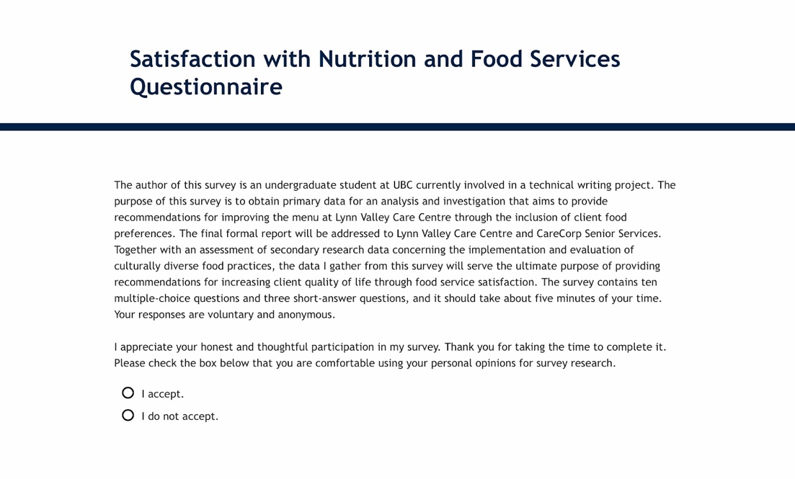

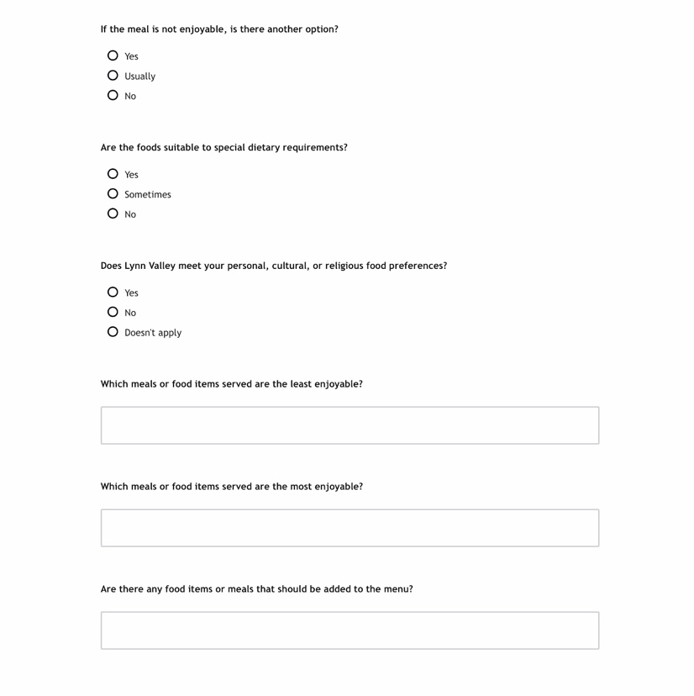

Figure 1: Satisfaction with Nutrition and Food Services Questionnaire

1. Quality of food

Participants were asked to evaluate the quality of the food, in terms of palatability, taste, and temperature. Figure 2 details the client’s satisfaction with meals and snacks. Figure 3 shows the client’s perception of the taste of the food. Together, the results of these questions reveal that overall food quality is perceived positively, with the majority of participants finding that the food tastes good, and it is always or sometimes enjoyable. It is important to note the results of the question pertaining to hot foods, with 50% of participants finding they were not the correct temperature, although cold food is generally cold enough.

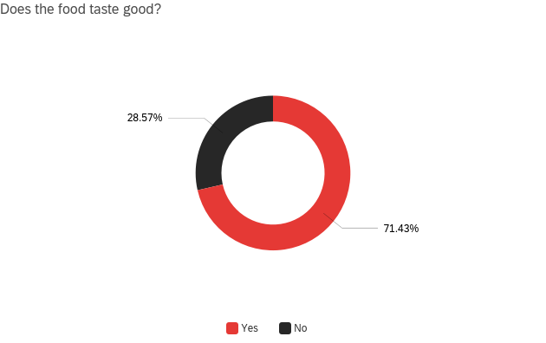  
  
Figure 2: Taste: Participants were asked whether they thought the food tasted good. 71.43% said yes (n = 10) while 28.57% said no (n = 4).

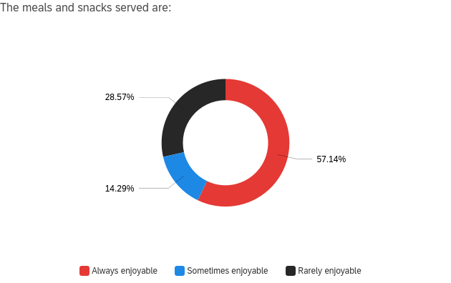  
Figure 3: Participants were asked whether they thought the food was enjoyable. 57.1% said always enjoyable (n = 8), 14.29% said sometimes enjoyable (n = 2), and 28.57% said rarely enjoyable (n = 4).

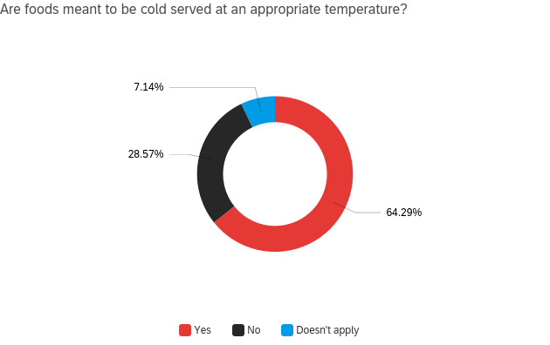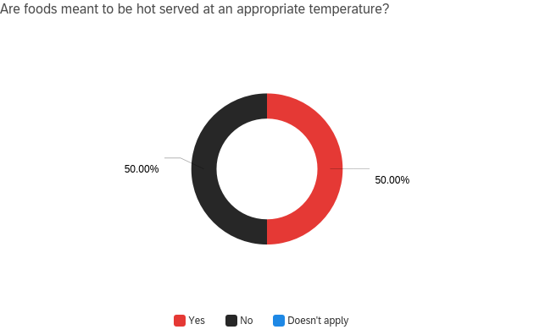

Figure 4: Participants were asked whether they thought the foods were served at an appropriate temperature. For hot foods, 50% (n = 7) said yes, and 50% (n = 7) said no. For cold foods, 64.29% (n = 9) said yes, 28.57% (n = 4) said no, and 7.14% (n = 1) said it doesn’t apply.

1. Quantity of food

Participants were asked to evaluate whether the quantity of food served was adequate. The results of these questions reveal that the vast majority of participants found that there was always or usually enough food available. Additionally, just over half of participants stated that they never eat most of the food that is served to them.

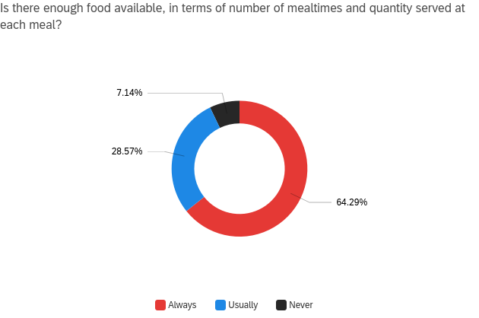

Figure 5: Participants were asked whether there was enough food available, considering the quantity of both mealtimes and food served. 64.29% (n = 9) said always, 28.57% (n = 4) said usually, and 7.12% (n = 1) said never.

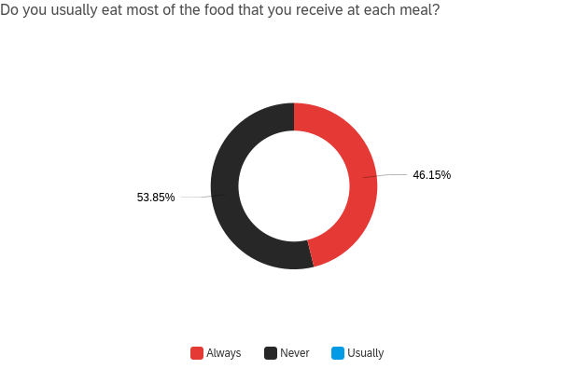

Figure 6: Participants were asked whether they ate most of the food they received at each meal. 46.15% (n = 6) said always, while 53.85% (n = 7) said never.

1. Presentation of food

Participants were asked whether the meals and snacks were presented in an attractive and appetizing fashion. The majority of participants stated they found the food to be visually appealing, though there is still a significant number of individuals who feel contrary to this opinion.

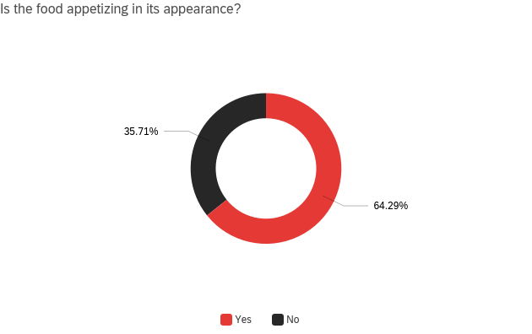

Figure 6: Participants were asked whether they perceived the food to be appetizing. 64.29% (n = 9) said yes, while 35.71% said no (n = 5).

1. Personal, cultural, and religious preferences

Participants were asked whether the food met their personal, cultural, and religious preferences, as well as the specific foods of which they liked, disliked, and desired. The majority of participants felt that the foods were always or sometimes suitable to special dietary requirements, and there was always or usually a secondary option if preferred. However, there is still a significant portion of individuals who thought that there was not another option offered to them. In terms of personal, cultural and religious preferences, many of the participants felt that this question did not apply to them. However, those that did felt equally strongly that the menu did and did not suit their individual preferences. Table 1 reveals that the list of disliked and preferred foods is substantial, and will be taken into account when making menu suggestions.

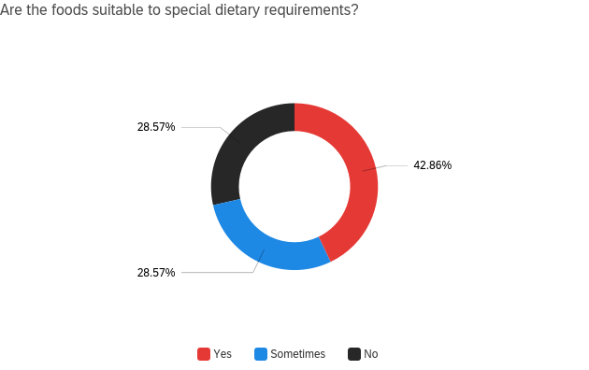

Figure 7: Participants were asked if they considered the foods suitable to unique dietary requirements. 42.86% (n = 6) said always, 28.57% (n = 4) said sometimes, and 28.57% (n = 4) said no.

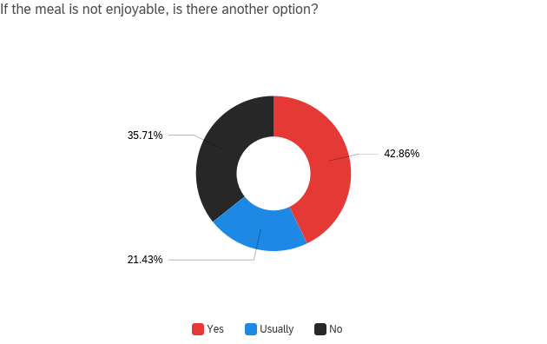

Figure 8: Participants were asked whether there was another option available if they disliked the meal served. 42.86% (n = 6), 21.43% (n = 3) said usually, and 35.71% (n = 5) said no.

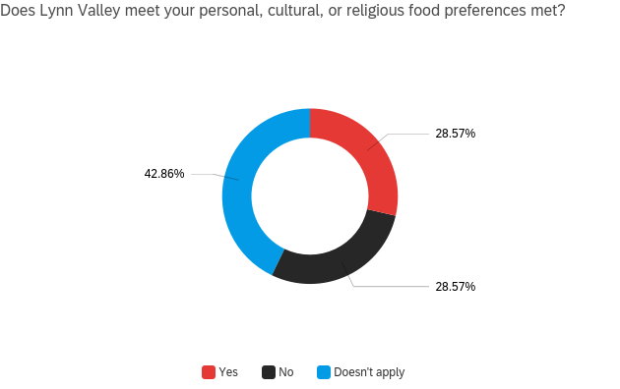

Figure 9: Participants were asked whether the food met their personal, cultural, and/or religious food preferences. 28.57% (n = 4) said yes, 28.57% (n = 4) said no, and 42.86% (n = 6) said this does not apply to them.

Table 1: Participants were asked which food items were most and least enjoyable, and for their personal menu suggestions. The square brackets dictate the number of times items were mentioned (with no brackets referring to just once mentioned).

|  |  |  |
| --- | --- | --- |
| **Most Enjoyable** | **Least Enjoyable** | **Menu Suggestions** |
| Desserts | Chicken and meat [2] - overcooked and poor quality | Pita |
| Rice (note: needs soy sauce) | Deli meat | Shawarma |
| Squash | Eggs [4] - cold, overcooked, runny | Birthday meal choice |
| Fish and chips | Meat with gravy | French toast |
| Jello | Overcooked vegetables (potatoes, carrots, beans) | Fresh fruit (not canned) [2] |
| Fish [2] | Overcooked/low quality meat | Lamb |
| Chow mein | Cold soup | Quality mashed potatoes |
| Meat | Soggy toast | Shepards pie |
| Chicken | Burnt muffins | Good italian food |
| Ice cream | Pork | Asian foods |
| Spaghetti | Spicy foods | Veggies with dressing |
| Chicken pot pie | Turnips | Chef’s salad |
| Sweet and sour pork on rice | Pasta | Spicy curry |
| Sandwiches | Lasagna | More meat |
|  | Beef | Steak |
|  | Pork | Bacon |
|  |  | Fried eggs |
|  |  | Wine |
|  |  | Ice cream |
|  |  | Better salads |
|  |  | Steak |
|  |  | Wine |
|  |  | Burgers |
|  |  | Chinese food [2] |

B. Assessment of menu and long-term nutrition care plans.

Figure 10 displays a sample menu at Lynn Valley Care Centre. In order to determine the nutritional adequacy of the menu, a nutrient assessment is performed, the results displayed in Table 2 (Health Canada). It is important to note that this is the basic menu that does not include dietary modifications as per NCPs, so this menu does not reflect the intake for all clientele. Further, Figure 6 revealed that 54% of participants did not consume all of the food they were served, so this menu reflects only the available nutrients opposed to that which is consumed. A comprehensive nutrition assessment of the clients is required to determine their nutritional status, but this form of assessment is out of the scope of this report.

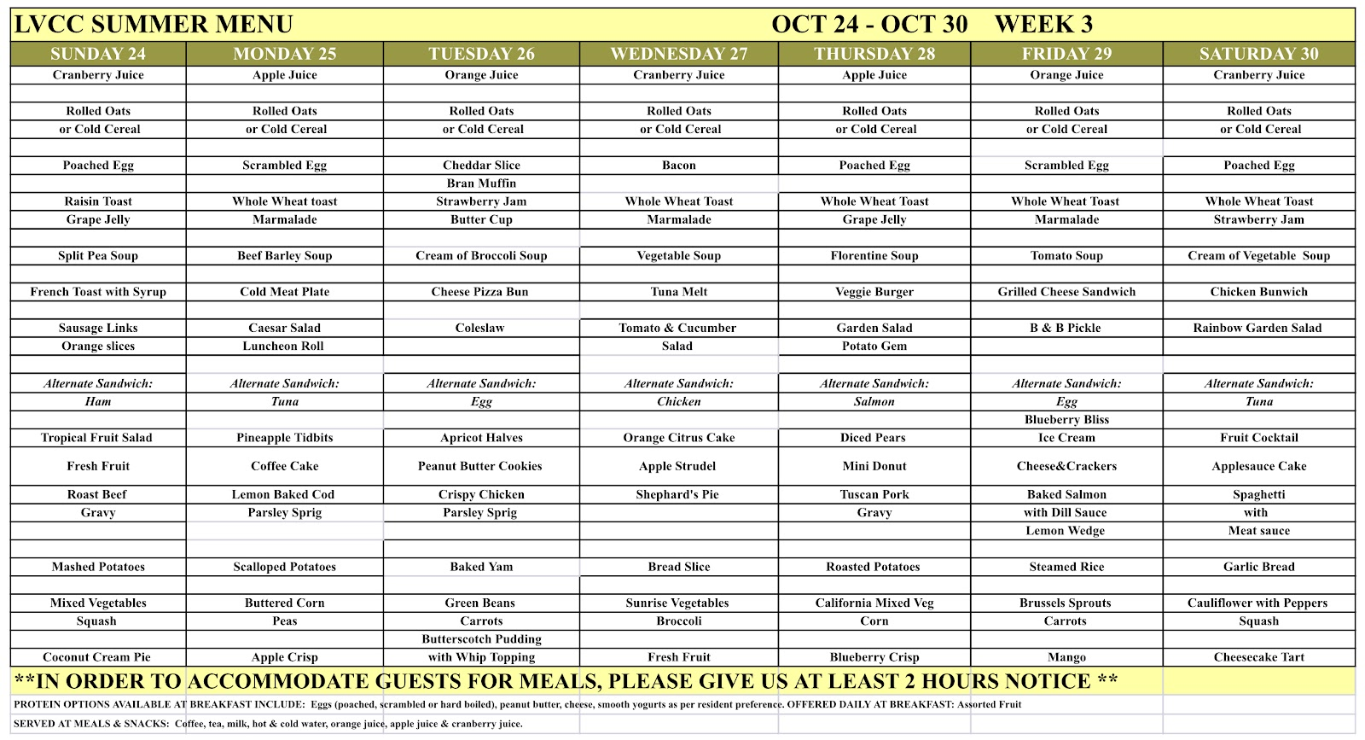

Figure 10: Sample summer menu at Lynn Valley Care Centre.

Using the Government of Canada nutrient profile database (Health Canada), the nutrient composition of this sample menu is determined. The mean macronutrient distribution of the menu is approximately 58.165% carbohydrates, 16.67% protein, and 25.165% fat. The Acceptable Macronutrient Distribution Range (AMDR) is 45-65% carbs, 10-35% protein, 20-35% fat (Health Canada), so the menu distribution is adequate. Macronutrient and micronutrient intake is compared to Dietary Reference Intakes (DRIs) for males and females over the age of 70 (the average age of residents at Lynn Valley Care Centre is predicted to be greater than 70, being that the age range of clientele is 60-100). It is determined that both protein and carbohydrate consumption is higher than recommended, though this is likely a strategic decision since a significant portion of the clientele is not consuming their meals in full. Though there is not a designated Upper Limit (UL) for protein, some experts suggest that intakes close to 2g/kg can begin to cause issues ("When It Comes To Protein, How Much Is Too Much? - Harvard Health"). For males and females over the age of 70, this would total to approximately 140g/d, and 115g/day, respectively. As such, even with potentially higher protein intake as a result of supplements prescribed for pressure ulcers or other needs for increased protein intake, the current mean intake of 70.67g is of little concern. Mean carbohydrate intake appears to be almost twice the DRI for individuals over the age of 70; however, there is no UL set for carbohydrates, and considering the diet fits within the AMDR, carbohydrate intake is expected to be suitable.

For micronutrients, Vitamin A intake is seen to be inadequate, with mean intake at a level of 594.28mcg, which is 66.03% of the DRI for males and 84.89% of the DRI for females. Vitamin A is vital to processes in vision and cellular differentiation, especially for maintaining organs such as the heart, lungs, and kidney ("Vitamin A - Fact Sheet For Health Professionals"). As such, inadequate intakes could have detrimental impacts on these processes, especially considering that the majority of clientele are not consuming the entire menu and would thus have more concerningly low intakes. Vitamin D intake was similarly seen to be inadequate, with a mean intake of 3.25mcg being 16.25% of the DRI. The role of vitamin D in bone mineralization and remodeling has crucial implications on the development of osteomalacia and osteoporosis in older adults, so adequate consumption is of utmost concern for this age group ("Vitamin D - Fact Sheet For Health Professionals''). Mean intake of vitamin B5 is calculated to be 23.00% of the DRI for males and females. Vitamin B5 is necessary for the synthesis of coenzyme A and acyl carrier protein, which themselves function in a variety of anabolic and catabolic processes vital for the body (“Pantothenic Acid- Fact Sheet For Health Professionals”). The dramatically low intakes seen in the clientele suggest that these processes could be impaired. Intake of vitamin B9 is seen to be 83.90% of the DRI for males and females. Though this inadequacy is not largely significant, it could potentially cause issues in the areas of cell division and amino acid metabolism, while increasing the risk of megaloblastic anemia (“Folate - Fact Sheet For Health Professionals”). Mean intake of vitamin E is calculated to be merely 25.80% of DRI for males and females, which is of concern due to the antioxidant roles it holds (“Vitamin E - Fact Sheet For Health Professionals”). Insufficient vitamin E intakes could result in increased risk of infection and disease, however, vitamin E deficiency is not common in the general population (“Vitamin E - Fact Sheet For Health Professionals”). Mean vitamin K intakes are recorded to be 25.11% of the DRI for males and 33.48% of the DRI for females. Inadequate intakes of vitamin K impair its function as a coenzyme in blood clotting and bone metabolism (“Vitamin K - Fact Sheet For Health Professionals”). This could be of particular concern for individuals prescribed anticoagulants (i.e. blood thinners) which may be common in LTC facilities (“Vitamin K - Fact Sheet For Health Professionals”). Mean intakes of calcium are also seen to be quite low in this diet, at 46.75% of DRI for males and females. Calcium is of particular concern for this age group due to its importance in the structure of bones and teeth, with calcium deficiency increasing the risk of osteoporosis development (“Calcium - Fact Sheet For Health Professionals”). Sodium intake is difficult to measure as the menu does not report the quantity of salt being added to meals by the chef and/or clients themselves, so the mean intake is imprecise. Nonetheless, the calculated intake levels are 3.63 times higher than the DRI, and 2052 mg higher than the UL. Excessive sodium intake poses a risk for development of stroke, hypertension, and cardiovascular disease, amongst other complications, which may be of increased concern for LTC clientele as they are at a greater risk, and have potentially already encountered these ailments (Health Canada). Mean intakes of vitamins B1, B2, B3, B6, B12, B9 and C, as well as iron, are seen to be within 10% of the DRI and are thus considered adequate.

Table 2: Comparison of mean nutrient intakes to Dietary Reference Intakes.

|  |  |  |  |
| --- | --- | --- | --- |
| **Nutrient** | **Mean intake** | **DRI (males >70 yo)** | **DRI (females >70 yo)** |
| Calories (kilocalories) | 1776.33 |  |  |
| Protein (g) | 70.67 | 56 | 46 |
| Carbohydrates (g) | 247.73 | 130 | 130 |
| Fat (g) | 51.03 |  |  |
| Vitamin A (mcg) | 594.28 | 900 | 700 |
| Vitamin D (mcg) | 3.25 | 20 | 20 |
| Thiamin B1 (mg) | 1.219 | 1.2 | 1.1 |
| Riboflavin B2 (mg) | 1.381 | 1.3 | 1.1 |
| Niacin B3 (mg) | 14.839 | 16 | 14 |
| Pantothenic acid B5 (mg) | 1.160 | 5 | 5 |
| Vitamin B6 (mg) | 1.401 | 1.7 | 1.5 |
| Vitamin B12 (mcg) | 3.61 | 2.4 | 2.4 |
| Folate B9 (mcg) | 335.63 | 400 | 400 |
| Vitamin C (mg) | 103.37 | 90 | 75 |
| Vitamin E (mg) | 3.87 | 15 | 15 |
| Vitamin K (mcg) | 30.13 | 120 | 90 |
| Calcium (mg) | 560.97 | 1200 | 1200 |
| Iron (mg) | 13.29 | 8 | 8 |
| Sodium (mg) | 4352.12 | 1200 | 1200 |

The literature reports that LTC clients tend to consume adequate energy levels, often meeting their daily requirements for kilocalories, but are not meeting their dietary reference intakes for micronutrients (Durant). It is also seen that MTDs tend to have lower mean energy and macronutrient levels than regular diets - with an approximate difference of 450 calories and 7g of protein (Durant). As the MTDs do not follow the regular menu plan, they tend to be repetitive as food service staff need only prepare a few of these meals. Further, MTDs and other forms of therapeutic diets designed for LTC clients tend to be restrictive in nature. As such, this is likely to result in less diversity in therapeutic diets, which is correlated with poor diet quality (Wu et al.). Further, oral nutritional supplementation may have a significant effect on the energy and nutrient intake of LTC clients, but their precise effect is unclear (Durant). These oral nutritional supplements, such as the Boost products that are frequently consumed at Lynn Valley Care Centre, are not included in the menu, and are instead given as necessary and/or desired, so their nutritional impact is difficult to quantify.

As nutrition assessments were not conducted for the purpose of this report, a literature review was conducted to find secondary research on the nutritional status of LTC clients. Nutritional status is an important indicator of health, and is regularly evaluated in LTC facilities through biochemical and clinical assessments. One particular clinical assessment that is of importance in LTC contexts is the Mini Nutritional Assessment (MNA), which determines if an individual is malnourished or at risk of malnourishment. In one particular study, MNA found that 32.8% of participants (LTC clients) were malnourished, while 30.5% were at risk of malnourishment (Ho et al.). Another study utilized Subjective Global Assessment to determine that 52.8% of residents were mild/moderately undernourished, while 17% were severely undernourished (Sacks et al.). These examples reveal that clientele in LTC facilities are at significantly increased risk of malnourishment. Due to age and disease incidence, much of the clientele has low appetites, as well as difficulty digesting and absorbing foods, which results in an increased prevalence of undernourishment. However, the risk of malnourishment could be mitigated in part by increasing interest in the food available to the clients. LTC facilities attempt to include client preference in menu design when it relates to specific dietary restrictions, notably those that are religion or value-based. However, they neglect to consider innate likes and dislikes, such as that seen in Table 1.

C.  Assessment of culturally-relevant food practice

Culture is one of, if not the most, significant factors influencing dietary choices throughout the lifespan. Besides religious-based taboos, there are many foods favoured and avoided simply as a result of cultural habits. As a community shares their practice of obtaining food by way of regional availability and local markets, they develop a characteristic way of eating. These “cultural differences in eating attitudes and behaviours imply that an individual’s cultural orientation may influence the attitudes and behaviours” around food and eating  (Orji & Mandryk). Food choices can even be seen as a symbol of one’s ethnic identity (Das & Priya). Maintaining one’s identity is an especially important component of aging, as individuals' lives begin to become less busy and potentially less fulfilling. Moreover, memory-related disorders that are correlated with age inhibit people’s ability to have a strong grasp on their identity. This strong relationship between culture and identity can thus be used as a means of maintaining a positive quality of life. This practice can be particularly useful in the context of LTC as clients are in an unfamiliar setting that may provoke their loss of self-image. Serving clients familiar and culturally-appropriate foods could serve as a reminder of positive memories and a tool for enhancing quality of life. Further, food choice behaviours are found to be an important determining factor for nutritional status and overall health (Monterrosa et al.). Food satisfaction has a notable link to happiness in seniors, with those that are completely satisfied with their diet having a more positive quality of life (Lobos et al.).

**III. CONCLUSION**

A. Summary and overall interpretation of findings

The results of the primary research reveal that there are some discrepancies in menu satisfaction across the clientele of Lynn Valley Care Centre. More specifically, in the area of food quality (Figures 2, 3, 4) clientele is determined to be overall satisfied in taste, palatability, and temperature of cold foods, with satisfaction rates at 71.43%, 71.39%, and 64.29%, respectively. Figure 5 shows satisfaction in the availability of food, at 92.86% of clientele. Presentation of food (Figure 6) was generally regarded well, with 64.29% of clientele finding the meals visually appealing. Figures 7 and 8 show that 71.43% declared that the food was always or sometimes suitable to dietary preferences, while 64.29% stated there was always or usually an alternative option on the menu.

Areas of dissatisfaction include temperature of hot foods, with 50.0% of clientele reporting complaints. Moreover, Figure 6 also shows clientele frequently reporting that there is an excess of food at each meal, with 53.85% of clientele stating there is too much food served. In terms of whether the menu met personal, cultural, and/or religious food preferences, Figure 9 shows an equal distribution (28.57%) of agreeance and disagreeance, while just below half (42.86%) of clientele stated they have no relevant preferences in this area. As such, this question requires further exploration in order to determine whether bias within the participant population prevented a concrete answer from appearing, or rather if the population of Lynn Valley Care Centre is disproportionately inaffected by personal, cultural, and religious food preferences. Nonetheless, Table 1 reveals that the clientele has specific preferences that should be considered in modification of the menu.

The analysis of the nutrient composition of the sample menu at Lynn Valley reveals that the menu offers adequacy in macronutrients, but there are some inadequacies present in the content of micronutrients. The menu contains adequate contents of vitamins B1, B2, B3, B6, B12 and C, as well as iron. In contrast, the menu is assessed to be inadequate in vitamins A, D, B5, B9, E, K, and calcium, with sodium levels exceeding the UL. As such, the content of the latter vitamins and minerals require amendment in the updated menu.

Secondary research reveals that malnutrition disproportionately impacts clientele in LTC facilities, which underscores the need for menu modification to ensure the potential for adequate nourishment. Further, increasing the cultural appropriateness and preference focus of the menu design decreases the likelihood of food insecurity and has potential opportunity for enhancing QOL.

B. Recommendations

Through determination of the opinions and personal preferences of the clientele of Lynn Valley Care Centre, appropriate recommendations can be made in order for the menu to better serve current and future clients. In order to improve client satisfaction of food temperatures, it is recommended to modify the food service practices in order for the hot foods to be served at appropriate temperatures. This could involve preparing meals in smaller batches so that food has less time to get cold. It is also important to ensure that the food is kept on the stove and/or heating trays for as long as possible before serving, and that the meals are served immediately after being portioned as opposed to being portioned in large batches and then waiting on serving trays. Further, as clientele repeatedly found that food was served in excess, it would be in their best interest to alter the amount of food served depending on a person’s regular intake. This would also benefit the facility by reducing the amount of waste at each meal, which is likely plenty if the majority of individuals are not finishing their meals. Subsequently, in order to ensure that they are still receiving adequate nutrients, individuals who are served reduced portions on account of their intake should be given supplements, such as Boost products or specific vitamins, to supplement their intake. This process could be organized by way of the Dietary and Care Aides recording the quantities leftover at each meal, and then altering the NCPs as necessary. In order to take into account the clients’ specific preferences and dislikes, it is recommended that upon admission and at each regular evaluation, the client’s preference list is created and modified as necessary. The primary data collected in this report provides a suitable place to start, as the menu can be modified to include and exclude the items listed in Table 1. Though the primary research did not necessarily suggest need for amendment in terms of the cultural focus of the menu, the literature details the positive implications that incorporating a cultural focus will have on the self-identity of clientele. As such, it is recommended that the clientele be interviewed, when available for current residents and upon admission of new clientele, on the basis of their cultural identification. Subsequently, the menu can be modified with the addition of the popular menu items from each client’s culture.

Suggested ways to incorporate increased quantities of these nutrients are in Table 2, which also incorporates plant-based options to increase the sustainability of the menu. These suggestions would be best incorporated alongside those in Table 1.

|  |  |
| --- | --- |
| **Nutrient** | **Foods** |
| Vitamin A  ("Vitamin A - Fact Sheet For Consumers") | * dark leafy greens (kale, spinach, swiss chard)   + salads   + incorporated into dishes such as pot pie, quiche, scrambled eggs * fresh fruits (cantaloupe, apricots, mangoes)   + fruit salad at breakfast * fortified dairy products   + add milk to porridge   + serve milk with meals * fortified breakfast cereals   + switch to Post Great Grains, Special K, or Cheerios Original |
| Vitamin D  ("Vitamin D - Fact Sheet For Consumers") | * fortified dairy products   + add milk to porridge   + serve milk with meals * fortified breakfast cereals   + switch to Post Great Grains, Special K, or Cheerios Original * increase servings of fatty fish (trout, tuna) * bring clients outside during the warmer months for sun exposure |
| Vitamin B5  ("Pantothenic Acid- Fact Sheet For Consumers") | * eggs   + try fried eggs   + ensurd proper temperature to increase intakes   + quiches * mushrooms   + incorporate into stir fries, shepards pie * whole grains   + switch white cinnamon raisin for whole wheat cinnamon raisin   + whole wheat buns * peanuts   + for snacks * chickpeas   + in salad   + hummus as a snack |
| Vitamin B9  ("Folate- Fact Sheet For Consumers") | * asparagus, brussels sprouts, dark leafy greens   + try to rotate local vegetables into lunch and dinner * oranges   + if not in season, ensure juice is fortified with B9, vitamin C, etc * nuts   + as snacks   + cereal/oatmeal topping * beans   + chili * fortified flour   + baked goods |
| Vitamin E  ("Vitamin E- Fact Sheet For Consumers") | * vegetable oils (sunflower, safflower)   + for salad dressing, cooking * nuts * spinach * fortified breakfast cereal |
| Vitamin K ("Vitamin K- Fact Sheet For Consumers") | * dark leafy greens (kale, spinach, swiss chard) * vegetable oils * blueberries and figs   + snacks   + cereal/oatmeal topping   + smoothies * soybeans   + tofu in lunch/dinner meals |
| Calcium ("Calcium - Fact Sheet For Consumers") | * dairy   + yogurt at breakfast * kale, broccoli, bok choy * calcium-fortified juice, tofu, soy beverages |

C. References

Black, C.R. et al. "A Randomized Clinical Trial Comparing Liberalized Diets And

Therapeutic Diets In Long-Term-Care Residents". Journal Of The American Dietetic

Association, vol 111, no. 9, 2011, p. A31. Elsevier BV,

<https://doi.org/10.1016/j.jada.2011.06.115>.

"Calcium - Fact Sheet For Consumers". NIH Office Of Dietary Supplements, 2021,

<https://ods.od.nih.gov/factsheets/Calcium-Consumer/>

"Folate - Fact Sheet For Health Professionals". NIH Office Of Dietary Supplements, 2021,

[https://ods.od.nih.gov/factsheets/Folate-HealthProfessional](https://ods.od.nih.gov/factsheets/VitaminA-HealthProfessional/)

Das, Suraj, and Priya. "Food Choices And Beliefs: Factors Influencing Dietary Preferences In

Chandigarh, India". Ecology, Economy And Society - The INSEE Journal, vol 5, no.

1, 2022, pp. 177-194. Research Innovation Initiative,

https://doi.org/10.38157/society_sustainability.v3i1.244.

Durant, Matthew. "A Comparison Of Energy Provision By Diet Order In A Long-Term Care

Facility". Canadian Journal On Aging / La Revue Canadienne Du Vieillissement, vol

27, no. 2, 2008, pp. 225-227. Cambridge University Press (CUP),

<https://doi.org/10.3138/cja.27.2.225>.

Food and Agriculture Organization. "Policy Brief - Food Security.". Food And Agriculture

Organization Of The United Nations., 2006,

<https://www.fao.org/fileadmin/templates/faoitaly/documents/pdf/pdf_Food_Security_>

Cocept_Note.pdf.

Health Canada. "Dietary Reference Intakes Tables". Canada.Ca, 2006,

[https://www.canada.ca/en/health-canada/services/food-nutrition/healthy-eating/dietary](https://www.canada.ca/en/health-canada/services/food-nutrition/healthy-eating/dietary-reference-intakes/tables.html)

[-reference-intakes/tables.html](https://www.canada.ca/en/health-canada/services/food-nutrition/healthy-eating/dietary-reference-intakes/tables.html).

Health Canada. "Sodium In Canada". Canada.Ca, 2017,

<https://www.canada.ca/en/health-canada/services/food-nutrition/healthy-eating/sodiu>

m.html.

Health Canada. "Canadian Nutrient File". Canada.Ca, 2021,

<https://food-nutrition.canada.ca/cnf-fce/newSearch-nouvelleRecherche.do?action=ne>

w_nouveau.

Ho, Mu-Hsing et al. "Screening Malnutrition In Long-Term Care Facility: A Cross-Sectional

Study Comparing Mini Nutritional Assessment (MNA) And Minimum Data Set

(MDS)". Collegian, 2021. Elsevier BV, <https://doi.org/10.1016/j.colegn.2021.10.014>.

Lobos, Germán et al. "With Health And Good Food, Great Life! Gender Differences And

Happiness In Chilean Rural Older Adults". Social Indicators Research, vol 127, no. 2,

2015, pp. 865-885. Springer Science And Business Media LLC,

https://doi.org/10.1007/s11205-015-0971-0.

Monterrosa, Eva C. et al. "Sociocultural Influences On Food Choices And Implications For

Sustainable Healthy Diets". Food And Nutrition Bulletin, vol 41, no. 2, 2020, pp.

59S-73S. SAGE Publications, https://doi.org/10.1177/0379572120975874.

Orji, Rita, and Regan L. Mandryk. "Developing Culturally Relevant Design Guidelines For

Encouraging Healthy Eating Behavior". International Journal Of Human-Computer

Studies, vol 72, no. 2, 2014, pp. 207-223. Elsevier BV,

<https://doi.org/10.1016/j.ijhcs.2013.08.012>.

"Pantothenic Acid - Fact Sheet For Health Professionals". NIH Office Of Dietary

Supplements, 2021,

[https://ods.od.nih.gov/factsheets/PantothenicAcid-HealthProfessional/](https://ods.od.nih.gov/factsheets/VitaminA-HealthProfessional/).

Sacks, Gordon S. et al. "Use Of Subjective Global Assessment To Identify

Nutrition-Associated Complications And Death In Geriatric Long-Term Care Facility

Residents". Journal Of The American College Of Nutrition, vol 19, no. 5, 2000, pp.

570-577. Informa UK Limited, https://doi.org/10.1080/07315724.2000.10718954.

"Vitamin A - Fact Sheet For Health Professionals". NIH Office Of Dietary Supplements,

2021, <https://ods.od.nih.gov/factsheets/VitaminA-HealthProfessional/>.

"Vitamin D - Fact Sheet For Consumers". NIH Office Of Dietary Supplements, 2021,

https://ods.od.nih.gov/factsheets/VitaminD-Consumer/.

"Vitamin E - Fact Sheet For Health Professionals". NIH Office Of Dietary Supplements,

2021, [https://ods.od.nih.gov/factsheets/VitaminE-HealthProfessional](https://ods.od.nih.gov/factsheets/VitaminA-HealthProfessional/)

"Vitamin K - Fact Sheet For Health Professionals". NIH Office Of Dietary Supplements,

2021, [https://ods.od.nih.gov/factsheets/VitaminK-HealthProfessional](https://ods.od.nih.gov/factsheets/VitaminA-HealthProfessional/)

Vucea, V. et al. "Modified Texture Diet And Long Term Care: A Secondary Data Analysis Of

Making The Most Of Mealtimes (M3) Project.". Innovation In Aging, vol 1, 2017, pp.

899-900. Oxford University Press (OUP), https://doi.org/10.1093/geroni/igx004.3226.

"When It Comes To Protein, How Much Is Too Much? - Harvard Health". Harvard Health,

2020,

<https://www.health.harvard.edu/nutrition/when-it-comes-to-protein-how-much-is-too->

much.

Wu, Sarah et al. "Are Therapeutic Diets In Long-Term Care Affecting Resident Food Intake

And Meeting Their Nutritional Goals?". Canadian Journal Of Dietetic Practice And

Research, vol 81, no. 4, 2020, pp. 186-192. Dietitians Of Canada,

https://doi.org/10.3148/cjdpr-2020-015**.**