2250 Wesbrook Mall,
Vancouver, BC V6T 1S5

March 28, 2022

Catherine Alkenbrack
Director, Facilities Planning
Musqueam Traditional Territory
2210 West Mall
Vancouver, BC Canada V6T 1Z4

Subject: Letter of Transmittal

Dear Ms. Alkenbrack:

Please find the attached report on Recommendations for Small-Wheeled Vehicle Lanes on the Main Roads in UBC Vancouver Campus. During the process of researching and preparing this report, I have gained insights to students’ thoughts and opinions on the implementation of small-wheeled vehicle lanes on campus. This report will also provide recommendations for the locations and strategies of implementation. With this knowledge, I hope that it can help you and your team on the decision to implement small-wheeled vehicle lanes within the UBC Vancouver campus.

I understand the work and challenges in infrastructure development. I appreciate your time and consideration in this project as the project aims to improve the riding experiences of small-wheeled vehicle riders and ensure the safety of pedestrian students on campus.

Lastly, I am grateful for the experience that this research project has brought. If you have any comments or questions regarding this report, feel free to contact me at duffydu@student.ubc.ca.

Sincerely,

Duffy Du

Recommendations for Small-Wheeled Vehicle Lanes on the Main Roads in UBC Vancouver Campus

For
Catherine Alkenbrack
Director, Facilities Planning

By
Duffy Du
ENGL 301 Technical Writing Student
duffydu@student.ubc.ca
March 28, 2022
Table of Contents
Abstract iv
I. Introduction 1
A. Definition of small-wheeled vehicles 1
B. Background information 1
C. Statement of the problem 2
D. Purpose of this report and the proposed solution 2
E. Data Collection and Research Methods 3
F. Scope of this inquiry 3
II. DATA SECTION 4
A. UBC Student Opinions 4
1. Responses from skaters 4
2. Responses from Non-skaters 5
B. Practicality of Implementation 6
1. Rules and regulations 6
2. Choice of roads and materials 7
3. Road design 8
III. CONCLUSION 9
A. Summary and overall interpretation of findings 9
B. Future suggestions and recommendations 10
IV. Works Cited 11
V. Appendices 12

Figures
Figure 1…………………………………………………………………………………………....9
Figure 2……………………………………………………………………………..……………10
Figure 3………………………………………………………………………….….……………11
Figure 4…………………………………………………………………………………………..12

Abstract
With the increasing popularity of the use of small-wheeled vehicles as a method of transportation within the UBC Vancouver campus and the lack of small-wheeled vehicle rider friendly lanes, the need for the addition of small-wheeled vehicle specific lanes seems to be very prominent.
With the aims to survey student opinions on the addition of small-wheeled vehicle specific lanes and provide recommendation for strategies on the implementation of such lanes on the major roads on campus, this study collects data through voluntary survey distributed to UBC students and references bike lane implementation guides.
The results of the survey suggested that most students agree with the need for small-vehicle specific lanes, especially on the roads Main Mall and University Boulevard. Bike lane implementation guides also suggest that given the current width of the roads, it is feasible to implement such a lane on those roads. Hence, the following recommendations are provided given these results:
  - Implementing small-wheeled vehicle specific lanes on the sides of Main Mall and University Boulevard on UBC Vancouver campus
  - Paving these Small-wheeled vehicle specific lanes with smooth asphalt
  - Allowing small-wheeled vehicle riders to ride on these lanes and share them with cyclists
  - These lanes could expand to roads with driveways, however, more research should be conducted before implementation

Introduction

Definition of small-wheeled vehicles

For this document, small-wheeled vehicles are defined as any motorized or nonmotorized vehicle equipped with smaller wheels than cars and bikes used for recreational purposes or travelling from point A to point B. Some examples include cruiser boards, skateboards, longboards, electric longboards, scooters, electric scooters, one wheel, hoverboards etc. Riders of small-wheeled vehicles will be referred to as skaters and students who don’t ride small-wheeled vehicles will be referred to as non-skaters.

Background information
As skating gains popularity over the past years, it has transitioned from merely a street sport to something people use to get around different destinations. With the UBC campus being over 400 hectares in size, it is therefore difficult for students to travel across campus quickly, especially within the allotted 10 minutes between classes. Many students have adopted the use of small-wheeled vehicles such as a skateboard, cruiser board, penny board, longboard or scooter as their main method of transportation between classes. Recent development of electric versions of these vehicles have even eliminated the need to manually push.
Skateboards as a method of transportation have many advantages over traditional bikes – they are smaller in size, meaning that they are easier to carry around on busses and into classes, which in turn greatly reduces the possibility of it getting stolen. The other popular alternative method of transportation is biking. However, bike thieves have been a deep-rooted problem in universities. All these advantages of small-wheeled vehicle use have contributed to the increasing popularity of skateboard adoption as their method of transportation on campus between classes. Yet, UBC does not currently provide separate lanes for these vehicles and some main roads are even paved with tiles that are hard to skate on.

Statement of the problem
Main mall, as an iconic pedestrian axis of UBC, is equipped with cleanly paved tiled roads. However, the gaps between small tiles creates extra difficulty for small-wheeled vehicles to roll on. As a major road spanning the north and south of the university, traffic on main mall can get especially heavy between classes. Skating down main mall is made more difficult as crowds of pedestrians share the same road. Road sharing also means pedestrians must be on a constant lookout to avoid these skaters. Similar problems exist on west mall and east mall, but with road sharing between drivers and skaters.

Purpose of this report and the proposed solution
One simple solution to this problem would be to build a separate lane with smooth concrete or asphalt surface for bikers and skaters separate from the pedestrian walk and the car lanes on the main streets on campus such as Main Mall, University Boulevard, East Mall and West Mall. This will not only provide skaters with a smoother surface to skate on, but also give pedestrians and drivers the peace of mind as the need to avoid people on these small-wheeled vehicles are eliminated.
The purpose of this report is to survey opinions of UBC students and provide recommendations for whether if separate lanes specifically built for small-wheeled vehicles on the major roads of UBC are needed and some implementation strategies of these lanes. These additional lanes will not only improve the experiences of students using small-wheeled vehicles for travelling between classes, but also increase the sense of safety for pedestrians and drivers as separate lanes are provided for them.

Data Collection and Research Methods
The primary data of this research is collected from a survey created on the UBC Qualtrics survey system. The link to the survey was then posted on the following private groups in UBC:
- Vancouver skaters Group
- UBC longboard club Facebook Group
- UBC BCS 21fall Group
- BCS Second degree program Facebook Group
The participation in the survey is completely voluntary with no rewards provided for survey completion. The survey contains a set of questions that gather opinions on the current infrastructure regarding road sharing and the possibility of adding a lane specifically for small-wheeled vehicles (see appendix for the full list of survey questions). The recommended planning and implementation strategies of these lanes reference various city building and bike lane implementation guides from web searches.

Scope of this inquiry
To assess the opinions and the needs of UBC students on small-wheeled specific lanes, I intend to investigate the following questions:
- What is the prevalence of small-wheeled vehicle use on campus?
- What do skaters want the most in terms of infrastructure improvements?
- What is the proportion of skaters who are skilled enough to feel comfortable skating through crowds on main mall?
- Which roads needs the implementation of small-wheeled vehicle lanes the most?
- What are the opinions of skaters and non-skaters on the addition of a lane specific for small-wheeled vehicles?

DATA SECTION

UBC Student Opinions

Responses from skaters
The use of small-wheeled vehicles on campus is very frequent with the majority of the participants (22 out of 25) reporting seeing small-wheeled vehicle use at least one to three times per week. Within the participants who own and use small-wheeled vehicles for travelling, 92% of riders use small-wheeled vehicles for at least 1-3 times a week, and majority reported that small-wheeled vehicles are the main way in which they travel around campus whenever weather permitting. While one rider reported that they are experienced enough in their skating skills to weave through crowds during busy hours on Main Mall, with the majority of participants (75%) rating themselves as beginner/intermediate skaters, more than half (61%) reported riding on Main Mall during busy hours with great difficulty.
In addition, riders tend to stay on pedestrian sidewalks more often than driveways, but skilled riders usually ride on whichever lane is emptier. Overall, skaters rated lowest satisfaction for riding experiences on Main Mall, East Mall, and University Blvd, which all have sections paved with tiles as opposed to asphalt. High satisfaction ratings are reported for the riding experiences on Wesbrook Mall (has bike lanes on the side) and Agronomy Road (roads are paved with asphalt) with separate bike lanes on the side.

Responses from Non-skaters
A great majority of the non-skater participants choose walking or bussing as their major mode of transportation on campus. Road sharing between pedestrians, drivers and skaters creates a sense of anxiety for some parties. A great majority of the pedestrians report being on higher alert for potential skaters and trying to get out of their way when they hear the wheels approaching. Drivers also report that they often had to drive behind the skater slowly when the skater is using their lane. But, when non-skaters were asked about incorporating small-wheeled vehicle into their daily commute if given a chance would, only one participant is hesitant of that idea.

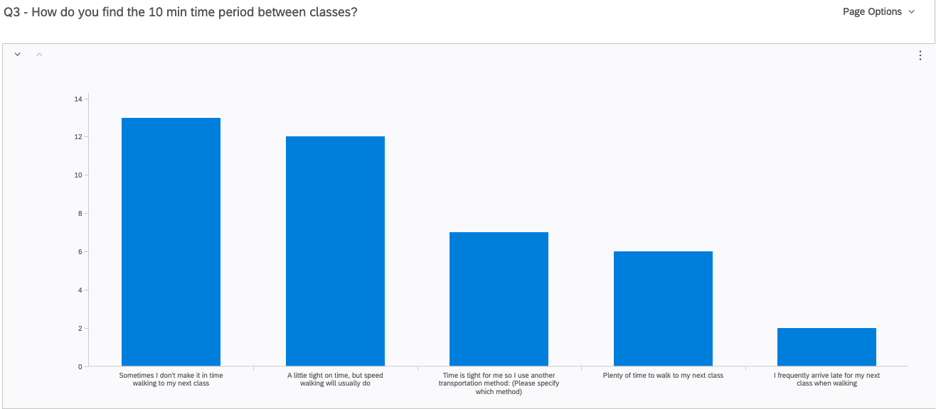
Figure 1. Number of responses on each category for the question “How do you find the 10 min time period between classes?”
- General Responses on Implementation
Overall, only 10% of participants report that 10 minutes between classes is sufficient for walking to the next class in time. On the other hand, Main Mall receives the highest rating (a mean of 4.55/5) on the need for implementation of small-wheeled vehicle specific lanes, followed by University Blvd (a mean of 4.36/5).
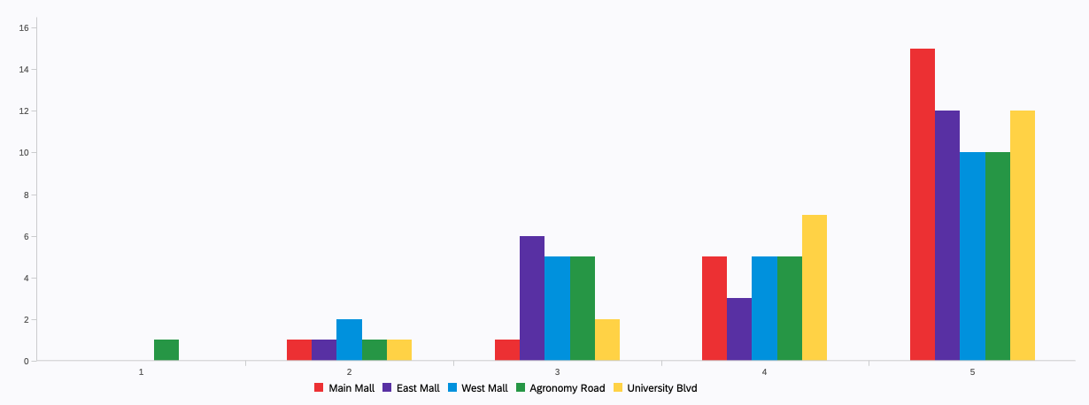
Figure 2. Number of responses for each rating (1-5; 1 = strongly disagree, 5 = strongly agree) on small-wheeled vehicle specific lane implementation on various main roads on UBC campus
Figure 2 shows that majority of the participants’ responses are positive with the implementation of small-wheeled vehicle specific lanes on main roads of UBC, with Main Mall being the most highly rated in the need for implementation of these lanes.
Some interesting additional comments expressed excitement for implementation and suggestion that roads with bike lanes don’t require a specific lane for skaters compared to roads without bike lanes, and that the implementation will be especially useful on busier roads.

Practicality of Implementation

Rules and regulations
According to a memorandum on Low-Powered and Non-Motorized Small Vehicles on Streets, Sidewalks, and Pathways sent to the mayor and council of city of Vancouver from the general manager of engineering services in 2017, the use of nonmotorized vehicles on roadway, park pathways, and protected bike lanes are permitted (Dobrovolny). Operation of motorized vehicles like motorized skateboards are limited to private property and parade routes (Dobrovolny). In these small-wheeled vehicle specific lanes, motorized skateboards and scooters will be permitted. In addition, cyclists are allowed to share with other riders because they have similar speed as small-wheeled vehicle riders, even though bikes were not included in the definition of small-wheeled vehicles.

Choice of roads and materials
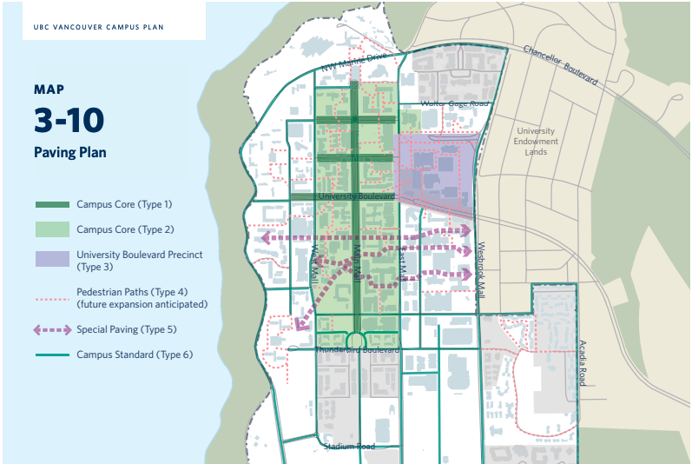
Figure 3. Paving pattern of major roads on UBC Vancouver Campus (UBC Vancouver Campus Plan).
The main target roads for the implementation of small-wheeled vehicle lane are:
  - Main Mall - section spanning from the UBC flagpole to the reconciliation pole (shown as dark green in Figure 3 with campus core type 1 pavement)
  - University Boulevard - section spanning from Lower Mall to East Mall (shown as dark green in Figure 3 with campus core type 1 pavement)
These roads currently have the Campus Core (Type 1) paving which includes sandblasted concrete paver units ranging from 8" x 16" to 24" x 16" in size (UBC Vancouver Campus Plan). While these pavers make it easy to identify the pedestrian and cyclist friendly areas, their small size and big gaps between pavers provide an elevated risk of small wheels getting caught in between the gaps, making it difficult for less advanced skaters to ride on, and a reduced smoothness of ride regardless of skater skill level. The best paving material for the small-wheel vehicle specific lane is smooth asphalt which are the materials currently used for pedestrian paths (type 4) in figure 3.

Road design
Roads like Main Mall and University Boulevard was originally designed to be pedestrian and cyclist friendly. Therefore, they do not have an elevated curb for pedestrian walk. The small-wheeled vehicle specific lane can be implemented on the two sides of the street, on the right side of pedestrian walk. According to the Urban Bikeway Design Guide, a conventional bike lane needs to have a ridable surface with a width of 4 feet Campus (Orcutt and Bailey). The small-wheeled vehicle specific lane integrated with the pedestrian walk can be implemented as the bike lane shown in figure 4.
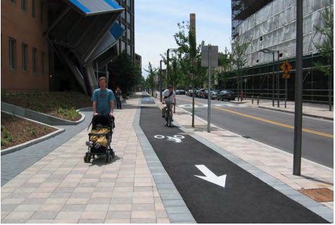
Figure 4. Elevated bike lane integrated with pedestrian walk (Orcutt and Bailey)

CONCLUSION

Summary and overall interpretation of findings
With the limited time between classes and a lack of small-wheeled vehicle friendly pavement on the main roads of UBC, survey results demonstrated the need for not only a better paved surface for skaters, but also lanes separate from pedestrians on Main Mall and University Blvd. The major concern of the riders does not lie on roads with bike lanes installed as they often share the lanes with the cyclists. A large majority of participants support the addition of small-wheeled vehicle specific lane on the major roads of UBC regardless of whether if they are a skater themselves or not. The addition of the lane does seem to provide extra reassurance of safety for both parties.

Future suggestions and recommendations
One limitation of this study is the small sample size used for the surveys, and the sample proportion of skaters vs. non-skaters does not reflect real UBC population proportions. Our sample also had an underrepresentation of drivers, so there is lacking information on road sharing between small-wheeled vehicle users and drivers. Future work can be focused on a larger scale study with a larger sample that is more representative of the UBC student population. In addition, UBC staff’s opinion should also be surveyed as they are an essential group within the UBC community. Nevertheless, this study acts as pilot research for the implementation of small-wheeled specific lanes on the main roads of UBC Vancouver campus and provides the following recommendations:
  - Implementing small-wheeled vehicle specific lanes on the sides of Main Mall and University Boulevard on UBC Vancouver campus
  - Paving these Small-wheeled vehicle specific lanes with smooth asphalt
  - Allowing small-wheeled vehicle riders to ride on these lanes and share them with cyclists
  - These lanes could expand to roads with driveways, however, more research should be conducted before implementation

Works Cited
Dobrovolny, Jerry. Received by Mayor and Council, Use of Low-Powered and Non-Motorized Small Vehicles on Streets, Sidewalks, and Pathways, 7 Dec. 2017.
Orcutt, Jon, and Linda Bailey. “Conventional Bike Lanes.” Urban Bikeway Design Guide, National Association of City Transportation Officials, New York, NJ, 2014.
“UBC Vancouver Campus Plan.” Vancouver Campus Plan | UBC Campus & Community Planning, June 2010, https://planning.ubc.ca/planning-development/policies-and-plans/campus-land-use-planning/vancouver-campus-plan.

Appendices – Survey Questions
- Ethical Introduction:

I am an undergraduate student at UBC engaged in a technical writing project. The purpose of this survey is to obtain primary data for an analysis and investigation that aims to provide recommendations for improving the experience of road sharing with small-wheeled vehicle riders on the UBC Vancouver campus. The final formal report will be addressed to UBC Infrastructure Planning staff. The data I gather from this survey will serve the ultimate purpose of providing recommendations for implementing a separate lane for small-wheeled vehicles on the main roads of UBC Vancouver Campus. The survey contains 10-14 multiple-choice questions, and it should take about 5 minutes of your time. Your responses are voluntary and anonymous. Thank you, I appreciate your generous participation in my survey.

We define small-wheeled vehicles as any vehicle that are equipped with smaller wheels than cars and bikes and used for the purpose of travelling from point A to point B or for recreational purposes. Some examples include cruiser board, skateboard, longboard, electric longboard, scooter, electric scooter, one wheel, hoverboard.

- General Question Block 1:

- How often do you see the use of these small-wheeled vehicles for transportation purposes on campus?
- Multiple times a day
- Once a day
- 1-3 times a week
- 1-3 times a month
- Rarely see them

- Do you ride a small-wheeled vehicle for transportation on campus?
  - No. I don’t.
  - I do ride small-wheeled vehicles, but not for the purpose of transportation
  - I ride small-wheeled vehicles for transportation

- How do you find the 10 min time period between classes? (Multiple selection allowed)
  - Plenty of time to walk to my next class
  - A little tight on time, but speed walking will usually do
  - Sometimes I don’t make it in time walking to my next class
  - I frequently arrive late for my next class when walking
  - Time is tight for me so I use another transportation method: (please specify which method)

- Question block for Skaters (only shown if participant selected that they ride small-wheeled vehicles):

- Which small-wheeled vehicle(s) do you ride? (Multiple selection allowed)
  - Skateboard
  - Longboard
  - Electric Longboard
  - Scooter
  - Electric Scooter
  - Hoverboard
  - One Wheel
  - Other (Please specify):

- How often do you use small-wheeled vehicles for transportation purposes on campus?
  - Whenever I can, weather permitting
  - 3+ times/week
  - 1-3 times/week
  - 1-3 times/month
  - 1-3 times/semester
  - Never

- How would you rate your skill level in riding the small-wheeled vehicle you own?
  - Advanced
  - Intermediate
  - Beginner
  - Brand New

- How do you feel about riding a small-wheeled vehicle on main mall during busy hours?
  - Road is very crowded, and it is very difficult to ride and avoid pedestrians at the same time
  - Crowded road can be hard to ride on, but I am confident in avoiding pedestrians with my skill level
  - I have no trouble riding during those busy hours

- Where do you usually ride on the road?
  - I ride on the same lanes as cars
  - I ride on pedestrian side walks
  - I ride on whichever one is more empty

- How satisfied are you with the riding experience on the following roads on campus?
 | 0- Not Satisfied | 1 | 2 | 3 | 4 | 5- Very Satisfied | Never ridden there
Main Mall
East Mall
West Mall
Agronomy Road
University Blvd

- Question block for non-skaters (only shown if participant selected that they don’t ride small-wheeled vehicles):

- What is/are your major mode(s) of transportation on campus? (Multiple selection allowed)
  - Walk
  - Bike
  - Bus
  - Car
  - Other (Please specify):

- As a pedestrian, how do you usually react when you hear the wheel sound of a small-wheeled vehicle coming towards you?
  - I look for the position of the rider and try to avoid them
  - I keep walking and assume that they will avoid me
  - Other (Please specify):

- What do you usually do when you see a small-wheeled vehicle rider on the road in front of you while driving? (Only shown if car is selected in question 10)
  - I slow down and drive behind them
  - I try to find a way to go around them
  - I alert them with a honk and wait for them to get out of my way
  - Other (Please specify):

- Would you incorporate small-wheeled vehicles into your daily commute on campus if you were given a chance?
  - Yes
  - Maybe
  - No

- Why or why not? (Continuing from the previous question)

- General Question Block 2:

- How do you feel about the implementation of small-wheeled vehicle specific lanes (separate from car lanes and pedestrian walk) on the major roads on campus?
 | Strongly Disagree | Somewhat Disagree | Neither Agree nor Disagree | Somewhat Agree | Strongly Agree
Main Mall
East Mall
West Mall
Agronomy Road
University Blvd

- Please leave any additional comments or suggestions you have below:

