Implementation of Subsidized Hot Beverage Vendors on Campus
For the review of UBC’s Food Services Director

Wednesday March 16, 2022

BY: VARNEEGA THEVA | ENGL 301 STUDENT
TABLE OF CONTENTS
I. INTRODUCTION
A. Background on Food Insecurity
B. Overview of Problem and Purpose
C. Methods of Inquiry
D. Limitations of the Study
E. Scope of Investigation
F. Overview of Conclusions
II. DATA SECTION
A. Analysis of Survey Results
B. Sustainable Coffee Consumption Study – Dalhousie University
C. Interview with UBC Director of Food Services
D. Implementation of subsidized hot beverages vendors on campus
III. CONCLUSION
A. Summary and Overall Interpretation of Findings
B. Recommendations for Action
IV. APPENDIX
- Survey Questions
V. Works Cited

I. INTRODUCTION

A. BACKGROUND ON FOOD INSECURITY

Campus food insecurity can be defined as “inadequate or insecure access to food due to financial constraints” and impacts a large majority of university students, including many at UBC. Self-reporting data show 37% of students at UBC Vancouver report low to very low food security (Figure 1) ("Campus Food Insecurity"). This is concerning for university students because of the negative impacts on learning, academics, and overall mental health. Food insecure students typically show lower grades, higher concerns for mental health well-being and a higher tendency to reduce course load, thereby requiring additional time to complete their degree.

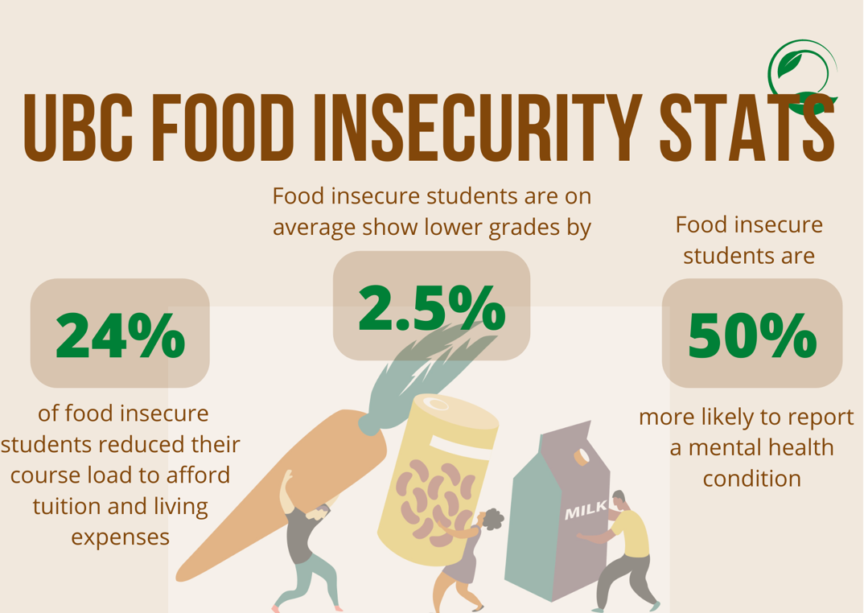
Figure 1: 2020 UBC Statistics collected from UBC Food Services

A shocking statistic is that 54% of food insecure students worry about how to pay their tuition and living expenses ("Campus Food Insecurity"). This can be significantly attributed to the fact that while tuition has increased by 238% in the last 2 decades, wages and financial assistance have not (Quadros). In a city ranked as the second least affordable city in all of Canada to reside in, there has been dramatic increases in the cost of living. When coupled with inadequate financial assistance, it is clear where food insecurity stems from.

UBC Food Services provides some of its profits back to the university for many programs and services that benefit the community. One recent initiative that has taken off is their “Fooood” program. This project operates as a not-for-profit service, with food and labour costs subsidized by UBC while offering healthy vegan and non-vegan meal options to UBC students for the low price of $3 during peak lunch hours Monday through Friday at two locations on campus. Since the introduction of this initiative, self-reports have shown reduced food insecurity numbers by up to six percent. While UBC recognizes this as not an ideal long-term solution, food security is complicated and relates to overall financial security caused by a complex web of factors.

B. OVERVIEW OF PROBLEM AND PURPOSE

A similar issue that UBC students on campus face is the lack of affordable, quality hot beverages on campus. Caffeine is inevitably an important part of a daily routine for students, with nearly half of 18 to 24 year olds in the U.S being habitual coffee drinkers (Perez). The average cup of coffee on campus at UBC costs $3.66 on campus, which produces an average profit margin of $2.49 per cup. A proposal for a similar initiative would be to create subsidized cafes on campus for the vast majority of students who rely on caffeine to keep them awake during the busiest weeks of the semester. The purpose is to provide the director of Food Services at UBC will supplemental information that can be used to evaluate whether this initiative can be successfully implemented.

C. METHODS OF INQUIRY

To investigate the usefulness of this initiative, current student demand of hot drinks on campus is measured through the use of an online survey targeted to consumers. As part of this primary data collection, an interview with Colin Moore is used to attain insider statistics and information based on additional polls and feedback received by students. Secondary sources including researching coffee consumption of students at other universities and their impact.

D. LIMITATIONS OF THE STUDY

The coverage of this study is limited by the sample size of 68 students who completed the online survey. All participants are anonymous UBC students to reduce unrelated external factors.

Additionally, a formal in-person interview with the Food Services Director at UBC, Colin Moore, was unable to occur due to scheduling conflicts. A brief zoom interview was used as a supplement.

E. SCOPE OF INVESTIGATION

The following four areas of inquiry are used to lead the investigation into the implementation of subsidized cafes on campus.
- To what extent do financial restrictions limit students’ decision to buy beverages on campus
- Most important factors considered by hot beverage consumers at UBC
- The feasibility in the implementation of self-serve kiosks
- UBC space and fund availability

F. OVERVIEW OF CONCLUSIONS

Following factors were identified through survey findings and information derived from secondary sources:
- < to be completed>
- < to be completed>
- < to be completed>
- < to be completed>
- < to be completed>

II. DATA SECTION

- SURVEY RESULTS

Figure 2: An anonymous survey of 68 UBC students, consisting of 5 questions (refer to appendix for reference of survey questions)

The survey utilized was developed to investigate the importance of providing affordable and quality hot brewed beverages on campus, and whether the current students’ needs are being met. The first question analyzes the frequency of consumption, with exactly 50% of students purchasing drinks 3 to 4 times a week. According to results from the second and third question, 69% of these beverages are caffeinated and 78% of these students rate the affordability as not quite reasonable. The majority of these sales come from the vendor, Tim Horton’s, with Starbucks next in line and other vendors on campus slightly behind. A shockingly 76% of students voted affordability as the number one factor in deciding where to purchase these drinks, and 18% of students preferring convenience.

- SUSTAINABLE COFFEE CONSUMPTION STUDY – DALHOUSIE UNIVERSITY

A study on ethical and sustainable coffee consumption at Dalhousie University that investigates consumer choices produced very similar results, with the relationship between environmentally conscious perspectives and ethical coffee consumption behaviour to be weak. Although three quarter of participants indicate they care about the environmental implications of coffee they consume on campus, on average, students claimed to prioritize cost, proximity, flavour, and available food options over sustainability when deciding where to buy coffee. These students reported they feel constrained by prices, and on average, prefer to buy the least expensive coffee on campus which correlates to our findings.

These results depict a disconnect between students’ sustainability values and the coffee vendor they up choosing from. This can partially be explained by the influence of factors at play in the life of being a student, such as time, money, convenience, class locations on campus, and social influence. These results indicate current concerns of adequate pricing is not being met by UBC, and there is room for improvement.

- INTERVIEW WITH UBC FOOD SERVICES DIRECTOR

< to be completed>

III. CONCLUSION

- SUMMARY AND OVERALL INTERPRETATION OF FINDINGS
< to be completed after interview has been conducted>

- RECOMMENDATIONS AND APPLICATION OF PROPOSED SOLUTION

Financial burdens can be a heavy weight for students to bear during their period of studies. Although UBC has implemented subsidized food vendors on campus to help mitigate some of this stress, a future step would be to implement subsidized hot beverages in cafes on campus. To further reduce costs incurred by these establishments, an additional proposal would be to implement self-serve kiosks that would decrease costs by reducing the need of hourly workers. This sort of establishment is currently in use at many universities across Ontario such Western and McMaster University and have proved useful for students according to previously conducted polls. Currently there are many open spaces on campus where the possibility of introducing them is feasible such as the UBC Life Building and Neville’s Café. Some important factors to consider would the location and price point per cup as these were the biggest concerns according to the results in the data section. By taking into consideration of the suggestions and needs of students, a progressive step can be taken towards solving food insecurity and financial burdens that students face.

