Enhancing Resident Engagement in Marine Drive

For
Niloufar Rohani and Abhijhit Pandhari
Residence Life Managers of Marine Drive Residence
The University of British Columbia
Vancouver, British Columbia, Canada

By
Katherine Chan
ENGL 301 99C – Technical Writing
Instructor: Dr. Erika Paterson

Table of Contents
ABSTRACT 3
INTRODUCTION 4
DATA SECTION 6
The Benefits of Participating in Residence 6
Residence as a Learning Community 6
Current Marine Drive Resident’s Perceptions and Opinions 6
Figure 1. Residents previous residence background 7
Figure 2. Residents sense of belonging in the Marine Drive community 7
Figure 3. Number of programs attended in the past six months 8
Figure 4. Residents’ overall experience with programs 9
Figure 5. How do residents typically find out about programs 9
Figure 6. Residents’ motivation to participate in program 10
Current Marine Drive Residence Life Managers’ Perceptions and Opinions 10
CONCLUSION 12
Summary and Overall Interpretation of Findings 12
Limitations 12
Recommendations 13
APPENDIX 14
Survey Questions 14
Interview Questions 15
WORKS CITED LIST 16

ABSTRACT
For many university students living in residence is their first opportunity to develop a sense of community. Living in residence is a fantastic way for students to meet new people and build valuable life skills during their journey at UBC. This study examined residents’ satisfaction and motivation for participating in programming in Marine Drive residence. In particular, this study assessed opportunities to enhance resident engagement in Marine Drive. The sample included twenty-one residents in a primary survey and interviews with two current Residence Life Managers. The study found that program topic and timing impact residents’ participation in Marine Drive program. Additionally, posters and social media are the most popular method on how residents learn about programs. The major recommendation from this study is to focus on fostering healthy relationships between resident and resident advisors. Resident advisors need to better understand and address the needs and interests of their residents, which will be used to tailor future programs and enhance resident engagement in Marine Drive.

INTRODUCTION

The University of British Columbia (UBC) is a diverse community of students and staff from different cultures, backgrounds, norms and expectations. Student Housing and Community
Services strives to provide a safe and secure living and learning environment for residents via
educational and social programs that promote personal growth and academic success. For over
sixty years UBC Housing has developed policies and practices through conversations with
residents, resident councils, and residence staff to foster a positive living environment. UBC Student Housing is the largest Canadian university residence with approximately 13,000 residents who come from diverse backgrounds, lived experiences, and demographics. For many students living in residence is their first opportunity to develop a sense of community. Living in residence is a fantastic way for students to meet new people and build valuable life skills during their journey at UBC. In fact, most first year students are guaranteed housing in designated first-year residences, which have facilities such as dining rooms. Moreover, approximately 27% of the UBC Vancouver students are international students, which makes Student Housing a preferred on-campus living option.
Living in an upper-year residence, such as Marine Drive Residence, is challenging especially during COVID. Upper-year studios and shared units have in-unit bathrooms and kitchens. This is a major transition from first-year residences with communal bathrooms and dining rooms, which encourages students to meet their community and alleviates the responsibility of cooking and cleaning. Currently there is a significant number of students who did not live in first-year residence and transitioned into upper-year residence because the 2020/2021 Winter academic term was virtual. On the other hand, there are students in upper-year residence who have developed an independent routine after multiple renewals of their housing contract. Examples of specific consequences include roommate conflicts over shared common space, cleanliness, and noise due to roommates with different lived experiences.
Twenty-one Marine Drive residents responded to the short survey designed to analyse opinions and perspectives of living in residence and residence programming. Moreover, the survey gauged residents’ interests and potential to increase participation and engagement in programming. Additionally, interviews were conducted with two current Residence Life Managers on their perspective on the high-level needs and expectations of Marine Drive residents in terms of community building.

This report covers four major topics: what type of programs would residents be interested in participating in Marine Drive, how satisfied are residents with the current activities hosted by Marine Drive, what transferable life skills are residents learning and developing through residence, and how can Marine Drive create a sense of community and inclusion among residents.

This report concludes by acknowledging the decrease in participating of residents in programs and by recommending immediate solutions to enhance participation.

DATA SECTION

The Benefits of Participating in Residence
Research shows that living in residence impacts a student’s character and university
experience (Schroeder & Mable, 1994). Students living in residence compared to commuter students participate in a greater number of extracurricular, social, and cultural events; interact more frequently with faculty and peers in informal settings; are significantly more satisfied with their university experience; and are more likely to persist and graduate from university (Schroeder & Mable, 1994).

Residence as a Learning Community
UBC Housing strives to create and build an inclusive learning community. One of the main benefits of residence as a learning community is that students are more active and engaged in the classroom and informal settings, which enhances the university experience (Tinto, 2000). Through active learning communities, students report a greater coherence in their field of study as well as increase interactions with their faculty and peers outside of the classroom through mentorship and extracurricular opportunities (St Onge, Peckskamp, & McIntosh, 2003).

Current Marine Drive Resident’s Perceptions and Opinions
Twenty-one Marine Drive residents responded to a short survey designed to analyze residents’ perceptions and opinions on residence life. Majority of current residents have lived in first-year or another upper-year residence community (86.36%). Of all residents who participated in the survey they ranked their sense of belong in the Marine Drive community as 4.36 where a rank of 1 represents strongly disagree and 5 represents strongly agree. On average the surveyed residents attended 2.68 programs in the past six months. In Marine Drive there are a minimum of eight programs per a month, which equals to a minimum of forty-eight programs in six months.

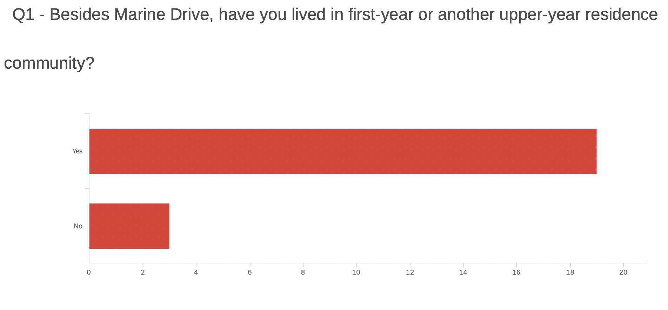

Figure 1. Residents previous residence background

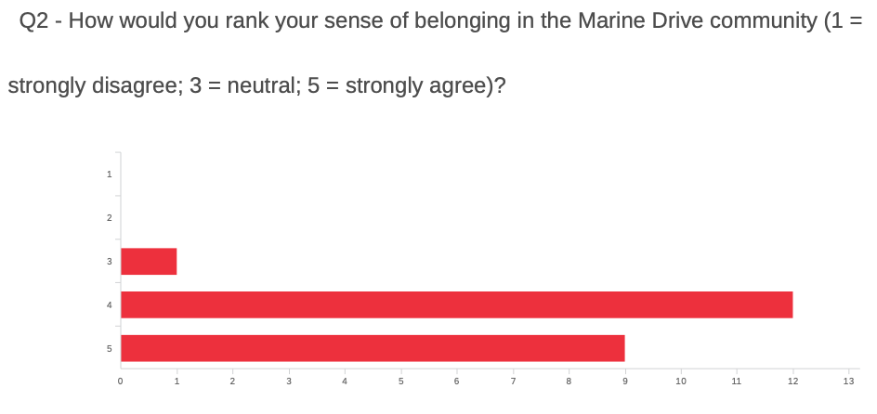

Figure 2. Residents sense of belonging in the Marine Drive community

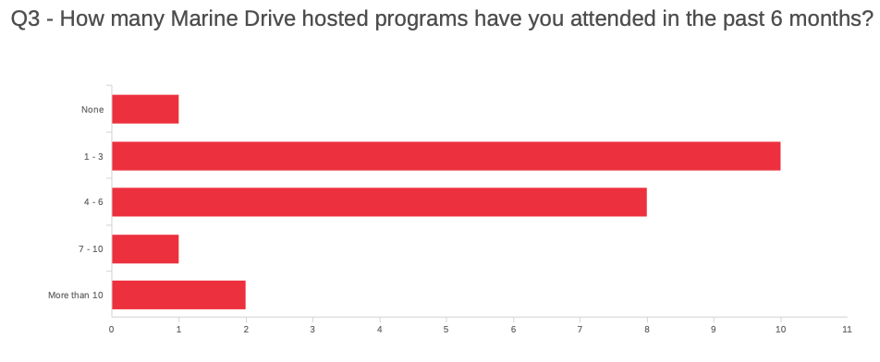

Figure 3. Number of programs attended in the past six months

Majority of students (71.43%) are very satisfied with their overall experience with programs and only 4.76% ranked their overall experience with programs as neutral. The most common methods residents’ find out about programs are posters (52.53%) and social media like Facebook and Instagram (36.84%). Intriguingly, resident advisor reach out emails are not as impactful (5.26%) and one surveyed resident (5.26%) was not aware about programs. The residents’ motivation for participating in programs showed the most variation. The most common motivation for attending programs is interest in the program topic (45.45%) followed by program timing fitting residents’ schedule (27.27%). A smaller number of residents are motivated to participate in programs to meet others or build relationships (13.64%). Additionally, some residents are motivated due to the incentives such as food or prizes (13.64%).
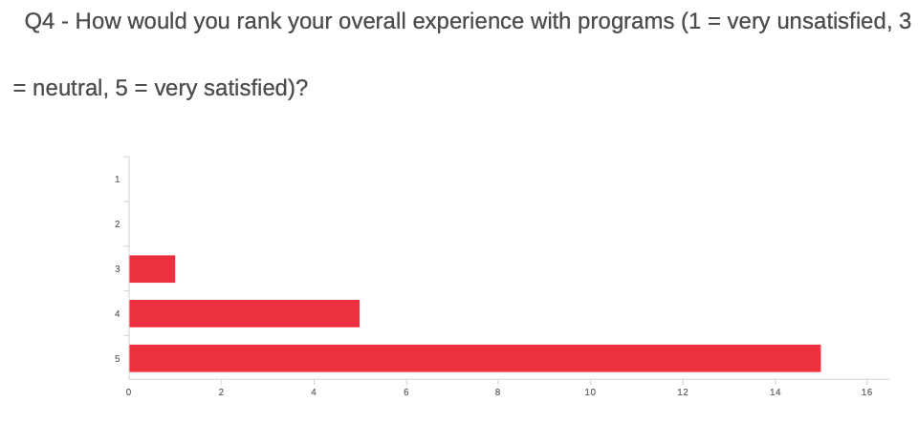

Figure 4. Residents’ overall experience with programs

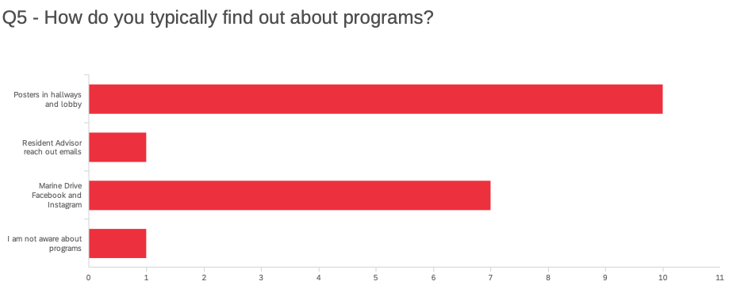

Figure 5. How do residents typically find out about programs

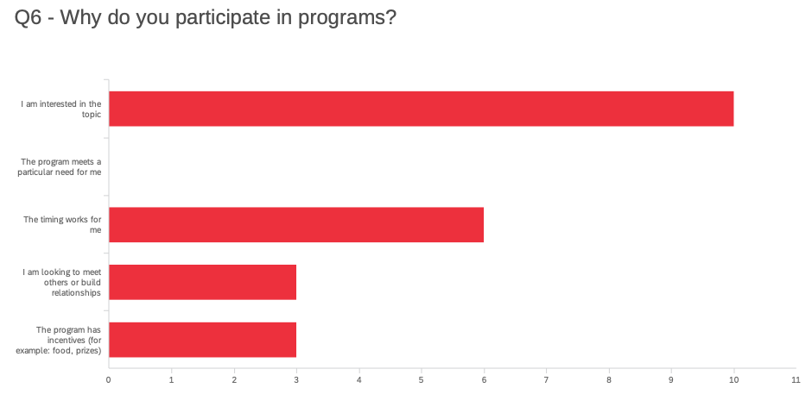

Figure 6. Residents’ motivation to participate in program

Current Marine Drive Residence Life Managers’ Perceptions and Opinions
The two current Residence Life Managers of Marine Drive were interviewed for this project. They have extensive experience managing a total of 1605 residents and 28 Residence Advisors. The most common concerns residents bring up to the Residence Life Managers are conflicts and disruptive conduct by roommates followed by safety and wellbeing concerns for roommates. The most common reasons Residence Life Managers reach out directly to residents are follow-up on standards or conduct violations and disruptive behaviour that impact the community. According to the Residence Life Managers, resident engagement can be improved through good rapport between residents and Residence Advisors. Staff can create a positive environment where residents feel a sense of belonging to the community through active listening and non-judgemental conflict facilitation between roommates. The Residence Life Managers believe residents are motivated to build relationships within the residence community through impactful interactions such as unit visits, programming, and representation and collaboration with other UBC organizations such as UBC Recreation.

CONCLUSION

Summary and Overall Interpretation of Findings
The primary survey suggests program topic and timing impact residents’ participation in Marine Drive programs. The Residence Life Managers emphasized the importance of healthy relationships between Residence Advisors and residents to collect information and then adjust programming to better assist residents’ academic and social needs. Resident satisfaction can be enhanced by tailoring programming to the current residents’ interests and academic schedule such as midterms and final exams. Moreover, the Residence Life Managers highlighted that communities with more resident-Residence Advisor interactions correlated with higher levels of satisfaction with residence community experience. Therefore, Residence Advisor accessibility and visibility in the community allow more genuine and meaningful interactions. Furthermore, personal investment and the sense of ownership by everyone in the community leads to successful learning communities.

Interestingly, resident advisor reach out emails were not as impactful as posters and social media posts regarding upcoming programs. A possible explanation is that email is a more formal method of communication compared to social media such as Facebook or Instagram. Moreover, posters in the hallways and lobby are a more personal approach, which is more valued by the residents.

Limitations
This study is limited by the small sample size of twenty-one residents in building one of Marine Drive. This can provide only a snapshot in time for a relatively small group of residents who participated in programs in the past six months. Longitudinal research can provide more substantial findings, which can contribute to a broader understanding of the effectiveness of enhanced resident engagement. Additionally, although the survey was anonymous it may be difficult for participants to be unbiased in their feedback because of the author’s current position as a Residence Advisor in the building. It would be interesting to perform the survey later in the term for residents who are moving out of Marine Drive because they may be more inclined to be honest and straight-forward with their responses.

Recommendations
UBC Housing need to focus on fostering a learning environment by emphasizing consistent communication and healthy relationships between resident and resident advisors. Resident advisors need to better understand the needs and interests of their residents to tailor programs to support the academic, social, and mental wellbeing of the community. For instance, financial literacy knowledge is an important life skill and one of the most successful programs this year was a tax workshop. The tax workshop was successful with many registrants (n = 80) and high attendance rate (n = 57, 71% turnout rate). Furthermore, this program was hosted in March during tax season.

Another recommendation is highlighting resident advisors’ majors and extracurricular involvement such as clubs or sports on social media. This can help foster a sense of connectedness by highlighting mutual interests and career goals in the larger residence community.

APPENDIX

Survey Questions
- Besides Marine Drive, have you lived in first-year or another upper year residence?
  - Yes
  - No
- How would you rank your sense of belonging in the Marine Drive community (1 = strongly disagree; 3 = neutral; 5 = strongly agree)?
  - 1
  - 2
  - 3
  - 4
  - 5
- How many Marine Drive hosted programs have you attended in the past 6 months?
  - None
  - 1 – 3
  - 4 – 6
  - 7 – 10
  - More than 10
- How would you rank your overall experience with programs (1 = very unsatisfied, 3 = neutral, 5 = very satisfied)?
  - 1
  - 2
  - 3
  - 4
  - 5
- How do you typically find out about programs?
  - Posters in the hallway
  - Resident Advisor reach out emails
  - Marine Drive Facebook and Instagram
  - I am not aware about programs
- Why do you participate in programs?
  - I am interested in the topic
  - The program meets a particular need for me
  - The timing works for me
  - I am looking to meet others or build relationships
  - The program has incentives (for example: food, prizes)

Interview Questions
- What are the typical concerns for residents?
- What are the typical expectations of residents?
- How can resident engagement be improved?
- How can staff create an environment in which residents feel a sense of belonging to the community?
- What do you think fundamentally motivates residents to build relationships within the residence community (roommates, Residence Advisor, professional staff)?

WORKS CITED LIST
Schroeder, P., & Mable, P. (1994). Realizing the educational potential of residence halls. San Francisco: Jossey-Bass.
St. Onge, S., Peckskamp, T., & McIntosh, J. (2003). The impact of learning communities on residential communities and the roles of resident advisors. Journal of College and University Student Housing, 32(1), 16-23.
Tinto, V. (2000). Learning better together: The impact of learning communities on student success in higher education. Journal of Institutional Research, 9(1), 48-53.

