Feasibility Analysis of the Implementation of improving environmental practices at Flagship Dental to reduce its carbon footprint.

for
Dr. Jordan Turton
Principle Dentist and Owner
Flagship Dental
Cloverdale, BC

Trisha Bhamra
Student ENGL 301 99C

March 17th, 2022

INTRODUCTION
In the last year, extreme climate change such as severe forest fires, floods, tsunamis, and cyclones has highlighted the effects of global warming.The ramifications for not caring for the planet have become apparent now more than ever. Most countries are taking an action to improve their environmental practices and reduce the carbon footprint. As eco-consciousness is becoming popular, businesses from supermarket chains to car manufacturers are looking for ways to create and market “green” products.
College of Dental Surgeons of British Columbia (CDSBC) sets infection control guidelines for general dental practices to follow daily. Dental offices must follow the sterilization and personal protective equipment (PPE) use guidelines set by CDSBC to ensure patient, clinician, and staff safety. (9) Sterilization guidelines exist for critical items, semi critical items, and non-critical items. (9) Critical items include instruments/items that penetrate soft tissue and bone, enter or contact the bloodstream. (9) These items must be cleaned, appropriately packaged, and then sterilized. To ensure appropriate sterilization and storage of sterile instruments proper packaging is required. Packaging materials used for instruments and cassettes prior to sterilization cycle include textile wrap (woven vs. unwoven material), paper pouches and a combination of paper/plastic pouches. (9,10,11)
Plastic bags can take anywhere from 20-1000 years to degrade. (4) On average within a given day about 24 autoclave bags are used and disposed of in the garbage. Calculated on a 200-day work year, that amounts to 4,800 pieces of autoclave paper and plastic being diverted from the landfill each year. (R) In North America, dentistry discards approximately 1.7 billion sterilization pouches and 680 million chair barrier, light handle covers, and patient bibs into landfills every year. (4) Autoclave bags, which contain no biohazard materials, can be recycled in most communities after separating the plastic and paper portions of the bags. Alas, most dental offices don’t recycle the autoclave bags.
Such startling statistics can be found for Personal Protective Equipment (PPE) such as masks and gloves, especially since the pandemic started. Single use materials such as disposable cups, bibs, and saliva ejectors and plastic barriers to cover things that cannot be sterilized is a widespread practice in dentistry. (5) The daily waste created from day-to-day operations of a dental office makes a significant impact on the environment. Dental offices must consider the business costs and operating costs post pandemic when considering “green alternatives” to reduce their carbon footprint. They must do more than just recycling paper and other plastics within dental office to be considered truly “green”.
Purpose of this report
Although, Flagship Dental has some environmental practices in play, there is a lack of accountability to implement environmental practices within the sterilization program and “green” PPE to further reduce the carbon footprint. The major implication of this problem is adding to the existing global warming from poor environmental practices, especially when environmental alternatives exist. We all must be accountable at home and work in trying to minimize our carbon footprint.
One possible solution to the problem of improving environmental practices at Flagship Dental is by choosing “green” alternatives to PPE, sterilization materials, plastic barriers and one time use dental products. For example, separating the plastic and paper of the autoclave bag and recycling it appropriately will reduce the waste created from tossing the autoclave bags in the garbage.
Methods
My primary sources will include interviews with Dr. Jordan Turton, principal dentist and owner of Flagship Dental. The purpose of interviewing the decision maker is to gather insight on how "green" they believe their current practice is. They will also provide some insight on their budget for dental materials.
I will also provide a survey to the other workers within the office to determine the “green” changes they would like to see within the dental office. I will round my primary research with an online survey asking about the feasibility of current green alternatives within other dental offices in the lower mainland. This will provide data from other “green” dental offices and how they are faring with the changes.
Secondary sources will include publications on the feasibility and acceptance of green alternatives vs. traditional dental office equipment while staying within the best practices standards.
Scope of the Investigation
To assess the feasibility of improving environmental practices at Flagship Dental to reduce its carbon footprint.
- What some green alternatives to PPE (gloves and masks), the current sterilization program, plastic barriers, disposable cups, and saliva ejectors and what the costs associated with them?
- How large is the demand for green alternative for PPE (gloves and masks), the current sterilization program, plastic barriers within the dental practice? Will there be enough support from the staff to pursue this endeavour?
- Can green alternatives meet the day-to-day demand of the dental office as well as traditional plastic/ non green version?
- Does the dental market at large contain room for green alternatives? Is there enough demand for green alternatives in the field of dentistry?
- What are the costs for retrieving these green alternatives to meet the day-to-day demands of the dental office?
- What prices for the products can the dental office bear?

II. DATA SECTION
A. Carbon footprint Data Summary
Current measures to reduce the carbon footprint at Flagship Dental include recycling program for regular paper waste, plastic containers, and cardboard, use of woven material wraps for cassettes instead of one time use paper, and automated lights that turn off to conserve energy when no one is on the operatory. Water conservation is encouraged by everyone in the office. The efforts to reduce the carbon footprint of the dental office is moderate with four out of six staff members agreeing as shown below in the bar graph.
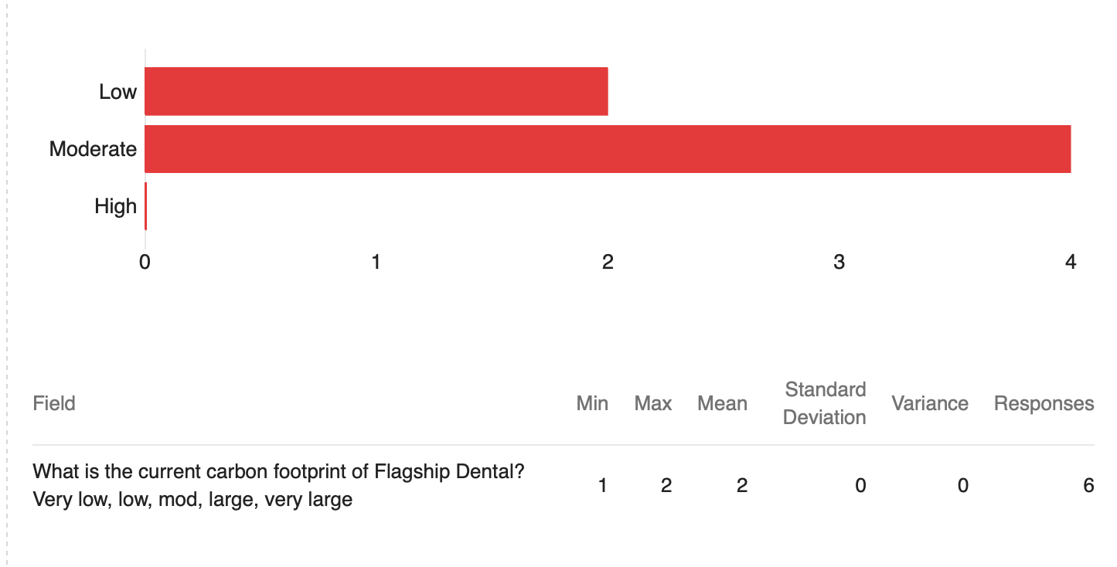
Figure 1. Staff perception on the carbon footprint of Flagship Dental

Cost of current dental materials such as PPE, sterilization materials, plastic barriers and one time use dental products (bibs, cups, barriers, saliva ejectors) More information will be added here later in the next week once I receive the information from the dental materials representative.
B. Staff opinions on “green” dentistry
Flagship Dental has 10 staff members apart from the principal dentist. Out of the 10 staff members only six staff members were willing to participate in the survey and share their opinions. The office survey was supposed to be shared with other dental professionals in the lower mainland as well to gauge the feasibility of current green alternatives within other dental offices. Due to lack of consent from the dental professionals’ group on Facebook, I was unable gather any primary data from sources outside of Flagship Dental.

The staff at Flagship Dental were unsure about benefits of implementing “green” practices within the office. Plastic is easy to manufacture, ensures cleanliness and sterility, and it is economical. (7) Dental offices have overhead costs that must be maintained while abiding by the CDSBC guidelines for sterilization, plastic sterilization pouches, barriers and one time use saliva ejectors keep the costs low. Some benefits of implementing green practices would ensure a reduction in the carbon footprint. Some disadvantages would entail increased cost and manpower to find and procure the “green” alternatives and the office not meeting the day to day demands from using the “green” alternatives on busy days. The staff consensus is 50:50, half the staff is open to trying “green” alternatives while the other half is not.
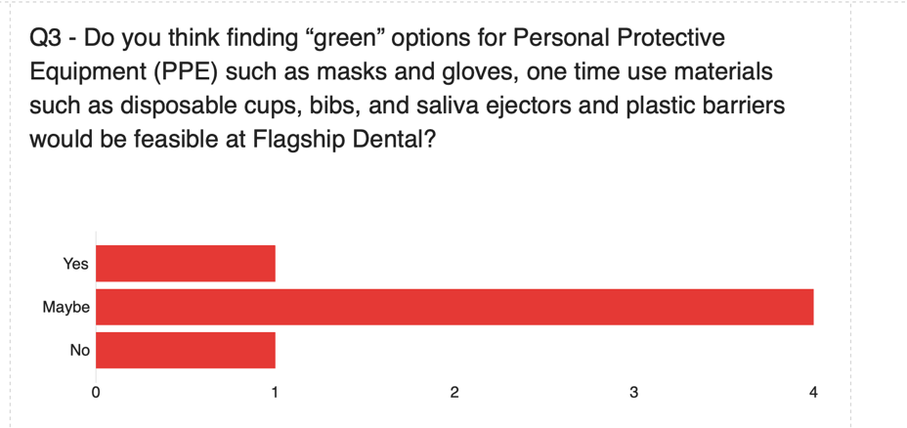
Figure 1.2 Staff perception of implementing “green” practices at Flagship Dental
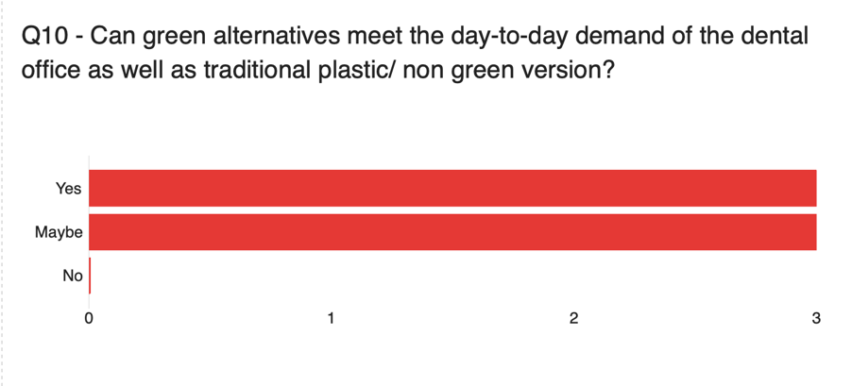
Figure 1.3- Staff perception on “green” alternatives meeting the day to day demand of the dental office.
C. Switching the dental materials to “green” alternatives
At any given time, there are four operatories that are functioning with eight patients each over the entire day at Flagship Dental. On average, more than one pair of gloves, masks, wipes, autoclave-sterilization sleeves, and tray liners are used with each patient, independent from the type of procedure delivered within one working day. Meeting the standards of infection control guidelines set by CDSBC from using the “green” alternatives to PPE, barriers and sterilization sleeves/pouches is of utmost importance for the dental office to operate. Some barriers to making the switch include cost of the procuring the “green” alternatives, “green” sterilization practices unable to keep up with the demand of the office.
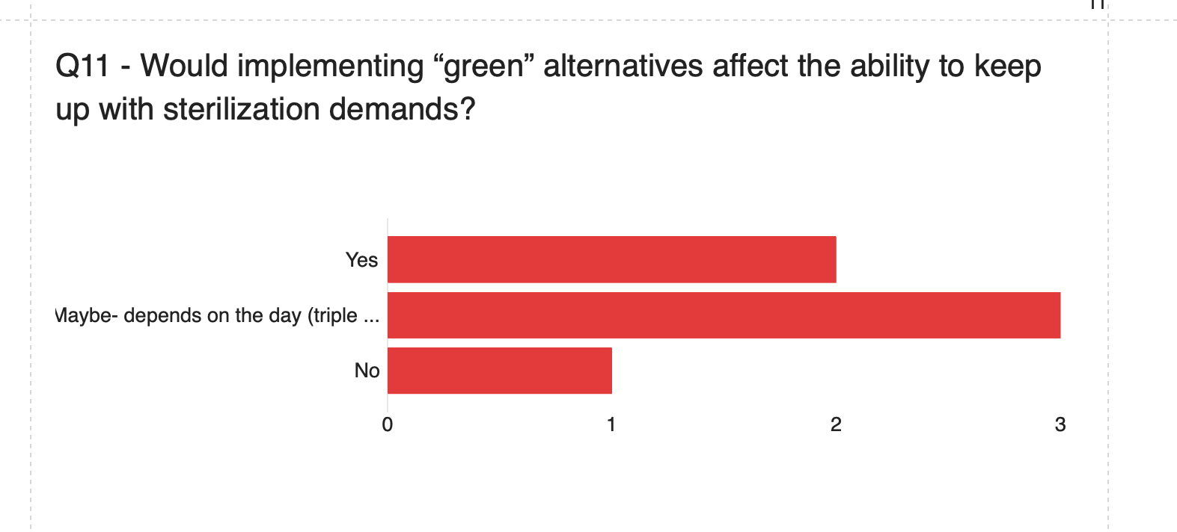
Figure 2.1 sterilization demands
Resources required to make the switch “green” alternatives would require the dentist to research, compare prices and find suitable alternatives to traditional PPE and sterilization bags. Using local vendors for simple items such as paper cups, paper bibs or paper headrest covers could be considered “green” alternative to current plastic variations. Most of the staff was not interested in biodegradable PPE or enrolling in recycling program such as Vitacore PPE recycling.
D. Secondary studies comparing “green” alternatives vs. traditional dental equipment within other dental offices and their experience- I will be adding more information here once I find more papers
Traditional (moderate to high carbon footprint) | “Green Alternative” (less than moderate carbon footprint)
PPE – nitrile gloves, masks | PPE- biodegradable gloves, masks OR enrolling in a recycling program for traditional PPE  Use face shield to minimize the need to replace the mask for every patient.
Plastic headrest covers  Plastic barriers and films | Paper headrest covers  Compostable plastic barriers made from corn, potato, and soy starches can break down more easily than plastic. Aluminium foil could be a good alternative as well.
Paper cups | Remove pre procedural rinse to reduce the paper cup use  Recycled material paper cups
Bibs | Paper or recycled material bibs
Single use plastic saliva ejectors | Bent saliva ejectors that can be sterilized on “plastics cycle” and reused
Paper cassette wraps  Plastic/Paper sterilization sleeves | Reusable woven Fabric cassette wraps reduce the paper waste from wrapping cassettes. (5,11)  Plastic/Paper sterilization sleeves can be reused with a proper sterilization indicator to reduce the waste created from one time use. Autoclaves in dental offices don’t have a vacuum component therefore a true seal is not mandatory for sterilization to occur. (5,11,7)

Carbon footprint would be reduced significantly by using “green” alternatives. The quantitative impact can be measured by reduction in number of traditional items ending up in the garbage. The green alternatives are mostly paper based or biodegradable, proper disposal of these materials will be very important in ensuring a reduced carbon footprint. Since the paper based products will come in contact with bodily fluids, the recycling of these materials must occur through specific recycling programs for hazardous materials such as Vitacore in Burnaby, B.C.

III. CONCLUSION
- Summary and interpretation of findings
Not completed yet as I don’t have all the data yet.
- Recommendations
Replace plastics with paper or biodegradable alternatives where possible, ensure an appropriate recycling program is in place for hazardous material paper waste. Minimize the use of single use products, opt out for materials that can be sterilized under the “plastics cycle”. Consider cups, barriers, bibs and headrest covers made from recyclable materials or repurposed recycled materials. Seek out for local vendors for PPE instead of overseas because the supply chain has a significant impact on the environment through the process of procurement of raw materials, manufacture, transport, and distribution. Minimize the use of multiple gloves with single patient. Use a face shield to minimize the need to switch the mask for every patient.

References (have not been formatted properly here and in text- I will be doing that for the final submission)

  - Ref Hanoon, Rodney. “What’s with the Green? Changes That Help Dentistry Preserve the Environment.” RDH, vol. 31, no. 3, Mar. 2011, pp. 74–86. EBSCOhost, https://search.ebscohost.com/login.aspx?direct=true&AuthType=shib&db=ccm&AN=104845656&site=ehost-live.

  - Henry K. “Go Green Dentistry.” RDH, vol. 29, no. 3, Mar. 2009, pp. 52–56. EBSCOhost, https://search.ebscohost.com/login.aspx?direct=true&AuthType=shib&db=ccm&AN=105477147&site=ehost-live.

  - Duane, B. Green Dentistry: Motivating change. Br Dent J 217, 388 (2014). https://doi.org/10.1038/sj.bdj.2014.915

  - Donaldson, Karen. “Is Your Office Environmentally Responsible?” RDH, vol. 31, no. 4, Apr. 2011, pp. 46–52. EBSCOhost, https://search.ebscohost.com/login.aspx?direct=true&AuthType=shib&db=ccm&AN=59935950&site=ehost-live.

  - Sitterson, Kay, and Jan Sitterson. “Single Use Plastics in Dentistry.” Dental Assistant, vol. 86, no. 3, May 2017, p. 14. EBSCOhost, https://search.ebscohost.com/login.aspx?direct=true&AuthType=shib&db=ccm&AN=123724615&site=ehost-live.

  - Duane, B et al. “An estimated carbon footprint of NHS primary dental care within England. How can dentistry be more environmentally sustainable?.” British dental journal vol. 223,8 (2017): 589-593. doi:10.1038/sj.bdj.2017.839

  - Martin, Nicolas et al. “Awareness and barriers to sustainability in dentistry: A scoping review.” Journal of dentistry vol. 112 (2021): 103735. doi:10.1016/j.jdent.2021.103735

  - Nasser, Mona. “Evidence summary: can plastics used in dentistry act as an environmental pollutant? Can we avoid the use of plastics in dental practice?.” British dental journal vol. 212,2 89-91. 27 Jan. 2012, doi:10.1038/sj.bdj.2012.72
  - https://www.cdsbc.org/CDSBCPublicLibrary/Infection-Prevention-and-Control-Guidelines.pdf
  - https://www.infectioncontroltoday.com/view/number-staff-not-ownership-predictor-nursing-home-covid-19-outcomes
  - Cuny E, and Bednarsh H. “Instrument Sterilization in Dentistry.” ELABORATE, Jan. 2010, pp. 26–30. EBSCOhost, https://search.ebscohost.com/login.aspx?direct=true&AuthType=shib&db=ccm&AN=105209835&site=ehost-live.

