Hello, my name is Madison Strasman and I am an undergraduate student in the Bachelor of Arts program at the University of British Columbia. I am conducting a survey regarding the absence of streetlights on Southwest Marine Drive between W 41st Avenue and W 16th Avenue and Northwest Marine Drive between Agronomy Road and West Mall for a formal report assignment for an English Technical Writing Course. This report is addressed to William Emo, the manager of the University Endowment Lands and will use the data collected from the surveys to accompany external research.

I have attached a map of the location for your reference.
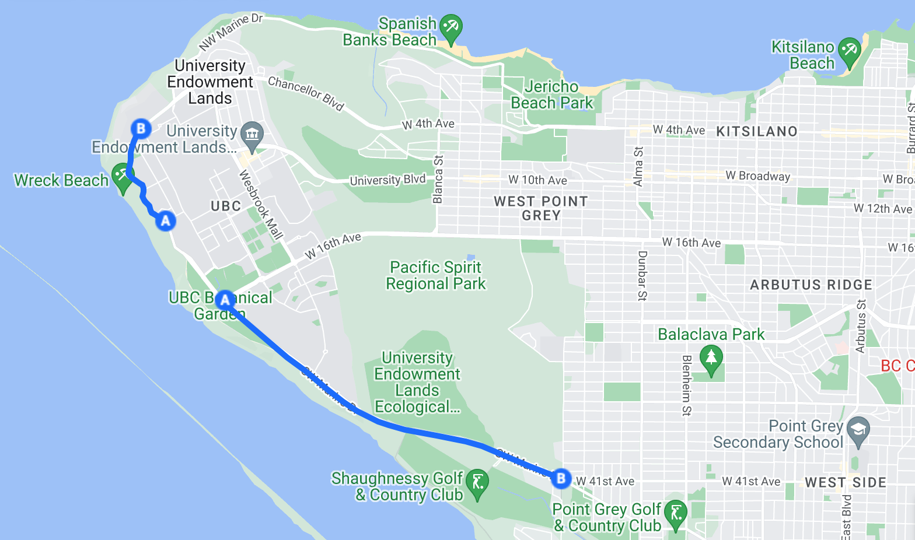

This survey is intended to provide insight on your experiences using this road regarding personal safety and usage to provide urgency in installing streetlights on this stretch of road. Your responses are voluntary and anonymous. Thank you for taking the time to participate in this survey.

- Are you a student at UBC?
Yes
No

- Have you relied on either/both of these two routes to commute?
Yes
No

- How often do you use either/both of these routes for your commute?
5-7 days a week
2-4 days a week
1-3 days a week
Never

- What method of transportation do you utilize when travelling along either/both of these routes?
Car
Bus
Bike
Walking
Other

- How would you rate the visibility on these streets at night?
Clear
Satisfactory
Unclear

