Installation of New Streetlights on Northwest and Southwest Marine Drive

To William Emo
Manager of the University Endowment Lands

Madison Strasman (ENGL 301 Student)
July 22, 2022

Table of Contents

Introduction………………………………………………………………………………………3
Purpose…………………………………………………………………………………...3
Method…………………………………………………………………………………...4
Scope……………………………………………………………………………………..5
Data Section……………………………………………………………………………………...6
Analysis of Survey Results………………………………………………………………6
Survey Results……………………………………………………………………………8
Analysis of Costs…………………………………………………………………………9
Analysis of Locations of Previous Incidents……………………………………………..9
Conclusion……………………………………………………………………………………….10
Summary of Findings……………………………………………………………………10
Works Cited……………………………………………………………………………………...11

Introduction

Southwest and Northwest Marine Drive, also commonly known as the UBC Highway, connects the University of British Columbia to Metro Vancouver. Between these two regions lies the University Endowment Lands consisting of approximately 3000 acres of land. The University Endowment Lands was founded in 1907 at the time of the University Endowment Land Act which was to fund the opening of the University of British Columbia. The University Endowment Lands is separate from the Province of British Columbia mayor governing system and is instead run by a Manager. In 1925, the first pieces of property were sold via public auction which established the first residential community. In 1989, the undeveloped land was handed to the Vancouver Regional District to be designated as Pacific Spirit Regional Park (University Endowment Lands - About, n.d.).
Many commuters rely on Southwest and Northwest Marine Drive as a major route to the University of British Columbia. Alternate roads such as West 16th Avenue, University Boulevard, and West 4th Avenue are also utilized and are situated on the University Endowment Lands.
Purpose

Northwest and Southwest Marine Drive have endured many incidents with pedestrians and drivers over the past years. Most recently, an incident involving children around nine or ten years old, were struck by a vehicle while walking near the UBC Botanical Gardens in June of 2022 (Grade 4 Youngsters Hurt, Recovering, as Car Veers onto Sidewalk at UBC). Leaving the community struck for another time as not long ago, another incident along this stretch of road occurred. In September of 2021, two UBC students were walking along Northwest Marine Drive around 2 a.m. and were struck by a vehicle that veered off the road (Gul et al.). In 2011, there was a motorcycle collision on the same section of Northwest Marine Drive (Prasad).
Student and community safety is at risk and with the publication of these incidents, residents are expressing their concerns.
Calls to install more lighting have been highlighted by students, residents, and faculty at the University of British Columbia. Reddit has become a conversational platform for individuals to express their thoughts and grieve after these accidents. One post highlighted the absence of streetlighting as a primary cause for the accident involving two UBC students in September of 2021. “Georgia Yee, a biology student and Board of Governors representative, tweeted her concerns, saying that she was once almost struck by a vehicle on the same road” (Sangar). Although only few incidents have been recorded, there have been additional instances where fortunately there have been no deaths. Ms. Yee’s experience brings light to the problem. The discussion of installing new streetlights is the start to increased safety.
Method

Ten residents of the Metro Vancouver area have responded to a short five question survey conducted via SurveyMonkey.com and distributed through Instagram and personal messages. This survey is designed to analyze the visibility of Southwest and Northwest Marine Drive and to investigate the use of these roads. An additional investigation of approximate costs was completed to assist in the practicality of installing new streetlights.
News reports of incidents along Southwest and Northwest Marine Drive have also been used in correlation to the absence of streetlights and to support the proposal. With this foundation of information, the necessity to install new streetlights is important for the safety and well-being of the UBC community
Scope

To assess the feasibility of installing new traffic lights along Southwest and Northwest Marine Drive, I ask the following questions:

- What will the cost be to install new lights?
- Will the University Endowment Lands approve of this proposal?
- Will lights interfere with the Pacific Spirit Regional Park and its wildlife?
- Will lights draw more pedestrian traffic into the park?
- What are the implications of unlit streets?
- Is there an alternative method to providing lighting (reflectors, painting curbs etc.)?

Data Section

The residents of Metro Vancouver who have completed the survey have responded to five questions.
- Are you a student at UBC?
- Have you relied on either/both of these two routes to commute?
- How often do you use either/both of these routes for your commute?
- What method of transportation do you utilize when travelling along either/both of these routes?
- How would you rate the visibility on these streets at night?
To assist in accurate responses, an attached map was used to assist in highlighting the discussed areas of Southwest and Northwest Marine Drive (Fig. 1).
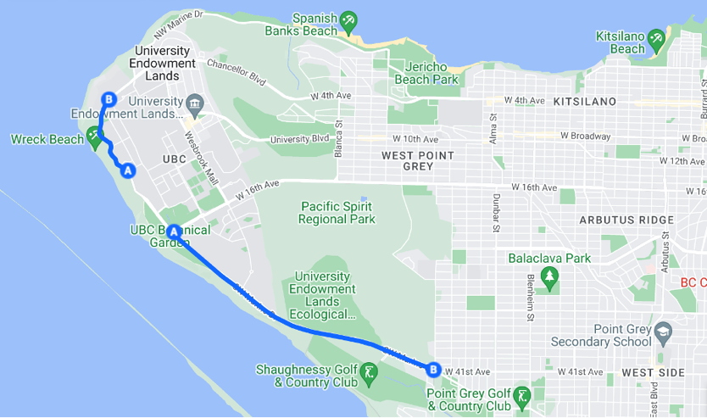

Figure 1

Analysis of Survey Results:

40% of the ten respondents had stated they were UBC students (Fig. 2). While majority of respondents were not UBC students, there were 50% of participants who answered “yes” to using Southwest and/or Northwest Marine Drive for their commute (Fig. 3). This demonstrates the demand to install new streetlights as many users rely on this route for reasons aside from travelling to and from the university. The results from question three additionally supported the requirement for streetlights to be added. 30% of respondents depended on Southwest and/or Northwest Marine Drive for two to four days of the week and an additional 20% answered that they relied on these routes for their commute one to three days a week. The remaining 50% have responded to never use these routes for their commute (Fig. 4). While the division of responses concludes that there were only five respondents out of ten who actively relied on Southwest and/or Northwest Marine Drive, the remaining two survey questions supported the dangers of the current absence of streetlights.
50% of respondents recorded that they use a vehicle while travelling on either or both routes (Fig. 5). This, paired with the incidents recorded on Southwest and Northwest Marine Drive, correlate to the amount of traffic and the potential for car accidents. Additionally, the concluding question asked respondents to rate the visibility of Southwest and Northwest Marine Drive at night. 90% rated the visibility to be unclear and the remaining 10% found the visibility to be satisfactory (Fig. 6). No respondents ranked the visibility of the road to be clear at night. This highlights the consensus for the need for new streetlights to be installed.

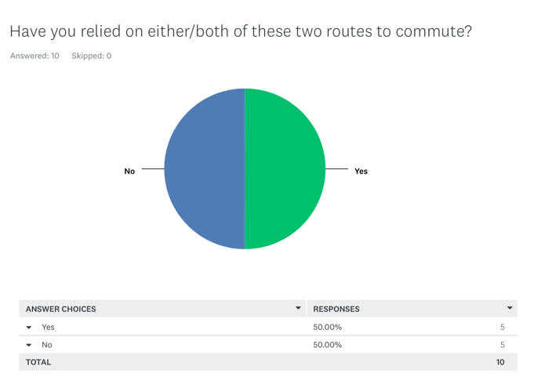
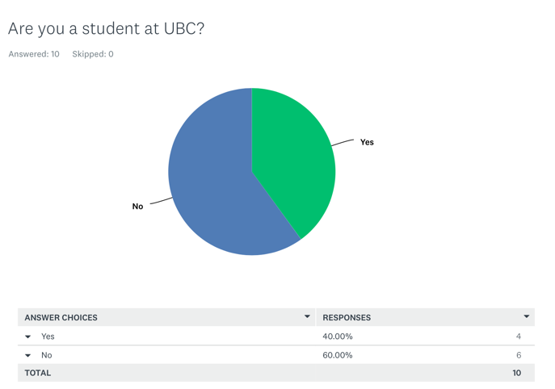

Figure 2
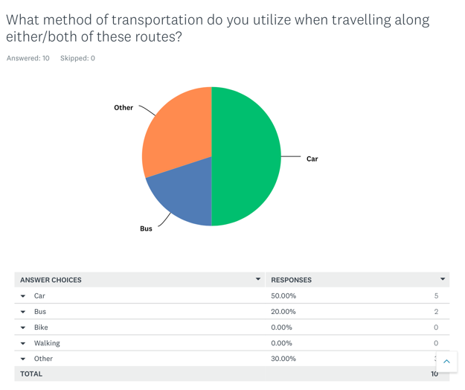
Figure 3
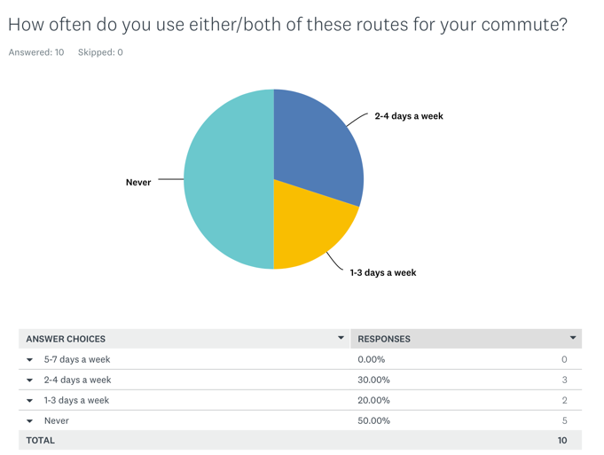
Figure 5
Figure 4
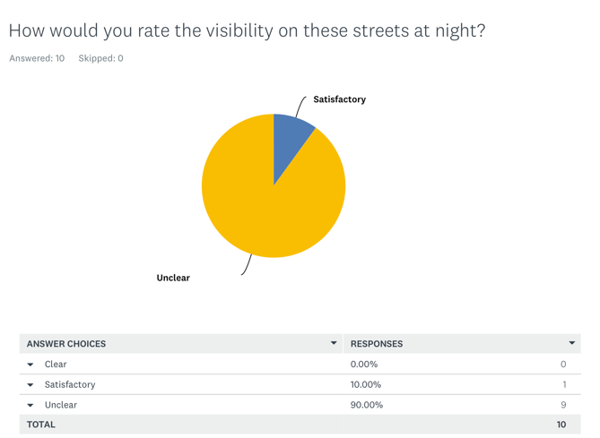
Figure 6

Analysis of Costs

The stretch of unlit road on Southwest and Northwest Marine Drive is approximately 5.40 kilometers. For the purpose of this proposal, a streetlight should be installed every .05 kilometers on either side of the road. Each streetlight is estimated to be at a cost of $3,000 and an additional $1,000 for installation (“How Much Do Street Light Poles Cost?”). With 5.40 kilometers and a streetlight at every 0.05 kilometers on either side of the road, there can be an estimate of 216 streetlights to be installed. For optimal lighting purposes, LED streetlight should be used which costs around $180 each (Wenli).
To calculate the total cost of installing 216 streetlights, the cost of a LED bulb, installation, and the cost for the streetlight pole have all been considered.
($3,000 + $1,000) x 216 = $864,000
($180 x 216) + $864,000 = $902,880

An approximate cost for installing new streetlights on Southwest and Northwest Marine Drive can be concluded to be $902,880. Although costs are quite high, the installation of new streetlights is necessary for community safety.

Analysis of Locations of Previous Incidents

Previous incidents along Southwest and Northwest Marine Drive have been reported.
(Collect more data)

Conclusion

Summary of Findings

The Metro Vancouver community has expressed their concern for community safety, and this can be near resolved if the installation of streetlights were to be implemented. The results from surveys were almost 100% agreeable that these two sections of road had unclear visibility. With the addition of accident data to support these findings, it can be concluded that Southwest and Northwest Marine Drive need new streetlights.

Works Cited

“Grade 4 Youngsters Hurt, Recovering, as Car Veers onto Sidewalk at UBC.” Vancouversun, 2 June 2022, vancouversun.com/news/local-news/grade-4-youngsters-hurt-recovering-as-car-veers-onto-sidewalk-at-ubc.
‌
Gul, Monika, et al. “CityNews.” Vancouver.citynews.ca, 21 Sept. 2021, vancouver.citynews.ca/2021/09/27/ubc-road-safety-fatal/.
‌
“How Much Do Street Light Poles Cost?” Lightmart.com, www.lightmart.com/blog/how-much-do-street-light-poles-cost/.
‌
Prasad, Travis. “Calls for Improved Road Safety Following Deadly Crash on UBC Campus.” British Columbia, 27 Sept. 2021, bc.ctvnews.ca/calls-for-improved-road-safety-following-deadly-crash-on-ubc-campus-1.5602855.
‌
Sangar, Vik. “‘Not Just Isolated Incidents’: Community Members Call for Safety Improvements to NW Marine Drive after Two Pedestrian-Involved Car Collisions.” The Ubyssey, 13 Oct. 2021, www.ubyssey.ca/news/nw-marine-drive-safety-concerns/.
‌
“University Endowment Lands - About.” Www.universityendowmentlands.gov.bc.ca, www.universityendowmentlands.gov.bc.ca/about/about.htm.
‌
Wenli. Do You Know How Much a Street Light Costs to Run. 5 July 2021, kanglight.com/how-much-does-a-street-light-cost-to-run/.
‌

