Three Definitions of “High-Density Lipoprotein”

Introduction: The objective of this assignment is to understand the importance of definitions and to learn how audience and purpose determine their granularity and content. I will provide three types of definitions for “high-density lipoprotein” - parenthetical, sentence, and extended (with at least four expansions) – for a non-technical audience.

Reading situation: A brochure explaining the role of high-density cholesterol in relation to cardiovascular health.

Parenthetical definition: This test will determine the amount of high-density lipoprotein (the “good” cholesterol) in your blood plasma.

Sentence definition: High-density lipoprotein (HDL) is a type of lipoprotein, which is a complex of lipids (fats) and protein that is used to transport cholesterol and other types of lipids in the bloodstream. Higher amounts of HDL in blood are associated with higher cardiovascular health.

Expanded definition:

What is high-density lipoprotein?
High-density lipoprotein (HDL) is a type of lipoprotein, which is a complex of lipids (fats) and protein that is used to transport cholesterol and other types of lipids in the bloodstream. Since cholesterol and other fats are not soluble in water, they cannot travel freely in blood and must be “packaged” to be transported. The “high-density” in high-density lipoprotein comes from the fact that its density is higher than that of other types of lipoproteins.

What is its relation to cardiovascular health?
Higher amounts of HDL in blood are associated with higher cardiovascular health. For this reason, it is commonly known as the “good” cholesterol. Low-density cholesterol, or “bad” cholesterol, is responsible for build-up of fatty deposits commonly known as “plaques”. The HDL particles may slow plaque formation through its role in absorbing cholesterol from the body and directing it for excretion. For this reason, people with lower levels of HDL than usual are advised to speak with a doctor about lifestyle changes that can help increase it.

What is it composed of?
Just like other lipoproteins, high-density lipoprotein is about 5-12 nm in size (one nanometer is one-billionth of a meter). It is a particle that consists of an outer layer and a core (see Figure 1). The outer layer is made of phospholipid, which is the same biological compound that makes up membranes in human cells, cholesterol, and lipoprotein-specific proteins. The inner core contains compounds that are commonly known as fats, which are triglycerides and modified cholesterol.

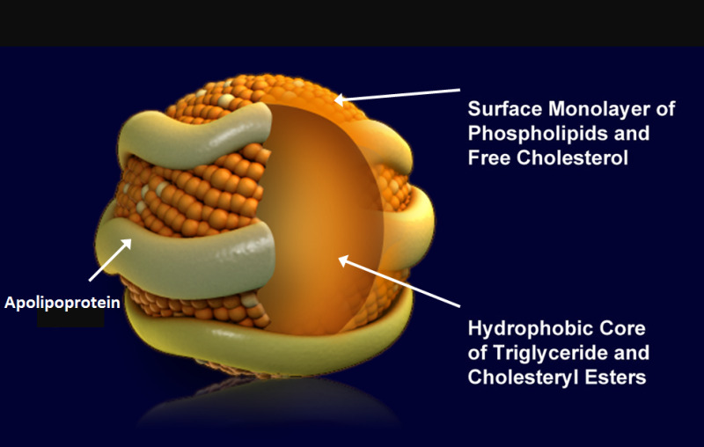
Figure 1 Structure of a lipoprotein

How is it different from other lipoproteins?
Besides being higher in density than other lipoprotein types, HDL also has different functions and effects on the body. For example, while low-density lipoprotein transports cholesterol from the liver to the tissues, HDL transports cholesterol from the tissues back to the liver, where cholesterol is broken down and consequently excreted from the body.

References
Encyclopædia Britannica, inc. (n.d.). Lipoprotein. Encyclopædia Britannica. Retrieved June 8, 2022, from https://www.britannica.com/science/lipoprotein
Feingold KR. Introduction to Lipids and Lipoproteins. [Updated 2021 Jan 19]. In: Feingold KR, Anawalt B, Boyce A, et al., editors. Endotext [Internet]. South Dartmouth (MA): MDText.com, Inc.; 2000-. Retrieved June 8, 2022, from https://www.ncbi.nlm.nih.gov/books/NBK305896/

