Definitions Assignment

“Operculectomy”
Parenthetical: Operculectomy (minor surgery removing excess skin over a tooth). (Abate, 2020)
Sentence Definition: An operculectomy is the removal of any excess skin over a partially erupted tooth via surgery, or, used with orthodontic treatment in correcting the position of a tooth by aiding it to erupt in the proper place by cutting the gum tissue. (Abate, 2020)

Expanded definition:

Operculectomy

“Operculectomy” is a surgical procedure where the excess tissues surrounding a partially erupted tooth due to pain or infection in most cases. This procedure can also be used to aid unerupted teeth to erupt by creating an easier path of eruption (Bonetti, 1999). This procedure is commonly used with partially erupted or impacted 3rd molars (wisdom teeth). In many cases, an operculum is formed when there is pressure or forces from the occluding (tooth on opposite jaw) teeth which result in a damaged and inflamed gum tissue. Another reason for this pain would be if the tooth is impacted (unable to erupt due to it being stuck against bone or another tooth), and unable to erupt properly, leading to a food trap in the mouth that may become infected.
The world “operculectomy” comes from the latin derived word “operculum” which means “cover or lid” (Harper, 2022). This is referring to the excess gum tissue covering the tooth like a cover would. The second part of the word “-ectomy”, comes from the latinized Greek -ektomia "a cutting out of,"(Harper, 2022). This part of the word refers to the surgical removal of the excess tissue.

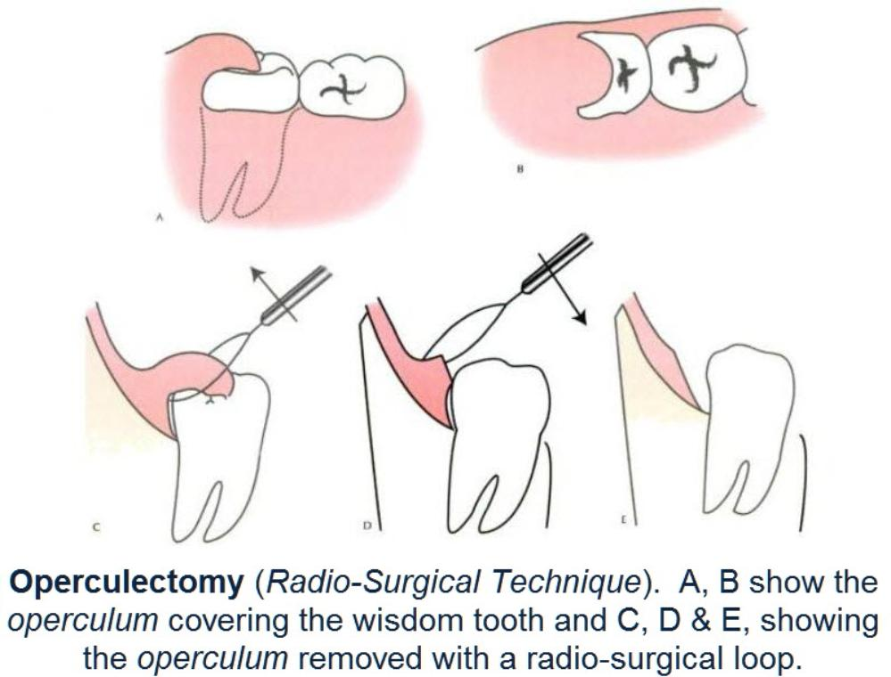
https://images.app.goo.gl/52gdFj2Z7cLeJ

An operculectomy is usually an elective procedure (not a danger if not done but may be used to reduce pain/infection). This surgery can be performed with either laser technology, or traditional surgical removal. Operculectomies are not often a permanent solution, as patients find that pain and swelling can return as tissues heals around area again. A more permanent solution would be braces (orthodontics) to fix the affected area or removal of the tooth under operculum. An operculectomy is not the removal of the tooth itself, simply the removal of gum tissue covering the tooth. This is a common misconception amongst dental patients.

Works Cited

Abate, Andrea et al. “Efficacy of Operculectomy in the Treatment of 145 Cases with Unerupted Second Molars: A Retrospective Case-Control Study.” Dentistry journal vol. 8,3 65. 1 Jul. 2020, doi:10.3390/dj8030065

Harper, Douglas. “Etymology of operculum.” Online Etymology Dictionary, https://www.etymonline.com/word/operculum. Accessed 1 June, 2022.

Harper, Douglas. “Etymology of -ectomy.” Online Etymology Dictionary, https://www.etymonline.com/word/-ectomy. Accessed 1 June, 2022.

Bonetti G.A., Pelliccioni G.A., Checchi L. Management of bilaterally impacted mandibular second and third molars. J. Am. Dent. Assoc. 1999;130:1190–1194. doi: 10.14219/jada.archive.1999.0373.

