Term: Mortgage
Introduction
The purpose of this assignment is the understand and practice the use of definitions in technical writing to a non-technical audience. In this definition, we learn about a mortgage which is a common real estate term used by appraisers, mortgage brokers, and banks for prospective homebuyers. We examine this word in three types of definition - parenthetical, sentence, and expansive.
Reading Situation
A mortgage broker explaining to a client what their options are for financing their home.
Parenthetical Definition
The Mortgage Broker was requesting information from their client to process the mortgage (substantial loan to buy a house).
Sentence Definition
The mortgage is a type of financial loan that is typically 25 or 30 years long in duration, classifying as a loan from the bank or a private lender, used to fund the purchase of a home.
Expanded Definition
- How does a mortgage work? (Operating Principle)
In order to avoid paying the full purchase price up front with cash, individuals and businesses can take out a mortgage where the borrower repays the loan plus interest over the span a specified number of years until the loan has been paid off (Dotdash Meredith, n.d.). Mortgages are offered to homebuyers through banks, credit unions, mortgage brokers, etc. and each party will offer slightly different terms and conditions.
- What are the types of mortgages? (Analysis of Parts)
There are many different types of mortgages you can opt for, but the two main ones that people choose to use are fixed rate and variable rate (Canadian Mortgages Inc., 2021). A fixed rate mortgage is one where the interest rate does not change throughout the term of the loan. With a variable-rate mortgage, the amount you pay will vary based on the fluctuating prime rate. Choosing the mortgage type will depend on current market conditions and each individual’s appetite for risk tolerance.

- Negation
A common confusion occurs between a mortgage pre-approval and a mortgage pre-qualification. When you are looking for a mortgage pre-qualification, you are providing detailed information about your employment status, income level, and debts to a lender (Hiscock, 2022). A pre-approval is where a lender will verify said information and only give you a likelihood of whether you will be qualified for a mortgage. Therefore, a mortgage is not granted in a pre-approval.
- Visuals
In this flow chart from Credible seen in Figure 1, it outlines the basic steps in obtaining a mortgage from start to finish. There are various steps in order to achieve the best rate and complete your due diligence when looking for a mortgage.
Figure 1
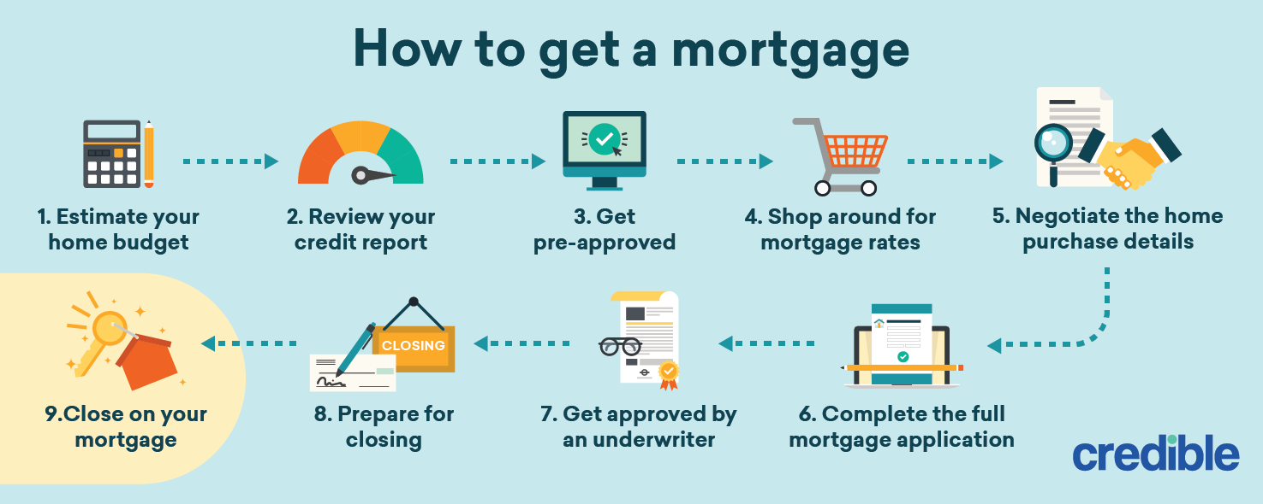
Source: “How to Get a Mortgage.” Credible, 2022, retrieved from https://www.credible.com/blog/mortgages/how-to-get-a-mortgage/

Bibliography
Canadian Mortgages Inc. (2021). Types of Mortgages in Canada and How They Apply to You. Retrieved from Canadian Mortgages Inc.: https://canadianmortgagesinc.ca/2018/10/types-of-mortgages-in-canada-and-how-they-apply-to-you.html
Dotdash Meredith. (n.d.). What Is a Mortgage? Retrieved from Investopedia.com: https://www.investopedia.com/terms/m/mortgage.asp
Hiscock, K. (2022). Top 11 Mortgage Myths to Be Aware Of When Buying A Home. Retrieved from Rochester Real Estate Blog: https://www.rochesterrealestateblog.com/top-11-mortgage-myths-aware-buying-home/
“How to Get a Mortgage.” Credible, 2022, retrieved from https://www.credible.com/blog/mortgages/how-to-get-a-mortgage/

